CCT College

Concurrency Systems

Programme Title: | Concurrency Systems
Lecturer’s Name: | Sam Weiss
Assignment Title: | Concurrency Systems Ca 2
Deadline Date: | 21/05/2023 11.59pm
Student Name: | Pedro Henrique Simoes Marcal
Student Number: | 2020300
Student Email: | Henrique.pedro.marcal@gmail.com
GitHub Repository: | https://github.com/pedromarcal12/CA2-ConcurrentSystems

Table of Contents

Introduction………………………………………………………………………………………………………………..3
Design & Documentation…………………………………………………………………………………………….4
Reference…………………………………………………………………………………………………………………….8

Introduction

Students are advised to review and adhere to the submission requirements documented after the assessment task. Scenario: YouTube is looking to integrate a real-time messaging functionality, YouChat, into its app, and has hired you to design and implement a prototype. This task has two components: YouChat Design and Documentation [50 Marks] You will need to create a report detailing the design of the app. This should include the rationale for the decisions you take. Be sure to discuss the concurrency issues faced in the app as well as how you solved them.
You should also document the features of the app and how to use them. This report should be suitable for both peers and project stakeholders.

Design & Documentation
YouChat 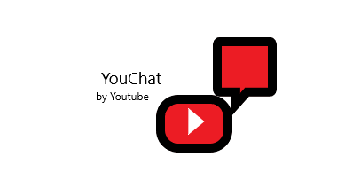
Goal
- To provide a fast chat service that will engage more with our platform.
- Create an intuitive and interactive chat service that will reach and connect people all over the world with same interests.
-To be able to provide a chat service that allow the users to send text, voice messages and images.
Software Documentation
Nowadays, most of the media software created includes a chat message, even if watching a streaming, it is very important that people can interact with themselves and engage your software, as much time as they spend in there, it is better your business. The main goal with this new YouTube extension is to each time more, become an interactive social media where people can talk, send photos, share common interests, create new contents, make partnership with others digital creators, infinite possibilities that is what we are looking for.
The new YouTube Chat, YouChat is coming soon to be the messenger of YouTube, people will be able to text friends and create groups with them. The first prototype will be available soon and the application will be developed using Eclipse, the main idea of the first version will be a prompt screen where will display multiple group chat and will show up if there is a new connection, if someone just disconnect, the message and the sender of the message.
Development Documentation
The software was developed using the Eclipse IDE, and the implementation of three classes, one for the server to work, named "Server", another for users to connect, named "Client" and a third to take care of the client functions, named "Handler". The Server class is where the server is created, we have three methods there: start(), for starting the server, close(), for closing the server and the main method that contains the server info. The Client is where the client is created on the server, where he has to enter his user and password, password option is created but still needs implement so it will be marked as a comment, with the Client class, sendMessage() method where the message written by the user is send using BFWriter, lookForMessage() method with the thread because it has to be constantly updated because a message can come at any time by any user and the main method that will ask the user to enter his username and password and will pass this info to the Client constructor object.

Stakeholders
Our user targets are mainly people that will bring engagement to the platform, people with visibility and people that will be texting others about videos or any subjects and will bring curiosities/content, information, to others.
For the prototype, we just have one developer that has experience on chat applications, Pedro. He coded the application alone, but it still needs improvements and implementations for the original release so for that, we will build a team that will be working on the front-end and one to work on the back-end.
Prototype Design
Displaying message to all users when a new user connects.
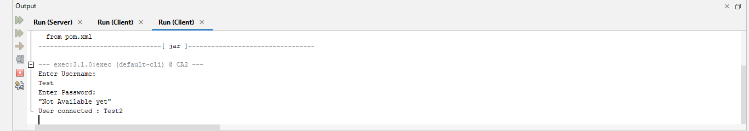
Here I created 7 different Users to show that the Server method is successfully working and will let us know when a new connection is made.
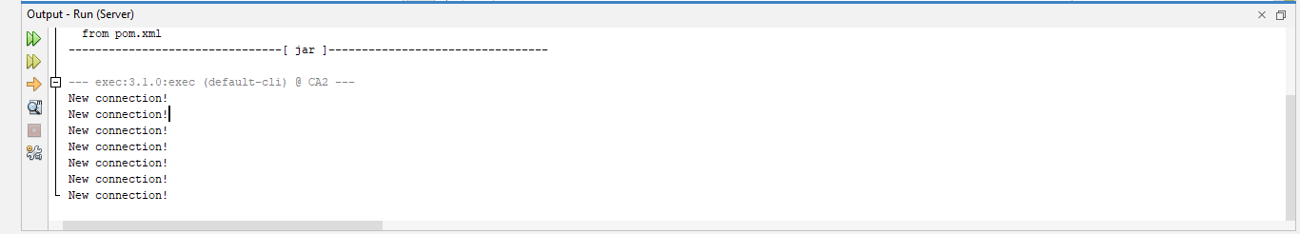
Here is the user that will receive a message side.
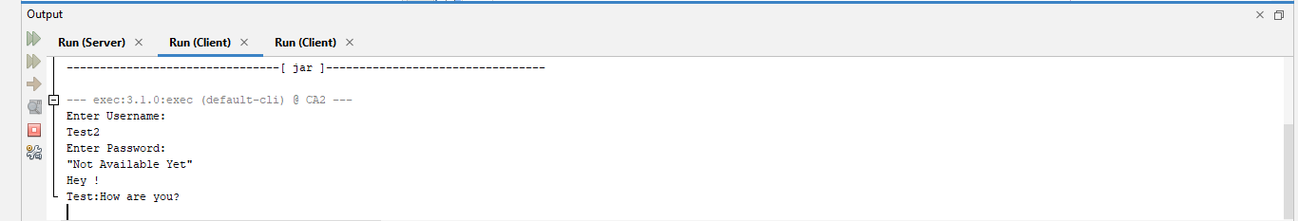
Displaying message when the user disconnects
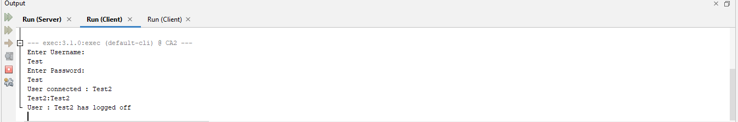

Group-Chat User Case
The User-case diagram for the group chat where all involved can send and receive messages.
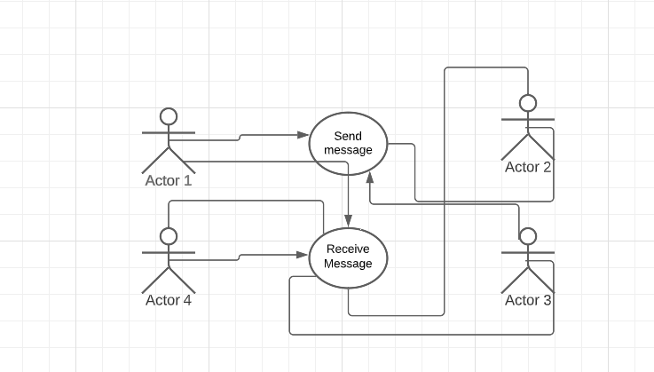

The Chat User-case where people can receive and send messages on a comment of streaming video, video and talk within the chat.
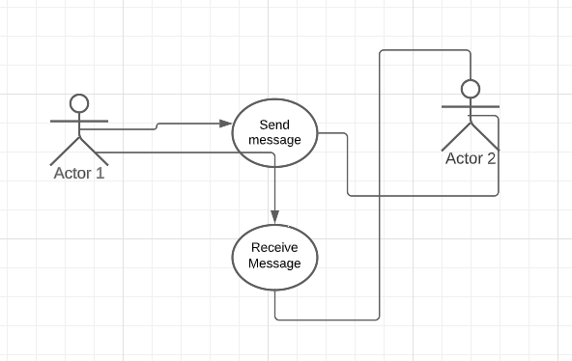

Concurrency Issues

Concurrency Issues are mostly connected to errors that are due to the same resource, being shared, accessed simultaneously, and having to be constantly working. On this app, I faced issues when I tried to implement the method that will be looking for messages sent by each user, so to solve it what was needed was to implement a Thread, that works as a small CPU that will execute the code constantly and by priority order
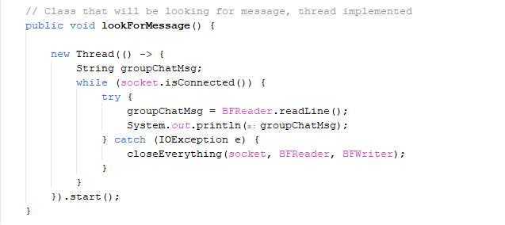

Reference

MozDevNet (no date) Writing a websocket server in java - web apis: MDN, Web APIs | MDN. Available at: https://developer.mozilla.org/en-US/docs/Web/API/WebSockets_API/Writing_a_WebSocket_server_in_Java (Accessed: 10 May 2023).

