4.

Test connectivity between Router1 and SWL3 A.

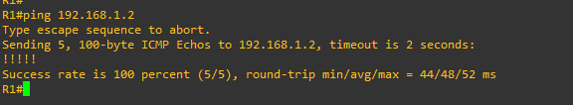

5.

Analyze the captured packets and verify that the source/destination MAC addresses match the

respective MAC address of the interfaces of the routers.

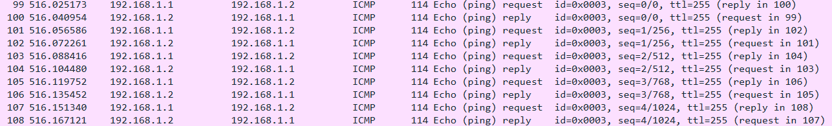 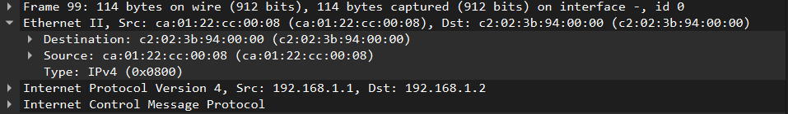  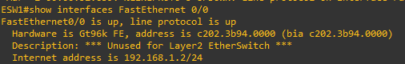

7.

Verify the status of all interfaces (show ip int br) and check that all connected links are operational

(status should be up/up).



Test connectivity between PCA and PCB and the other terminals.

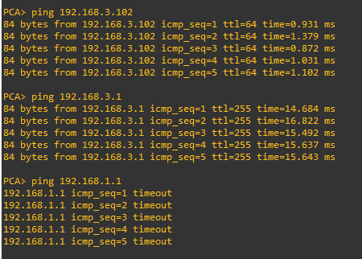

Which terminals do not have connectivity with PCA and PCB? Explain the reason.

Os PCA e PCB não tem conectividade com o Router 1 e o PC1 porque não foi estabelecida uma rota estática entre eles, a rota estática serve para o router saber para onde encaminhar os pacotes.

Add a routing solution (static routes) in Router 1 to achieve full connectivity.

R1(config)#ip route 192.168.3.0 255.255.255.0 192.168.1.2

