Consumer Choice: Model Analysis and Baseline Simulation of an Agent-Based Model of Habits and Social Influence
[Author 1], [Author 2], [Author 3], [Author 4]
[Institution], [Programme]
{[student1], [student2], [student3], [student4]}@[domain]
Abstract. This report analyses the Consumer Choice model, an agent-based model in which consumers choose between two products under the influence of habits, information from friends and social norms. The model was implemented in Python with Mesa 3, following the rules of the original NetLogo model. We describe the agents, their state variables and actions, and define a baseline. We then run 1000 replications of the baseline and a sensitivity analysis of three parameters, using only the outputs of the model: the market shares of the two products and consumer clustering. In the baseline, clustering reaches 0.94 at tick 1000, while the final market share of each product varies widely between runs (standard deviation 0.25). A small difference in quality determines which product dominates. These results define the reference for the extension of the model to a real market.
Keywords: Agent-based modelling, Consumer behaviour, Social influence, Habits, Mesa.
1 Introduction
This report addresses the first two tasks of Project 1 of the course Multi-Agent Systems and Simulation of Organizations: (1) to analyse the chosen model and run it with a basic setup that becomes the baseline, and (2) to run the simulations for a large number of iterations to obtain meaningful statistics for the variables of interest. The remaining tasks (fitting the model to a real situation, learning agents and the analysis of the new model) will build on the baseline defined here.
The chosen model is Consumer Choice [1], from the NetLogo Models Library [2]. It derives from a basic model by M. A. Janssen and from earlier work on habits and social processes in market dynamics [3]. It simulates a market with two competing products whose quality can change. Consumers are linked in a social network and choose a product according to three mechanisms: habit, informative social influence (learning about quality from friends) and normative social influence (using the same product as the majority of friends) [4]. The model shows how these mechanisms produce clusters of consumption, tipping points and social lock-in, a situation in which a product of lower quality keeps its market because it is the norm [5].
The model was implemented in Python with the Mesa 3 framework [6]. The implementation follows the NetLogo code rule by rule. The description in Section 2 is organised along the lines of the ODD protocol [7] and places each rule next to the code that implements it. Section 3 presents the baseline experiments and their statistical analysis. Section 4 outlines how the model will be fitted to a real market in the next phase of the project. The code, data and figures are available in the project repository.
2 Model Description
2.1 Purpose and Entities
The purpose of the model is to explain how habits and social influence shape the market shares of two products, and why consumers may fail to adopt a product of higher quality. The model contains one type of agent, the consumer. The social network and the products are not agents (Table 1).
Table 1. Entities of the model.
Entity | Represents | Role in the model
Consumer (100) | A person who buys one of two products | The only agent type. It chooses a product, learns about quality and influences its friends
Link (≈250) | A friendship | Channel through which information and norms are transmitted. The network is fixed during a run
Product: orange (0) and blue (1) | Two competing brands | Defined by global parameters (quality_orange, quality_blue) that can be changed during a run

Time is discrete. In each tick all consumers first execute the consumption decision and then update their utilities. Within each phase the consumers are activated in random order (Listing 1). The outputs are recorded at the end of each tick.
126 def step(self):
127 self.agents.shuffle_do("consume")
128 self.agents.shuffle_do("update_utilities")
129 self.datacollector.collect(self)
Listing 1. Schedule of one tick (consumer_choice/model.py, lines 126–129).
2.2 State Variables of the Consumer
Each consumer holds five state variables (Table 2, Listing 2), and a position used only to build the network (Sect. 2.3). The variable satisfaction links product quality to habit: it is the probability that the consumer keeps its current product without considering the alternative. The variable personal_experience is the memory of the consumer; it is updated only for the product in use and may therefore become outdated when the quality of the other product changes.
Table 2. State variables of the consumer.
Variable | Values | Role | Consequence
choice | 0 (orange) or 1 (blue) | Product in use | Counts for the market share; it is what friends observe when they compute the norm
satisfaction | log10(1 + 9q) of the product in use | Probability of keeping the product (habit) | With q = 0.5 it equals 0.74. Higher quality produces stronger habits and less attention to the alternative
personal_experience | Remembered quality of each product, initially [0, 0] | Memory of the consumer | A product never used is valued at 0; a change in the quality of the unused product is not perceived
utilities | Total utility of each product | Basis of the choice when the consumer neither keeps nor explores | Combines norm and product utility (Sect. 2.4)
friends | List of linked consumers | Social network of the consumer | Source of information and of the norm

17 class Consumer(mesa.Agent):
18 """A consumer who uses one of two products and has friends."""
19
20 def __init__(self, model, choice, pos):
21 super().__init__(model)
22 # product in use: 0 orange, 1 blue
23 self.choice = choice
24 # total utility of each product
25 self.utilities = [1.0, 0.0] if choice == ORANGE else [0.0, 1.0]
26 # probability of keeping the product (habit)
27 self.satisfaction = model.satisfaction(choice)
28 # remembered quality of each product
29 self.personal_experience = [0.0, 0.0]
30 # location, used only to build the network
31 self.pos = pos
32 # linked consumers (social network)
33 self.friends = []
Listing 2. Consumer state variables (consumer_choice/model.py, lines 17–33).
2.3 Social Network
Each consumer is placed at a random position in a 51 × 51 space. Links are created one at a time: a random consumer is linked to the nearest consumer to which it is not yet linked, until the number of links equals avg_connections × num_consumers / 2 (250 in the baseline). The position is used only for this purpose (Listing 3). Because links connect nearby consumers, the network is local: friends of a consumer tend to be friends of each other. This property favours the formation of clusters of consumers that use the same product.
108 def build_network(self, avg_connections):
109 """Link a random consumer to its nearest unlinked consumer."""
110 num_links = (avg_connections * self.num_consumers) / 2
111 links = 0
112 while links < num_links:
113 a = self.random.choice(self.consumers)
114 cands = [c for c in self.consumers
115 if c is not a and c not in a.friends]
116 if not cands:
117 continue
118 d_min = min(math.dist(a.pos, c.pos) for c in cands)
119 nearest = [c for c in cands
120 if math.dist(a.pos, c.pos) == d_min]
121 target = self.random.choice(nearest)
122 a.friends.append(target)
123 target.friends.append(a)
124 links += 1
Listing 3. Construction of the social network (consumer_choice/model.py, lines 108–124).
2.4 Actions of the Consumer
Consumption Decision. In each tick the consumer applies three rules in sequence (Listing 4). First, with probability equal to satisfaction, it keeps the current product (habit). Second, if it did not keep the product, it switches to the other product with probability exploration. Third, if it neither kept nor explored, it chooses the product with the higher utility; if both utilities are equal, it keeps the current product. Satisfaction is then recomputed for the product in use. In the baseline the probability of exploring in a given tick is (1 − 0.74) × 0.01 ≈ 0.003.
35 def consume(self):
36 """Keep the product, explore the other, or choose by utility."""
37 if self.random.random() < self.satisfaction:
38 pass # habit: keep the product
39 elif self.random.random() < self.model.exploration:
40 self.choice = 1 - self.choice # explore the other product
41 elif self.utilities[ORANGE] != self.utilities[BLUE]:
42 self.choice = (ORANGE if self.utilities[ORANGE]
43 > self.utilities[BLUE] else BLUE)
44 self.satisfaction = self.model.satisfaction(self.choice)
...
104 def satisfaction(self, choice):
105 """Satisfaction grows with the log of quality: log10(1 + 9q)."""
106 return math.log10(1 + 9 * self.quality[choice])
Listing 4. Consumption decision and satisfaction (consumer_choice/model.py, lines 35–44, 104–106).
Utility Update. After the consumption phase, each consumer computes the utility of each product (Listing 5) in four steps: (1) the experience of the product in use is set to its current quality; (2) with probability information_exchange, and only if at least one friend uses the product, the consumer receives the current quality of that product; (3) the norm-based utility is the share of friends who use the product; (4) the total utility is
U = w · N + (1 − w) · (E + I) / 2 ,
where w is norm_influence, N the share of friends using the product, E the remembered quality and I the quality reported by friends (0 if no information was received). Without information from friends, the product utility is half of the remembered quality. As a result, information exchange favours the product that friends already use, in the same direction as the norm.
46 def update_utilities(self):
47 """Combine own experience, friends' information and the norm."""
48 m = self.model
49 for option in (ORANGE, BLUE):
50 # 1. own experience: only the product in use is updated
51 if self.choice == option:
52 self.personal_experience[option] = m.quality[option]
53 # 2. information exchange: a friend who uses the product
54 # reports its current quality
55 neighbor_info = 0.0
56 if (self.random.random() <= m.information_exchange
57 and any(f.choice == option for f in self.friends)):
58 neighbor_info = m.quality[option]
59 # 3. social norm: share of friends who use the product
60 norm_util = 0.0
61 if self.friends:
62 users = sum(f.choice == option for f in self.friends)
63 norm_util = users / len(self.friends)
64 # 4. total utility: norm-based and product utility
65 prod_util = (self.personal_experience[option]
66 + neighbor_info) / 2
67 self.utilities[option] = (
68 m.norm_influence * norm_util
69 + (1 - m.norm_influence) * prod_util)
Listing 5. Utility update (consumer_choice/model.py, lines 46–69).
Table 3 summarises the actions and their consequences.
Table 3. Actions of the consumer, in the order in which they are executed.
Action | When | Consequence
Keep the product (habit) | With probability satisfaction | No change. The consumer does not consider the alternative, so improvements of the other product are not perceived
Explore | If not kept, with probability exploration | Switches to the other product and learns its actual quality in the next update. It is the only way to discover an improvement of a product that no friend uses
Choose by utility | If neither kept nor explored, and utilities differ | Selects the product with the higher utility; in a tie it keeps the current product
Update experience | Every tick, for the product in use | Memory of that product equals its current quality
Ask friends | For each product, with probability information_exchange, if a friend uses it | Receives the current quality. Reinforces the product used by friends
Observe the norm | Every tick | Pulls utility towards the local majority; produces clusters and can produce lock-in

Taken together, habit slows down change, exploration is the only source of new information about an unused product, and information exchange and the norm reinforce the product that is already used by friends. These mechanisms produce the three patterns described by the authors of the model: clustering of consumption, amplification of small differences in quality and social lock-in [1].
2.5 Global Parameters and Baseline
The model has eight parameters (Listing 6). The baseline uses the default values of the original model file (Table 4).
75 def __init__(self, num_consumers=100, avg_connections=5,
76 initial_pct_orange=50, norm_influence=0.15,
77 information_exchange=0.05, exploration=0.01,
78 quality_orange=0.5, quality_blue=0.5, rng=None):
79 super().__init__(rng=rng)
80 self.num_consumers = num_consumers
81 self.norm_influence = norm_influence
82 self.information_exchange = information_exchange
83 self.exploration = exploration
84 self.quality = [quality_orange, quality_blue]
Listing 6. Model parameters and their baseline values (consumer_choice/model.py, lines 75–84).
Table 4. Global parameters, baseline values and role. The last column summarises the effect measured in Sect. 3.3; parameters marked “not tested” were kept at the baseline value.
Parameter | Baseline | Role | Effect of increasing the value
num_consumers | 100 | Size of the market | Not tested
avg_connections | 5 | Average number of friends | Not tested
initial_pct_orange | 50 | Initial share of orange consumers | Not tested
norm_influence | 0.15 | Weight of the norm against product utility | From 0 to 0.1, mean clustering rises from 0.54 to 0.94; above 0.1 it changes little
information_exchange | 0.05 | Probability of learning from friends | Not tested
exploration | 0.01 | Probability of trying the other product | At 0.2, mean clustering falls to 0.67 and the dispersion of market shares decreases
quality_orange | 0.5 | Quality of the orange product | Not tested (reference value)
quality_blue | 0.5 | Quality of the blue product | A difference of 0.05 gives the better product 93–95% of the market (mean)

2.6 Model Outputs
The original model reports two plots: the market shares of the two products and the clustering of consumers. The implementation records the same three quantities at every tick with a Mesa DataCollector (Listing 7, Table 5). The analysis in Section 3 uses only these outputs.
97 self.datacollector = mesa.DataCollector(model_reporters={
98 "orange": lambda m: m.count_choice(ORANGE),
99 "blue": lambda m: m.count_choice(BLUE),
100 "clustering": lambda m: m.consumer_cluster(),
101 })
102 self.datacollector.collect(self)
...
132 def count_choice(self, product):
133 return sum(c.choice == product for c in self.consumers)
134
135 def consumer_cluster(self):
136 """Mean share of friends who use the consumer's product."""
137 total = 0.0
138 for c in self.consumers:
139 if c.friends:
140 same = sum(f.choice == c.choice for f in c.friends)
141 total += same / len(c.friends)
142 return total / self.num_consumers
Listing 7. Model outputs (consumer_choice/model.py, lines 97–102, 132–142).
Table 5. Outputs of the model.
Output | Definition | Interpretation
Orange consumers | Number of consumers with choice = 0 | Market share of the orange product (out of 100)
Blue consumers | Number of consumers with choice = 1 | Market share of the blue product (out of 100)
Clustering | Mean, over consumers, of the share of friends that use the same product | 1: all friends use the same product; ≈0.5: choices independent of friends

2.7 Notes on the Implementation
Three differences between the description in the Info tab of the original model and its code were found; the implementation follows the code:
– The Info tab states a default exploration of 0.05; the model file uses 0.01.
– The Info tab states that friends may share outdated information. In the code, a friend always reports the current quality of the product.
– The Info tab states that less satisfied consumers seek more information. In the code, the probability of information exchange does not depend on satisfaction; satisfaction only determines whether the utilities are used in the decision.
3 Baseline Simulation and Statistical Analysis
3.1 Experimental Setup
The baseline was replicated 1000 times with different random seeds (0 to 999), for 2000 ticks each, with the outputs recorded at every tick. The statistics are reported at tick 1000, and ticks 1500 and 2000 are used to check the horizon. For the sensitivity analysis, three parameters were varied one at a time, with 100 replications per value and 1000 ticks per run (Table 6). The same 100 seeds were used for every value of a parameter (common random numbers), so that differences between values are not due to different random draws. The experiments use the Mesa batch_run function (Listing 8).
Table 6. Experimental design.
Experiment | Parameter values | Runs per value | Ticks
Baseline | Table 4 | 1000 | 2000
Norm | norm_influence = 0, 0.1, …, 1.0 | 100 | 1000
Quality | quality_blue = 0.3, 0.4, 0.45, 0.5, 0.55, 0.6, 0.7 | 100 | 1000
Exploration | exploration = 0, 0.01, 0.05, 0.1, 0.2 | 100 | 1000

24 BASELINE = dict(num_consumers=100, avg_connections=5,
25 initial_pct_orange=50, norm_influence=0.15,
26 information_exchange=0.05, exploration=0.01,
27 quality_orange=0.5, quality_blue=0.5)
...
49 results = batch_run(ConsumerChoiceModel, parameters=params,
50 rng=list(range(seed0, seed0 + runs)),
51 max_steps=ticks,
52 data_collection_period=1 if every_tick else -1,
53 number_processes=PROCESSES,
54 display_progress=False)
Listing 8. Baseline values and batch run (experiments/run_experiments.py, lines 24–27, 49–54).
For each output we report the mean, the standard deviation (SD), the 95% confidence interval of the mean (Student’s t), the median and the 5th and 95th percentiles (P5, P95). Market shares are expressed as fractions of the 100 consumers.
Number of Runs. Figure 2 shows the mean of each output at tick 1000 as a function of the number of runs. With 100 runs, the half-width of the 95% confidence interval is 0.051 for the orange share and 0.006 for clustering. With 1000 runs it is 0.016 and 0.002. The market share requires more runs than clustering because its variance between runs is about 67 times larger. We therefore use 1000 runs for the baseline and 100 runs per value in the sensitivity analysis, where the differences between parameter values are larger than this precision.
Horizon. Table 8 shows the outputs at several ticks. Mean clustering increases by 0.018 between ticks 500 and 1000 and by 0.011 between ticks 1000 and 2000. The SD of the orange share keeps increasing (0.21, 0.25, 0.29 at ticks 500, 1000 and 2000). The model does not reach a stationary distribution of market shares within 2000 ticks: individual markets continue to move away from the initial 50/50 split. Tick 1000 is used as the reference horizon because the change of mean clustering after it is small and the shares have already separated. Statistics at a later tick would show a larger dispersion of shares; this must be considered when the extended model is compared with the baseline.
3.2 Baseline Results
Table 7 reports the statistics of the three outputs at tick 1000 over the 1000 runs, and Fig. 1 shows their evolution.
Table 7. Baseline outputs at tick 1000 (1000 runs).
Output | Mean | SD | 95% CI | Median | P5 | P95
Orange market share | 0.506 | 0.252 | 0.490–0.521 | 0.510 | 0.11 | 0.92
Blue market share | 0.494 | 0.252 | 0.479–0.510 | 0.490 | 0.08 | 0.89
Clustering | 0.937 | 0.031 | 0.935–0.939 | 0.941 | 0.88 | 0.98

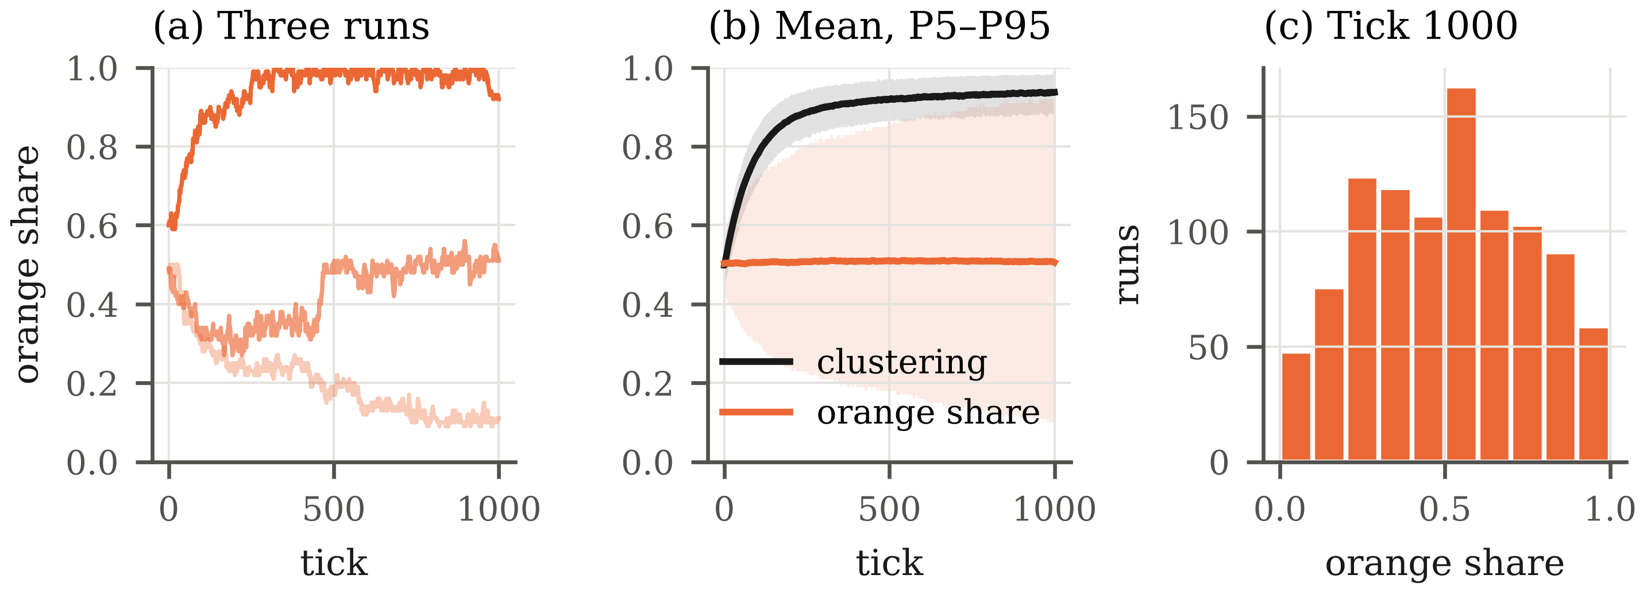
Fig. 1. Baseline. (a) Orange market share in three runs (the 5th, 50th and 95th percentile of the final share). (b) Mean clustering and mean orange share over 1000 runs, with the band between P5 and P95. (c) Distribution of the orange share at tick 1000.
Three results characterise the baseline:
– Each market becomes segmented. Mean clustering rises from 0.50 at tick 0 to 0.94 at tick 1000 (95% CI 0.935–0.939). On average, 94% of the friends of a consumer use the same product. The variation between runs is small (SD 0.031), so this result does not depend on the random seed.
– The market outcome is not predictable. The mean orange share is 0.51, as expected from the symmetry of the baseline (equal qualities and initial shares), but the SD between runs is 0.25. In 90% of the runs the orange share lies between 0.11 and 0.92. Orange holds the majority in 50.5% of the runs and blue in 47.4% (ties: 2.1%). Only 27% of the runs end with shares between 0.40 and 0.60, and 10.8% end with one product at 90% or more.
– The mean share is not informative; the dispersion is. With identical products, the result of a run depends on early random events that are amplified by the norm and by information exchange. The relevant statistic for the baseline is therefore the distribution of shares (Fig. 1c), not its mean.
Table 8. Mean and SD of the outputs over time (baseline).
Tick | Clustering (mean) | Clustering (SD) | Orange share (mean) | Orange share (SD)
0 | 0.499 | 0.033 | 0.503 | 0.051
100 | 0.779 | 0.043 | 0.505 | 0.128
250 | 0.887 | 0.036 | 0.507 | 0.176
500 | 0.919 | 0.031 | 0.510 | 0.210
750 | 0.931 | 0.032 | 0.509 | 0.235
1000 | 0.937 | 0.031 | 0.506 | 0.252
1500 | 0.944 | 0.028 | 0.510 | 0.274
2000 | 0.948 | 0.031 | 0.511 | 0.291

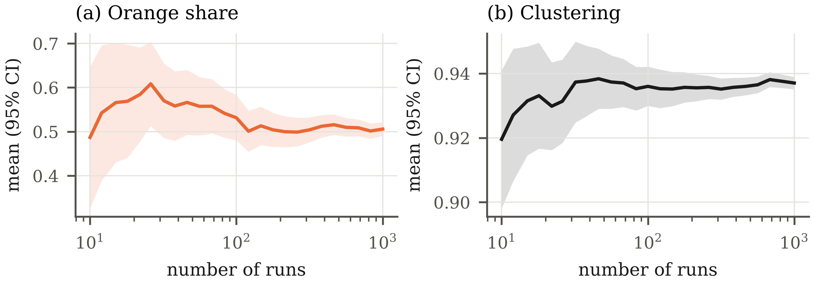
Fig. 2. Mean of the outputs at tick 1000 as a function of the number of runs, with the 95% confidence interval. (a) Orange market share. (b) Clustering.
3.3 Sensitivity Analysis
The sensitivity analysis varies one parameter at a time, with all other parameters at the baseline. Figures 3 to 5 show the distribution of the orange share and the mean clustering at tick 1000, and Tables 9 to 11 report the statistics.
Social Norm. Without norm (norm_influence = 0), mean clustering is 0.54, close to the value of independent choices, and the orange share stays near 0.5 (SD 0.07). With norm_influence = 0.1, mean clustering is 0.94 and the SD of the orange share is 0.24. Above 0.1 both values change little (clustering between 0.94 and 0.95). The effect of the norm is a threshold, not a gradual effect. The reason is visible in the utility function. With both qualities equal to q, the product utility of a consumer can only take the values 0, q/2 and q, so the difference between the two products is either 0 or at least q/2. The norm can reverse a non-zero difference only if w / (1 − w) > q/2, that is, w > q / (2 + q) = 0.2 for q = 0.5. For w ≤ 0.2 the norm acts only when the product utilities are equal. This explains why the results for w = 0.1 and w = 0.2 are identical under common random numbers (Table 9), and why a small positive norm is sufficient to coordinate the choices of friends.
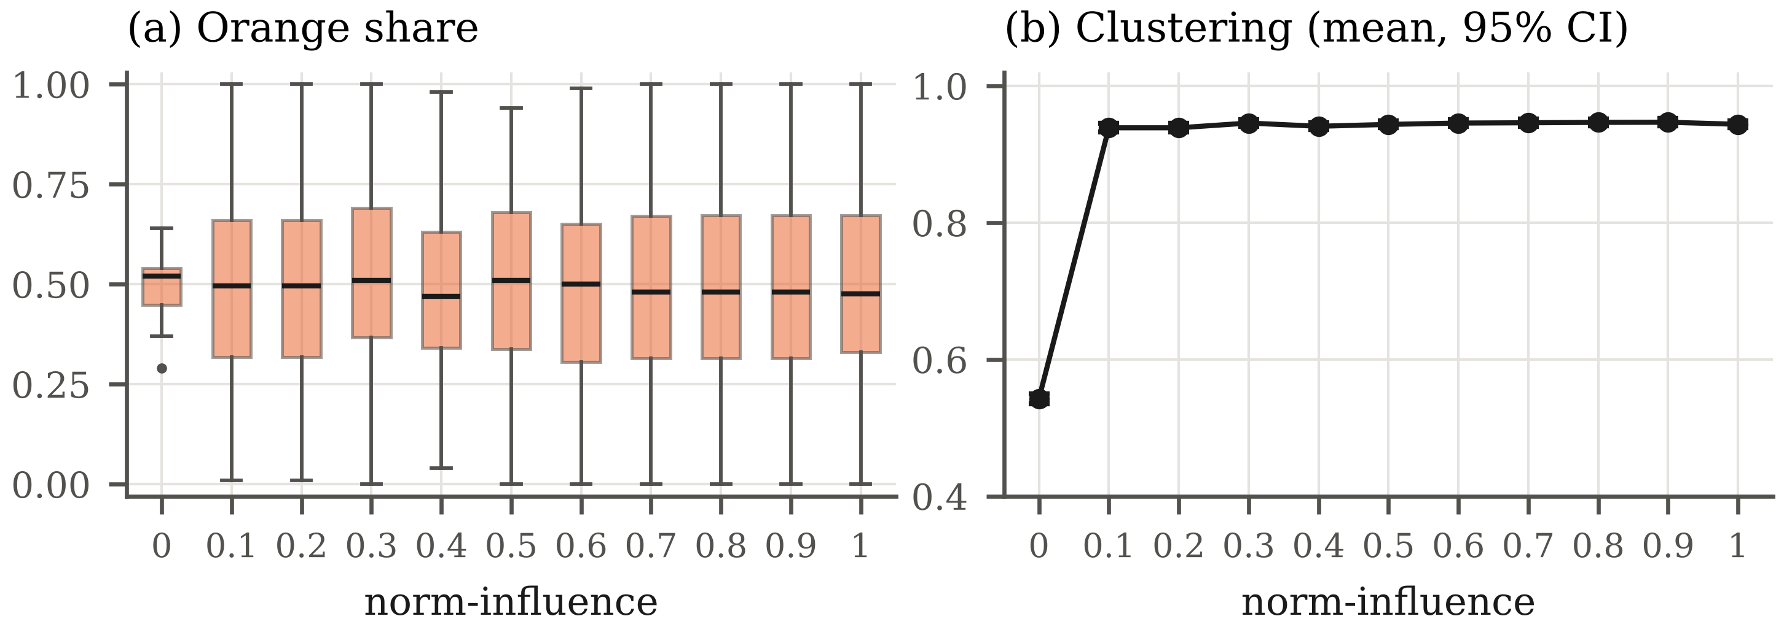
Fig. 3. Effect of norm_influence (100 runs per value). (a) Distribution of the orange share at tick 1000. (b) Mean clustering at tick 1000 with 95% confidence interval.
Table 9. Outputs at tick 1000 as a function of norm_influence (100 runs per value).
norm_influence | Orange share (mean) | Orange share (SD) | Clustering (mean) | Clustering 95% CI
0 | 0.499 | 0.067 | 0.543 | 0.535–0.550
0.1 | 0.506 | 0.238 | 0.939 | 0.932–0.945
0.2 | 0.506 | 0.238 | 0.939 | 0.932–0.945
0.3 | 0.524 | 0.239 | 0.946 | 0.940–0.951
0.4 | 0.490 | 0.209 | 0.941 | 0.936–0.946
0.5 | 0.506 | 0.232 | 0.944 | 0.939–0.949
0.6 | 0.492 | 0.231 | 0.946 | 0.941–0.951
0.7 | 0.499 | 0.234 | 0.946 | 0.941–0.951
0.8 | 0.504 | 0.237 | 0.947 | 0.941–0.952
0.9 | 0.503 | 0.238 | 0.947 | 0.942–0.952
1 | 0.504 | 0.235 | 0.944 | 0.939–0.949

Product Quality. With quality_orange fixed at 0.5, a small difference in quality determines the market. With quality_blue = 0.45, the mean orange share is 0.95; with 0.55, it is 0.07, which gives blue a mean share of 0.93. With a difference of 0.1 or more, the better product holds at least 98.8% of the market in the mean. Mean clustering is higher when qualities differ (0.98 at 0.3 and 0.99 at 0.7) than when they are equal (0.94), because most consumers then use the same product. The dispersion of the outcome is largest when the products are equal (SD 0.25) and falls to 0.014 or less when the difference is 0.1 or more.
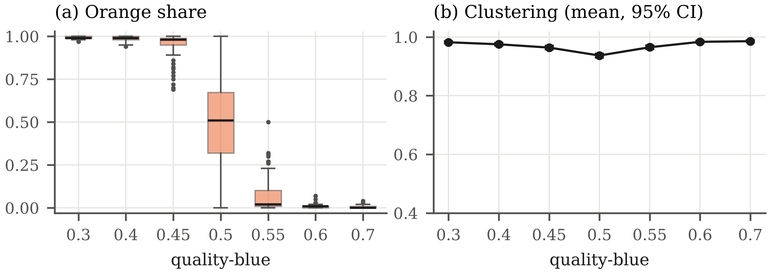
Fig. 4. Effect of quality_blue, with quality_orange = 0.5 (100 runs per value). (a) Distribution of the orange share at tick 1000. (b) Mean clustering at tick 1000 with 95% confidence interval.
Table 10. Outputs at tick 1000 as a function of quality_blue (quality_orange = 0.5; 100 runs per value).
quality_blue | Orange share (mean) | Orange share (SD) | Clustering (mean) | Clustering 95% CI
0.3 | 0.992 | 0.008 | 0.982 | 0.979–0.985
0.4 | 0.988 | 0.013 | 0.975 | 0.971–0.980
0.45 | 0.951 | 0.074 | 0.964 | 0.958–0.970
0.5 | 0.508 | 0.251 | 0.937 | 0.930–0.943
0.55 | 0.071 | 0.107 | 0.965 | 0.960–0.971
0.6 | 0.010 | 0.014 | 0.984 | 0.980–0.987
0.7 | 0.006 | 0.009 | 0.986 | 0.983–0.989

Exploration. Mean clustering decreases as exploration increases, from 0.94 at 0.01 to 0.86 at 0.05 and 0.67 at 0.2, because random switches break the agreement between friends. The dispersion of the orange share is not monotonic: its SD is 0.18 without exploration, 0.26 at 0.05 and 0.12 at 0.2. A possible interpretation is that, without exploration, few consumers change product and the shares move slowly; moderate exploration increases the number of changes and lets clusters grow; high exploration randomises choices and keeps the shares close to 0.5.
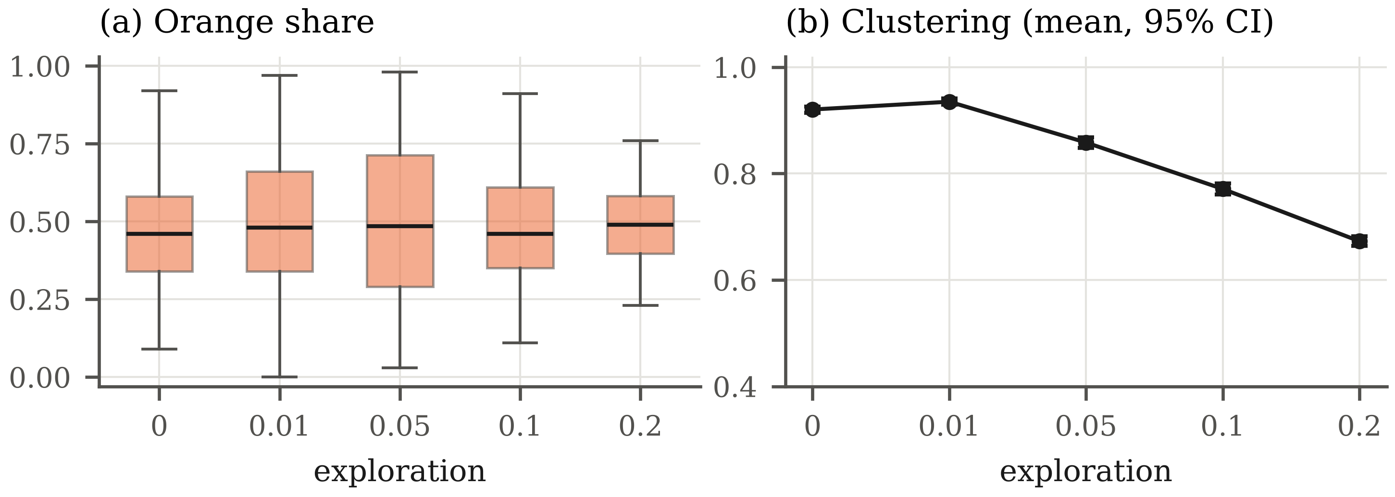
Fig. 5. Effect of exploration (100 runs per value). (a) Distribution of the orange share at tick 1000. (b) Mean clustering at tick 1000 with 95% confidence interval.
Table 11. Outputs at tick 1000 as a function of exploration (100 runs per value).
exploration | Orange share (mean) | Orange share (SD) | Clustering (mean) | Clustering 95% CI
0 | 0.468 | 0.177 | 0.920 | 0.914–0.926
0.01 | 0.493 | 0.229 | 0.935 | 0.929–0.941
0.05 | 0.499 | 0.259 | 0.858 | 0.849–0.868
0.1 | 0.483 | 0.181 | 0.771 | 0.761–0.781
0.2 | 0.488 | 0.121 | 0.673 | 0.664–0.682

3.4 Summary of Findings
The baseline and the sensitivity analysis lead to four conclusions that will serve as reference for the extended model:
– Social influence segments the market. All tested positive values of norm_influence (0.1 to 1.0) lead to a mean clustering of about 0.94; without norm, clustering stays at 0.54.
– With equal products, the outcome of a market is path dependent: the same rules produce markets dominated by either product (SD of the share 0.25). The baseline must be described by the distribution of outcomes, not by the mean.
– Small differences in quality are amplified: a difference of 0.05 gives the better product about 93–95% of the market.
– Exploration is the only mechanism that brings new information into a cluster; it reduces clustering but also determines how fast markets can change.
4 Next Step: Fitting the Model to a Real Market
In the next phase, the model will be fitted to the entry of a new operator in the Portuguese mobile telecommunications market. DIGI entered the market at the end of 2024 with prices below those of MEO, NOS and Vodafone. According to data from the national regulator ANACOM, it held 2.8% of bundled-service customers in the first half of 2025 [8].
Problem. Which combination of price, network quality and trial campaigns allows a new operator to cross the tipping point, and how long does it take? The same question can be asked from the point of view of the incumbents: which response limits the loss of market share?
Table 12. Correspondence between the original model and the proposed model.
Original model | Proposed model
2 products | 4 operators (MEO, NOS, Vodafone, DIGI); DIGI enters at tick T
Quality | Network and service quality (ANACOM indicators or network tests)
— | Price, as a new attribute of utility
Habit (satisfaction) | Habit and contract lock-in (24-month contracts: a consumer can switch only when the contract ends)
Social norm | Family plans and recommendations of friends
Exploration | Trial periods, number portability, promotions

Steps.
– Generalise the code from two to N products (lists instead of 1 − choice).
– Add price and a heterogeneous sensitivity to price, for example U = a · quality − b · price + norm, with b specific to each consumer.
– Add the contract (a counter per agent) and the entry of new operators during a run.
– Calibrate the weights with the ANACOM market shares before the entry of DIGI.
– Validate by comparing the simulated adoption curve of DIGI with the quarterly data.
– Experiments: grid of DIGI price × quality investment × intensity of trial campaigns; measure the DIGI share after two years and the time to reach 10%.
– Learning agents (task 5): replace the fixed exploration rate by consumers that learn as in a multi-armed bandit (ε-greedy or UCB) [9], or let operators learn prices with Q-learning.
– Compare the new model with the baseline of this report (task 6), in particular the clustering and the dependence on early random events observed for norm_influence > 0.
This case fits the mechanisms of the model: switching between operators is infrequent (habit and contracts), family plans and recommendations act as a norm, and trial offers and portability correspond to exploration. Public market-share data allow calibration and validation.
References
1. Jager, W., Wang, S.: NetLogo Consumer Choice model. Center for Connected Learning and Computer-Based Modeling, Northwestern University, Evanston, IL (2024). http://ccl.northwestern.edu/netlogo/models/ConsumerChoice
2. Wilensky, U.: NetLogo. Center for Connected Learning and Computer-Based Modeling, Northwestern University, Evanston, IL (1999). http://ccl.northwestern.edu/netlogo/
3. Janssen, M.A., Jager, W.: Fashions, Habits and Changing Preferences: Simulation of Psychological Factors Affecting Market Dynamics. Journal of Economic Psychology 22(6), 745–772 (2001)
4. Cialdini, R.B., Goldstein, N.J.: Social Influence: Compliance and Conformity. Annual Review of Psychology 55, 591–621 (2004)
5. Nyborg, K., et al.: Social Norms as Solutions. Science 354(6308), 42–43 (2016)
6. ter Hoeven, E., Kwakkel, J., Hess, V., Pike, T., Wang, B., Rht, Kazil, J.: Mesa 3: Agent-Based Modeling with Python in 2025. Journal of Open Source Software 10(107), 7668 (2025). https://doi.org/10.21105/joss.07668
7. Grimm, V., et al.: The ODD Protocol for Describing Agent-Based and Other Simulation Models: A Second Update to Improve Clarity, Replication, and Structural Realism. Journal of Artificial Societies and Social Simulation 23(2), 7 (2020)
8. 4gnews: DIGI começa 2026 a mostrar à MEO, NOS e Vodafone como se faz (ANACOM data, first half of 2025). https://4gnews.pt/digi-comeca-2026-a-mostrar-a-meo-nos-e-vodafone-como-se-faz/
9. Sutton, R.S., Barto, A.G.: Reinforcement Learning: An Introduction, 2nd edn. MIT Press, Cambridge, MA (2018)

