MathGames

Universidade de Aveiro

Departamento de Eletrónica, Telecomunicações e Informática

Projeto em Informática

Technical Report

Diogo Carvalho, Diogo Cunha, Pedro Amaral, Pedro Santos, Rafael Baptista, Ricardo Cruz

Advisor Nuno Lau, Co-Advisor Diogo Gomes

21 de junho de 2021

MathGames

Report from Projeto em Informática from Licenciatura em Engenharia Informática from Universidade de Aveiro done by Diogo Carvalho, Diogo Cunha, Pedro Amaral, Pedro Santos, Rafael Baptista, Ricardo Cruz under orientation of advisor Nuno Lau and co-advisor Diogo Gomes

# Keywords

# Abstract

# Table of Contents

I. Keywords 3

II. Abstract 4

III. Table of Contents 5

1. Introduction 7

2. State of the Art 8

2.1. Digital Web Games 8

2.2. Math Games 9

2.3. Technologies Used 9

3. Conceptual Modelling 10

3.1. Actors 10

3.2. Personas 11

3.3. Use Cases 12

3.4. Functional Requirements 17

3.4.1. Playing Games 17

3.4.2. Communication 17

3.4.3. Customization 17

3.4.4. Tournaments 17

3.4.5. Authentication 18

3.4.6. Admin Privileges 18

3.4.7. User Records 18

3.5. Non-Functional Requirements 18

3.5.1. Performance 18

3.5.2. Usability 18

3.5.3. Availability 19

3.5.4. Security and Data Integrity 19

3.5.5. Regulatory 19

3.5.6. Capacity 19

3.6. System Architecture 19

3.6.1. Architecture Diagram 19

3.6.2. Domain Model 20

3.6.3. Deployment Diagram 21

4. Implementation 22

4.1. Frontend 22

4.1.1. Web Application 22

4.1.2. Mobile Application 22

4.1.3. Game Engines 22

4.1.4. Artificial Intelligence Agents 22

4.2. Backend 22

4.2.1. Introduction 22

4.2.2. API endpoints 22

4.2.3. Websockets 22

4.2.4. Database Connection 22

4.2.5. Authentication 22

5. Results and Discussion 23

5.1. Implemented Features 23

5.2. Planned but Not Implemented Features 23

5.3. Added Features 23

6. Conclusion 24

7. References 25

# Introduction

# State of the Art

## Digital Web Games

In order to better understand what had already been done, what worked and what didn’t in terms of functionalities, we researched some of the available services which had similar characteristics to those we are going to develop for our own app. We began by looking at apps that members of our team already knew and used, starting with some of the popular chess websites, like chess.com and lichess.org, because even though chess is not one of the games we are going to develop, all board games have some similar characteristics, therefore we could extract some knowledge from these popular services, we also analyzed other services recommended by our advisors like Kaggle.com.

These services helped us better understand the current state of web games (useful/ interesting functionalities), the state of web tournaments, what relevant information is stored and shown relative to user profiles and what gamification methods are used.

## Math Games

In order to better understand what and how currently recognized math games were played, we researched several resources available online and spoke with Professor Pedro Pombo, manager of Fábrica Centro Ciência Viva de Aveiro.

From our research we reached the conclusion that current math games like Rastros, Cães e Gatos, Yoté, and others, have not yet made the transition to the digital space, meaning they are solely played with a physical board or a paper with the board layout printed on it, this meant that there is still a lot of room for improvement. Previous tournaments were also organized in person at the FCCV which meant that during the pandemic, it was no longer viable to organize them.

## Technologies Used

We also analyzed what current technologies are the most popular for developing web applications/ web games. Most resources and websites only listed HTML, CSS, and JS, but we were looking for a framework which could simplify some of the code we needed to write. With the suggestion from our advisors, we looked at Phaser 3, a popular JS framework used in web game development. This framework turned out to be perfect for us since it had a lot of documentation, lots of game examples/ tutorials and it simplified the development of our games and their functionalities.

# Conceptual Modelling

## Actors

With the development of our system, we are mainly targeting kids and teenagers who will make use out of the several games we are going to provide, we will be creating a simple UI to help users with less technological knowledge/ experience, without the need to create an account since they may not yet possess a personal email. From this requirement we can extract one of our actors, which is a user without an account. These users will be able to play matches (from all available games) with other users on the platform, they will also have access to our offline tools, which are playing vs AI and playing with a friend on the same device, their progress however, will not be stored.

We hope to capture these users’ attention by providing a fun, competitive and engaging environment, which will hopefully lead to the creation of an account, generating our second actor, a user with an account. These users will have access to all of the functionalities stated above, while also having their progress stored so they don’t risk losing it when transferring between different devices. The match history will also be available, they will have a rank (increased/ decreased by winning/ losing games), an account level (increased by playing games) and will have access to limited content unlocked by leveling up their account. They will also have the ability to participate in tournaments.

Our third actor is a user with tournament privileges, these users have the additional functionality of creating and managing tournaments, these privileges are granted by a system admin.

The actors stated above will have access to the offline functionalities through the web and desktop apps, online functionalities will be available through all technologies, web app, desktop app and mobile app.

We are also targeting the FCCV staff (system admins), by providing a way to organize tournaments through the internet without need for the physical presence of participants, and, even if they are hosted at the FCCV, competitors could be provided with computers to play out the games. Organizers will also have the ability to manage users by banning those who are misbehaving or disrespecting rules. These users will be mostly using our web and desktop app.

## Personas

In this section we are going to present personas based on the actors defined in the section above.

|  |  |
| --- | --- |
| Persona | Motivation |
| Rui is an 8-year-old shy kid who loves board games, he knows how to play chess and checkers, which he mostly played with his friends at school before the pandemic started. | Rui is looking for a website where he can play fun and interesting board games with other people, he does not have an email so he can’t use websites that require an account. Since he is shy, he prefers to learn how to play the games before challenging other people, so he also wants to be able to train alone. |
| Ricardo is a very competitive teenager, he excels in most of his classes and always works hard to accomplish his goals. Lately he’s been feeling like there is no competition for him at school, so he wants a different way to compete with others. | Ricardo wants an app where he can challenge and be challenged, he wants to be able to use it anywhere so that he can always feel the thrill of competition. He wants to be able to visually see his improvement while competing against similarly matched people. |
| Ana is a middle school teacher who wishes to organize a fun activity with his students, she is always looking for innovative ways of teaching and entertaining the minds of her students, and she believes board games are a  great way of stimulating creativity and problem-solving skills. | Ana wants to be able to create and manage multiple board game tournaments intuitively, she also wants to invite as many or as little students as she would like. |
| Artur is one the members of Fábrica Centro Ciência Viva de Aveiro, he was unable to host the math games tournament this year due to regulations that took place due to the pandemic. | Artur wants to have control over an application where users can play the recognized math games, he also wishes to be able to organize official digital tournaments of those games. He also wants access to important statistics to view which games are the most popular. |

## Use Cases

In this section, we are going to present our use case diagrams of the whole system, where we can have a look into how our actors will interact with the system, we’ll also give a description of each use case and its priority. We have divided the use cases in two sets of actors: Regular users (Figure 1) and Administrator users (Figure 2).

* **Play Against Random Player**

Rui intends to play Avanço against a random person, to do this he must first access our main page, he must then press a button present on that page or, through the side menu, access the games option. After reaching the games page he will be able to choose what game he wants to play, which will then show the multiple game modes for that specific game, after choosing the mode for online versus another player, the matchmaking process will begin and after a while the game will begin.

*Priority: High*

* **Play Offline Against AI**

Rui wants to improve his skills in Rastros by playing against the computer. he must first access our main page, he must then press a button present on that page or, through the side menu, access the games option. He can then choose the game he wants to play and, on the page of the game he chose, click on the respective mode.

*Priority: High*

* **Play Against Someone on the Same Device**

Rui wants to play Yoté against his brother on a computer without access to the internet. To do this, he must first access our main page, he must then press a button present on that page or, through the side menu, access the games option. He can then choose the game Yoté, which will show the different game modes available, after selecting the option for playing against a player on the same device, the game will start.

*Priority: High*

* **Play with a Friend on Different Devices**

Rui wants to challenge a friend in a game of Rastros, so he must first access our main page, he must then press a button present on that page or, through the side menu, access the games option. Then choose the specific game he wants to play and finally, on the game page, he must choose the option to invite a friend. A link will then be generated, which can be sent to another his friend. After accessing the link, the game will begin.

*Priority: High*

* **Create an Account**

Rui wants to create an account on the platform to be able to play against his friends. If the users want to create an account on the platform, they must first access the login page, then click on the create account button, which will open a new page with the registration form, after filling it, they will be able to submit it, later receiving a confirmation e-mail.

*Priority: High*

* **Add a Friend**

Ricardo wants to add his real life friend on the platform in order to find out what his rank is. To add a friend, the user must access his list of friends and click on the icon which represents adding a new friend. Then, the user is asked to enter their friend's username and press send. The friend who received the request must access his own list of friends so he can accept it.

*Priority: High*

* **Challenge a Friend**

Ricardo wishes to challenge one of his friends directly through the app, to do that he can access his friend list from the navbar, he can then press the challenge button next to the friend he wants to challenge.

*Priority: Medium*

* **Participate in a Tournament**

Ricardo wants to compete in a large tournament created by his school’s teacher. Users wishing to participate in public or private tournaments must access the tournament list page through the side menu. Then choose the tournament in which they wish to participate, the user is then redirected to the tournament page where he can choose to sign up.

*Priority: High*

* **View Game Statistics**

Ricardo wants to view his progress over the last few matches. To accomplish that, users can access a page to view their match history and statistics of previously played games, this page can be accessed through the side menu.

*Priority: Medium*

* **Change Account Settings**

Ricardo wants to change information regarding his account (password, e-mail, …). He can accomplish that by accessing the definitions page through the side menu. His information appears so that he can choose what he wants to change.

*Priority: High*

* **View Personal Rank of a Specific Game**

Ricardo wants to know his rank in a specific game, in order to find that out, a user should access the Games page through the side menu and then choose the game he’s looking for which will redirect him to a page with the game’s information and the user’s rank.

*Priority: Low*

* **Create a Tournament**

Ana wants to create a tournament to give her students a way of having fun while still learning new skills. After requesting permission to create tournaments, she can access the tournaments page on the side menu, where she will have the option to create a new tournament, by filling the various settings that are required like max number of students and whether the tournament is public or private.

*Priority: High*

* **Invite/ Kick a user from a tournament**

After creating it, Ana wants to invite her students to participate in a tournament. She can accomplish that by choosing the tournaments option on the side menu, she can then select the tournament from the list of personal tournaments. From inside the tournament page, she will have an option to invite participants. If she invites someone by mistake, she will be able to kick the player from inside the same page.

*Priority: Medium*

* **Change Tournament Settings**

In case Ana wants to alter any information regarding the tournament’s settings (description, max number of players, …) she can do so by choosing the tournaments option on the side menu, she can then select the tournament from the list of personal tournaments. From inside the tournament page, she can choose to edit the various settings.

*Priority: Medium*

* **View Statistics About the Platform**

Artur wishes to see the statistics of all the games, in order to find out what the most played games are. Administrators who want to see statistics for all games should access the statistics page through the side menu.

*Priority: Medium*

* **Ban a User**

Artur intends to ban an account that has been reported by multiple users of using cheats. Administrators can ban users by accessing the page with the list of all players through the side menu. Then search for the account they want to ban and click on the ban icon.

*Priority: High*

## Functional Requirements

### Playing Games

* Play games with a friend in the same device;
* Play games with a friend in distinct devices;
* Play games against an AI Bot;
* Allow changing AI Bot’s difficulty;
* Play games against random people (with or without identical rank).

### Communication

* Allow communication via chat with pre-defined sentences;
* Report users;
* Add friends;
* Remove friends;
* Invite friends to play.

### Customization

* Change personal account settings;
* Change/Customize avatar.

### Tournaments

* Create public or private tournaments;
* Administrate tournaments (Change configurations);
* Invite players to tournament;
* Kick players from tournament;
* Join tournaments.

### Authentication

* Register a new account;
* Log-in using either a created account or through other services (Google, Facebook, …).

### Admin Privileges

* Upgrade account privileges;
* Ban users;
* Watch full statistics in admins side regarding all games/users.

### User Records

* Access match history;
* View ranking of a specific game;
* View account level.

## Non-Functional Requirements

### Performance

* Each page must load within 3 seconds.

### Usability

* Application must be open access for different devices;
* The software should be portable. Moving from one OS to another should not create any problem.

### Availability

* Application must be available all the time, except when in maintenance service, keeping maintenance time minimal.

### Security and Data Integrity

* User's information should be confidential;
* Passwords shall never be viewable at the point of entry or at any other time.

### Regulatory

* Application must follow GDPR guidelines.

### Capacity

* The app should be able to handle a high number of simultaneous users;
* Should also be able to store the data related to those users.

## System Architecture

### Architecture Diagram

Our architecture diagram aims to show the different layers of components in our project and how they are linked. Therefore, we will have a database in MySQL which will be connected to a remote NodeJS server that contains an API, the business logic, and the online game engines. In the client-side, we have a desktop application implemented with electron, react and phaser. This application will contain the react website, a local NodeJS server and a local database in SQLite that will be synchronized with the remote database whenever there a connection to the internet is established. Lastly, we also have a mobile application implemented in react native and phaser with only online functionalities.

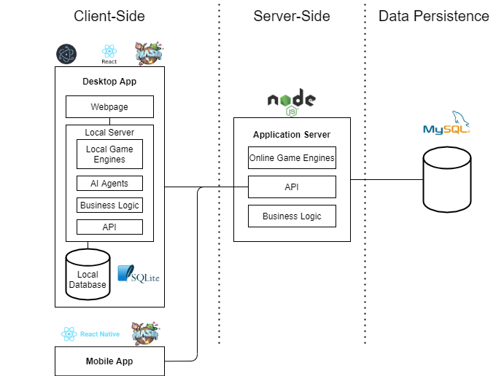

### Domain Model

Our domain diagram aims to represent the data our system will contain. Therefore, it includes:

* A user who must have an id, a username, an email, a password, an avatar, a global ranking, information if it is or is not an administrator, a rank for each game and N friends.
* A game which must have an id, a name, a description, and a recommended age.
* A game match which must include an id, a game, two users (player1 and player2), a winning player, the current state, a counter of moves and a game type.
* A tournament which must have an id, a creator, a name, a game, the max number of participants, information on whether it is private or public, a password, N participating users (with information if it has already been eliminated) and a winning user.
* A banned user who must have the reason why said user was banned.

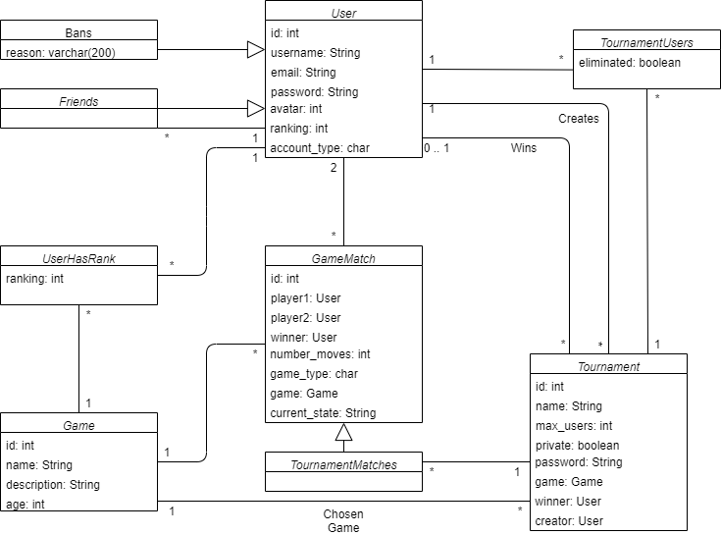

### Deployment Diagram

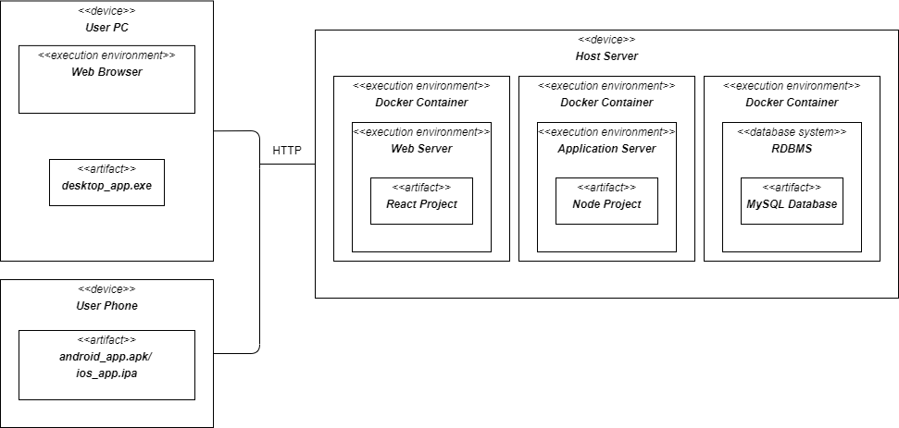Our project will contain distinct components, which can all run on different machines. Our deployment diagram seeks to show how the components are connected and deployed. Essentially, we will have a MySQL relational database (deployed in a mysql8 docker container), which will be connected through NodeJS’s MySQL Driver to our Application Server (deployed in a node docker container). Furthermore, we will have a mobile application and a desktop application in Electron (which internally contains a web server, a client browser and a local database). These applications will be connected to the Application Server API through HTTP.

# Implementation

## Frontend

### Web Application

### Mobile Application

### Game Engines

### Artificial Intelligence Agents

## Backend

### Introduction

### API endpoints

### Websockets

### Database Connection

### Authentication

# Results and Discussion

## Implemented Features

## Planned but Not Implemented Features

## Added Features

# Conclusion

# References