pyspread

Developer documentation
v 0.2.2
by Martin Manns

Table of Contents
1 Intended audience 3
2 The pyspread code 3
3 User actions 5
3.1 Create a new file 5
3.2 Open a file 5
3.3 Save file 7
3.4 Save file to a new filename 7
3.5 Import data 7
3.6 Export data 7
3.7 Approve file 7
3.8 Setup printer page 7
3.9 Print grid 8
3.10 Quit pyspread 8

Intended audience

This document is for people who would like to understand the code base of the software pyspread (Web-Site: http://manns.github.com/pyspread). This includes code contributors, testers as well as people who want to include parts of the program into their own GPL application.

This is not the user documentation.

The pyspread code
This document refers to pyspread v. 0.2.2.
Version 0.1.2 and previous have a different structure.

Pyspread is written in the Python programming language.

The code is organized in the src folder. There are the following sub-folders:
actions | Actions that change the model
gui | GUI elements including events
model | Core data structure
lib | Generically usable libraries

Figure 1 displays class instance dependencies of the different layers.
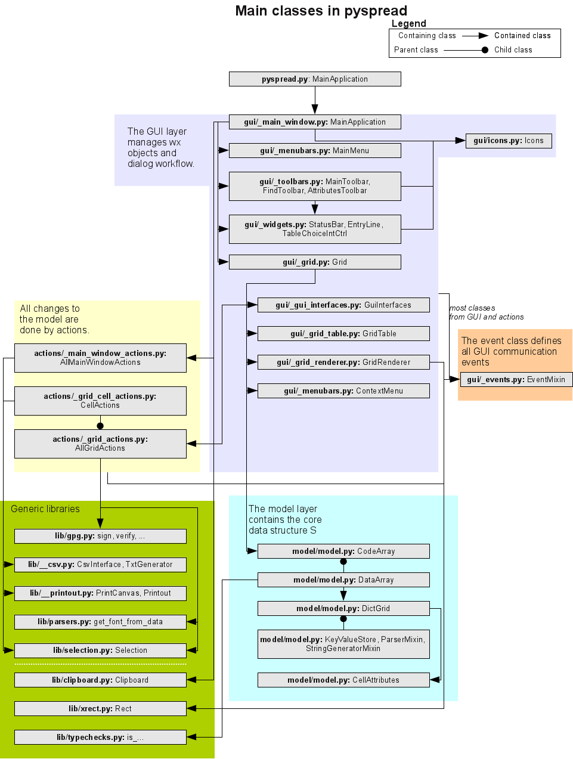
Figure 1: Dependencies and layers of pyspread.

Relations to dependencies
wxPython related code can be found
- in the action folder files,
- in the gui folder files (including events.py),
- in lib/clipboard.py,
- in lib/gpg.py,
- in lib/parsers.py,
- in config.py,
- in pyspread.py,
- in sysvars.py and
- in model/model.py.
The latter is necessary in order to use the wx constants in config.py

PyMe related code can be found in lib/gpg.py

numpy related code can be found in model/model.py

