Another

Zammad is a web-based open source helpdesk/customer support system with many features to manage customer communication via several channels.

The folks over Zammad have requested my help in their ongoing effort to make the best CRM system in the business. They were not looking for a completely new redesign neither it was their intention to break some of the flows that their current user-base grew with. Thus the goal was to simplify what it could be simplified while emphasizing the main user stories using nothing else than open source software.

My analysis started with reading the Zammad websites, Git repository, and their user forum. I also used the Zammad system for my own customers. Due to time and financial constraints we decided to focus solely on the main navigation. Here are a couple of screencasts documenting possible flaws, missing states or convoluted elements in the current application.

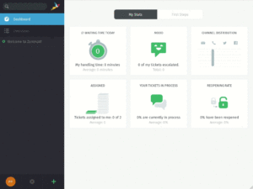Click to see the animated GIF

