Oncase2b

Pedro

25/01/2022

library(tidyverse)

## Warning: package 'tidyverse' was built under R version 4.1.2

## -- Attaching packages --------------------------------------- tidyverse 1.3.1 --

## v ggplot2 3.3.5 v purrr 0.3.4  
## v tibble 3.1.6 v dplyr 1.0.7  
## v tidyr 1.1.4 v stringr 1.4.0  
## v readr 2.1.1 v forcats 0.5.1

## Warning: package 'ggplot2' was built under R version 4.1.2

## Warning: package 'tibble' was built under R version 4.1.2

## Warning: package 'tidyr' was built under R version 4.1.2

## Warning: package 'readr' was built under R version 4.1.2

## Warning: package 'purrr' was built under R version 4.1.2

## Warning: package 'dplyr' was built under R version 4.1.2

## Warning: package 'stringr' was built under R version 4.1.2

## Warning: package 'forcats' was built under R version 4.1.2

## -- Conflicts ------------------------------------------ tidyverse_conflicts() --  
## x dplyr::filter() masks stats::filter()  
## x dplyr::lag() masks stats::lag()

library(forecast)

## Warning: package 'forecast' was built under R version 4.1.2

## Registered S3 method overwritten by 'quantmod':  
## method from  
## as.zoo.data.frame zoo

library(ggplot2)  
library(seasonal)

## Warning: package 'seasonal' was built under R version 4.1.2

##   
## Attaching package: 'seasonal'

## The following object is masked from 'package:tibble':  
##   
## view

library(seasonalview)

## Warning: package 'seasonalview' was built under R version 4.1.2

##   
## Attaching package: 'seasonalview'

## The following object is masked from 'package:seasonal':  
##   
## view

## The following object is masked from 'package:tibble':  
##   
## view

library(urca)

## Warning: package 'urca' was built under R version 4.1.2

library(readxl)

## Warning: package 'readxl' was built under R version 4.1.2

serie_tempo_2b <- read_excel("~/Job/Oncase desafio/serie_tempo_2b.xlsx")  
#View(serie_tempo_2b)

Transformando o data frame numa série temporal

ts_2b = ts(serie_tempo_2b$faturamento, start = c(2020,1), end = c(2021,9), frequency=365)

Verificando a existência de sazonalidade

autoplot(ts_2b)

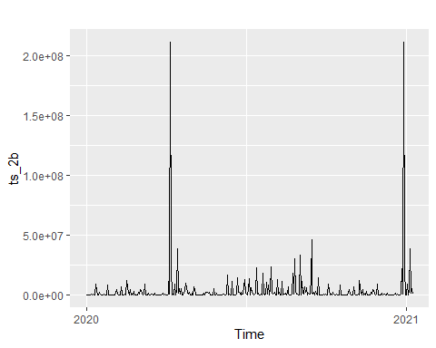

hist(ts_2b)

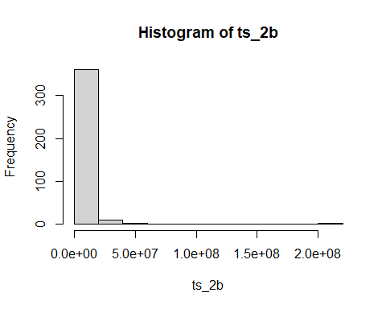

boxplot(ts_2b)

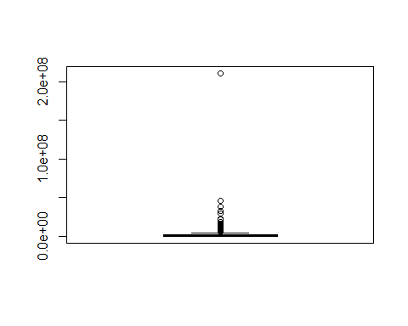

Segue abaixo uma análise de decomposição da série em estudo.

#dec = decompose(ts_2b)  
#autoplot(dec)

Percebe-se que não é possível decompor a série pois ela não tem mais de 1 período.

gerou um autoplot da decomposi??o acima observar se existe um padr?o de sazonalidade e verificar a regularidade

Foram realizadas algumas tentativas de avaliar a existência de sazonalidad porém não foi possível por não ter mais de um período na série.

#ggseasonplot(ts_2b)  
#ggseasonplot(window(ts_2b, start=c(2021)))

#teste de estacionariedade

est = ur.kpss(ts_2b)  
print(est)

##   
## #######################################   
## # KPSS Unit Root / Cointegration Test #   
## #######################################   
##   
## The value of the test statistic is: 0.1174

ndiffs(ts_2b)

## [1] 0

tsdisplay(ts_2b)

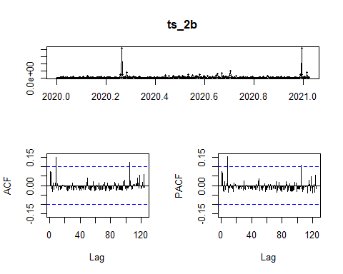

modelo = auto.arima(ts_2b, trace = T,stepwise = F, approximation = F )

## Warning: The chosen seasonal unit root test encountered an error when testing for the first difference.  
## From stl(): series is not periodic or has less than two periods  
## 0 seasonal differences will be used. Consider using a different unit root test.

##   
## ARIMA(0,0,0) with zero mean : 13502.73  
## ARIMA(0,0,0) with non-zero mean : 13486.17  
## ARIMA(0,0,1) with zero mean : 13500.31  
## ARIMA(0,0,1) with non-zero mean : 13486.36  
## ARIMA(0,0,2) with zero mean : 13497.74  
## ARIMA(0,0,2) with non-zero mean : 13486.31  
## ARIMA(0,0,3) with zero mean : 13499.64  
## ARIMA(0,0,3) with non-zero mean : 13488.27  
## ARIMA(0,0,4) with zero mean : 13501.68  
## ARIMA(0,0,4) with non-zero mean : 13490.08  
## ARIMA(0,0,5) with zero mean : 13502.75  
## ARIMA(0,0,5) with non-zero mean : 13491.88  
## ARIMA(1,0,0) with zero mean : 13499.36  
## ARIMA(1,0,0) with non-zero mean : 13486.11  
## ARIMA(1,0,1) with zero mean : Inf  
## ARIMA(1,0,1) with non-zero mean : 13487.39  
## ARIMA(1,0,2) with zero mean : 13499.59  
## ARIMA(1,0,2) with non-zero mean : 13488.32  
## ARIMA(1,0,3) with zero mean : Inf  
## ARIMA(1,0,3) with non-zero mean : 13490.24  
## ARIMA(1,0,4) with zero mean : Inf  
## ARIMA(1,0,4) with non-zero mean : 13491.97  
## ARIMA(2,0,0) with zero mean : 13497.48  
## ARIMA(2,0,0) with non-zero mean : 13486.58  
## ARIMA(2,0,1) with zero mean : 13499.49  
## ARIMA(2,0,1) with non-zero mean : 13488.52  
## ARIMA(2,0,2) with zero mean : Inf  
## ARIMA(2,0,2) with non-zero mean : Inf  
## ARIMA(2,0,3) with zero mean : Inf  
## ARIMA(2,0,3) with non-zero mean : Inf  
## ARIMA(3,0,0) with zero mean : 13499.49  
## ARIMA(3,0,0) with non-zero mean : 13488.38  
## ARIMA(3,0,1) with zero mean : Inf  
## ARIMA(3,0,1) with non-zero mean : 13490.3  
## ARIMA(3,0,2) with zero mean : Inf  
## ARIMA(3,0,2) with non-zero mean : Inf  
## ARIMA(4,0,0) with zero mean : 13501.54  
## ARIMA(4,0,0) with non-zero mean : 13490.03  
## ARIMA(4,0,1) with zero mean : Inf  
## ARIMA(4,0,1) with non-zero mean : 13491.96  
## ARIMA(5,0,0) with zero mean : 13502.4  
## ARIMA(5,0,0) with non-zero mean : 13491.91  
##   
##   
##   
## Best model: ARIMA(1,0,0) with non-zero mean

print(modelo)

## Series: ts_2b   
## ARIMA(1,0,0) with non-zero mean   
##   
## Coefficients:  
## ar1 mean  
## 0.0747 3678246.8  
## s.e. 0.0515 904697.1  
##   
## sigma^2 estimated as 2.649e+14: log likelihood=-6740.02  
## AIC=13486.04 AICc=13486.11 BIC=13497.82

checkresiduals(modelo)

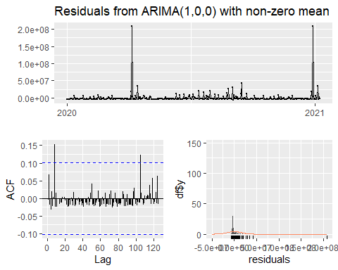

##   
## Ljung-Box test  
##   
## data: Residuals from ARIMA(1,0,0) with non-zero mean  
## Q* = 19.487, df = 73, p-value = 1  
##   
## Model df: 2. Total lags used: 75

shapiro.test(modelo$residuals)

##   
## Shapiro-Wilk normality test  
##   
## data: modelo$residuals  
## W = 0.18434, p-value < 2.2e-16

#previsao para 1 mês

previsao = forecast(modelo,h=4)  
previsao

## Point Forecast Lo 80 Hi 80 Lo 95 Hi 95  
## 2021.0247 3438728 -17419383 24296840 -28461001 35338457  
## 2021.0274 3660366 -17255787 24576519 -28328130 35648862  
## 2021.0301 3676912 -17239564 24593388 -28312078 35665902  
## 2021.0329 3678147 -17238331 24594625 -28310845 35667140

autoplot(previsao)

