Funky Town Fancy Pandas SyRS 2.0.0-2014

(Revision November 25, 2014)

**System Requirements Specification**

**Funky Town Fancy Pandas**

**IEEE SoutheastCon 2015 Competition**

Sponsor

The Department of Electrical, Computer, Software & Systems Engineering at Embry-Riddle Aeronautical University

Released November 25, 2014

Funky Town Fancy Pandas Development Team

# **Revision History**

Table 1 contains the information regarding the version control for this document including version, date, and description.

|  |  |  |
| --- | --- | --- |
| **Version** | **Date** | **Description** |
| 0.1.0 | Sept. 5, 2014 | Added functional and non-functional requirements |
| 0.2.0 | Sept. 7, 2014 | Refined functional and non-functional requirements after team review |
| 0.3.0 | Sept. 9, 2014 | Compiling requirements into one document |
| 0.4.0 | Sept. 10, 2014 | Refined functional requirements after team review |
| 0.5.0 | Sept. 11, 2014 | Added use cases, safety requirements, and introduction |
| 0.6.0 | Sept. 12, 2014 | Refined requirement sections after team review |
| 0.7.0 | Sept. 13, 2014 | Changed styling, refined use cases, and added use case diagrams. |
| 0.8.0 | Sept. 14, 2014 | Updating use cases |
| 0.9.0 | Sept. 15, 2014 | Refining and editing the entire document |
| 0.10.0 | Sept. 16, 2014 | Refining requirements based on feedback |
| 0.11.0 | Sept. 17, 2014 | Refining requirements based on feedback |
| 0.12.0 | Sept. 18, 2014 | Refining and editing document |
| 1.0.0 | Sept. 18, 2014 | Final document |
| 1.1.0 | Sept. 26, 2014 | Refining requirements based on feedback |
| 1.2.0 | Nov. 9, 2014 | Adding test cases and updating requirements |
| 1.3.0 | Nov. 10, 2014 | Refining requirements |

Table 1. Revision History

**Table of Contents**

**Revision History** ii

**1.****Introduction** 1

**1.1.****Purpose** 1

**1.2.****Mission Statement** 1

**1.3.****Scope** 1

**1.4.****Team Information** 1

**1.5.****Overview** 1

**2.****Overall Description** 3

**2.1.****Stakeholders** 3

**2.1.1.****Funky Town Fancy Pandas (FTFP) Development Team** 3

**2.1.2.****Dr. Barott, Dr. Seker, and Jorge Torres** 3

**2.1.3.****ERAU** 3

**2.1.4.****ECSSE** 3

**2.1.5.****IEEE** 3

**2.1.6.****Judges** 3

**2.2.****Product Perspective** 3

**2.3.****Product Functions** 3

**2.4.****User Characteristics** 4

**2.5.****Constraints** 4

**2.5.1.****Regulator Constraints** 4

**2.6.****Assumptions and Dependencies** 4

**2.7.****Use Cases** 5

**2.7.1.****Use Case Diagram** 5

**2.7.2.****Use Case 1: Initialize APS** 6

**2.7.3.****Use Case 2: Follow the Line** 7

**2.7.4.****Use Case 3: Play Simon Carabiner** 8

**2.7.5.****Use Case 4: Draw on Etch-a-Sketch** 10

**2.7.6.****Use Case 5: Rotate Rubik’s Cube** 12

**2.7.7.****Use Case 6: Pick up Playing Card** 14

**2.8.****Sequence Diagrams** 16

**2.8.1.****Use Case 1: Initialize APS** 16

**2.8.2.****Use Case 2: Follow the Line** 17

**2.8.3.****Use Case 3: Play Simon Carabiner** 18

**2.8.4.****Use Case 4: Draw on Etch-a-Sketch** 19

**2.8.5.****Use Case 5: Rotate Rubik’s Cube** 20

**2.8.6.****Use Case 6: Pick up Playing Card** 21

**3.****User Stories** 22

**3.1.****Epic** 22

**3.2.****General** 22

**3.3.****Simon Carabiner** 22

**3.4.****Etch-a-Sketch** 22

**3.5.****Rubik’s Cube** 22

**3.6.****Pick up Playing Card** 22

**4.****Functional Requirements** 23

**5.****Non-Functional Requirements** 24

**6.****Test Cases** 25

**Appendices** 26

**Appendix A: Figures** 26

**Appendix B: Glossary** 29

**Appendix C: Acronyms and Abbreviations** 30

**References** 31

**Table of Tables**

Table 1. Revision History ii

Table 2. Team member names and roles 1

Table 3. Test cases for the FTFP to test the APS 25

Table 4. Listing of terms and definitions used throughout this document 29

Table 5. Acronyms and their expanded phrase used throughout this document 30

**Table of Figures**

Figure 1. Use Case Diagram for the APS 5

Figure 2. Sequence Diagram for Use Case 1: Initialize APS 16

Figure 3. Sequence Diagram for Use Case 2: Follow the Line 17

Figure 4. Sequence Diagram for Use Case 3: Play Simon Carabiner 18

Figure 5. Sequence Diagram for Use Case 4: Draw on Etch-a-Sketch 19

Figure 6. Sequence Diagram for Use Case 5: Rotate Rubik's Cube 20

Figure 7. Sequence Diagram for Use Case 6: Pick up Playing Card 21

Figure 8. The playing board defined by IEEE SoutheastCon 2015 Hardware Competition 26

Figure 9. The Etch-a-Sketch defined in the IEEE SoutheastCon 2015 Hardware Competition 26

Figure 10. The Rubik's Cube defined by the IEEE SoutheastCon 2015 Hardware Competition 27

Figure 11. The Simon Carabiner defined by IEEE SoutheastCon 2015 Hardware Competition 27

Figure 12. The stack of cards to be determined by the IEEE SoutheastCon 2015 Hardware Competition 28

# **Introduction**

The introduction of this document defines the purpose, mission statement, and scope of the project.

## **Purpose**

The purpose of this document is to identify the system requirements for the Autonomous Panda System (APS). The APS is intended to participate in the Institute of Electrical and Electronics Engineers (IEEE) SoutheastCon 2015 Hardware Competition [~~7~~1]. The requirements contain functional ~~and~~ requirements, non-functional requirements, and limitations of the APS. This document is intended for the customers, ~~the~~ team members, and all persons with holding a stake in this project.

## **Mission Statement**

The mission of this project is to create an autonomous system capable of completing all tasks defined by the IEEE SoutheastCon 2015 Hardware Competition [1] safely and efficiently while acquiring as many points as possible during the allotted time.

## **Scope**

The APS is intended to participate in IEEE SoutheastCon 2015 Hardware Competition [~~7~~1] to accomplish a set of tasks created by the IEEE SoutheastCon 2015 Hardware Competition panel. The goal is to have the APS perform four ~~(4)~~ unique tasks accurately and within the allotted time in order to acquire the ~~most amount of points~~ highest score possible. The requirements in this document satisfy the rules set forth by the IEEE SoutheastCon 2015 Hardware Competition judging panel. The four ~~(4)~~ unique tasks are:

1. Play Simon Says for 15 seconds
2. Rotate one ~~(1)~~ row of a Rubik’s Cube 180 degrees
3. Draw the letters “IEEE” on an Etch-a-Sketch
4. Pick up one ~~(1)~~ card from a stack of cards

## **Team Information**

Table 2 contains the team member names and their corresponding roles.

|  |  |
| --- | --- |
| **Name** | **Role** |
| Kurt Pedrosa | Team Leader/Scrum Master |
| Merissa Roth | Software Leader |
| Mary Luongo | Hardware Leader/Product Owner |
| Luis Bogran | Development Leader |
| Kok Peng Tan | Developer |



Table 2. ~~Table stating~~ Team member names and roles

## **Overview**

This document has been divided into sections to better illustrate the project task. Section one ~~(1)~~ of this document serves as an introduction to the APS, which describes the purpose of the project, the scope, and the ~~group of people~~ team members involved in the project. Section two ~~(2) of this document~~ provides an overall description of the APS including the parties interested in its success, the APS’s functions, and detailed use cases for the construction of well-defined requirements. Section three ~~(3) of this document~~ describes the user stories and a general overview of the APS’s requirements. Section four ~~(4) of this document~~ contains the functional, non-functional, and safety requirements necessary for the APS to perform its tasks.

The Glossary contains detailed definitions of terms used throughout the document to eliminate ambiguity. A table of acronyms and abbreviations is ~~included~~ provided as reference for the reader to be free of uncertainty.

# **Overall Description**

~~The overall~~ A description ~~describes the~~ of general factors that affect the APS and its requirements and functionality.

## **Stakeholders**

The following ~~sections contain~~ list is an enumeration of the parties ~~having~~ that have a stake in the life cycle of the APS.

## **Funky Town Fancy Pandas (FTFP) Development Team**

The customers shall grade the FTFP Development Team based on the completion of the system. The FTFP Development Team shall also strive to apply the principles and concepts learned throughout their time at Embry-Riddle Aeronautical University (ERAU).

## **Dr. Barott, Dr. Seker, and Jorge Torres**

As customers of the product, Dr. Barott, Dr. Seker, and Mr. Torres are interested in the development and completion of APS that will be used in the IEEE SoutheastCon 2015 Hardware Competition [~~7~~1]. As advisors of the ~~Funky Town Fancy Pandas~~ FTFP, Dr. Barott and Dr. Seker are interested in the FTFP Development Team meeting the standards set forth by the Accreditation Board for Engineering and Technology (ABET), as well as the standards for the Capstone Senior Design Project set forth by the Department of Electrical, Computer, Software & Systems Engineering (ECSSE) of ERAU.

## **ERAU**

The University has sanctioned the project, therefore the conduct and actions of the FTFP Development Team reflects upon the University. The final product created by the FTFP Development Team reflects the name of ERAU and therefore must conform to the required standards of the University as defined in the student handbook for the 2014-2015 academic year [~~3~~2].

## **ECSSE**

ECSSE at ERAU has invested financial assistance in the project and is interested in the product being delivered on time and on or under budget, as specified by the budget document for this product.

## **IEEE**

The IEEE is sponsoring the SoutheastCon 2015 Hardware Competition [~~7~~1]. The APS must adhere to the rules of the competition as set forth by IEEE SoutheastCon 2015 Hardware Competition.

## **Judges**

The judges are concerned with the safety of the people at the competition and that the rules will be followed by attendees. The judges also determine the amount of points awarded based on the success of the tasks performed by the APS.

## **Product Perspective**

The APS is intended to compete on the IEEE SoutheastCon 2015 Hardware Competition [~~7~~1].

## **Product Functions**

The functionality of the APS is divided into two major subsystems: (1) The APS operational systems, referred to as the Operational System throughout this document, (2) the APS navigational system, referred to as the Navigational System throughout this document. These subsystems are meant to simplify the APS and are not to impose a design constraint.

## **User Characteristics**

It is important the user understand the mission of the APS before operating it. Knowledge of the IEEE SoutheastCon 2015 Hardware Competition [~~7~~1] will ~~help~~ aid the user during the operation of the APS. The APS will only perform as intended if placed in a playing board identical to the playing board used during the competition~~, since that is the only way APS will work~~.

## **Constraints**

The following constraints are imposed by the IEEE SoutheastCon 2015 Hardware Competition [~~7~~1] panel.

## **Regulator Constraints**

The constraints imposed on the APS are set by the IEEE SoutheastCon 2015 Hardware Competition [~~7~~1] panel. The APS is intended to compete in the IEEE SoutheastCon 2015 Hardware Competition. The APS is subject to changes in design, construction, operation, or requirements at any time.

## **Assumptions and Dependencies**

* **IEEE Regulations** – as of ~~March 19~~ October 14, 2014, the rules set forth by the IEEE SoutheastCon 2015 Hardware Competition panel have ~~not been finalized. All rules and regulation changed after the time of publications of this document will be reflected in a later version~~ been updated. The requirements found below have been updated to fulfill the updated rules [1].
* **Units** – as per the rules set forth by IEEE SoutheastCon 2015 Hardware Competition, the units to be used are English Units (i.e. feet, inches). This may be refined as the rules update.

# **Use Cases**

The following use cases describe the APS’s operational capabilities and goals. The use cases demonstrate the normal operation of the APS, as well as detailed alternatives to problems that may arise.

## **Use Case Diagram**

Figure 1 depicts the Use Case Diagram for the APS.

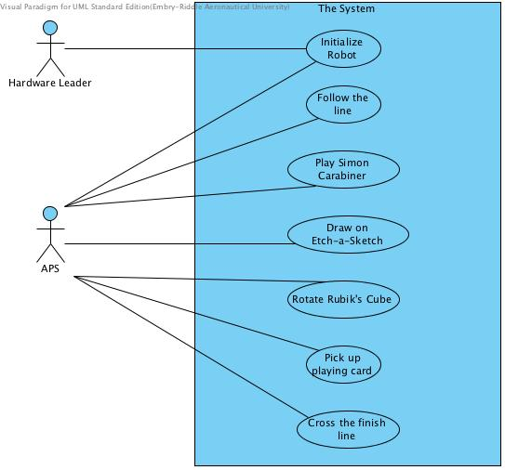

Figure 1. Use Case Diagram for the APS

## **Use Case 1: Initialize APS**

**Scope**: The APS

**Level**: User goal

**Primary** **Actor**: Hardware Leader

**Supporting Actor:** APS

**Stakeholders** **&** **Interests**

* **Judges** – The APS will be judged as per the IEEE SoutheastCon 2015 Hardware Competition rules [~~7~~1], where the judges will award points for each task.
* .

**Preconditions**: The APS is not powered on.

**Post** **Conditions**: The APS is powered on and is ready to begin the competition.

**Main** **Success** **Scenario**:

1. The Hardware Leader places the APS in the start position on the playing board.
2. The Hardware Leader powers on the APS.
3. The APS waits until the steady red light-emitting diode (LED) powers off.

**Extensions**:

2a. The APS fails to power on when the Hardware Leader attempts to power it on:

1. The Hardware Leader powers off the APS
2. The Hardware Leader powers on the APS

2a. The APS still does not power on:

* 1. The Hardware Leader powers off the APS
  2. The Hardware Leader picks up the APS ~~and exits the competition~~
  3. The APS will not compete in the competition

2b. The APS powers on:

1. The APS shall resume operation in accordance with the *Main Success Scenario*

3a. The APS fails to recognize the red LED is powered on within 60 seconds of placing the APS

on the board

1. The APS waits for 60 seconds to ensure the red LED has powered off
2. The APS resumes operation in accordance with the *Main Success Scenario*

3b. The APS fails to recognize the red LED have powered off within 60 seconds of placing the

APS on the board

1. The APS waits for 60 seconds to ensure the red LED has powered off
2. The APS resumes operation in accordance with the *Main Success Scenario*

**Frequency of Occurrence**

This use case occurs every time the APS is placed on the playing board. It determines whether the

APS will run or not. This use case is important for the start of each round of the competition, as the APS cannot compete without turning on.

## **Use Case 2: Follow the Line**

**Scope**: The APS

**Level**: User goal

**Primary** **Actor**: The APS

**Stakeholders** **&** **Interests**:

* **Judges –** The judges will evaluate the APS as per the IEEE SoutheastCon 2015 Hardware Competition rules [~~7~~1].
* **FTFP –** The FTFP are interested in the APS being able to follow the line on the floor to be able to complete the tasks. The FTFP grades rely on the success of the APS.

**Preconditions**: The APS has been initialized and the red LED has been powered off.

**Post** **Conditions**: The APS follows the line on the floor from one position to the next position in order to complete a task.

**Main** **Success** **Scenario**:

1. The APS identifies the line on the floor.
2. The APS starts moving to the next position within the playing board.

**Extensions**:

*. At any time the APS veers off the line on the floor:

1. The APS moves to its most recent position when it was still on the line
2. The APS starts following the line on the floor again

1a. The APS fails to identify the line on the floor to be followed:

1. The APS rotates 360 degrees to search for the line on the floor
2. The APS still fails to identify the line on the floor to be followed:

2a. The APS terminates operations

**Frequency of Occurrence**:

This use case will occur anytime the APS is moving throughout the competition. This use case is crucial throughout this competition and the APS cannot compete without this use case. This case occurs continuously during normal operation.

## **Use Case 3: Play Simon Carabiner**

**Scope**: The APS

**Level**: User goal

**Primary** **Actor**: The APS

**Supporting Actor**: Simon Carabiner

**Stakeholders** **&** **Interests**:

* **Judges –** The APS will be judged as per the IEEE SoutheastCon 2015 Hardware Competition rules [~~7~~1].
* **FTFP –** TheFTFP are interested in the APS completing the Simon Carabiner challenge in order to be awarded the most points possible.

**Preconditions**: The APS has followed the line on the floor to the Simon Carabiner.

**Post** **Conditions**: The APS successfully completes the task of playing Simon Says on a Simon Carabiner for 15 seconds.

**Main** **Success** **Scenario**:

1. The APS identifies the Simon Carabiner.
2. The APS presses the middle button on the Simon Carabiner to start the game.
3. The APS recognizes the pattern of lights turning on and off.
4. The APS replays the pattern on the Simon Carabiner.

*Repeat steps 3-4 until 15 seconds is over.*

1. The APS acknowledges the task is over.
2. The APS returns to the line on the floor ~~being followed~~ to continue following it.

**Extensions**:

1a. The APS fails to identify the Simon Carabiner:

1. The APS tries again to identify the Simon Carabiner

1a. The APS still fails to identify the Simon Carabiner:

* 1. The APS goes back to the line on the floor being followed
  2. The APS ~~moves on~~ continues to the next game station

1b. The APS successfully identifies the Simon Carabiner:

1. The APS resumes operation in accordance with the *Main Success Scenario*

2a. The APS fails to press the middle button on the Simon Carabiner:

1. The APS tries again to press the middle button again

1a. The APS still fails to press the middle button on the Simon Carabiner:

* 1. The APS puts the Simon Carabiner back in its initial position
  2. The APS returns to the line on the floor being followed
  3. The APS ~~moves on~~ continues to the next game station

1b. The APS successfully presses the middle button on the Simon Carabiner:

1. The APS resumes operation in accordance with the *Main Success Scenario*

3a. The APS does not recognize the pattern on the Simon Carabiner:

1. The APS returns to the line on the floor being followed
2. The APS ~~moves on~~ continues to the next game station

4a. The APS fails to repeat the pattern on the Simon Carabiner:

1. The APS presses the middle button on the Simon Carabiner
2. The APS replays the pattern on the Simon Carabiner

2a. The APS still fails to replay the pattern on the Simon Carabiner:

* 1. The APS returns to the line on the floor being followed
  2. The APS moves on to the next game station

2b. The APS successfully replays the pattern on the Simon Carabiner:

1. The APS resumes operation in accordance with the *Main Success Scenario*

5a. The APS fails to acknowledge the task is over:

1. The APS returns to the line on the floor being followed
2. The APS resumes operation in accordance with the *Main Success Scenario*

**Frequency of Occurrence**:

This use case will occur once throughout the duration of each round of the competition. This use case is the first task to be played any time the APS competes. During normal operation, this use case should only take place once the APS finds the game station and reaches the Simon Carabiner. During an exception, the APS will have to fix the error and redo the task.

## **Use Case 4: Draw on Etch-a-Sketch**

**Scope**: The APS

**Level**: User goal

**Primary** **Actor**: The APS

**Supporting Actor**: Etch-a-Sketch

**Stakeholders** **&** **Interests**:

* **Judges –** The APS will be judged as per the IEEE SoutheastCon 2015 Hardware Competition rules [~~7~~1].
* **FTFP –** TheFTFP are interested in the APS completing the Etch-a-Sketch challenge in order to be awarded as many points possible.

**Preconditions**: The APS has completed the Simon Carabiner task and followed the line on the floor to the Etch-a-Sketch game station.

**Post** **Conditions**: The APS successfully completes the task of drawing IEEE on the Etch-a-Sketch.

**Main** **Success** **Scenario**:

1. The APS identifies the Etch-a-Sketch.
2. The APS identifies the knobs on the Etch-a-Sketch.
3. The APS interacts with the knobs to write IEEE on the Etch-a-Sketch.
4. The APS acknowledges completion of the task.
5. The APS returns to the line on the floor to continue following it.

**Extensions**:

1a. The APS fails to identify the Etch-a-Sketch:

1. The APS tries again to identify the Etch-a-Sketch

1a. The APS still fails to identify the Etch-a-Sketch:

* 1. The APS goes back to the line on the floor being followed
  2. The APS ~~moves on~~ continues to the next game station

1b. The APS successfully identifies the Etch-a-Sketch:

* 1. The APS resumes operation in accordance with the *Main Success Scenario*

2a. The APS fails to identify one ~~(1)~~ knob on the Etch-a-Sketch:

1. The APS tries again to identify both knobs on the Etch-a-Sketch

1a. The APS still fails to identify one ~~(1)~~ knob on the Etch-a-Sketch:

* 1. The APS goes back to the line on the floor being followed
  2. The APS ~~moves on~~ continues to the next game station

1b. The APS successfully identifies the knobs on the Etch-a-Sketch:

1. The APS resumes operation in accordance with the *Main Success Scenario*

2b. The APS fails to identify both knobs on the Etch-a-Sketch:

1. The APS tries again to identify both knobs on the Etch-a-Sketch

1a. The APS still fails to identify both knobs on the Etch-a-Sketch:

1. The APS goes back to the line on the floor being followed
2. The APS ~~moves on~~ continues to the next game station

1b. The APS successfully identifies both knobs on the Etch-a-Sketch:

1. The APS resumes operation in accordance with the *Main Success Scenario*

3a. The APS fails to write any letter on the Etch-a-Sketch:

1. The APS returns to the line on the floor being followed
2. The APS ~~moves on~~ continues to the next game station

3b. The APS only writes the letter ‘I’ on the Etch-a-Sketch:

1. The APS fails to write the letter ‘I’ on the Etch-a-Sketch

1a. The APS goes back to the line on the floor being followed

1b. The APS ~~moves on~~ continues to the next game station

3c. The APS tries to write the letter ‘E’ on the Etch-a-Sketch three times ~~(3)~~ in a row

* 1. The APS fails to write the letter ‘E’ on the Etch-a-Sketch any of the three ~~(3)~~ times:

1a. The APS goes back to the line on the floor being followed

1b. The APS ~~moves on~~ continues to the next game station

4a. The APS fails to acknowledge the task is over:

1. The APS returns to the line on the floor being followed
2. The APS ~~moves on~~ continues to the next game station

**Frequency of Occurrence**:

This use case will occur once throughout the duration of each round of the competition. This use case is the second task to be played any time the APS competes. During normal operation, this use case should only take place once the APS finds the game station and reaches the Etch-a-Sketch. During an exception, the APS will have to fix the error and redo the task.

## **Use Case 5: Rotate Rubik’s Cube**

**Scope**: The APS

**Level**: User goal

**Primary** **Actor**: The APS

**Supporting Actor**: Rubik’s Cube

**Stakeholders** **&** **Interests**:

* **Judges –** The APS will be judged as per the IEEE SoutheastCon 2015 Hardware Competition rules [~~7~~1].
* **FTFP –** TheFTFP are interested in the APS completing the Rubik’s Cube challenge in order to be awarded the most points possible.

**Preconditions**: The APS has completed the Etch-a-Sketch task and has followed the line on the floor to the Rubik’s Cube game station.

**Post** **Conditions**: The APS successfully completes the task of rotating one ~~(1)~~ row of the Rubik’s Cube 180 degrees.

**Main** **Success** **Scenario**:

1. The APS identifies the Rubik’s Cube.
2. The APS rotates one ~~(1)~~ row of the Rubik’s Cube 180 degrees.
3. The APS acknowledges the task is over.
4. The APS returns to the line on the floor being followed.

**Extensions**:

1a. The APS fails to identify the Rubik’s Cube:

1. The APS tries again to identify the Rubik’s Cube

1a. The APS still fails to identify the Rubik’s Cube:

* 1. The APS goes back to the line on the floor being followed
  2. The APS ~~moves on~~ continues to the next game station

1b. The APS successfully identifies the Rubik’s Cube:

1. The APS resumes operation in accordance with the *Main Success Scenario*

2a. The APS fails to rotate one ~~(1)~~ row of the Rubik’s Cube 180 degrees:

1. The APS tries again to rotate one ~~(1)~~ row of the Rubik’s Cube 180 degrees

1a. The APS still fails to rotate one ~~(1)~~ row of the Rubik’s Cube 180 degrees:

1. The APS returns to the line on the floor being followed
2. The APS continues to the next game station

1b. The APS successfully rotates one ~~(1)~~ row of the Rubik’s Cube 180 degrees:

1. The APS resumes operation in accordance with the *Main Success Scenario*

2b. The APS rotates one ~~(1)~~ row of the Rubik’s Cube more than 180 degrees:

1. The APS calculates the error margin
2. The APS uses the error margin to rotate the row back to meet the 180 degree requirement

2c. The APS rotates one ~~(1)~~ row of the Rubik’s Cube less than 180 degrees:

1. The APS calculates the error margin
2. The APS uses the error margin to rotate the row more to meet the 180 degree requirement

2d. The APS rotates more than one row of the Rubik’s Cube:

1. The APS resumes operation in accordance with the *Main Success Scenario*

3a. The APS fails to acknowledge the task is over:

1. The APS returns to the line on the floor being followed
2. The APS resumes operation in accordance with the *Main Success Scenario*

**Frequency of Occurrence**:

This use case will occur once throughout the duration of each round of the competition. This use case is the third task to be played any time the APS competes. During normal operation, this use case should only take place once the APS finds the game station and reaches the Rubik’s Cube. During an exception, the APS will have to fix the error and redo the task.

## **Use Case 6: Pick up Playing Card**

**Scope**: The APS

**Level**: User goal

**Primary** **Actor**: The APS

**Supporting Actor**: Playing card

**Stakeholders** **&** **Interests**:

* **Judges –** The APS will be judged as per the IEEE SoutheastCon 2015 Hardware Competition rules [~~7~~1].
* **FTFP –** TheFTFP are interested in the APS completing the playing card challenge in order to be awarded as many points possible.

**Preconditions**: The APS has completed the Rubik’s Cube task and has moved on to the next task.

**Post** **Conditions**: The APS successfully completes the task of picking up one ~~(1)~~ playing card from the stack of cards and crosses the finish line.

**Main Success Scenario**:

1. The APS identifies the stack of cards.
2. The APS picks up one ~~(1)~~ playing card from the stack of cards.
3. The APS follows the line on the floor to the finish line while holding the playing card.
4. The APS crosses the finish line.
5. The APS stops moving.

**Extensions**:

1a. The APS fails to identify the stack of cards:

1. The APS tries again to identify the stack of cards

1a. The APS still fails to identify the stack of cards:

* 1. The APS goes back to the line on the floor being followed
  2. The APS crosses the finish line

1b. The APS successfully identifies the stack of cards

* 1. The APS resumes operation in accordance with the *Main Success Scenario*

2a. The APS fails to pick up one ~~(1)~~ playing card from the stack of cards:

1. The APS tries to pick up ~~a~~ one playing card again

1a. The APS still fails to pick up a playing card:

* 1. The APS returns to the line on the floor being followed

1b. The APS successfully picks up a playing card:

* 1. The APS resumes operation in accordance with the *Main Success Scenario*

2b. The APS picks up more than one ~~(1)~~ playing card:

1. The APS releases the playing cards in its possession
2. The APS tries to pick up one ~~(1)~~ playing card from the stack of cards

1a. The APS fails again to pick up one ~~(1)~~ playing card:

* 1. The APS returns to the line on the floor being followed

1b. The APS picks the playing card up successfully

1. The APS returns to the line on the floor being followed with the playing card

2c. The APS drops the playing card:

1. The APS goes back to the playing card and picks up the playing card
2. The APS resumes operation in accordance with the *Main Success Scenario*

3a. The APS drops the playing card:

1. The APS goes back to the location of the playing card
2. The APS picks up the playing card

1a. The APS still fails to pick up the playing card:

* 1. The APS follows the line on the floor to cross the finish line
  2. The APS stops moving once the finish line has been crossed

1b. The APS successfully picks up the playing card:

1. The APS follows the line on the floor to cross the finish line while holding the playing card
2. The APS stops moving once the finish line has been crossed

5a. The APS fails to stop moving:

1. The Hardware Leader physically picks up the APS

**Frequency of Occurrence**:

This use case will occur once throughout the duration of each round of the competition. This use case is the final task to be played any time the APS competes. During normal operation, this use case should only take place once the APS finds the game station and reaches the stack of cards. During an exception, the APS will have to fix the error and redo the task.

## **Sequence Diagram**

This sections contains the sequence diagrams for the Main Success Scenario of every Use Case.

## **Use Case 1: Initialize APS**

Figure 2 describes the interaction between the Hardware Leader and the APS upon initialization.

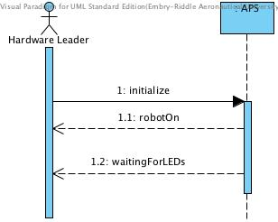

Figure 2. Sequence Diagram for Use Case 1: Initialize APS

## **Use Case 2: Follow the Line**

Figure 3 describes the interaction between the navigational system and the operational system of the APS when following the line.

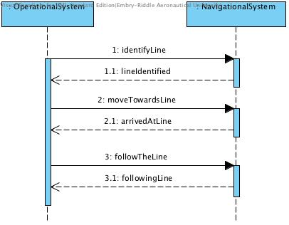

Figure 3. Sequence Diagram for Use Case 2: Follow the Line

## **Use Case 3: Play Simon Carabiner**

Figure 4 describes the interaction between the APS’s navigational system and operational system when interacting with the Simon Carabiner.

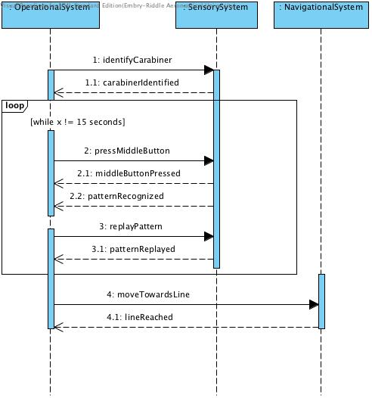

Figure 4. Sequence Diagram for Use Case 3: Play Simon Carabiner

## **Use Case 4: Draw on Etch-a-Sketch**

Figure 5 describes the interaction between the APS’s navigational system and operational system when interacting with the Etch-a-Sketch.

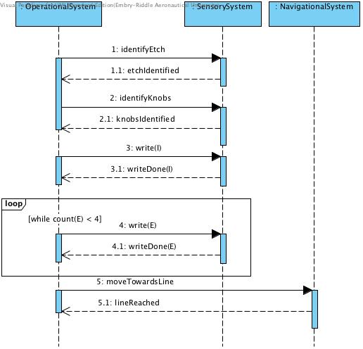

Figure 5. Sequence Diagram for Use Case 4: Draw on Etch-a-Sketch

## **Use Case 5: Rotate Rubik’s Cube**

Figure 6 describes the interaction between the APS’s navigational system and operational system when interacting with the Rubik’s Cube.

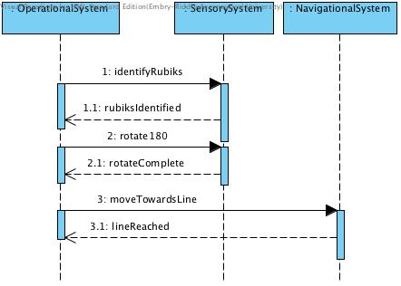

Figure 6. Sequence Diagram for Use Case 5: Rotate Rubik's Cube

## **Use Case 6: Pick up Playing Card**

Figure 7 describes the interaction between the APS’s navigational system and operational system when picking up one ~~(1)~~ playing card and crossing the finish line.

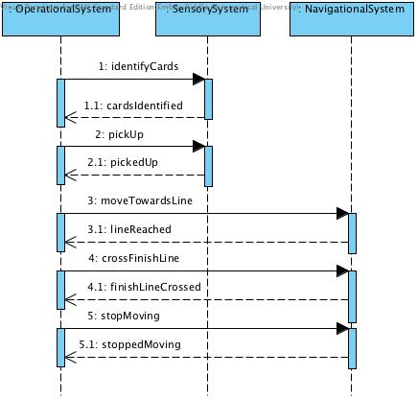

Figure 7. Sequence Diagram for Use Case 6: Pick up Playing Card

# **User Stories**

## **Epic**

* + 1. As a competitor, I want to build an APS so that I can complete a set of defined tasks in a defined playing board.
    2. As the APS, I want to follow the line on the floor so that I can reach all four ~~(4)~~ objects.
    3. As the APS, I want to interact with all four ~~(4)~~ objects to complete specific tasks with each object.

## **General**

* + 1. As the APS, I want to identify color to perform certain tasks.
    2. As the APS, I want to have a way to interact with the objects so I can position and manipulate each object.
    3. As the APS, I want to be smaller than the stipulated size to adhere to the requirements.
    4. As the APS, I want to detect real-time events so that I can respond to them.

## **Simon Carabiner**

* + 1. As the APS, I want to reach the Simon Carabiner location so that I can interact with it for the specified time of 15 seconds.
    2. As the APS, I want to press the middle button on the Simon Carabiner so that I can start the task.
    3. As the APS, I want to identify each color sequence so that I can successfully play for 15 seconds.
    4. As the APS, I want to identify when the Simon Carabiner task is over.

## **Etch-a-Sketch**

* + 1. As the APS, I want to reach the Etch-a-Sketch location so that I can interact with it until the task is completed.
    2. As the APS, I want to write “IEEE” on the Etch-a-Sketch so that I can complete the task.
    3. As the APS, I want to identify when the Etch-a-Sketch task is over.

## **Rubik’s Cube**

* + 1. As the APS, I want to reach the Rubik’s Cube location so that I can interact with the Rubik’s Cube until the task is completed.
    2. As the APS, I want to turn one ~~(1)~~ row of the Rubik’s Cube 180 degrees so that I can complete the course.
    3. As the APS, I want to be able to know when the Rubik’s Cube task is over.

## **Pick up Playing Card**

* + 1. As the APS, I want to reach the card location so that I can interact with it until the task is completed.
    2. As the APS, I want to pick up one ~~(1)~~ playing card from a stack of cards.
    3. As the APS, I want to identify when I am holding the playing card so that I can proceed to the finish line.

# **Functional Requirements**

* 1. **General Requirements**
     1. The APS shall receive power from ~~an independent~~ a standalone, on-board, battery.
     2. The APS shall perform autonomously within one ~~(1)~~ minute of being placed on the playing board.
     3. The APS shall monitor the red LED on the floor.
        1. The APS shall identify when red LED powers on.
        2. The APS shall identify when red LED powers off.
     4. The APS shall start moving when the red LED powers off.
     5. The APS shall follow the line on the floor.
        1. The APS shall monitor current position in relation to the line on the floor.
        2. The APS shall continuously correct any deviations from the line on the floor.
     6. The APS shall remain within the playing board at all times throughout the competition.
        1. The APS shall identify the edges of the playing board.
     7. The APS shall follow the line on the floor to reach the next object.
        1. The APS shall identify the game station.
        2. The APS shall return to the line after leaving the game station.
     8. The APS shall stop moving once the finish line is crossed.
  2. **Challenge Completion Requirements**
     1. The APS shall press the middle button on the Simon Carabiner to start playing.
     2. The APS shall recognize the colors lit up on the Simon Carabeaner using light intensity resistors.
     3. The APS shall rotate to position the rod over the detected color on the Simon Carabiner.
     4. The APS shall move in the z-direction to push the detected color on the Simon Carabiner.
     5. The APS shall play with the Simon Carabiner for 15 seconds.
     6. The APS shall rotate one row ~~(1)~~ of the Rubik’s Cube 180 degrees using a rotation system.
     7. The APS shall determine when one row of the Rubik’s Cube has rotated 180 degrees.
     8. The APS shall stop interacting with the Rubik’s Cube.
     9. The APS shall identify the Etch-a-Sketch using an object detection system.
     10. The APS shall position the rotation system over the knobs on the Etch-a-Sketch.
     11. The APS shall move in the z-direction to attach the rotation system to the Etch-a-Sketch knobs.
     12. The APS shall draw “IEEE” on the Etch-a-Sketch by rotating the knobs on the Etch-a-Sketch.
     13. The APS shall draw “IEEE” on the Etch-a-Sketch in a font size visible to the judges located 4 ft. away from the playing board.
     14. The APS shall stop interacting with the Etch-a-Sketch when “IEEE” has been written.
     15. The APS shall pick up one ~~(1)~~ playing card from the stack of cards.
     16. The APS shall cross the finish line with one ~~(1)~~ playing card.

# **Non-Functional Requirements**

* 1. The FTFP shall place all games on the playing board within one minute.
  2. The APS shall ~~finish~~ complete all the tasks in five minutes.
  3. The APS shall complete three rounds of competition to receive a calculated score by the judges at the end of the third round.
  4. The APS shall fit within a 1 ft. x 1 ft. x 1 ft. area before the competition begins.
  5. The APS shall fit within a 1 ft. x 1 ft. x 1 ft. area after the competition ends.
  6. The APS shall operate without human interaction.
  7. The APS shall remain as a whole system during the competition, containing no detachable parts.
  8. The APS should remain within budget.
  9. The APS shall respond to real-time events by analyzing sensor outputs.
  10. The APS shall remain flexible to adapt to changes in rules and regulations made by IEEE SoutheastCon 2015 Hardware Competition.
  11. The APS shall allow the Rubik’s Cube, Simon Carabiner, Etch-a-Sketch, and one ~~(1)~~ playing card to be visible at all times.
  12. The APS should weigh no more than 50 pounds to adhere to the two ~~(2)~~-man lift rule [3].

# **Test Cases**

Table 3 describes the test cases used by the FTFP to assure all the requirements have been fulfilled.

|  |  |  |  |
| --- | --- | --- | --- |
| **Requirement Number** | **Test Cases** | **Fulfilled** | **Time for Requirement** |
| 4.1.1 | The APS is not connected to an external power source |  |  |
| 4.1.2 | The APS performs autonomously |  |  |
| 4.1.2 | The APS begins movement within one minute of being placed on the playing board |  |  |
| 4.1.3.2 | The APS recognizes the red LED has turned off |  |  |
| 4.1.4 | The APS moves once the red LED turns off |  |  |
| 4.1.5 | The APS follows the white line |  |  |
| 4.1.6 | The APS remains within the playing board |  |  |
| 4.1.7.1 | The APS reaches the game stations |  |  |
| 4.1.7.2 | The APS returns to the line after reaching the game station |  |  |
| 4.1.8 | The APS stops moving once the finish line is crossed |  |  |
| 4.2.1 | The APS pushes the middle button |  |  |
| 4.2.2 | The APS recognizes colors through light intensity |  |  |
| 4.2.4/4.2.11 | The APS moves in the z-direction |  |  |
| 4.2.4 | The APS pushes the color on the Simon Carabiner |  |  |
| 4.2.5 | The APS plays Simon for 15 seconds |  |  |
| 4.2.6 | The APS rotates one row of the Rubik’s Cube 180 degrees |  |  |
| 4.2.12 | The APS draws “IEEE” on the Etch-a-Sketch |  |  |
| 4.2.13 | The drawn “IEEE” is visible to a person 4 ft. away |  |  |
| 4.2.15 | The APS picks up one playing card from a stack of cards |  |  |
| 4.2.16 | The APS crosses the finish line |  |  |
| 4.2.16 | The APS crosses the finish line while holding the playing card |  |  |
| 5.1 | The FTFP places all objects within the respected game stations under one minute |  |  |
| 5.2 | The APS completes the competition round under five minutes |  |  |
| 5.3 | The APS competes in three rounds of the IEEE SoutheastCon 2015 Hardware Competition |  |  |
| 5.4/5.5 | The APS is no bigger than 1 ft. x 1 ft. x 1 ft. |  |  |
| 5.6 | The APS performs without human interaction |  |  |
| 5.7 | The APS has no detachable parts |  |  |
| 5.11 | The APS allows all games to be visible to the judges at all times |  |  |
| 5.12 | The APS weighs less than 50 lbs. |  |  |

Table 3. Test cases for the FTFP to test the APS

# **Appendices**

The appendices ~~hold~~ contain supplementary material relating to the IEEE SoutheastCon 2015 Hardware Competition [1].

## **Appendix A: Figures**

The following figures are references to the playing board and game stations. Figure 8~~8~~ describes the playing board to be used in this competition.

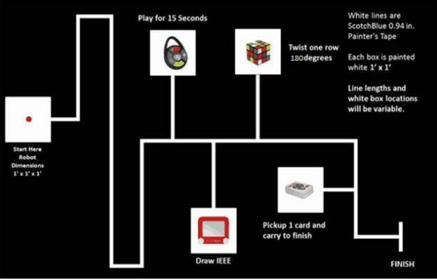

Figure 8. The playing board defined by IEEE SoutheastCon 2015 Hardware Competition [~~7~~1]

Figure 9 depicts the Etch-a-Sketch to be used during the competition.

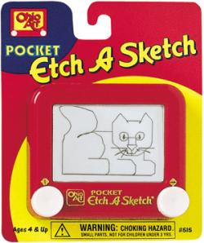

Figure 9. The Etch-a-Sketch defined in the IEEE SoutheastCon 2015 Hardware Competition [~~7~~1], [~~9~~4]

Figure 10 depicts the Rubik’s Cube to be used during the competition.

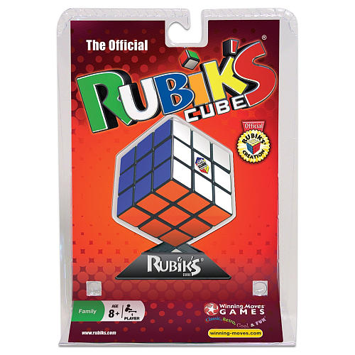

Figure 10. The Rubik's Cube defined by the IEEE SoutheastCon 2015 Hardware Competition [~~7~~1], [~~10~~5]

Figure 11 depicts the Simon Carabiner to be used during the competition.

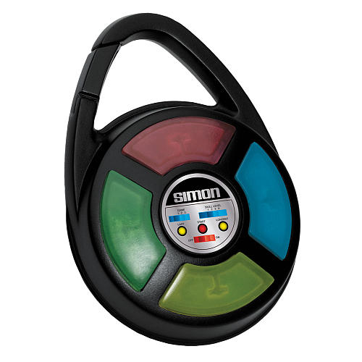

Figure 11. The Simon Carabiner defined by IEEE SoutheastCon 2015 Hardware Competition [~~7~~1], [~~11~~6]

Figure 12 depicts the stack of cards to be used during the competition.

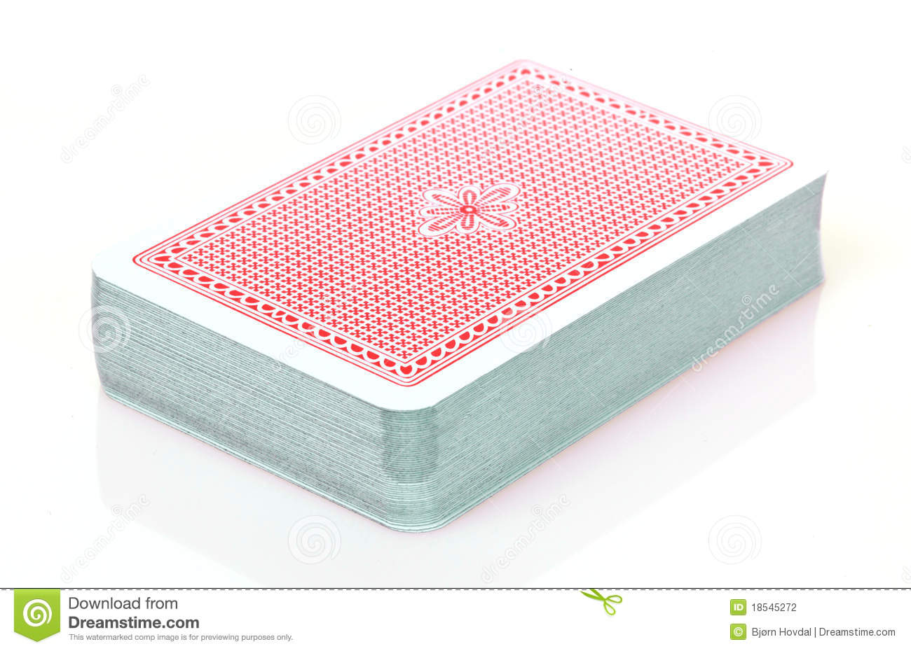

Figure 12. The stack of cards to be determined by the IEEE SoutheastCon 2015 Hardware Competition [~~2~~1], [7]

## **Appendix B: Glossary**

|  |  |
| --- | --- |
| **Entry** | **Definition** |
| * | At any time throughout a use case. |
| Autonomous | Behavior independent of any outside commands or authority. Moves and performs tasks by itself without human interaction past powering the APS on. |
| Edges | The boundaries of the playing board. |
| Error Margin | The range of suboptimal data for a specific set of data. |
| Etch-a-Sketch | Small, travel version of the toy, Etch-a-Sketch.  By: Ohio Art – “R” Web# 636061, SKU: FD79DD3F, UPC/EAN/ISBN: 026511051508 [~~7~~1]. |
| Finish Line | A line signifying the end of the course. |
| Game Station | White box, 1 ft. x 1 ft. in size 6 in. away from the edge of the playing board, on the playing boards where the objects are sitting. |
| Line | White lines painted on the playing board defined by painter’s tape.  Scotch Blue 0.94 in. x 60 yds. Painter’s Tape; Home depot: Model# 2090-1J Store SKU # 958999 [~~7~~1]. |
| Middle Button | On the Simon Carabiner, ~~there are three (3) round buttons that control the game setting, the round button in the middle is referred to as the middle button.~~ there is a large button used to start the game. |
| Navigational System | A subsystem controlling direction, speed, and maneuvering of the APS. |
| Object | The game as per IEEE SoutheastCon 2015 Hardware Competition rules [~~7~~1]. |
| Object Detection System | The system used to detect the objects at the game stations. |
| One Playing Card | A single card from the standard 52-card deck. |
| Operational System | A subsystem controlling all functions related with the interaction of the APS with each of the objects. |
| Pattern | The random sequence of lights to be repeated by pressing the corresponding buttons on the Simon Carabiner. |
| Play Simon Says | Game that challenges the user to repeat a pattern of flashing lights and sounds using the Simon Carabiner. |
| Playing Board | A 5/8 in. x 4 ft. x 8 ft. sanded pine plywood surface as defined by IEEE SoutheastCon 2015 Hardware Competition rules [~~7~~1]. |
| Position | A location within the playing board. |
| Power Off | A state in which no current or voltage is being supplied to the system. |
| Power On | A state in which current and voltage is being supplied to the system. |
| Real-Time Events | Any event that requires a system response bound by time. |
| Rod | A stick used to push the buttons on the Simon Carabiner. |
| Rotation System | The system attached to the APS used to rotate the Rubik’s Cube and rotate the rod for the Simon Carabiner. |
| Rubik’s Cube | “R” Web# 374846, SKU: DAD09D9E, UPC/EAN/ISBN: 714043050273 [~~7~~1]. |
| Sensory System | A complex collection of input/output (I/O) devices. |
| Simon Carabiner | Small, travel version of the game Simon Says.  “R” Web# 351215, SKU: 226CE810, UPC/EAN/ISBN: 014397018500 [~~7~~1]. |
| Stack of Cards | Multiple playing cards stacked on top of each other from the standard 52-card deck. |
| Standard 52-Card Deck | Toys ”R” Us# (TBD) [~~7~~1]. |
| System | A collection of parts that make up one ~~(1)~~ single unit. |
| Task | Specified interaction mandated by rules defined by IEEE SoutheastCon 2015 Hardware Competition [~~7~~1]. |
| Two-Man Lift Rule | 50 pounds or more must be carried by two people as per the Occupational Safety and Health Administration (OSHA) materials handling regulations [~~1~~3]. |

Table 4. Listing of terms and definitions used throughout this document

## **Appendix C: Acronyms and Abbreviations**

|  |  |
| --- | --- |
| **Entry** | **Expanded Phrase** |
| ABET | Accreditation Board for Engineering and Technology |
| APS | Autonomous Panda System |
| ECSSE | Electrical, Computer, Software & Systems Engineering |
| ERAU | Embry-Riddle Aeronautical University |
| FTFP | Funky Town Fancy Pandas |
| I/O | Input/Output |
| IEEE | [The] Institute of Electrical and Electronics Engineers |
| LED | Light-Emitting Diode |
| OSHA | Occupational Safety and Health Administration |
| TBD | To Be Determined |

Table 5. Acronyms/abbreviations and their expanded phrase used throughout this document

# **References**

[1] Nova Southeastern University & Broward College. (2014, March 19). *SoutheastCon 2015 Hardware Competition Rules (DRAFT*) [Online]. Available: https://docs.google.com/file/d/

0B8nHHJOB5RWcUFPQVlXdngyTVk/edit?pli=1

2

[3] B. Besser. (n.d.). *Materials handling: heavy lifting* [Online]. Available:

https://www.osha.gov/SLTC/etools/electricalcontractors/materials/heavy.html

[4] Toys R Us. *Pocket Etch A Sketch* *- Red* [Online]. Available: http://www.toysrus.com/product/

index.jsp?productId=2395954&cp=2255960.2256553&parentPage=family

[5] Toys R Us. *Rubik’s 3x3 Cube* [Online]. Available: http://www.toysrus.com/buy/

brain-teasers/rubik-s-3x3-cube-wm5027-29224016

[6] Toys R Us. *Simon-Carabiner* [Online]. Available: http://www.toysrus.com/buy/

card-puzzlegames/ simon-carabiner-1850-3839349

[7] Dreamstime. *Deck-Cards* [Online]. Available: http://thumbs.dreamstime.com/z/

deck-cards-18545272.jpg

[8] *IEEE Editorial Style Manual*, vol. 6, Mar. 2014

[9] *IEEE guide to software requirements specifications*, ANSI/IEEE Standard 830-1984, 1984.

[10] C. Larman, *Applying UML and Patterns: An Introduction to Object-Oriented Analysis and Design and Iterative Development,* 3rd ed. Westford, MA: Pearson, 2005.

[11] J. Straus, *The Blue Book of Grammar and Punctuation*, 11th ed. Indianapolis, IN: Wiley,

2014.