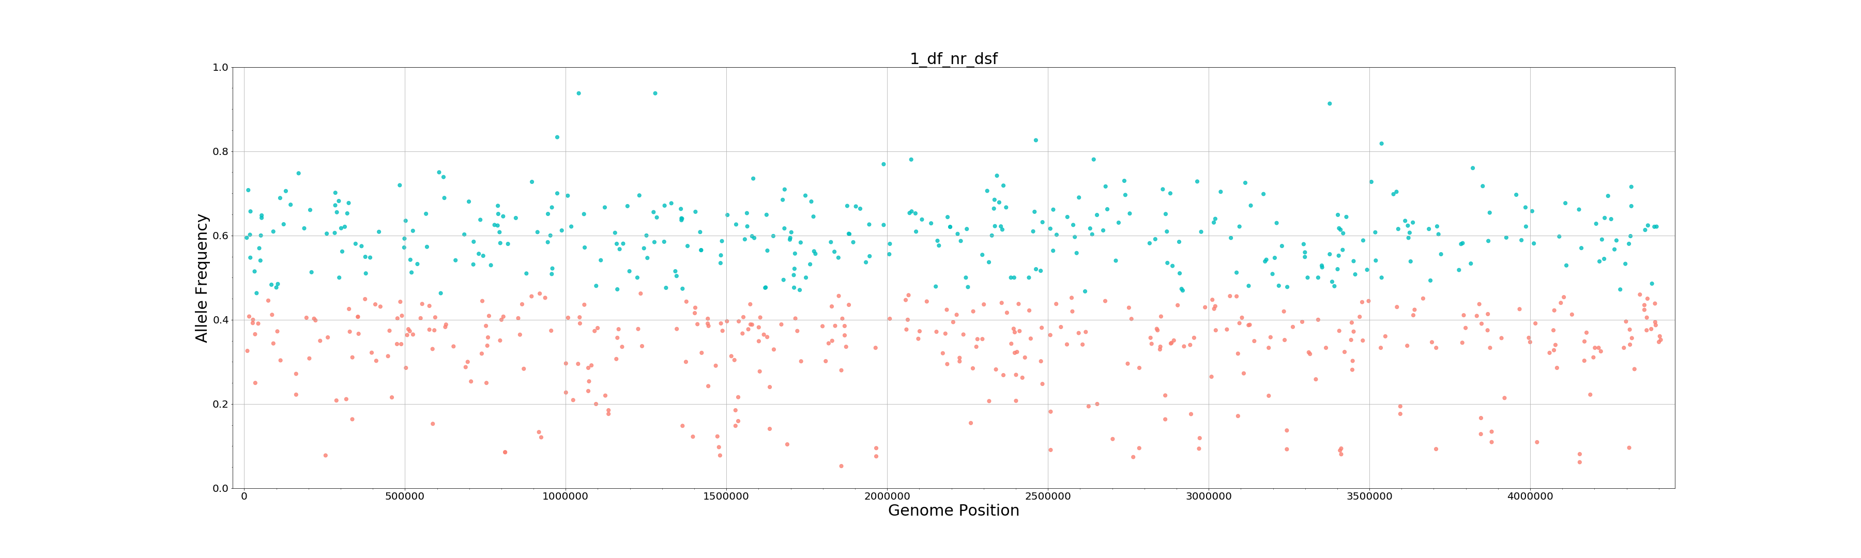
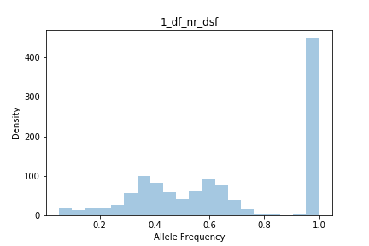
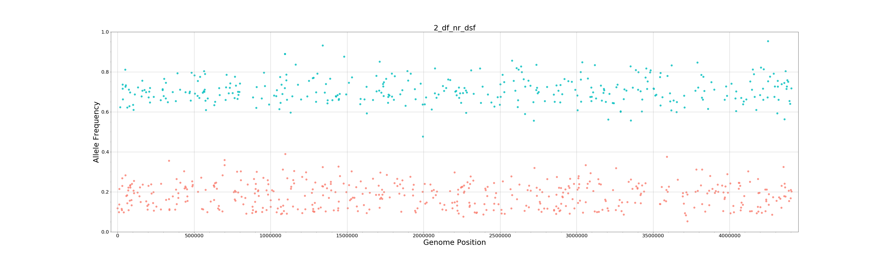
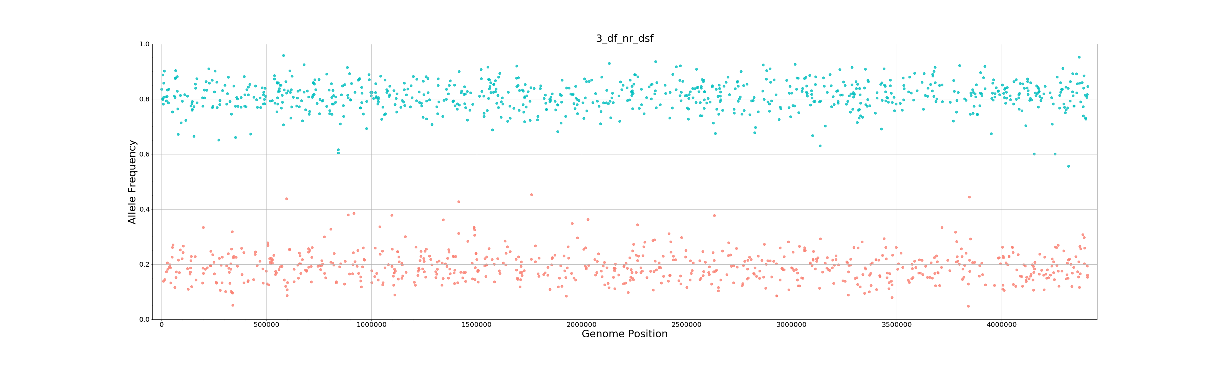
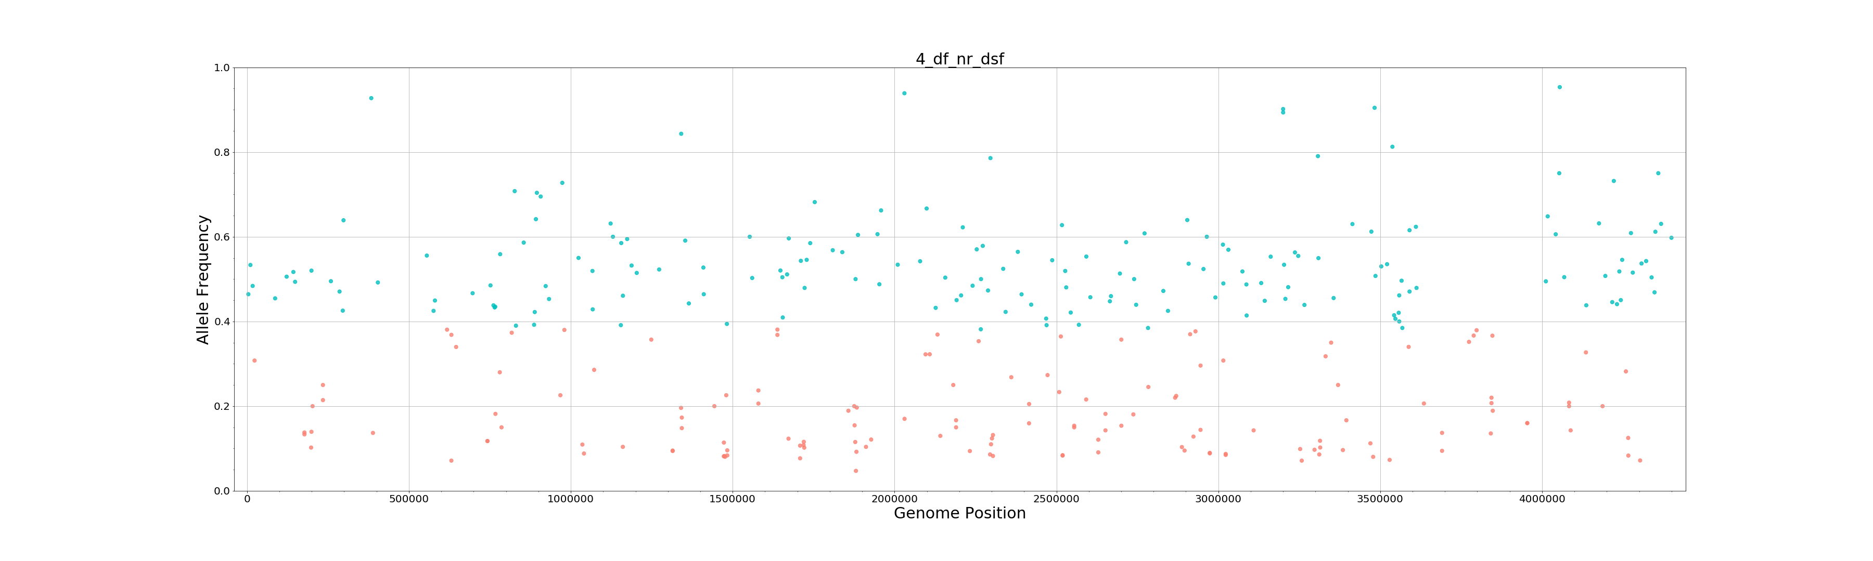
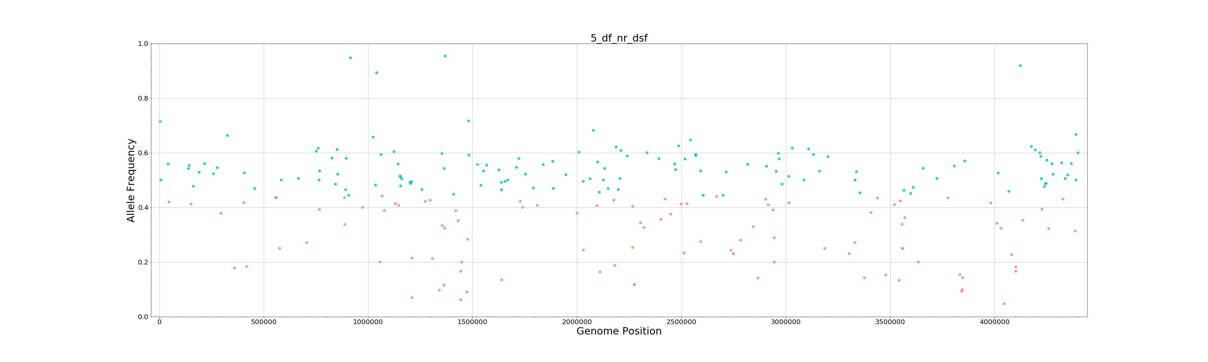
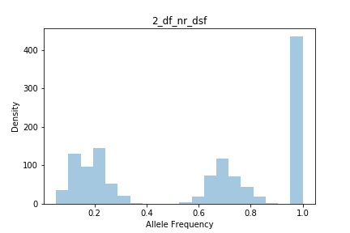
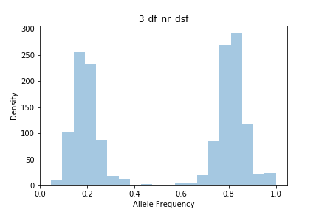
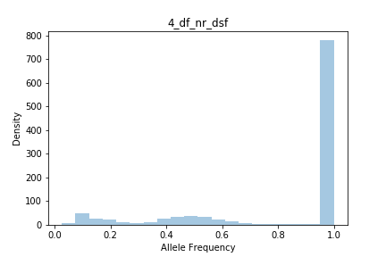
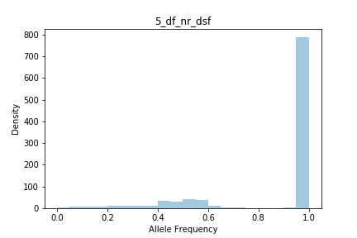
Tentative Population Frequencies:
1mixed: Pop. Freq 1: 0.61, Pop. Freq 2: 0.39
2mixed: Pop. Freq 1: 0.71, Pop. Freq 2: 0.29
3mixed: Pop. Freq 1: 0.81, Pop. Freq 2: 0.19
4mixed: Pop. Freq 1: 0.54, Pop. Freq 2: 0.46
5mixed: Pop. Freq 1: 0.55, Pop. Freq 2: 0.45
Scatter plot showing the allele frequency (AF) of all “heterozygous” filtered variants called at each position of the genome. Color represent AF higher (cyan) and lower (light red) than mean AF.
Histogram showing cumulative sum of variants at each allele frequency (include “homozygous” - AF = 1)

