Documentation of array dimension reordering to pdfemcode3

Changes

The order of the dimension of certain multi-dimensional arrays was changed to optimize memory acces. The arrays that were changed are used in the function step in femswe.f90 and therefore used multiple times depending on the step count. An example is eofv( : , : , : ), which is used in the function „dualadvflx“, that is used twice during one step. The old version looks like this:

DO iv1 = 1, nv
temp = 0.0d0
DO ix = 1, neofv(iv1,igrid)
ie1 = eofv(iv1,ix,igrid)
temp = temp + f(ie1)*eofvin(iv1,ix,igrid)
ENDDO
df(iv1) = temp
ENDDO

The index ix is used to iterate over the second dimension. The order of the required memory is eofv(1,1,igrid) → eofv(1,2,igrid) → eofv(1,3,igrid) → etc. But the index, that is changed during the loop should always be the first dimension. Thus, the required entries of the array are aligned in the memory. This leads to the following code.

DO iv1 = 1, nv
temp = 0.0d0
DO ix = 1, neofv(iv1,igrid)
ie1 = eofv(ix,iv1,igrid)
temp = temp + f(ie1)*eofvin(ix,iv1,igrid)
ENDDO
df(iv1) = temp
ENDDO

The only change is the exchange of the first and second dimension of the eofv-array. This was applied to all arrays that are used during the function step. The following list shows all modified arrays with an example, which array dimensions have been changed.

fnxte(if0, ix, igrid) → fnxte(ix, if0, igrid)
vofe(ie0, ix, igrid) → vofe(ix, ie0, igrid)
eoff(if0, ix, igrid) → eoff(ix, if0, igrid)
eoffin(if0, ix, igrid) → eoffin(ix, if0, igrid)
eofv(iv0, ix, igrid) → eofv(ix, iv0, igrid)
eofvin(iv0, ix, igrid) → eofvin(ix, iv0, igrid)
stenadvf(if0, ixs) → stenadvf(ixs, if0)
stenadvv(iv0, ixs) → stenadvv(ixs, iv0)
intmonf(if0, ixs, m) → intmonf(ixs, if0, m)
intmonv(iv0, ixs, m) → intmonv(ixs, iv0, m)
xminv(ie0, ixm, igrid) → xminv(ixm, ie0, igrid)
xminvsten(ie0, ixm, igrid) → xminvsten(ixm, ie0, igrid)
lsten(if0, ix, igrid) → lsten(ix, if0, igrid)
lmass(if0, ix, igrid) → lmass(ix, if0, igrid)
jstar(iv0, ix, igrid) → jstar(ix, iv0, igrid)
jsten(iv0, ix, igrid) → jsten(ix, iv0, igrid)
msten(ie0, ix, igrid) → msten(ix, ie0, igrid)
mmass(ie0, ix, igrid) → mmass(ix, ie0, igrid)
hstar(ie0, ix, igrid) → hstar(ix, ie0, igrid)
hsten(ie0, ix, igrid) → hsten(ix, ie0, igrid)
wsten(ie0, ix, igrid) → wsten(ix, ie0, igrid)
wcoeff(ie0, ix, igrid) → wcoeff(ix, ie0, igrid)
rxsten(iv0, ix, igrid) → rxsten(ix, iv0, igrid)
rxcoeff(iv0, ix, igrid) → rxcoeff(ix, iv0, igrid)
tsten(if0, ix, igrid) → tsten(ix, if0, igrid)
tcoeff(if0, ix, ixx, igrid) → tcoeff(ixx, ix, if0, igrid)
ressten(if0, ix, igrid) → ressten(ix, if0, igrid)
reswgt(if0, ix, igrid) → ressten(ix, if0, igrid)
injsten(if0, ix, igrid) → injsten(ix, if0, igrid)
injwgt(if0, ix, igrid) → injwgt(ix, if0, igrid)

Validation
To have correct results, these changes have to be done in the grid and operator generation as well. The restart files have been checked for bit-reproducibility. When using the GNU compiler (GCC version 4.8.2), all optimizations can be used. If the INTEL compiler (ifort version 13.1.3) is used, the program build_op has to be compiled without optimizations (-O0) to achieve bit-identical results.
The restart files are bit-identical for all test cases, that can be chosen in function „setini“.

The following two pictures show the output, printed with matlab, for the Galewsky test after 144 hours (thus 288 time steps). On the left, it is the original version and on the right, we see the modified version. They are identical as well.

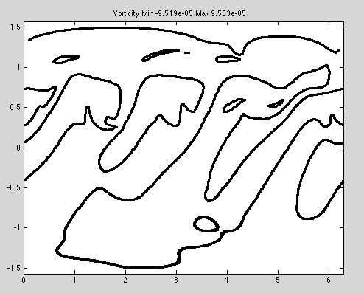

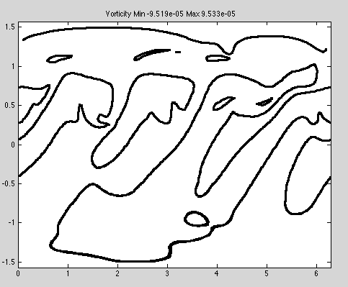

Results
The tests show a speed up of about a factor of 2 when using the reordered array dimension im comparison to the original version.

This speed up is possible due to the increased cache-hit rate on the L1-cache. The following data was collected with the perf tool for simulations on cubed sphere grids of level 8 (884736 faces).
Original version on 32 cores:

26,664,580,614,531 instructions
377,388,612,718 cache-references
71,676,995,307 cache-misses # 18.993 % of all cache refs
6,877,155,951,004 L1-dcache-loads
434,306,228,677 L1-dcache-load-misses # 6.32% of all L1-dcache hits
1,671,973,967,882 L1-dcache-stores
21,425,907,844 L1-dcache-store-misses
46,315,660,545 L1-dcache-prefetches
17,361,934,958 L1-dcache-prefetch-misses
289,493,081,218 LLC-loads
312,015,495,771 LLC-load-misses # 107.78% of all LL-cache hits
162,090,331,694 LLC-stores
84,690,573,222 LLC-store-misses
22,365,207,832 LLC-prefetches
31,950,657,226 LLC-prefetch-misses

742.303969857 seconds time elapsed

Modified version on 32 cores:

26,641,976,975,015 instructions
51,551,063,908 cache-references
35,631,508,474 cache-misses # 69.119 % of all cache refs
6,873,725,311,549 L1-dcache-loads
95,381,514,832 L1-dcache-load-misses # 1.39% of all L1-dcache hits
1,655,546,676,918 L1-dcache-stores
11,298,982,549 L1-dcache-store-misses
100,285,399,166 L1-dcache-prefetches
22,207,367,154 L1-dcache-prefetch-misses
37,975,577,276 LLC-loads
41,499,442,088 LLC-load-misses # 109.28% of all LL-cache hits
11,244,220,005 LLC-stores
8,348,024,731 LLC-store-misses
52,227,847,163 LLC-prefetches
43,505,181,858 LLC-prefetch-misses

Original version on 1 core:

23,762,520,192,204 instructions
488,569,935,962 cache-references
47,333,125,281 cache-misses # 9.688 % of all cache refs
2,785,883,712,742 L1-dcache-loads
343,780,267,096 L1-dcache-load-misses # 12.34% of all L1-dcache hits
1,139,736,888,897 L1-dcache-stores
14,407,439,229 L1-dcache-store-misses
19,308,156,504 L1-dcache-prefetches
37,619,148,954 L1-dcache-prefetch-misses
275,757,122,130 LLC-loads
103,342,553,642 LLC-load-misses # 37.48% of all LL-cache hits
16,920,987,545 LLC-stores
34,791,151,076 LLC-store-misses
269,304,508,218 LLC-prefetches
639,035,110,063 LLC-prefetch-misses

6142.143991793 seconds time elapsed

Modified version on 1 core:

20,403,671,256,374 instructions
66,783,900,233 cache-references
44,940,410,376 cache-misses # 67.292 % of all cache refs
2,374,889,326,231 L1-dcache-loads
81,991,345,449 L1-dcache-load-misses # 3.45% of all L1-dcache hits
975,117,139,093 L1-dcache-stores
11,094,121,180 L1-dcache-store-misses
176,924,583,557 L1-dcache-prefetches
82,360,229,313 L1-dcache-prefetch-misses
41,629,814,738 LLC-loads
131,184,974,347 LLC-load-misses # 315.12% of all LL-cache hits
34,077,509,257 LLC-stores
41,594,071,441 LLC-store-misses
123,313,180,167 LLC-prefetches
116,463,844,679 LLC-prefetch-misses

