As far as I understand this is the definition of a markov chain:

$$P\left(S_{i}\right|S_{i-1})=P(S_{i}|S_{i-1}, S_{i-2}, S_{i-3}, …)$$

Basically the probability of going to state $S_{i}$ is only dependent on which state we were one step before. This is actually the case for my model. This is the model once again:

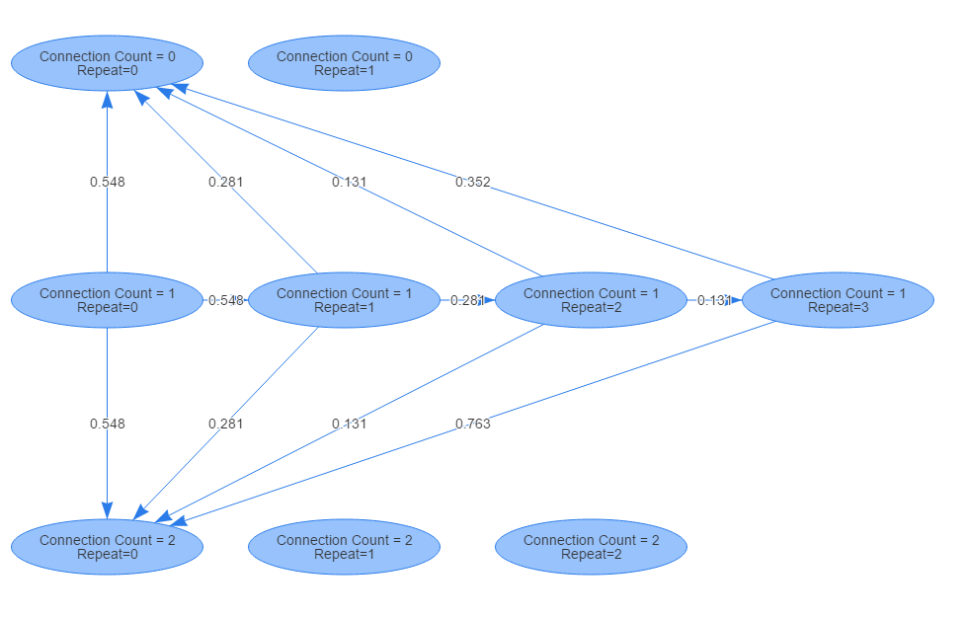

Now look at it this way:

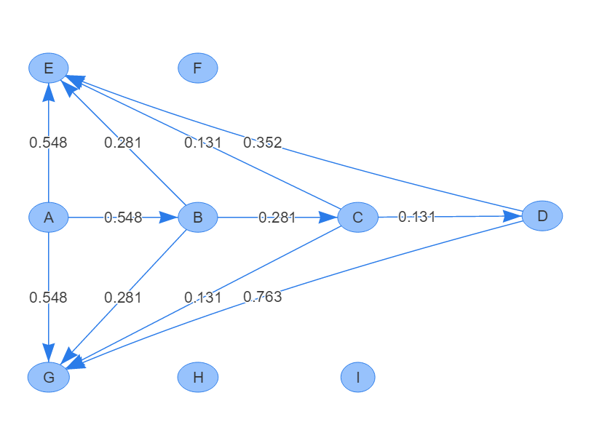

Lets consider $P\left(C | B\right)$. We have:

$$P\left(C | B\right)=0.281$$

This value is independent on how we arrived at B. That means:

$$P\left(C | B\right)=P\left(C | B, G, A\right)=P\left(C | B,A\right)=0.281$$

**Additional Notes:** In the picture above the numbers written on the edges are just random numbers. In the actual model the numbers outgoing from each node add up to 1.

**Additional Notes:** The actual graph looks something like this. I’ve omitted a lot of the edges for simplicity:

