FINAL PROJECT REPORT
AutoSage – AI Vehicle Expert Application using Gemini Flash
Team ID: LTVIP2026TMIDS48378
Date: 22nd Feb 2026
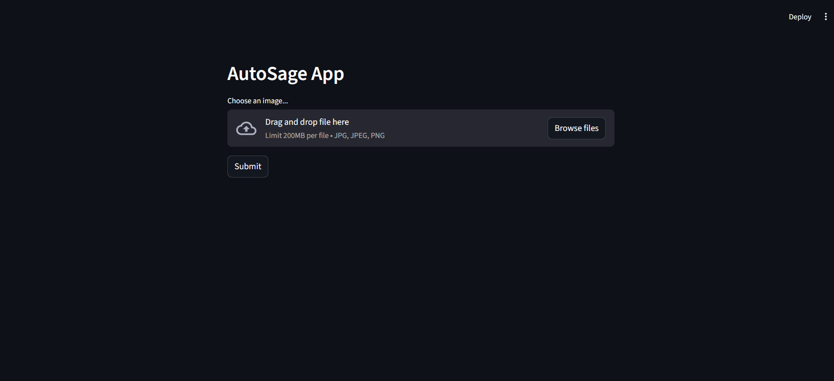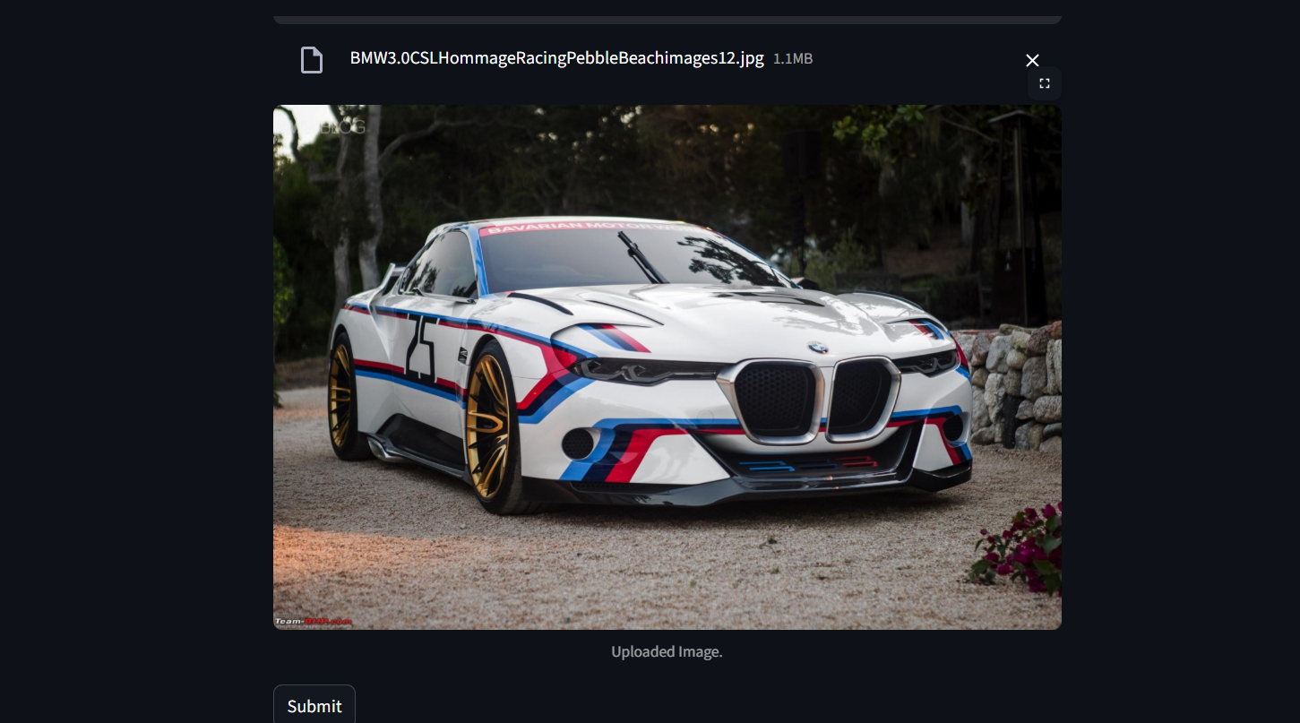

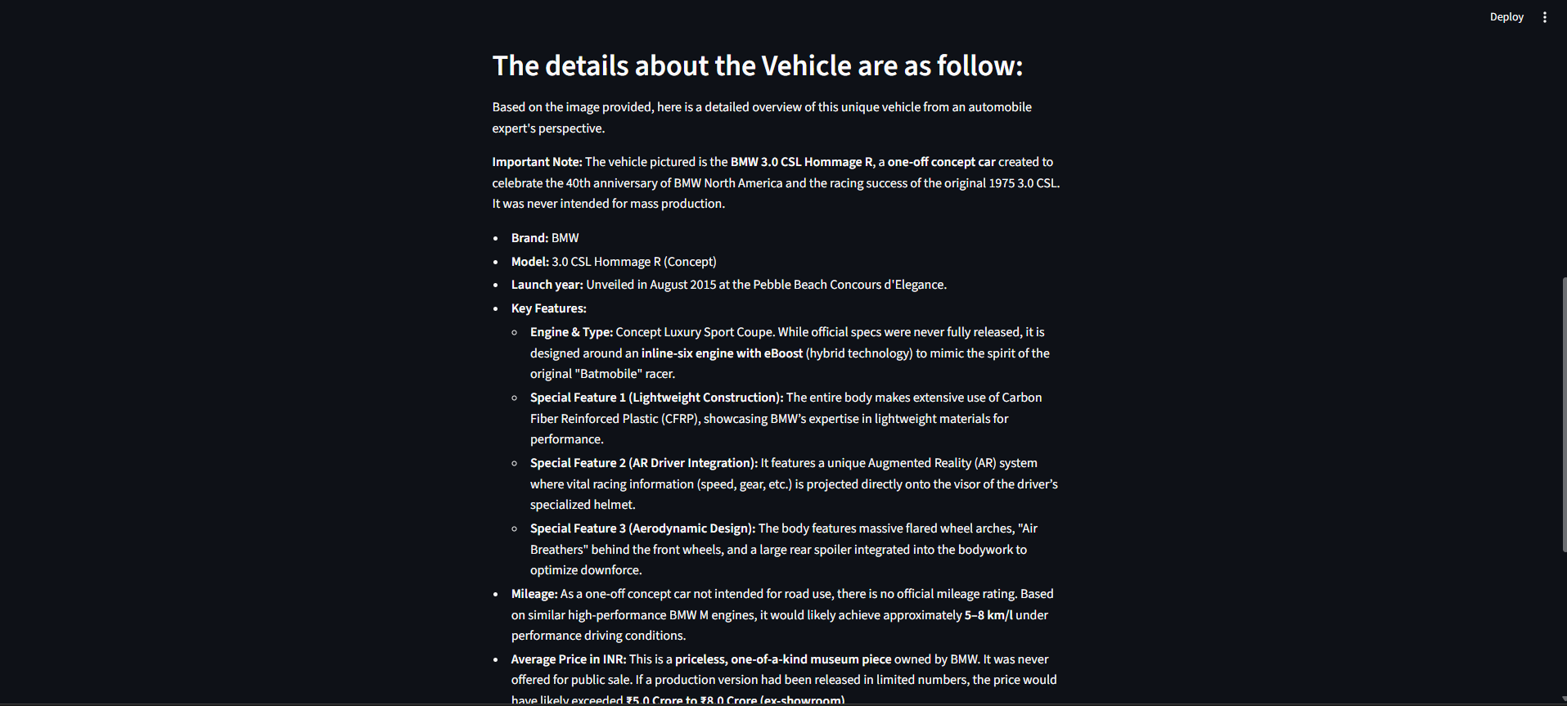

1. INTRODUCTION

1.1 Background
The automobile market has rapidly expanded with hundreds of models across different price ranges, fuel types, and performance categories.
Consumers often struggle to analyze specifications such as engine capacity, torque, mileage, maintenance cost, and resale value.
The need for a personalized intelligent assistant has become important to guide users in vehicle selection.

1.2 Motivation
Many buyers rely on YouTube videos, friends, or showroom staff. These sources are often biased or incomplete.
AutoSage aims to provide unbiased, AI-generated recommendations based on user requirements using natural language interaction.

1.3 Objectives
• Provide AI-based vehicle recommendations
• Enable easy comparison between vehicles
• Explain technical specifications in simple terms
• Provide maintenance and safety guidance
• Promote eco‑friendly vehicle adoption

2. LITERATURE SURVEY
Existing vehicle websites provide filters and specifications but lack conversational guidance.
Chatbots exist for customer support but are not specialized for automobile decision-making.
Recent advancements in generative AI models such as Gemini enable understanding natural language queries and summarizing large information sources.
AutoSage integrates conversational AI with automotive knowledge to improve decision support.

3. SYSTEM ANALYSIS

3.1 Existing System
Users manually search multiple websites, compare specs in spreadsheets, and rely on showroom explanations.
This consumes time and often leads to incorrect purchase decisions.

3.2 Limitations
• Scattered information
• Technical complexity
• Fake or promotional reviews
• No personalization
• No maintenance guidance

3.3 Proposed System
AutoSage centralizes vehicle information and uses Gemini Flash AI to interpret user queries and generate personalized recommendations.

4. METHODOLOGY
The system follows a client‑server architecture. The user sends a query via web interface.
The backend processes the request and sends a structured prompt to the Gemini Flash API.
The AI analyzes the query and generates a response. The backend formats and displays the result.

5. SYSTEM ARCHITECTURE
• User Interface (HTML, CSS, JavaScript)
• Backend Server (Python Flask)
• Gemini Flash AI Engine
• Database for storing queries

6. ALGORITHM / WORKFLOW
• User enters vehicle requirement
• System validates input
• Backend constructs prompt
• Gemini Flash processes prompt
• AI returns recommendation
• System displays results

7. IMPLEMENTATION

Frontend
HTML, CSS, and JavaScript provide a simple interactive UI.

Backend
Flask handles routing, API requests, and formatting responses.

AI Integration
Google Gemini Flash API processes user queries and returns intelligent responses.

8. TESTING
Functional testing verified query handling and recommendations.
Performance testing ensured response time below 5 seconds.
Load testing verified system stability under repeated queries.

9. RESULTS
The system successfully recommended vehicles based on budget, mileage, and preferences.
Users could compare models and obtain maintenance guidance.

10. ADVANTAGES
• Reduces decision confusion
• Personalized recommendations
• Easy to use
• Saves time
• Encourages eco‑friendly choices

11. LIMITATIONS
• Requires internet
• Dependent on API availability
• Recommendations based on available data

12. FUTURE SCOPE
• Mobile application
• Showroom locator
• Insurance suggestions
• EMI calculator
• Voice assistant integration

13. CONCLUSION
AutoSage demonstrates how generative AI can simplify vehicle purchasing decisions.
The system improves user confidence and reduces research effort by acting as a virtual vehicle expert.

