**TESTING REPORT OF JOBCALLME.COM**

1. 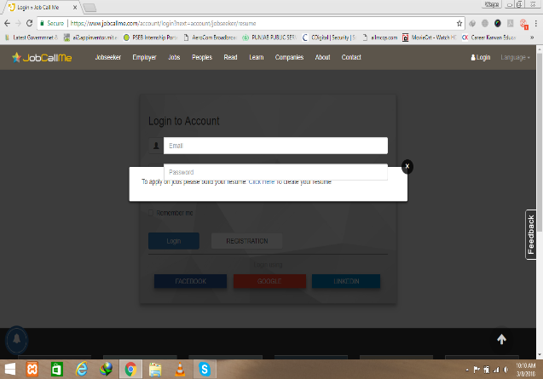From Jobs when click on Apply than [Click here button](Untitled.png) for Resume is displaced. Below is the link and screen short. <https://www.jobcallme.com/account/login?next=account/jobseeker/resume>
2. 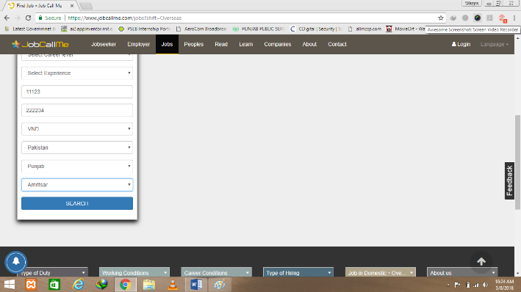On job search page, Refine Your search form Providing Irrelevant information. For example when we select county [Pakistan and Punjab](2.png) then in City option it display All cities from Pakistan and Indian Punjab. So recheck REFINE YOUR SEARCH Form. <https://www.jobcallme.com/jobs?shift=Overseas>
3. 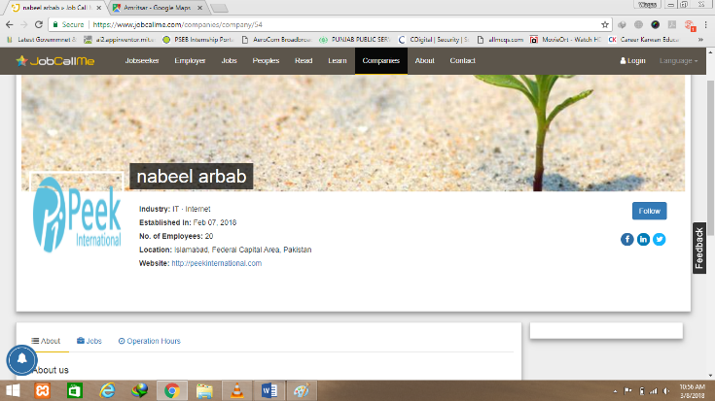No link of [Facebook](3.png) , twitter and linkedin behind their logos and Follow button on click changed to following (also login page is opend) while there is no user loged in.
4. 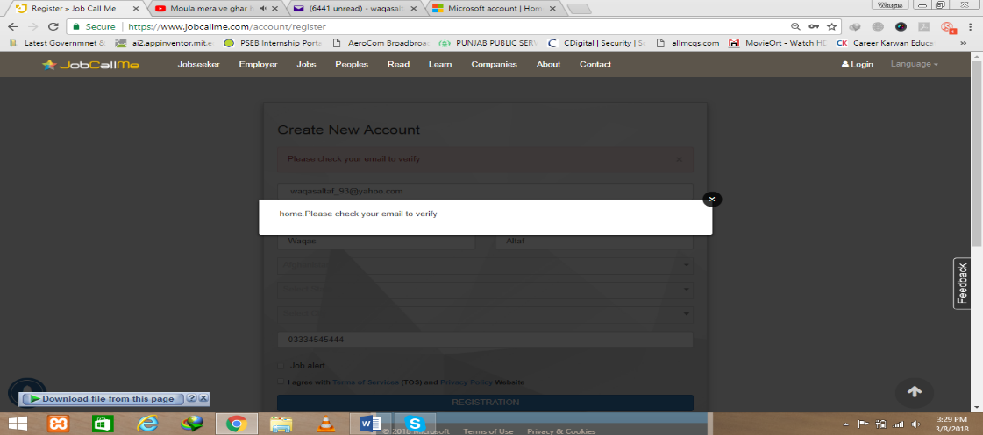[Language error](lang.png)….

<https://www.jobcallme.com/account/register>