**CS673 Software Engineering** 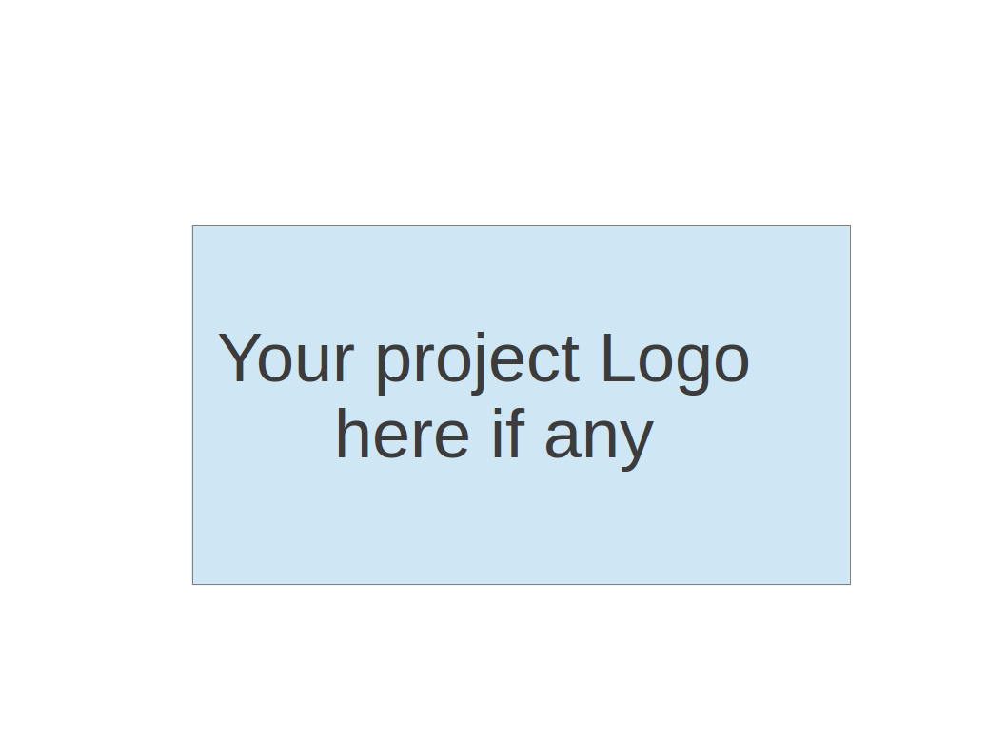

**Team 1 - Project Name**

**Project Proposal and Planning**

|  |  |  |  |
| --- | --- | --- | --- |
| Team Member | Role(s) | Signature | Date |
| Wasupol Tungsakultong | Team Leader | *WT.* | 09/10/2020 |
|  |  |  |  |
|  |  |  |  |
|  |  |  |  |
|  |  |  |  |
|  |  |  |  |
|  |  |  |  |
|  |  |  |  |
|  |  |  |  |

**Revision history**

|  |  |  |  |
| --- | --- | --- | --- |
| **Version** | **Author** | **Date** | **Change** |
| **1.0** |  | **09/10/2020** |  |
|  |  |  |  |
|  |  |  |  |
|  |  |  |  |

Overview

Related Work

Detailed Description

Management

Plan

[Process Model](https://docs.google.com/document/d/107bVcXdAG-ogRr90PquFB8-aWGvTwSua8pu_O4Kmz6c/edit#heading=h.27177f40uci)

[Risk Management](https://docs.google.com/document/d/107bVcXdAG-ogRr90PquFB8-aWGvTwSua8pu_O4Kmz6c/edit#heading=h.a4oqwntk3mw)

[Monitoring and Controlling Mechanism](https://docs.google.com/document/d/107bVcXdAG-ogRr90PquFB8-aWGvTwSua8pu_O4Kmz6c/edit#heading=h.ywdoc2clc9yt)

Schedule and deadline

[Quality Assurance Plan](https://docs.google.com/document/d/107bVcXdAG-ogRr90PquFB8-aWGvTwSua8pu_O4Kmz6c/edit#heading=h.72e1f4uawy2r)

Metrics

[Standard](https://docs.google.com/document/d/107bVcXdAG-ogRr90PquFB8-aWGvTwSua8pu_O4Kmz6c/edit#heading=h.vc72k6dweldv)

Inspection/Review Process

[Testing](https://docs.google.com/document/d/107bVcXdAG-ogRr90PquFB8-aWGvTwSua8pu_O4Kmz6c/edit#heading=h.r5d5mhtlf0kq)

[Defect Management](https://docs.google.com/document/d/107bVcXdAG-ogRr90PquFB8-aWGvTwSua8pu_O4Kmz6c/edit#heading=h.54a4wuncjg1c)

Process improvement process

[Configuration Management Plan](https://docs.google.com/document/d/107bVcXdAG-ogRr90PquFB8-aWGvTwSua8pu_O4Kmz6c/edit#heading=h.hw41vg4ykxen)

[Configuration items and tools](https://docs.google.com/document/d/107bVcXdAG-ogRr90PquFB8-aWGvTwSua8pu_O4Kmz6c/edit#heading=h.bwlb4d4vdox2)

code commit guidelines

[References](https://docs.google.com/document/d/107bVcXdAG-ogRr90PquFB8-aWGvTwSua8pu_O4Kmz6c/edit#heading=h.8mva2050iy7t)

Glossary

# Overview

(Please give an overview of your project. It should include the motivation, the purpose and the potential users of the proposed software system. )

# Related Work

(Please describe any similar software systems that you have found through the online research, and the differences between your software and those software systems.)

[Join Me (Video sharing screen on mobile application)](https://www.join.me/resources/user-tips/how-to-share-screen-with-android)

[Slack](http://slack.com/)

[Whatsapp](https://www.whatsapp.com/)

[Facebook Messager](https://www.messenger.com)

# Proposed High level Requirements

* 1. Functional Requirements  
     (For each functional requirement, please give a feature title and a brief description using the following format: As (a role), I want to (action), so that (value).)
     1. Essential Features (the core features that you definitely need to finish):

(For each essential features, please give a rough estimation in terms of person hours or an range of person hours)

1. Send a message to others.
2. Send pictures to others.
3. Authentication (User login, Google Login)
4. Create chat groups
   * 1. Desirable Features (the nice features that you really want to have too):
        1. SMS Authentication.
        2. Google Translate in the chat, if the message is not in english.
     2. Optional Features (additional cool features that you want to have if there is time):
        1. Send stickers to the chat.
        2. Video sharing on mobile.
   1. Nonfunctional Requirements (Scale, Quality, Security)
      * 1. Google Analytics (Track which features users use the most.)
        2. Set up automation build deploy
        3. Encryption and security (both android, backend)

# Management Plan

## Process Model

(Please describe your software process model, e.g. ?)

## Objectives and Priorities

(Please describe your project objectives with highest priority first. Project Goals can include but not limited to complete all proposed (essential) features, deploy the software successfully, the software has no known bugs, maintain high quality, etc )

## Risk Management (need to be updated constantly)

(Please write a summary paragraph about the main risks your group identified and how you plan to manage these risks. Then use the separate google sheet for detailed risk management. The template is provided in the same folder with this file. Please provide the link to the sheet.)

Risk Management Sheet Link:

## Monitoring and Controlling Tools and Mechanisms

We will use the following tools to facilitate group communication and monitor the project progress.

* + 1. Pivotaltracker Link:
       1. https://www.pivotaltracker.com/n/projects/2465407
    2. Slack Link:
       1. bumetcs673f20.slack.com
    3. Github Link:
       1. https://github.com/BUMETCS673/CS673F20T1
    4. Zoom meeting Link:
    5. Weekly meeting time:
       1. Currently Sunday morning @ 11 - 11:30 am EST.

## Timeline (need to be updated at the end of each iteration)

|  |  |  |  |  |
| --- | --- | --- | --- | --- |
| Iteration | Functional Requirements(E/D/O) | Tasks | Estimated/real person hours | Presentation Recording Link (5-10 minutes) |
| 1 |  |  |  |  |
| 2 |  |  |  |  |
| 3 |  |  |  |  |

# 

# Quality Assurance Plan

## Metrics

* + 1. Definition (e.g. define what metrics will be used, , how to keep track of metrics, and how to analyze the metrics for process improvement. Two types of metrics should be included: product metrics and process metrics. Particularly include product complexity (LOC, # of files, # of classes, # of methods etc.) cost (in terms of man hours), defect and defect fix rate etc.user story points,
    2. Results (to be completed at the end of each iteration),
  1. Standard  
     (e.g. documentation standard, coding standards etc. )

## Inspection/Review Process

## (e.g. describe what are subject to review, when to conduct review, who do the reviews and how ?)

Git flow (1 reviewer)

Plan branch

## Testing:

## (e.g. who, when and what type of testing to be performed? How to keep track of testing results?)

A separate document about testing results should be linked here.

## Defect Management

(e.g. describe the criteria of defect, also in terms of severity, extend, priority, etc. The tool used to management defect, actions or personnel for defect management)

# Configuration Management Plan

(For more details, please refer to SCMP document for encounter example)

## Configuration items and tools

## Change management and branch management

## Code commit guidelines

* 1. Integration and deployment plan

# References

(For more details, please refer to the encounter example in the book or the software version of the documents posted on blackboard. )

# Glossary