Assesmeent Tool-(High Coding Challenge)

1. Library Book Management using Classes & Encapsulation
Design a Book class with private fields such as bookId, title, author, and price. Implement constructors, getters, setters, and methods to issue and return books. Create a menu-driven program to manage multiple books using an array of objects. Also, construct suitable test cases to validate book addition, issue, return, and search operations.BTL: BL3 (Apply)
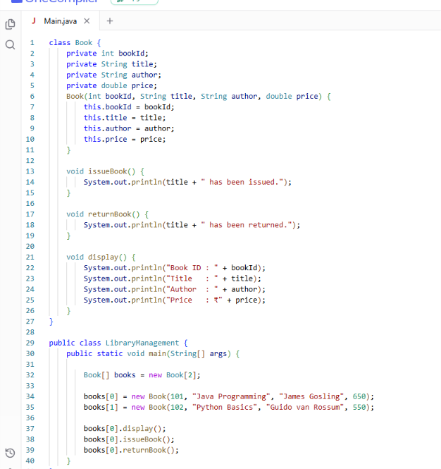
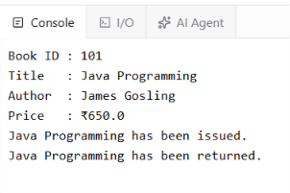

2. Employee Payroll System using Inheritance
Design a payroll system with a base class Employee and derived classes PermanentEmployee and ContractEmployee. Override a method calculateSalary() in each subclass to compute salary differently. Display employee details and salary using runtime polymorphism. Also, construct suitable test cases to validate salary calculation for different employee types.BTL: BL3 (Apply)
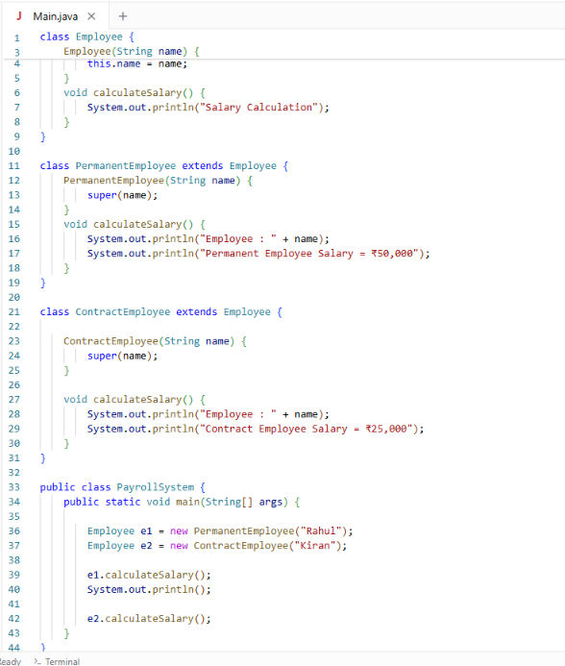
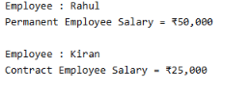

3. Vehicle Rental System using Runtime Polymorphism
Develop a vehicle rental system with a superclass Vehicle and subclasses Car, Bike, and Bus. Override the method calculateRent(int days) in each subclass. Store vehicles in an array of Vehicle references and generate rental bills dynamically. Also, construct suitable test cases to validate rent calculation for different vehicle categories.BTL: BL4 (Analyze)
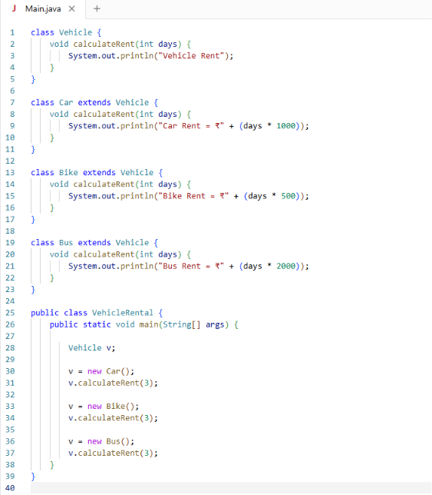

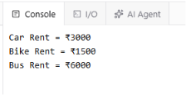

4. Bank Account System using Data Hiding
Design a BankAccount class with private fields accountNumber, holderName, and balance. Implement methods for deposit, withdrawal, and balance inquiry with proper validation. Prevent direct modification of balance from outside the class. Also, construct suitable test cases to validate valid and invalid transactions.BTL: BL3 (Apply)
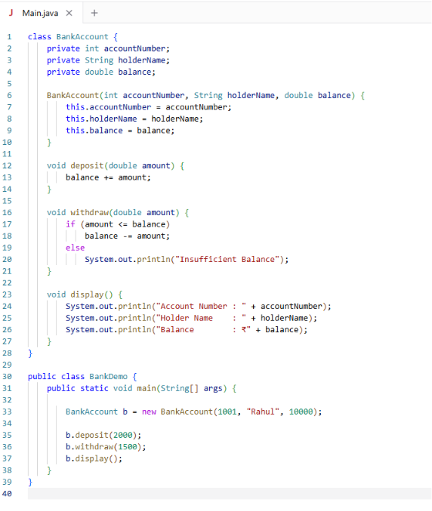\
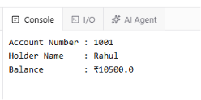

5. University Admission System using Method Overloading
Create an Admission class that overloads the method calculateFee() for:
- Undergraduate students,
- Postgraduate students,
- Scholarship students.

