|  |
| --- |
| SAHATHAI Web center |

1.Log In

Enter your username and password .

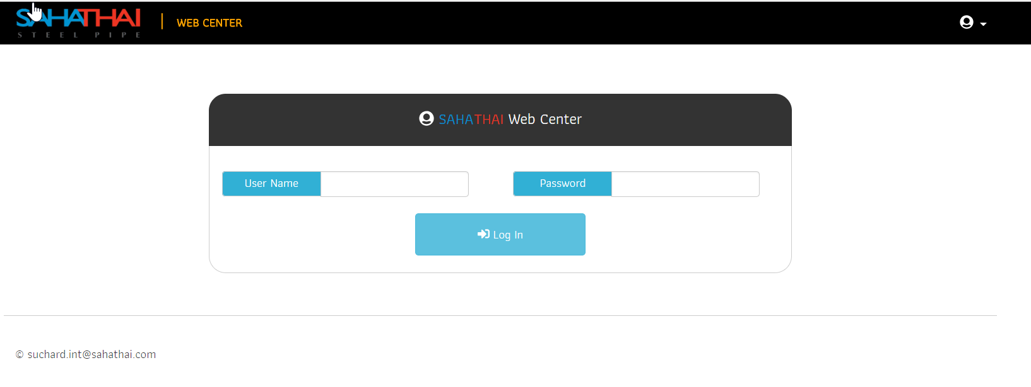

2.List Page

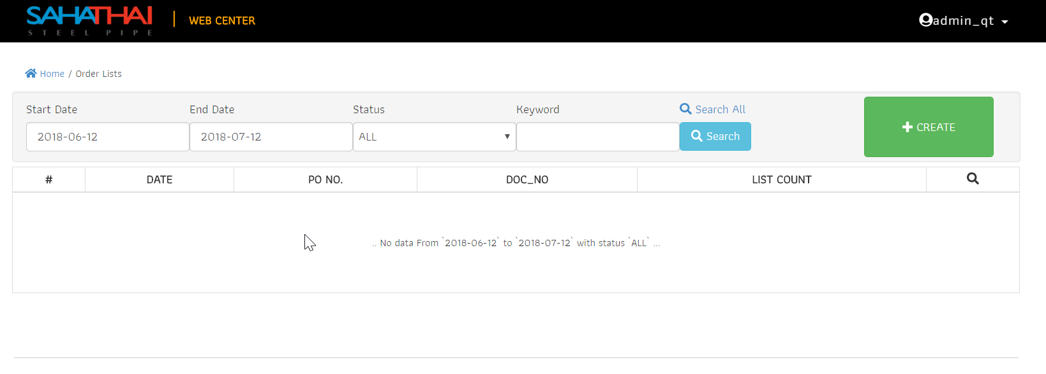

3

1

6

5

4

2

1.Link back to previous page.

2.Filter data.

3.Search all document without filter .

4.Button for filter processing.

5.Create new order.

6.List of data.

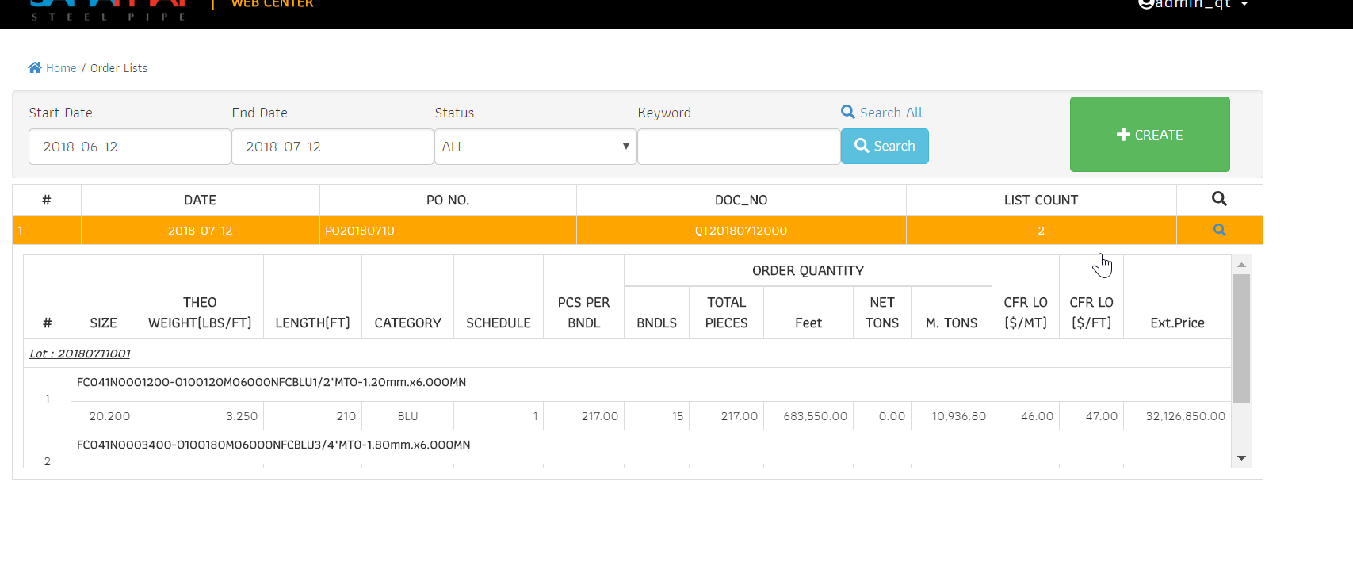

Click data row to show detail below

or click



To link view page

3.Create new order.

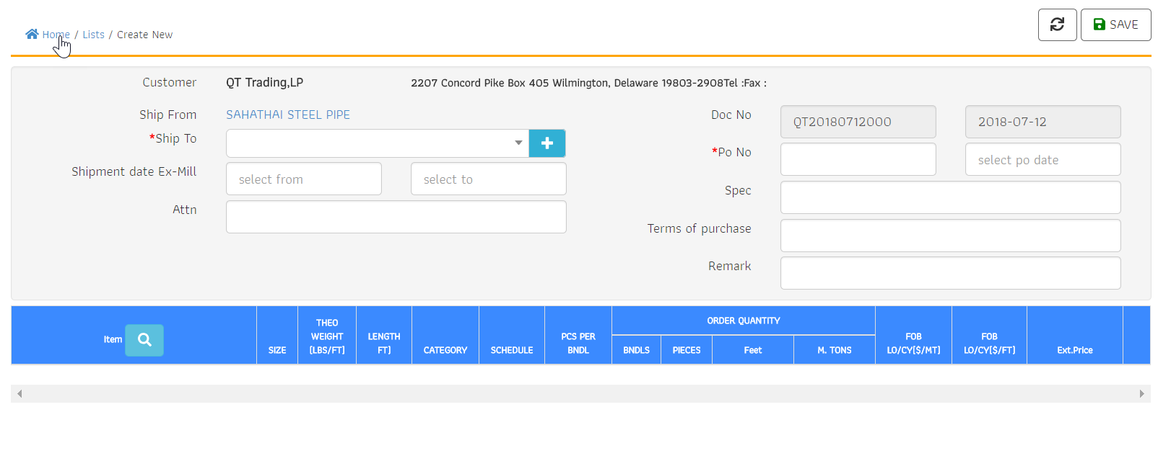

1

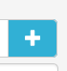 1.Select port . If need for new port data must click button .

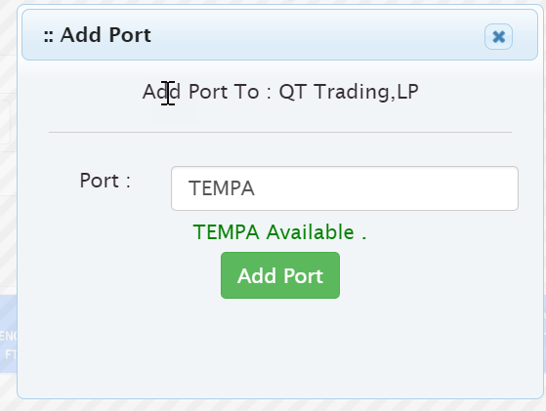

Add data button

validation

Input new port data

Close popup

2.Select Shipment date Ex-Mill period.

Click to show data picker

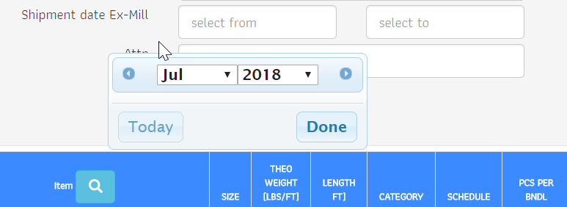

Select month and year and click “Done”

Click to show data picker

3.Item Select

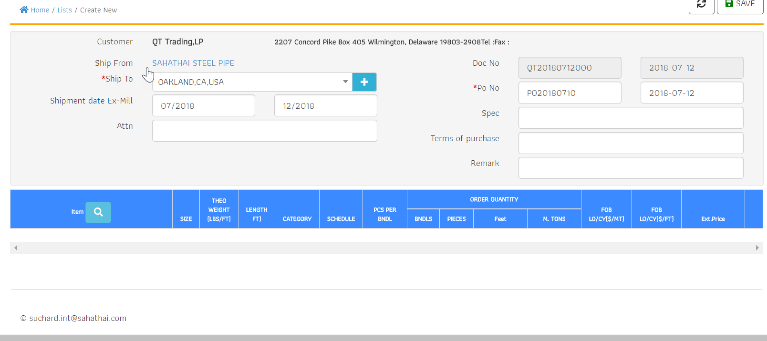

Click to open popup for item selection

4.Item selection

6

5

4

3

1

2

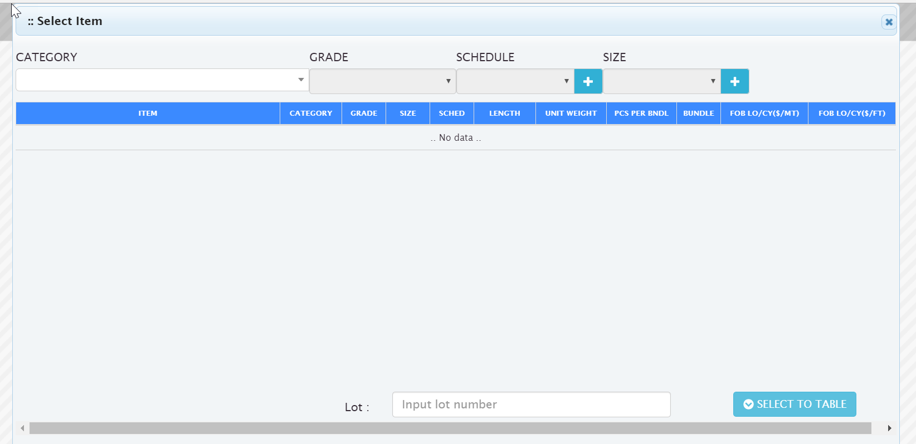

9

8

7

1.Select items’Category to unlock GRADE , SCHEDULE , SIZE dropdown

2.Select item’s GRADE.

3.Select item’s SCHEDULE.

4.Add SCHEDULE data.

5.Select item’s SIZE.

6.Add SIZE data.

7.Item List.

8.Lot input

9.Process button.

Example

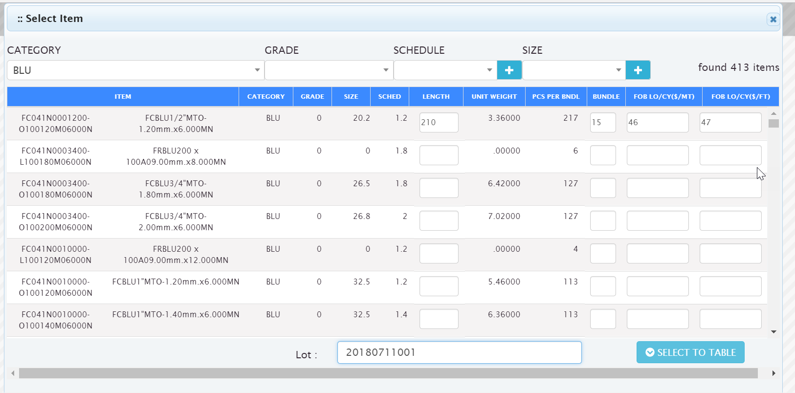

If done . Click to process

Input data to target item

5. List items

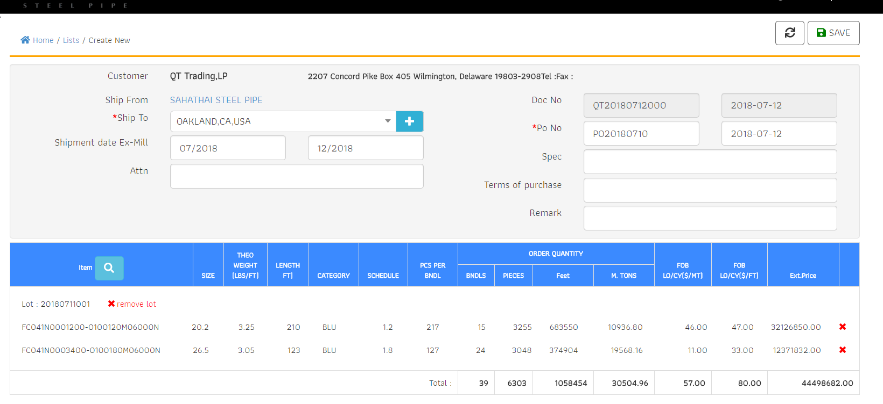

4

3

2

1

1.Data should be group by lot. If use item selection again data should increase value in same lot and separate when input other lot .

2.Remove data row entire lot.

3.Remove data row by index.

4.Click save when data is done.

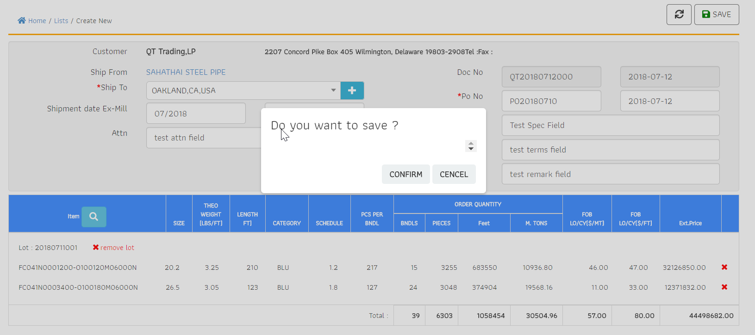

Confirm to save data

5.View page.

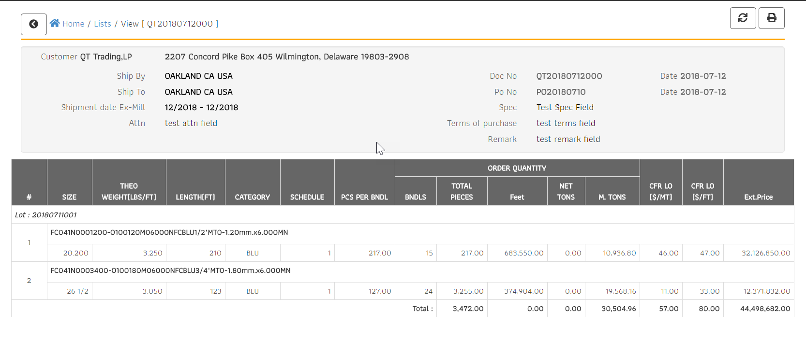

2

1

1.Data viewer

2.Print and Export button

6.Print and export.

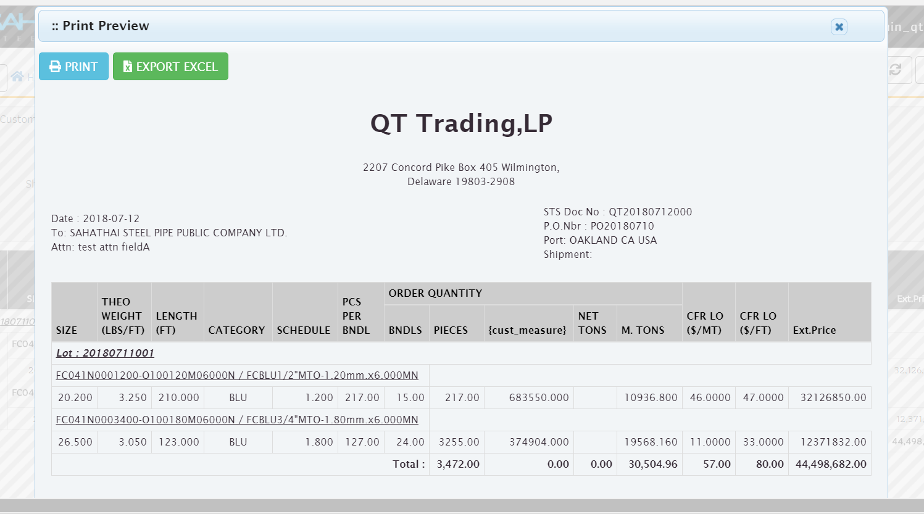

1

3

2

1.Print data viewer.

2.Print to printer.

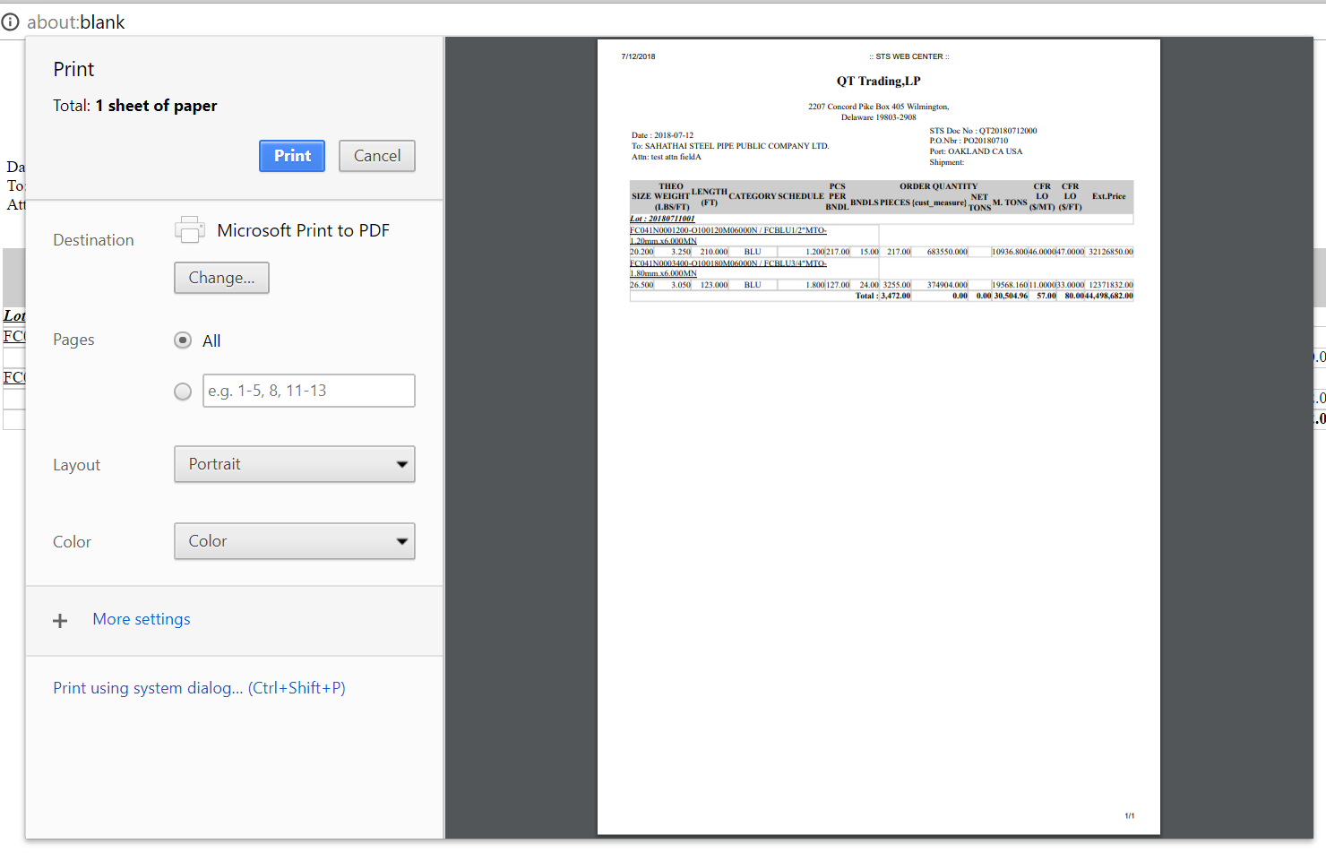

3.Export to excel.

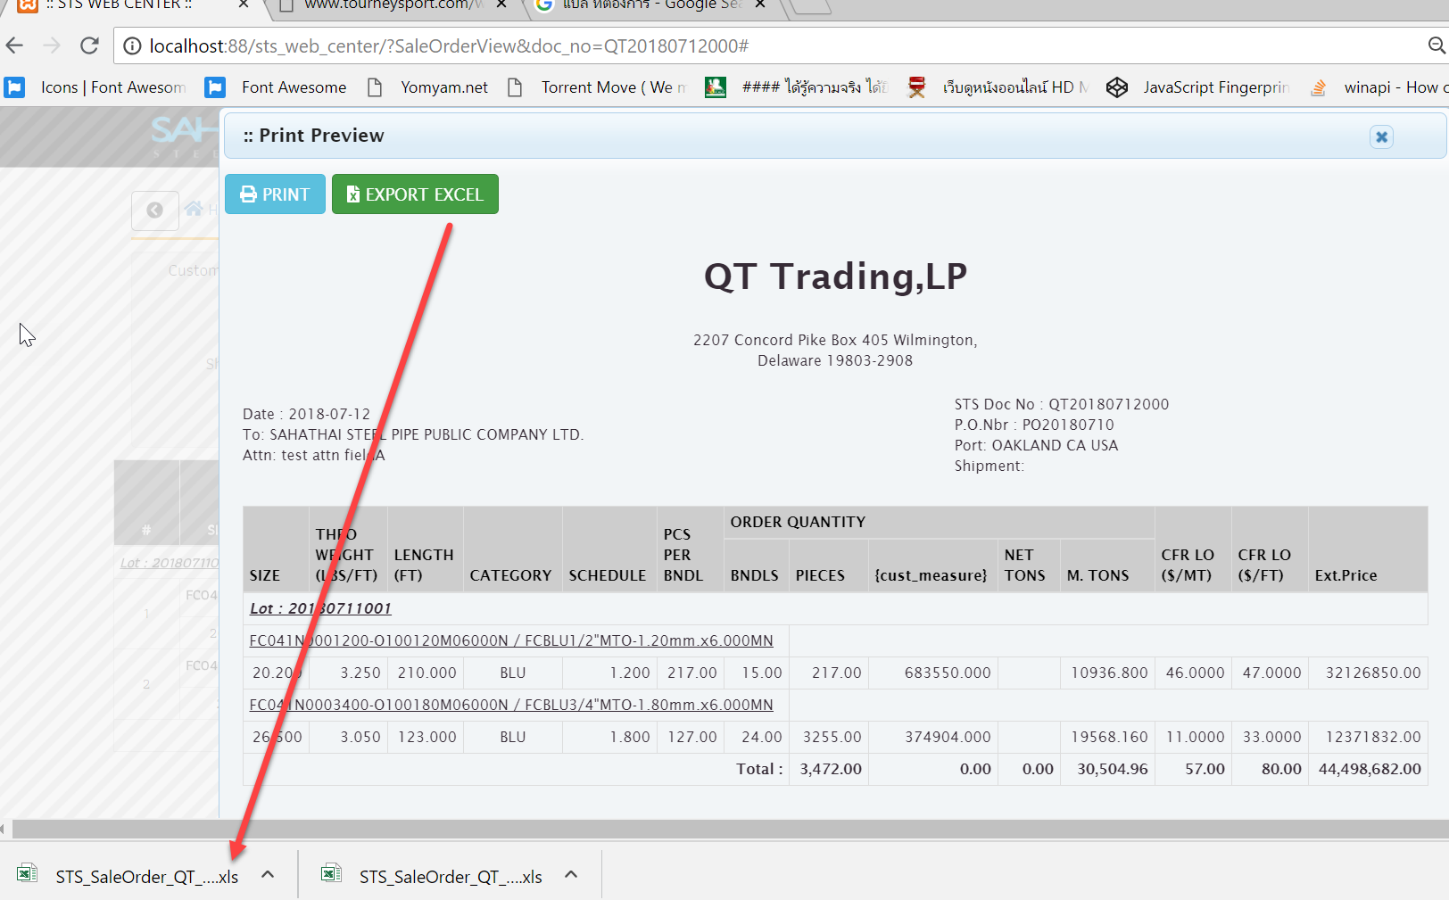

-Save file to your disk drive

-Format name is order by date time.

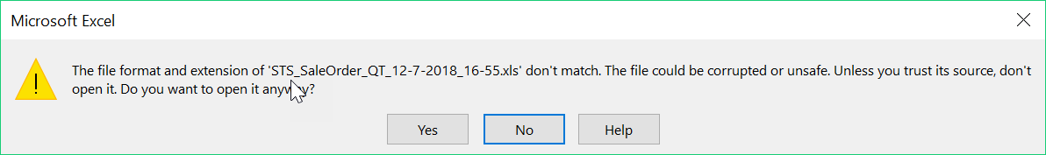

Select “Yes” to convert sheet document.

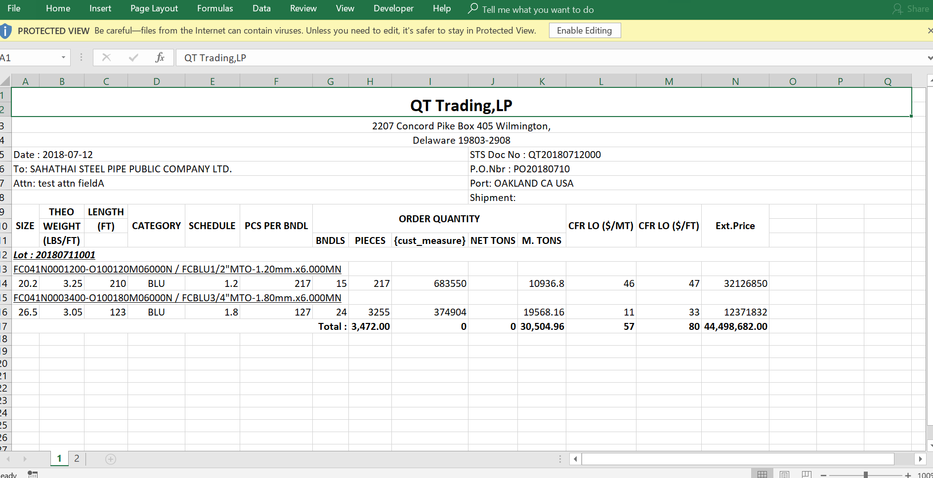

Unlock for edit

Excel viewer