1. 引入库

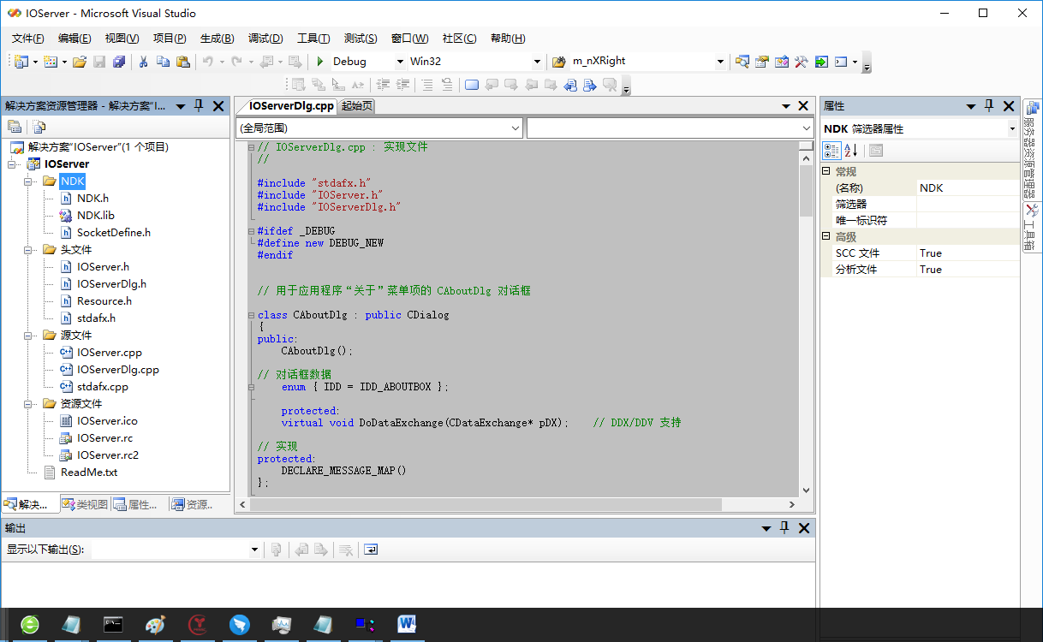

1. 第三方动态库拷贝到运行目录
2. 引用头文件和socket类

#include "ndk\ndk.h"

CNDKSocket *m_pNDKSocket;

1. 创建对象，并且初始化通信模型

m_pNDKSocket=GetNDKSocketPtr(SOCKET_TYPE_IO_OVERLAP_SERVER);

if(NULL == m_pNDKSocket)

{

CString msg;

msg.Format("启动TCP Server错误");

AfxMessageBox(msg);

exit(0);

}

int nRet=0;

nRet=m_pNDKSocket->Initial(RecvFunc, (long*)this, m_nPort, "0.0.0.0");//127.0.0.1

if(NDK_SUCC != nRet)

{

CString msg;

msg.Format("启动TCP Server错误, Error=%d",nRet);

AfxMessageBox(msg);

exit(0);

}

1. 加入SOCKET头文件

#include <afxsock.h> // MFC 套接字扩展

1. 编写回调函数

int WINAPI RecvFunc(char* pData, unsigned long ulLen, long* lpParent, NDK_SOCKET* pClient)

{

CIOServerDlg *pNewServerUIView = (CIOServerDlg*)lpParent;

switch(pClient->ulOperator)

{

case 1: // 连接

{

if(NULL != pNewServerUIView && NULL!=pClient)

{

int nSendBufLen=1*1024*1024;

if (0!=setsockopt(pClient->sSocket, SOL_SOCKET, SO_SNDBUF, (char *)&nSendBufLen ,sizeof(nSendBufLen) ) )

{

/*CString strMsg;

strMsg.Format("setsockopt error=%d",GetLastError());

pNewServerUIView->m_LogTrace.WriteLogError(strMsg);*/

}

CString strMsg;

strMsg.Format("TCP Connect: sSocket=%d,ulIp=%ld,ulPort=%ld,ulLoginTime=%ld,ulOperator=%ld,ucIp=%s\n",

pClient->sSocket,

pClient->ulIp,

pClient->ulPort,//对方Port

pClient->ulLoginTime,

pClient->ulOperator,

pClient->ucIp//对方IP

);

//pNewServerUIView->m_LogTrace.WriteLogError(strMsg);

setSocket.insert(pClient->sSocket);

}

}

break;

case 2: // 断开连接

{

if(NULL != pNewServerUIView && NULL!=pClient)

{

CString strMsg;

strMsg.Format("TCP Disconnect: sSocket=%d,ulIp=%ld,ulPort=%ld,ulLoginTime=%ld,ulOperator=%ld,ucIp=%s\n",

pClient->sSocket,

pClient->ulIp,

pClient->ulPort,//对方Port

pClient->ulLoginTime,

pClient->ulOperator,

pClient->ucIp//对方IP

);

//pNewServerUIView->m_LogTrace.WriteLogError(strMsg);

setSocket.erase(pClient->sSocket);

}

}

break;

case 3: // 接收到数据

{

}

break;

}

return 0;

}

1. 编译通过。
2. 简单程序就做好了。