Title: Eco.BNF1 Software Specification

USPD: US.ECO.00112-01 90 01 1
Name: Eco.BNF1
Short Description (max 300 char.): Backus-Naur Form (BNF) grammer component
Category: DEVTOOL
Type: COMPONENT
CID: 323DD55E33D040FA98068E2FCB1CBD49
Marketplace ID: n/a
Marketplace URL: n/a
Status: Draft
Modified Date: November 25, 2025
Version: 1.0

Tags: BNF, Backus-Naur, syntax of programming languages, computer grammar, language syntax

Authors | Company
Vladimir Bashev | PEERF

Content
1. Overview 3
1.1. Introduction 3
1.2. Notes 3
1.3. Links 3
2. Eco.Toolchain.BNF1 Component 4
3. IEcoBNF1 interface 5
3.1. IEcoBNF1 IDL 6
3.1.1. AddRule function 7
3.1.2. AddComment function 7
3.1.3. get_RuleList function 7
3.1.4. get_Alphabet function 7
3.1.5. get_TerminalAlphabet function 7
3.1.6. get_NonTerminalAlphabet function 7
3.1.7. Clear function 7
4. IEcoToolchainBNF1Rule Interface 8
4.1. IEcoToolchainBNF1Rule IDL 8
4.1.1. get_Name function 10
4.1.2. get_Id function 10
4.1.3. AddConcatenation function 10
4.1.4. AddAlternative function 10
4.1.5. AddSequenceGroup function 10
4.1.6. AddOptionalSequence function 10
4.1.7. AddSpecialSequence function 10
4.1.8. AddValueRangeAlternatives function 10
4.1.9. AddIncrementalAlternatives function 10
4.1.10. get_RuleSet function 11
5. IEcoToolchainBNF1Element Interface 12
5.1. IEcoToolchainBNF1Element IDL 12
5.1.1. get_Name function 13
5.1.2. get_Id function 13
5.1.3. IsOptional function 13
5.1.4. IsTerminal function 13
5.1.5. IsGroup function 13
5.1.6. IsEpsilon function 13
5.1.7. IsExcep function 13
5.1.8. IsSpecial function 13
5.1.9. IsRepeated function 13
5.1.10. set_Repetition function 13
5.1.11. get_LeastOccurrences function 13
5.1.12. get_MostOccurrences function 13
5.1.13. get_SpecialType function 14
5.1.14. get_SequenceSet function 14
6. In development … 15

1. Overview
This document describes the requirements for the implementation of the Eco.BNF1 component.

1.1. Introduction
Description. BNF (Backus-Naur Form) grammar is a formal notation system for describing the syntax of programming languages and other formal languages using production rules, defining how simple elements (terminals) combine into complex structures (nonterminals) via ::= (is defined as) and | (or). It's a bedrock for compilers and parsers, providing clear, human-readable definitions for language structure, crucial for defining valid sentences, commands, or data formats, including modern LLM outputs.
Key Components:
- Terminals: Literal symbols or keywords that appear in the language (e.g., +, def, return).
- Nonterminals (Syntactic Variables): Placeholders for structures, usually in angle brackets (e.g., `<digit>`, `<expression>`) that get replaced by other symbols or terminals.
- Rules (Productions): Define relationships, like name `::=` expansion.
- `::=` (is defined as): Separates a nonterminal from its possible expansions.
- `|` (or): Indicates a choice between options within a rule.

1.2. Notes

1.3. Links
This paragraph contains supplementary links to the component artifacts and information:
Available at marketplace: https://ecoos.dev/product/component_id

2. Eco.Toolchain.BNF1 Component

The Eco.BNF1 component
The component has the following description diagram:

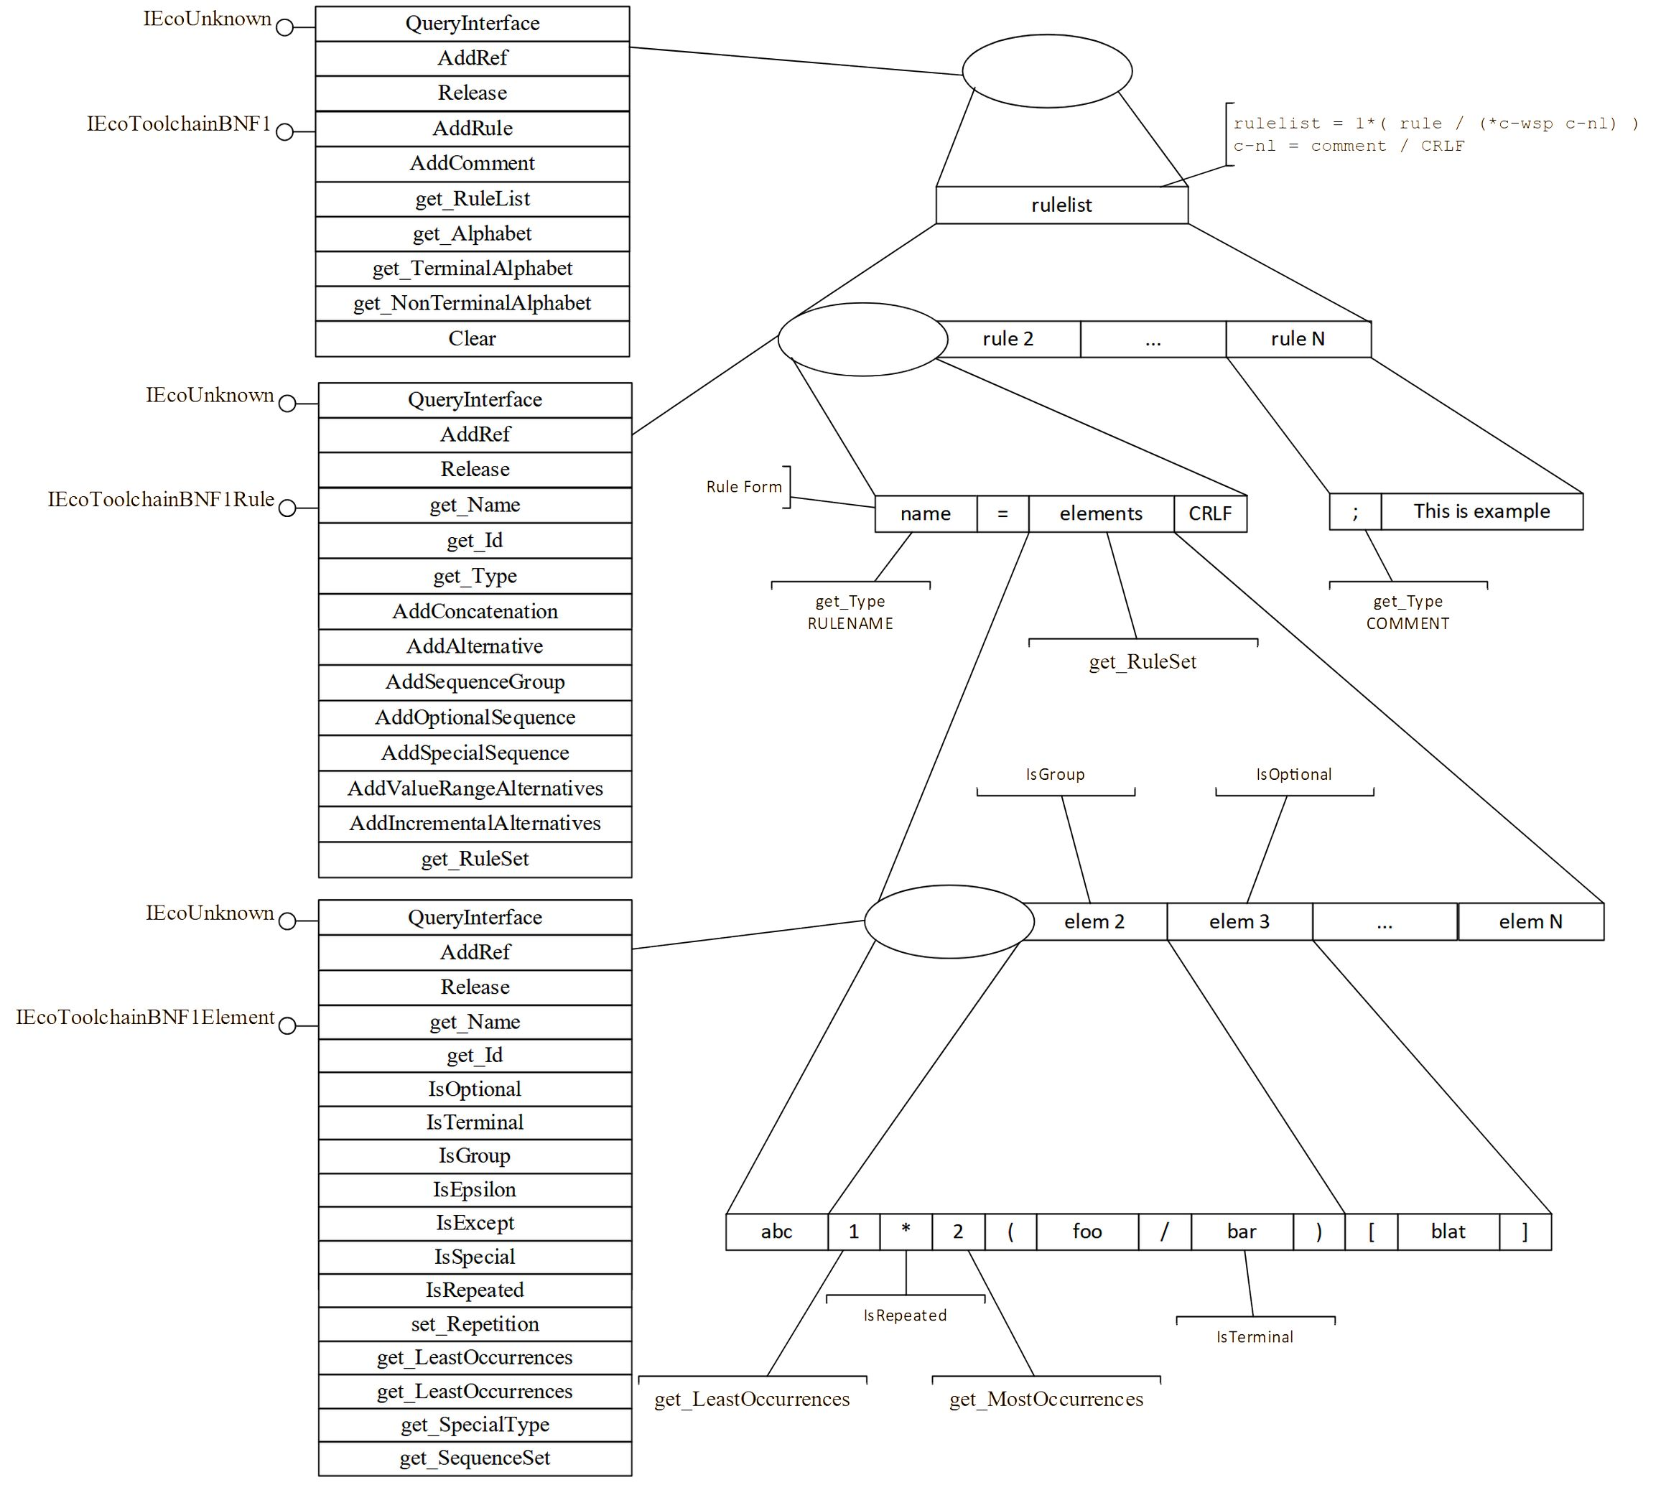

3. IEcoBNF1 interface

3.1. IEcoBNF1 IDL

ECO IDL
import "IEcoBase1.idl"
[
object,
uguid(93102958-9BDA-4637-A249-5674399D4F11),
]
interface IEcoToolchainBNF1 : IEcoUnknown {

IEcoToolchainBNF1Rule* AddRule ([in] char_t* Name);

IEcoToolchainBNF1Rule* AddComment ([in] char_t* Note);

IEcoList1* get_RuleList ([in] void);

IEcoList1* get_Alphabet ([in] void);

IEcoList1* get_TerminalAlphabet ([in] void);

IEcoList1* get_NonTerminalAlphabet ([in] void);

int16_t Clear ([in] void);

}

3.1.1. AddRule function

The function adds a rule to a BNF instance with the given Name and returns a pointer to the IEcoToolchainBNF1Rule* grammar rule interface. The returned rule is of type ECO_BNF_1_RT_RULENAME.

3.1.2. AddComment function

The function adds a comment to the BNF instance specified by the Note parameter and returns a pointer to the IEcoToolchainBNF1Rule* grammar rule interface. The returned rule is of type ECO_BNF_1_RT_COMMENT.

3.1.3. get_RuleList function

The function returns a list of all rules as a pointer to the IEcoList1* list interface. The list element is a pointer to the IEcoToolchainBNF1Rule* grammar rule interface.

3.1.4. get_Alphabet function

The function returns the alphabet of all terminal and non-terminal symbols as a pointer to the interface for working with the list IEcoList1*. A list element is a pointer to a string of char_t* type.

3.1.5. get_TerminalAlphabet function

The function returns the alphabet of all terminal characters as a pointer to the interface for working with the list IEcoList1*. A list element is a pointer to a string of char_t* type.

3.1.6. get_NonTerminalAlphabet function

The function returns the alphabet of all non-terminal characters as a pointer to the interface for working with the list IEcoList1*. A list element is a pointer to a string of char_t* type.

3.1.7. Clear function

The function clears the BNF instance by removing all rules.

4. IEcoToolchainBNF1Rule Interface

4.1. IEcoToolchainBNF1Rule IDL

ECO IDL
import "IEcoBase1.idl"

[
object,
uguid(E67AC8DC-0D75-43B7-8FB1-D5D825DE67A8),
]
interface IEcoToolchainBNF1Rule : IEcoUnknown {

char_t* get_Name ([in] void);

int16_t get_Id ([in] void);

ECO_BNF_1_RULE_TYPE_e get_Type ([in] void);

IEcoToolchainBNF1Element* AddConcatenation ([in] int32_t indexSet,
[in] char_t* name,
[in] bool_t except);

IEcoToolchainBNF1Element* AddAlternative ([in] char_t* name,
[in] bool_t except,
[out] int32_t* indexSet);

IEcoToolchainBNF1Rule* AddSequenceGroup ([in] bool_t alternation,
[in] bool_t except,
[in] int16_t least,
[in] int16_t most,
[out] int32_t* indexSet);

IEcoToolchainBNF1Rule* AddOptionalSequence ([in] bool_t alternation);
[in] bool_t except,
[in] int16_t least,
[in] int16_t most,
[out] int32_t* indexSet);

IEcoToolchainBNF1Rule* AddSpecialSequence ([in] int32_t type,
[in] bool_t alternation,
[in] bool_t except,
[in] int16_t least,
[in] int16_t most,
[out] int32_t* indexSet);

IEcoList1* AddValueRangeAlternatives ([in] uchar_t start,
[in] uchar_t end,
[out] int32_t* indexSet);

IEcoList1* AddIncrementalAlternatives ([in] IEcoToolchainBNF1Rule* Rule);

IEcoList1* get_RuleSet ([in] void);

}

4.1.1. get_Name function

The function returns the name string of the rule.

4.1.2. get_Id function

The function returns the identifier of the rule.

4.1.3. AddConcatenation function

The function adds the rule name specified by the Name parameter to the ordered sequence of rule names by the indexSet index of the rule set.

4.1.4. AddAlternative function

The function adds the rule name specified by the Name parameter to a new rule set defined by the returned index indexSet.

4.1.5. AddSequenceGroup function

The function adds a group for elements enclosed in parentheses, returning a pointer to the IEcoToolchainBNF1Rule* grammar rule interface (interpreted as a single element with strict ordering). The returned rule is of type ECO_BNF_1_RT_SEQUENCE.

4.1.6. AddOptionalSequence function

The function adds an optional sequence for elements enclosed in square brackets, returning a pointer to the IEcoToolchainBNF1Rule* grammar rule interface (treated as a single element). The returned rule is of type ECO_BNF_1_RT_SEQUENCE.

4.1.7. AddSpecialSequence function

The function adds a specialized sequence for elements enclosed in special characters of a user-defined type, returning a pointer to the IEcoToolchainBNF1Rule* grammar rule interface (treated as a single element). The returned rule is of type ECO_BNF_1_RT_SEQUENCE.

4.1.8. AddValueRangeAlternatives function

The function adds ranges of variants of digital values by parameters start start of range and end end of range.

4.1.9. AddIncrementalAlternatives function

The function adds additional rule set options to the initial rule.

4.1.10. get_RuleSet function

The function returns a set of rules.

5. IEcoToolchainBNF1Element Interface

5.1. IEcoToolchainBNF1Element IDL

ECO IDL
import "IEcoBase1.idl"

[
object,
uguid(716BE46A-AEB2-4C65-8A0F-B914B81E9F18),
]
interface IEcoToolchainBNF1Element : IEcoUnknown {

char_t* get_Name ([in] void);

int16_t get_Id ([in] void);

bool_t IsOptional ([in] void);

bool_t IsTerminal ([in] void);

bool_t IsGroup ([in] void);

bool_t IsEpsilon ([in] void);

bool_t IsExcept ([in] void);

bool_t IsSpecial ([in] void);

bool_t IsRepeated ([in] void);

void set_Repetition ([in] int16_t least,
[in] int16_t most);

int16_t get_LeastOccurrences ([in] void);

int16_t get_MostOccurrences ([in] void);

int32_t get_SpecialType ([in] void);

IEcoList1* get_SequenceSet ([in] void);

}

5.1.1. get_Name function

The function returns the name string of the rule.

5.1.2. get_Id function

The function returns the identifier of the rule.

5.1.3. IsOptional function

The function checks if the element is optional.

5.1.4. IsTerminal function

The function checks if the element is a terminal.

5.1.5. IsGroup function

The function checks whether an element is a group of ordered elements.

5.1.6. IsEpsilon function

The function checks whether an element is an empty set.

5.1.7. IsExcep function

The function checks whether an element is “except”.

5.1.8. IsSpecial function

The function checks if the element is a special element.

5.1.9. IsRepeated function

The function checks if the element is repeatable.

5.1.10. set_Repetition function

The function sets a variable number of repetitions of the element.

5.1.11. get_LeastOccurrences function

The function returns the minimum number of repetitions.

5.1.12. get_MostOccurrences function

The function returns the maximum number of repetitions.

5.1.13. get_SpecialType function

The function returns a custom type.

5.1.14. get_SequenceSet function

The function returns a set of sequences of elements.

6. In development …
Application А

