Transfer weights

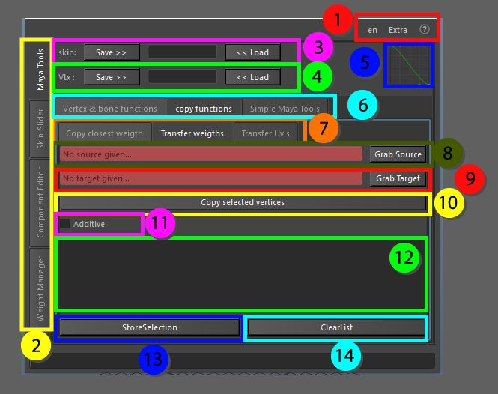

This tool allows the transfer of weights from one skin cluster to another. This can be useful in cases where a skin cluster is created and has most of the weights already in place the mesh can be copied and this second mesh can be used to tweak and modify the skin cluster. The joints do not even have to be the same so the focus can be on the new joints entirely. After the skinning is completed on the second skinned object the information can be moved over based on vertex ids.

1. Top menu, here you can change the language, use extra functions such as copy and pasting assets in the scene without garbage data, converting the skeleton to polygonal object for use in other packages as a visualizer, next to that you can find the help menu that has documentation on the API, the current window and an ability to display enhanced tooltips with videos
2. These tabs allow for switching between the bigger tools, all tabs can be torn off using the ctrl + mouse click and will be available in a separate window
3. Skin save and load, Store the object information so it can be loaded on a different mesh with the same vertex count and index
4. Vertex save and load, Store the information of a single vertex so it can be loaded on a different mesh, this works as long as the joint influences are the same
5. Bezier Graph, this graph is used in some functions that require smooth falloff information
6. Maya tools, these tabs are separated for convenience, all tabs can be torn off using the ctrl + mouse click and will be available in a separate window
7. Copy functions, these tabs are separated for convenience, all tabs can be torn off using the ctrl + mouse click and will be available in a separate window
8. Grab Source, based on the selected mesh the skin cluster to copy from is stored
9. Grab Target, based on the selected mesh the skin cluster to copy to is stored
10. Copy selected vertices, based on the current selection of vertices the influences will be copied over from the source to the target.
11. Additive, this will allow the weights to be added instead of replacing the original weights completely, the weights will be normalized after they are set
12. Selection list, here we can store component selections, once an item in this list is selected it will select the stored components in the Maya scene. If the components/objects do not exists in the current scene, they cannot be selected.
13. Store selection, store the current component selection as vertex information in the selection list
14. Clear list, clear the selection list and remove all previously stored information