Bezier Graph

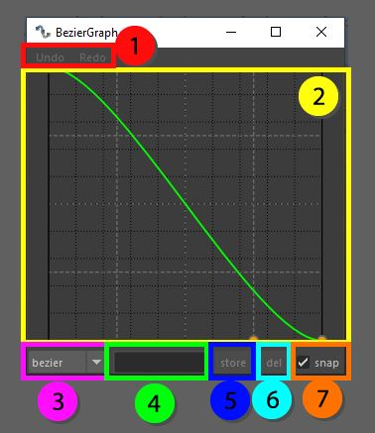

The Bezier graph is a window that displays a curve that can be altered. This curve is used to determine the falloff of weights. The basic curves in here are linear and a simple Bezier falloff, these can be tweaked and stored as well.

1. Simple undo and redo function on tweaking the curve
2. The curve UI, the 2 handles in the middle can be used to change the look of the curve and how the function works. The handles in the corner are locked.
3. Switch between all the stored curves for ease of use
4. If the curve has been changed it can be given a name and stored in the windows settings
5. Store the current curve with the given name
6. Delete the current curve from the list, if the curve selected is the original Bezier curve or the Linear curve it cannot be deleted.
7. Snap, this checkbox allows the control handles to be snapped on the grid of the ui, if it is turned off it can be placed freely