Copy closest weight

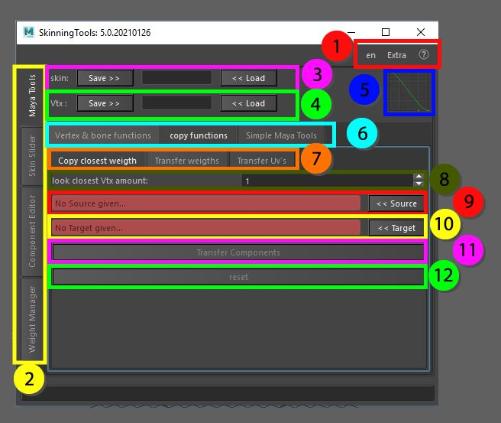

Transfer the information from one selection of components to another selection of components based on the closest amount of vertices from source to target. This works best on a single object on which you have information that you want to transfer. For example 2sided clothing, if the front side is already cleaned you can use that as the source, the back side as the target, and depending on the polygonal pattern the amount of vertices to derive information from can be set. That way the front and back side will move equally.

1. Top menu, here you can change the language, use extra functions such as copy and pasting assets in the scene without garbage data, converting the skeleton to polygonal object for use in other packages as a visualizer, next to that you can find the help menu that has documentation on the API, the current window and an ability to display enhanced tooltips with videos
2. These tabs allow for switching between the bigger tools, all tabs can be torn off using the ctrl + mouse click and will be available in a separate window
3. Skin save and load, Store the object information so it can be loaded on a different mesh with the same vertex count and index
4. Vertex save and load, Store the information of a single vertex so it can be loaded on a different mesh, this works as long as the joint influences are the same
5. Bezier Graph, this graph is used in some functions that require smooth falloff information
6. Maya tools, these tabs are separated for convenience, all tabs can be torn off using the ctrl + mouse click and will be available in a separate window
7. Copy functions, these tabs are separated for convenience, all tabs can be torn off using the ctrl + mouse click and will be available in a separate window
8. The amount of vertices to look for information. If its 1 it will do a one on one copy from the closest vertex, if its more it will get information from multiple vertices and weight them according to distance
9. Source, this would be the component selection that you want to copy the weight from
10. Target, this would be the component selection that you want to copy the weight to, the original weight will be replaced completely
11. Transfer components, this button will initiate the process to transfer the information
12. Reset, this will reset the original component information given to source and target