Maya Tools

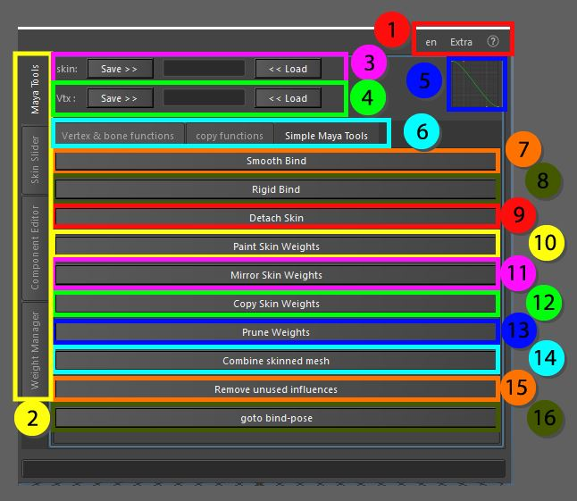

The Maya tools are a collection of buttons that use the functionality of the original tools available but enhances them. Tools that have extra options or an option window will open with the recommended settings already turned on.

1. Top menu, here you can change the language, use extra functions such as copy and pasting assets in the scene without garbage data, converting the skeleton to polygonal object for use in other packages as a visualizer, next to that you can find the help menu that has documentation on the API, the current window and an ability to display enhanced tooltips with videos
2. These tabs allow for switching between the bigger tools, all tabs can be torn off using the ctrl + mouse click and will be available in a separate window
3. Skin save and load, Store the object information so it can be loaded on a different mesh with the same vertex count and index
4. Vertex save and load, Store the information of a single vertex so it can be loaded on a different mesh, this works as long as the joint influences are the same
5. Bezier Graph, this graph is used in some functions that require smooth falloff information
6. Maya tools, these tabs are separated for convenience, all tabs can be torn off using the ctrl + mouse click and will be available in a separate window
7. Smooth bind, this setup is used to assign mesh to joints, the default setting in here is set to use only the selected joints
8. Rigid bind, no options in here are changed, this will just open the option window
9. Detach skin, the disconnection of the joints with the mesh, will delete the skin cluster and the history information
10. Paint skin weights, opens the skin weights tool, added the function to use the arrow keys on the keyboard to move between the joints
11. Mirror skin weights, opens the mirror weights window with label joints as main mirroring option, together with most tools in the Vert & bone functions window this will give the best results, even if joints are placed on top of each other
12. Copy skin weights, opens the copy skin weights window with label joints as main mirroring option, together with most tools in the Vert & bone functions window this will give the best results, even if joints are placed on top of each other
13. Prune weights, opens the prune weights window with default settings
14. Combine skinned mesh, combine skinned meshes, this will work with older versions of Maya as well that did not have this functionality included
15. Remove unused influences, remove joints from the skin cluster that do not influence the mesh in any way (weight total is 0)
16. Goto bind-pose, functionality to go back to the original bind pose of the mesh based on the pre-bind matrix in the skin cluster instead of the bind pose nodes