Skin slider

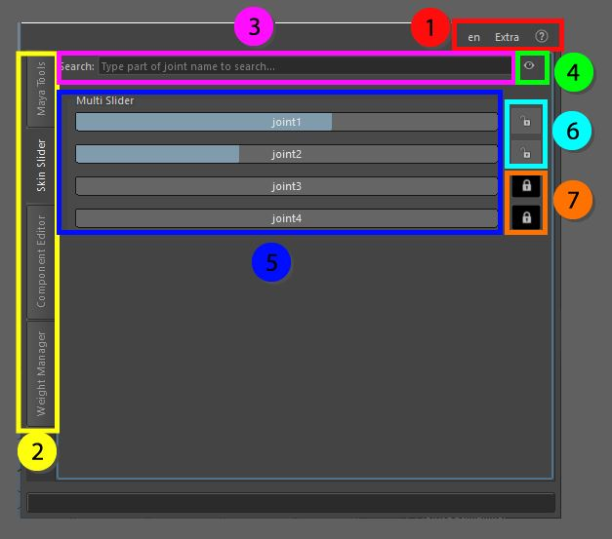

The skin slider is where the influences of the vertex selection can be modified interactively, the joints displayed are the ones currently driving the selection, if more vertices are selected at the same time, and the weights of the first selected vertex will be used as a base.

1. Top menu, here you can change the language, use extra functions such as copy and pasting assets in the scene without garbage data, converting the skeleton to polygonal object for use in other packages as a visualizer, next to that you can find the help menu that has documentation on the API, the current window and an ability to display enhanced tooltips with videos
2. These tabs allow for switching between the bigger tools, all tabs can be torn off using the ctrl + mouse click and will be available in a separate window
3. Search box, this is where joints can be searched by partial name identification, this can be very helpful when the skinned object has a lot of joints attached.
4. Visibility switch, this is where you can switch the visibility of sliders that are currently not in use, which means that influences that are locked or do not hold any weight will be hidden from view or shown.
5. The sliders, these sliders allow you to modify the weight value interactively, it will keep the weight normalized. But it does not adhere to the maximum allowed influences
6. Lock buttons, the unlocked version you see here shows that you can alter the weight information, if you click on the button it will lock the current weight and other sliders will take the currently locked weight into account when normalizing.
7. These buttons are locked and normally hidden from view, the weights that have 0 influence on the current vertex selection will be automatically locked if you want to add the information of a joint that is locked, just unlock the button and slide the weight in place.