Transfer UV’s

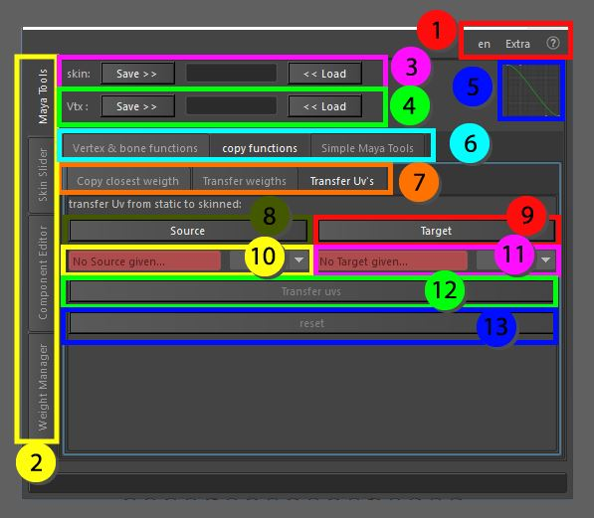

Transfer UV’s from a static mesh to a skinned object before deformation. This tool takes away the pain of having a non UV’d skinned mesh and transferring the skinning data to a UV’d static mesh. The UV’s of the static mesh will be set on the skinned mesh’s original data before the deformation chain.

1. Top menu, here you can change the language, use extra functions such as copy and pasting assets in the scene without garbage data, converting the skeleton to polygonal object for use in other packages as a visualizer, next to that you can find the help menu that has documentation on the API, the current window and an ability to display enhanced tooltips with videos
2. These tabs allow for switching between the bigger tools, all tabs can be torn off using the ctrl + mouse click and will be available in a separate window
3. Skin save and load, Store the object information so it can be loaded on a different mesh with the same vertex count and index
4. Vertex save and load, Store the information of a single vertex so it can be loaded on a different mesh, this works as long as the joint influences are the same
5. Bezier Graph, this graph is used in some functions that require smooth falloff information
6. Maya tools, these tabs are separated for convenience, all tabs can be torn off using the ctrl + mouse click and will be available in a separate window
7. Copy functions, these tabs are separated for convenience, all tabs can be torn off using the ctrl + mouse click and will be available in a separate window
8. Source, select the (static)mesh from which you want to gather the UV data
9. Target, select the skinned mesh on which the new UV data needs to be applied
10. Once the source is given you can change which map you want to transfer the UV data from if multiple maps are available
11. Once the target is given, you can change which map you want to give the new UV data
12. This button will start the function to transfer the UV information
13. Reset, clear the data stored in the current window