Component editor

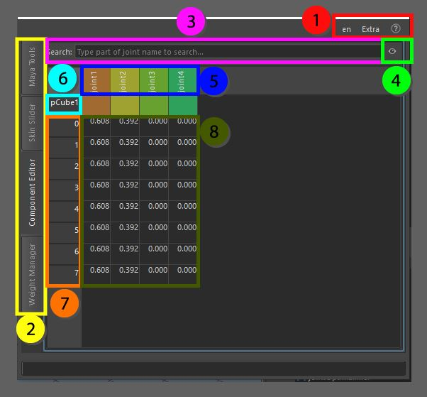

The component editor is a weights table that shows the association between the vertices and the joints. It visualizes the joints based on the colors they have in Maya and at the same time displays errors on the current vertex by showing orange if the maximum allowed joints to deform it is not adhered to, and red if the total weight on that vertex is over the 1.0 value.

1. Top menu, here you can change the language, use extra functions such as copy and pasting assets in the scene without garbage data, converting the skeleton to polygonal object for use in other packages as a visualizer, next to that you can find the help menu that has documentation on the API, the current window and an ability to display enhanced tooltips with videos
2. These tabs allow for switching between the bigger tools, all tabs can be torn off using the ctrl + mouse click and will be available in a separate window
3. Search box, this is where joints can be searched by partial name identification, this can be very helpful when the skinned object has a lot of joints attached.
4. Visibility switch, this is where you can switch the visibility of joints that are currently not in use, which means that influences that do not hold any weight will be hidden from view.
5. The joints that are currently attached to the skin cluster(s), double clicking will select the joints entire influences to alter, right-click will add the joint to the current selection for visualization.
6. The name of the current object we work with, all the following integers in the list are the vertices of the object that are selected, multiple objects can be selected at the same time and the weight information will be divided here by the names of the objects
7. The index information for each vertex within the current selection
8. These are the weights that are currently applied to the mesh, based on the selection the user can just start typing and the weights can be altered, after selecting (multiple) weights, right-click can open a separate menu with extra information and possibilities