Assign Soft Select

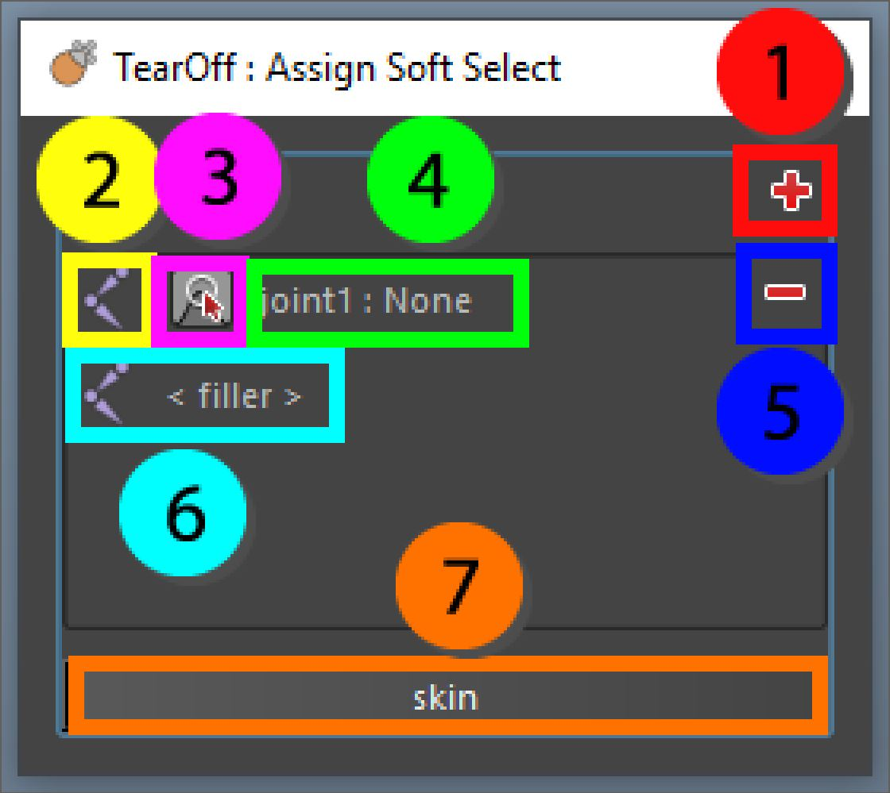

Convert soft selection into skin weights. More influences can be added by clicking the plus button. When more influences are added these weights are automatically blended. The influence and soft selection can be reselected by right clicking the influence widget and using the context menu.

Skin cluster settings like max influences and normalization will be taken into account when applying the skin weights.

1. Add new element to the list
2. Assign bone to the current element
3. Assign soft selection to the current element
4. Display of the current joint assigned to the element, will display “set” if there is a soft selection
5. Remove element from the list
6. The filler joint, if the mesh is not skinned it will need a filler joint, if it is skinned this can be left empty
7. Assign the soft selections to the current mesh based on the given soft selection