The Marking Menu

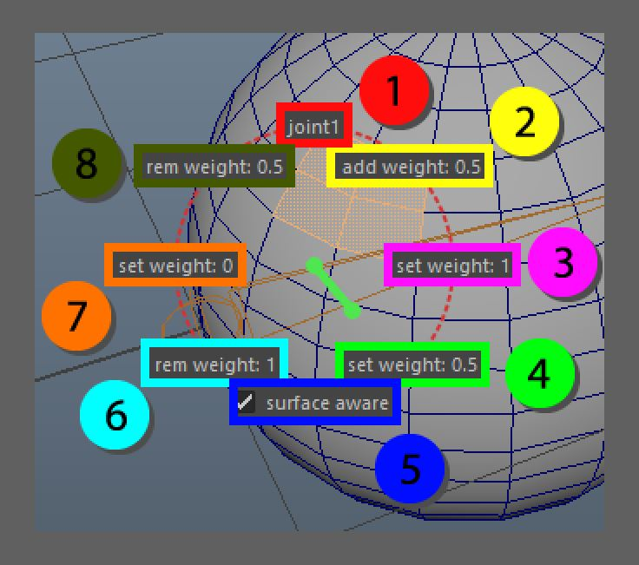

The marking menu is a hotkey based menu that allows the user to quickly alter weight information on selected components.  
To activate the marking menu the user should have (only) components selected. Then the mouse should be hovering above a joint (Maya pixel selection width is taken into account) and middle mouse should be pressed and hold. This will activate the menu and based on where the mouse is dragged buttons will light up.  
The Button that is lit up when the middle mouse is released will be activated.

1. Joint label, this button will notify the current joint that is being used as weight information, if this object is selected it will popup a small window in which the user is able to adjust a value between 0 and 1 which will be used for (8) and (2).
2. add weight, this will add the value that is indicated to the given joint
3. this will set the current weight to 1 for the current bone, removing all other weights from the component selection
4. set the weight for the current bone to .5, if the current bone has other values they will be brought up and/or down to make sure it meets the .5 weight value
5. surface aware, this is important for soft selection, if the components are part of a soft selection the surface aware will only be available to directly connected vertices, if this is turned off it will take into account all components within a certain radius in world-space
6. rem weight, this will remove the weight of 1 unit of the current joint from the weights list, this is in place for users that do not normalize the weights interactively
7. set weight to 0, this will make sure that the current joint is not part of the current components influences
8. rem weight, this will remove the value that is indicated from the weight list by the given joint.