Vert & Bone functions

The component editor is a weights table that shows the association between the vertices and the joints. It visualizes the joints based on the colors they have in Maya and at the same time displays errors on the current vertex by showing orange if the maximum allowed joints to deform it is not adhered to, and red if the total weight on that vertex is over the 1.0 value.

1. Top menu, here you can change the language, use extra functions such as copy and pasting assets in the scene without garbage data, converting the skeleton to polygonal object for use in other packages as a visualizer, next to that you can find the help menu that has documentation on the API, the current window and an ability to display enhanced tooltips with videos
2. These tabs allow for switching between the bigger tools, all tabs can be torn off using the ctrl + mouse click and will be available in a separate window
3. Skin save and load, Store the object information so it can be loaded on a different mesh with the same vertex count and index
4. Vertex save and load, Store the information of a single vertex so it can be loaded on a different mesh, this works as long as the joint influences are the same
5. Bezier Graph, this graph is used in some functions that require smooth falloff information
6. Maya tools, these tabs are separated for convenience, all tabs can be torn off using the ctrl + mouse click and will be available in a separate window
7. Average vtx, smooth a vertex's skinning information based on order of selection. Multiple vertices selected; last selected vertex will get the average weight of all selected vertices in current selection. 2 vertices selected; will create a path that travels from first to last vertex based on edge connection, the smoothing will be applied over that range. 2 edge loops selected; if the edge loops share the same mesh, it will smooth the vertices between the 2 edge loops. The average vertex button uses the Bezier graph to determine how to smooth the objects. use distance; if this option is selected it will use the distances between vertices to multiply with the smooth value, if its turned off it will be based on the range  
   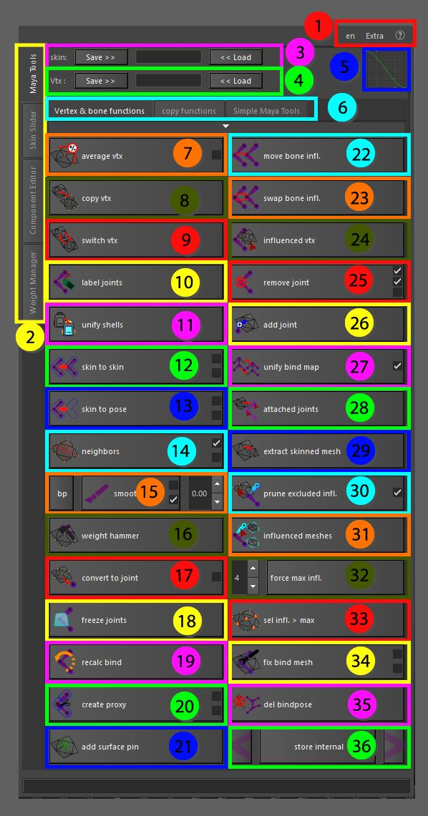
8. Copy vertex weights, all vertices that are in the current selection will take over the same weight information as the last selected vertex
9. Switch vertex weights, takes in 2 vertices to switch the weight information between
10. Label joints, automatically label the joints based on given information. '\*' are the wildcards that will give information on how to search for the left and right side of the skeleton. Make sure that the entire skeleton adheres to the same naming convention, that way the labels will be set properly on each joint and it can be used to help with mirroring and copying skinning information.
11. Unify shells, based on selections, all vertices that are touching each other through edges will be grouped together. Per group all vertex weights will be clustered and averaged. This average weight is then applied to each group. this is ideal for areas in the skin that are hard surface types
12. Skin to Skin, using 2 selected meshes, the first selected mesh is the source, the second selected mesh is the target. as long as the driving joints are the same the information can be copied from the source to the target. Smooth; smooths the operation instead of a 1 to 1 copy. uvSpace; copy’s information based on the UV settings instead of the vertex positions
13. Skin to Pose, using 2 selected meshes, the first selected mesh is the source, and the second selected mesh is the target. The second mesh can be static (without skincluster) and will be bound based on the current positions of the skeleton. Smooth; smooths the operation instead of a 1 to 1 copy. uvSpace; copies information based on the UV settings instead of the vertex positions
14. Neighbors, simple smoothing setup based on the information of neighboring vertices. Growing; will expand the selection after smoothing. Full; instead of direct connected vertices by edges the growing function uses vertices connected by faces
15. Smooth brush, to start the smooth brush the bind pose needs to be initiated using the 'BP' button. This will store all vertices in the current state as a point cloud. Once in pose the mesh can be smoothed using the brush, the smooth operation works on all joints at the same time so no need to select influences. Relax; with this function turned on it tries to keep the angles of each edge attached to the vertex in the same state preventing jagged edges where possible. Volume; the volume is the distance of vertices to search between in the point cloud allowing to smooth together vertices that are not connected, distance can be set in the box next to the current tool.
16. Weight Hammer, this tool is similar to the weight hammer in Maya, settings have been slightly changed to get better output
17. Convert to joint, either a vertex based selection (smooth values or not) or a cluster can be converted to a joint with the influences used to define the skinning. this can be used to attach joints to the existing rig without breaking the original skinning
18. Freeze joints, uses the freeze transformation tools in a way that it can be applied to joints that are bound to a mesh by a skincluster
19. Recalculate bind position, this option takes in a selection of joints and the affected meshes that are bound by these joints. The pre-bind position of the joints will be recalculated using the current position of the selected joints.
20. Proxy Mesh, cut the character in separate parts based on the skinning information. The meshes are connected to the joints directly using matrix information. Internal; prevents overlap in the cut up mesh parts, but will show visible holes. Use OPM; from Maya 2020 on we can use the offset parent matrix to connect parts instead of using a decompose matrix
21. Surface Pin, creates a locator on the center of the selected position using the component information to gather skincluster information. the same information is fed through matrix calculations to simulate the same calculation as the skincluster
22. Bone Move, move all the influences of the first selected bone to the second selected bone. this will only happen on the mesh that is selected as 3rd input
23. Bone Switch, swap the way the joints influence the mesh from the first selected joint to the second selected and vice versa. the mesh selected as 3rd option is the object on which the influences are switched
24. Select influenced vertices, given the joint and the mesh it will select all vertices that are influenced by the given joint. Any influence above 0.0 is included. this can be used to identify small influences that are out of place on the mesh
25. Delete joint, ability to remove the joint from the current chain without destroying the skin clusters or the influences. The default is using the closest joints as the new influence for joint that is to be removed. Use parent; if this is selected, instead of using the closest joint, all influences will be added to the current parent. Delete; will actually delete the joint and re-parent the children. Fast; will not take into account other joints at all, just removes the influence of the current joint and lets Maya handle the normalization.
26. Add Joint, add selected joint influences to the current selected mesh. the joints are automatically unlocked and paintable but do not add information to the current skincluster and do not disrupt the existing information when added.
27. Unify bind map, for all selected meshes that have skin clusters attached the driving joints will be unified. This way transferring skinning information between different objects does not create any errors. Query; will select the joints that are currently influencing all selected meshes.
28. Select influencing joints, selects all joints that are attached to the current skincluster, even if they do not have any influence on the mesh
29. Extract skinned meshes, this works differently based on selection: component selection; it will create a new mesh with the same skinning information. object selection; will separate the mesh into multiple objects based on shell information (pre-combined meshes)
30. Prune excluded influences, this takes a component selection and joints. The selected components will only be influences by the current joints in selection. Invert; this does the opposite, it will make sure that the components in selection are not influenced by the joints in selection.
31. Select influenced meshes, based on the selected joints, the influenced meshes will be selected, this selects meshes that are attached to a skincluster on which the joints are present, even if the weight is 0.
32. Fix Influences over maximum, based on the information given in the spin box, it will force the maximum amounts of weights, prune the list of weights to only keep the highest weights in total.
33. Show Influences over maximum, based on the information given in the spin box above, it will select all vertices on the given mesh that have more joint weights attached then the given number
34. Fix bind mesh, fix the bind setup of the mesh. The joints are able to move while bound to get a better bind pose. it’s based on the mesh selection, and needs the mesh selection again to stabilize. Model only; allows the alteration of the mesh, it can only move vertex positions or UV information, no extra vertices can be added or removed as it will change the index of the skin cluster attachment and break. in pose; shows both the pre-bind mesh as the final mesh, as to make it easier to see the end result of the tweaks
35. Delete bind pose nodes, this will delete all bind pose nodes in the current scene. Sometimes skin clusters don’t allow editing or addition of new joints as the bind pose might be out of order. The tools created here work without bind poses and use the joints themselves and the pre-bind matrices of the skincluster to initiate bind pose. That way we can edit everything without trouble
36. Store internal selection, based on component selection it can be stored and expanded upon.\n each expansion is based on the connected vertices to the current face. The '<' and '>' shrink and grow the setup making sure the initial selection is not part of the outcome