Weight manager

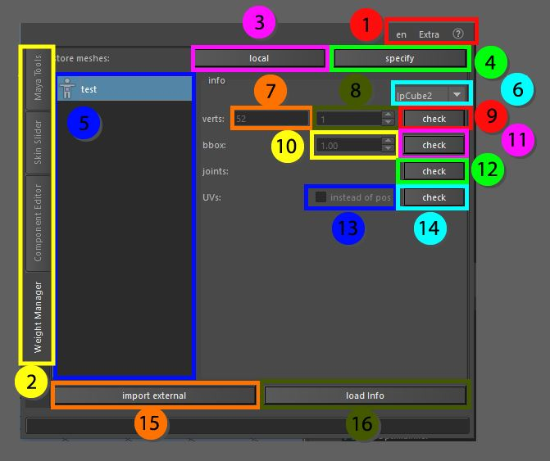

The weights manager is a widget that allows to store weight files on disk for import later. The stored information can be altered on load to make it work on a different mesh with a different skeleton as well.   
These functions can help re-apply information to a character that needs to change in scale, even if the vertex index is changed, the scale can be changed using the bounding box feature which will also show the bounding box before applying to give a better feel for what the end result may be. The widget will try to search for objects by name in the scene, if there is no object in the scene that has the same name as the stored information it will take in selection.

1. Top menu, here you can change the language, use extra functions such as copy and pasting assets in the scene without garbage data, converting the skeleton to polygonal object for use in other packages as a visualizer, next to that you can find the help menu that has documentation on the API, the current window and an ability to display enhanced tooltips with videos
2. These tabs allow for switching between the bigger tools, all tabs can be torn off using the ctrl + mouse click and will be available in a separate window
3. Local, store the current selected objects weights locally
4. Specify, specify the location on where the weights of the current selected objects need to be saved, the path will be added to the current settings so it will be added to the list (5)
5. All the stored weights will be placed here with the name given to the file, once an object is selected here, the information on the info side will be updated and visualized
6. Mesh selector, the names of all the meshes stored in the weights file are added here, the name can be switched to select the correct information
7. Verts, for the current selected mesh it displays the amount of vertices that are stored on file
8. This box allows you to change the closest amount of vertices to search by if the current object selected in Maya does not match in position or vertex id with the stored information
9. Check, this box will turn red if the object does not match, if it turns green there is no difference between the objects in terms of vertices and ids
10. Bbox, this information is the scale of the object, once the bounding box is visualized (11)the scale can be altered to try and match the information with the current elements in the scene
11. Check, this will generate an object in Maya that represents the current bounding box of stored information
12. Check, this will check if the joints in the scene match the joints that are present in the stored file, if the check button turns red, the joints will need to be remapped on load, if it turns green the weights can be loaded without problem
13. This checkbox will become available if the UV’s are checked (14) once this is done the user can choose to remap the weights on the object by closest UV association
14. Check, this will check if UV’s are available in the stored weights information and if UV’s are present on the current selected object in the scene
15. Import external, if there are weights files somewhere on the pc that are not visible in the current list, the path to those files can be added here and it will refresh the list
16. Load info, loads the current info from the weights file into the scene