Experiment 1
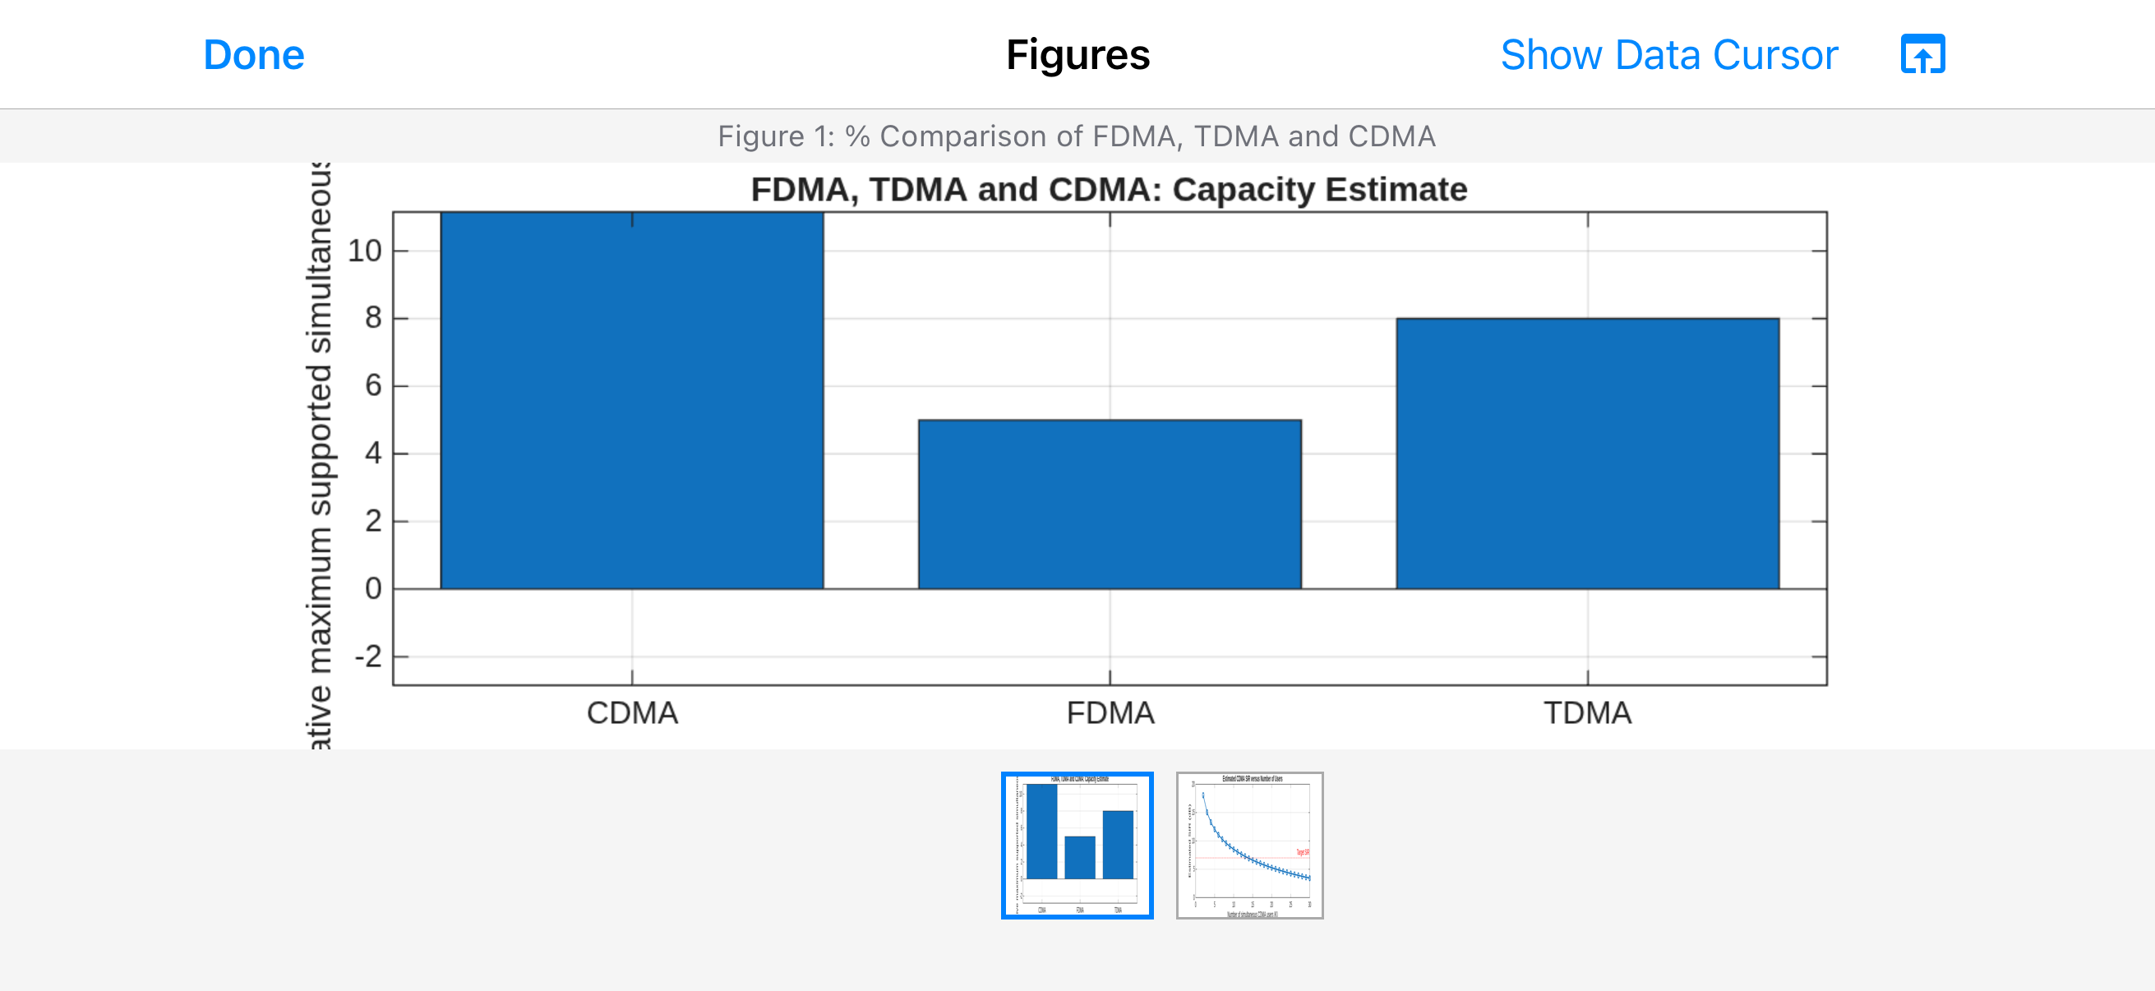
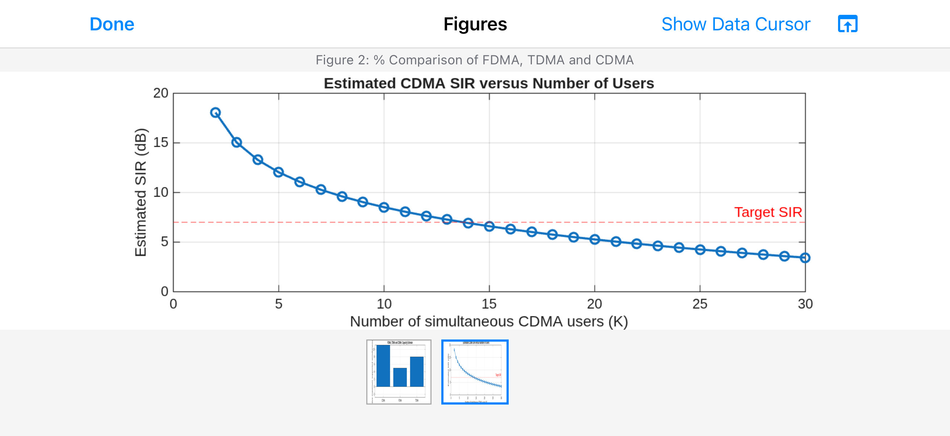
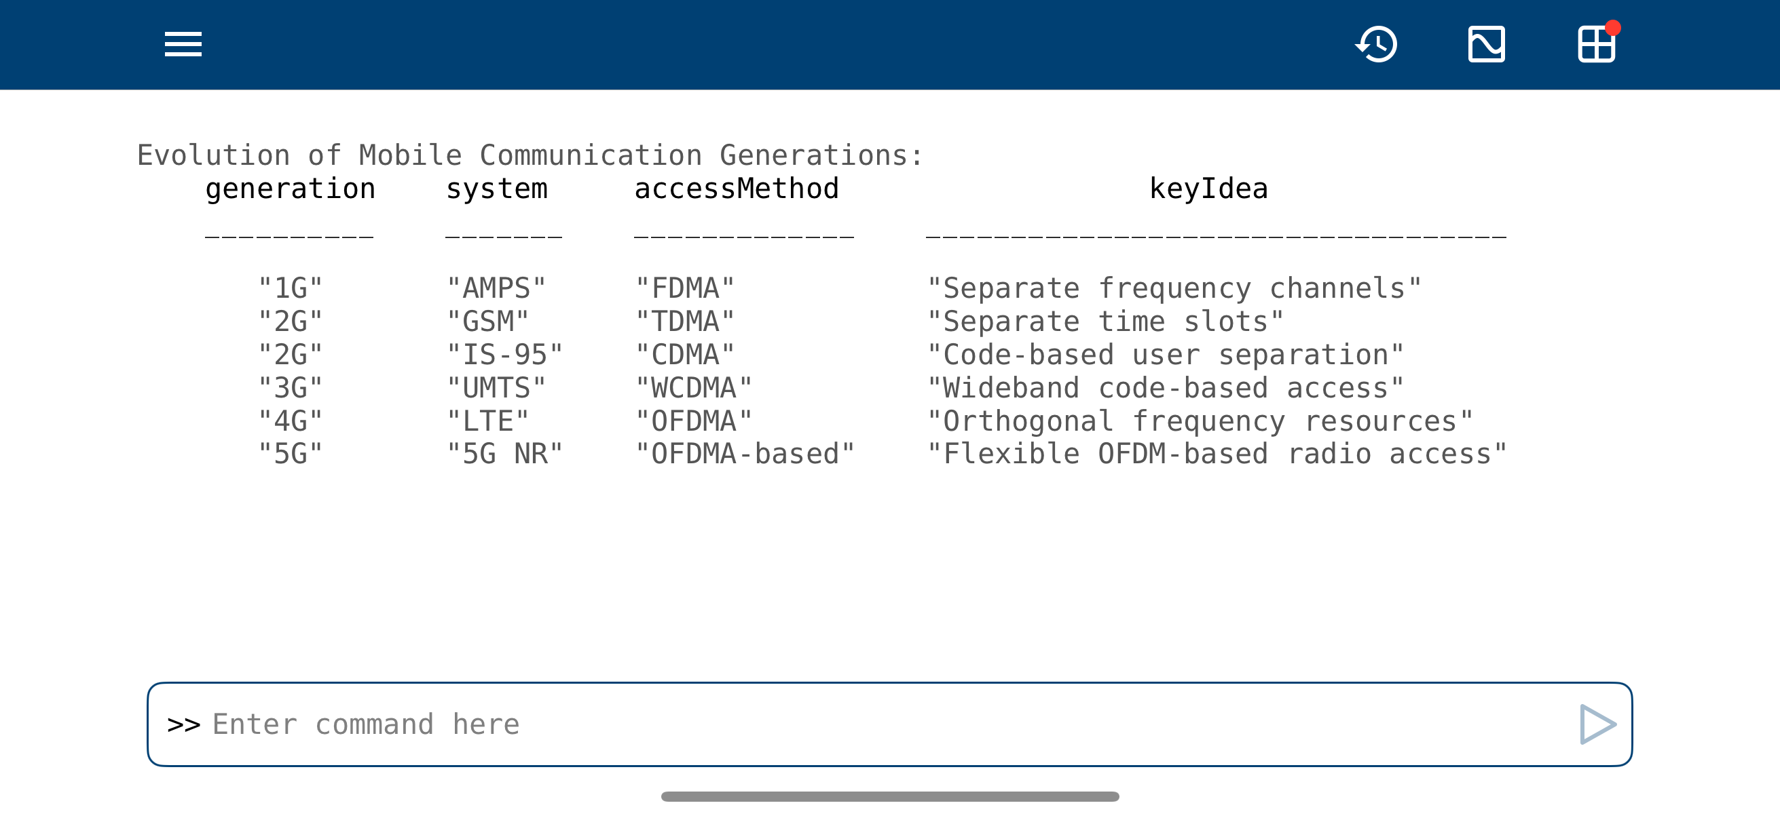
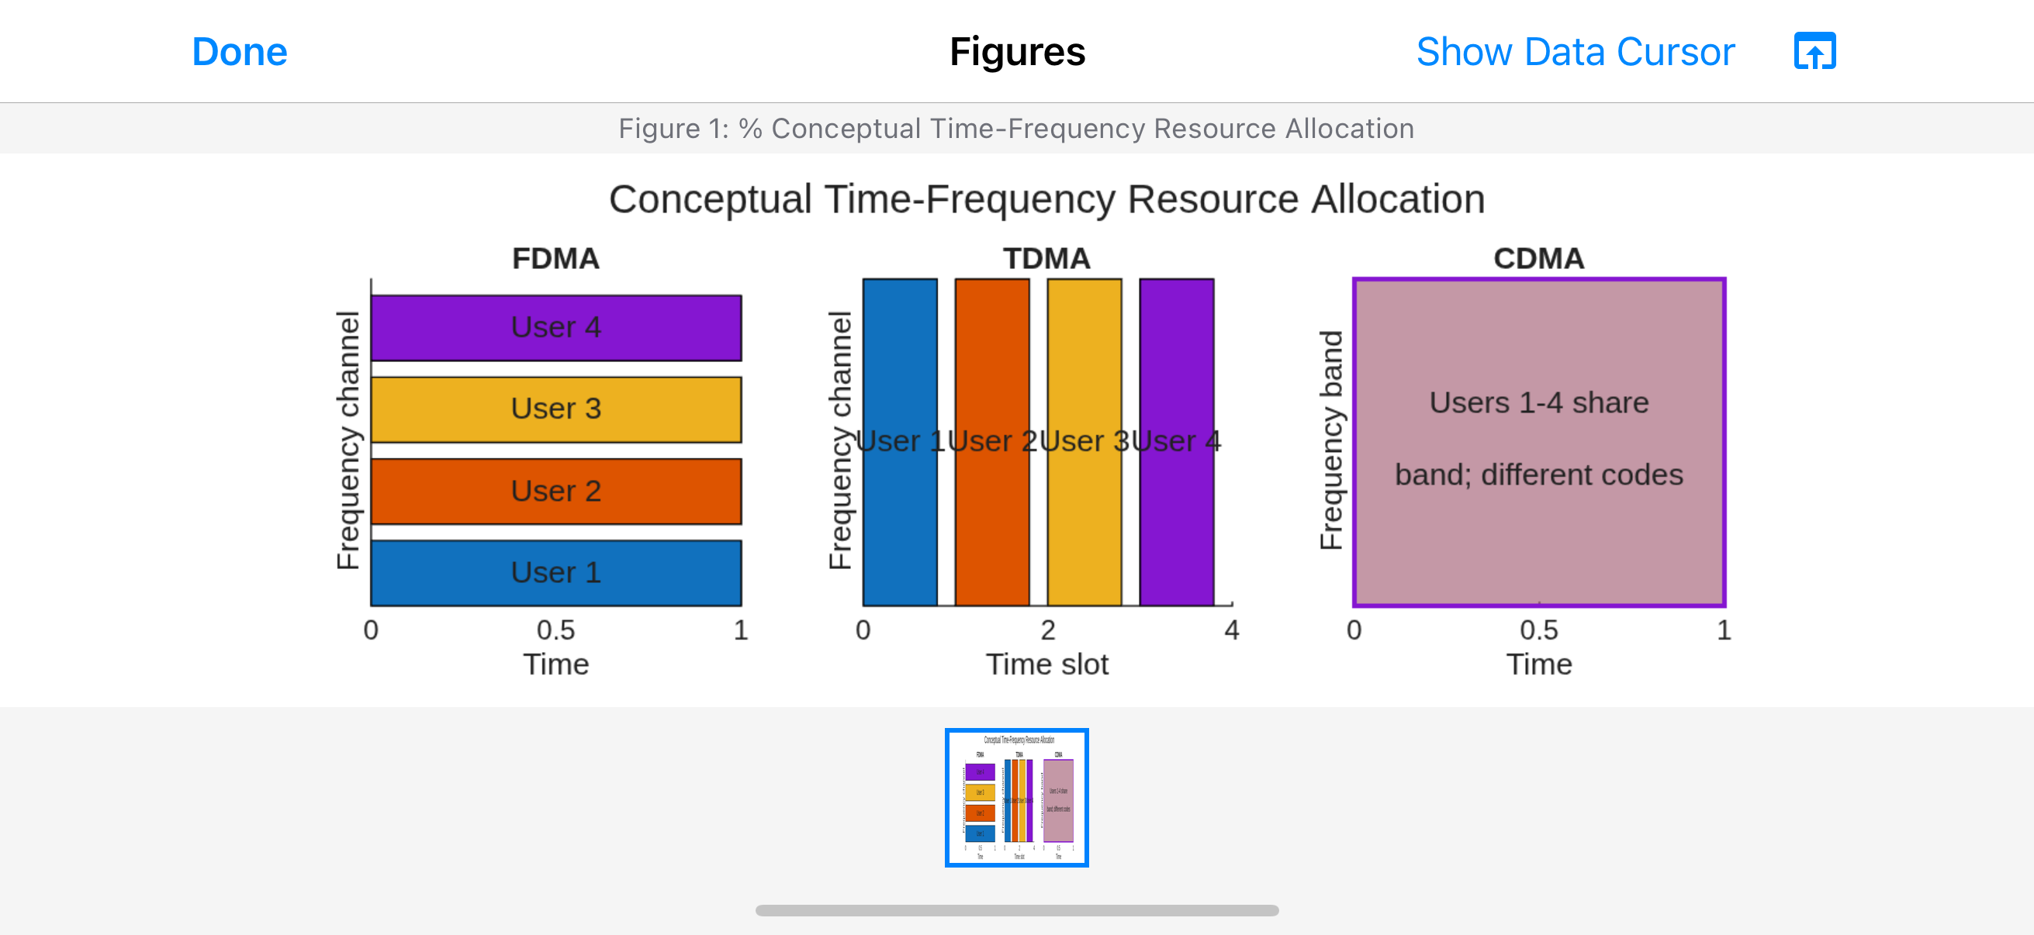

MATLAB Code
clc; clear; close all;
% FDMA, TDMA and CDMA capacity comparison
methods = {'CDMA','FDMA','TDMA'};
capacity = [11, 5, 8];
figure;
bar(capacity);
set(gca,'XTickLabel',methods);
ylabel('Relative maximum supported simultaneous users');
title('FDMA, TDMA and CDMA: Capacity Estimate');
grid on;
% Estimated CDMA SIR versus number of users
K = 2:30;
processingGain_dB = 20;
SIR_dB = processingGain_dB - 10*log10(K);
figure;
plot(K,SIR_dB,'o-','LineWidth',1.5);
hold on;
yline(7,'r--','Target SIR');
xlabel('Number of simultaneous CDMA users (K)');
ylabel('Estimated SIR (dB)');
title('Estimated CDMA SIR versus Number of Users');
grid on;
% Evolution of mobile access methods
generation = {'1G','2G','2G','3G','4G','5G'};
system = {'AMPS','GSM','IS-95','UMTS','LTE','5G NR'};
accessMethod = {'FDMA','TDMA','CDMA','WCDMA','OFDMA','OFDMA-based'};
keyIdea = {'Separate frequency channels','Separate time slots', ...
'Code-based user separation','Wideband code-based access', ...
'Orthogonal frequency resources','Flexible OFDM-based radio access'};
T = table(generation',system',accessMethod',keyIdea', ...
'VariableNames',{'Generation','System','AccessMethod','KeyIdea'});
disp(T);
% Conceptual resource allocation
figure;
subplot(1,3,1);
hold on;
for u = 1:4
rectangle('Position',[0,(u-1),1,0.8], ...
'FaceColor',[0.2+0.15*u,0.5,0.8],'EdgeColor','k');
text(0.5,(u-1)+0.4,sprintf('User %d',u), ...
'HorizontalAlignment','center');
end
xlim([0 1]); ylim([0 4]); xlabel('Time'); ylabel('Frequency channel');
title('FDMA'); grid on;
subplot(1,3,2);
hold on;
for u = 1:4
rectangle('Position',[u-1,0,0.8,1], ...
'FaceColor',[0.2+0.15*u,0.5,0.8],'EdgeColor','k');
text((u-1)+0.4,0.5,sprintf('User %d',u), ...
'HorizontalAlignment','center','Rotation',90);
end
xlim([0 4]); ylim([0 1]); xlabel('Time slot'); ylabel('Frequency');
title('TDMA'); grid on;
subplot(1,3,3);
rectangle('Position',[0,0,1,1],'FaceColor',[0.75,0.55,0.62], ...
'EdgeColor',[0.5,0,0.8],'LineWidth',1.5);
text(0.5,0.5,{'Users 1-4 share band;','different codes'}, ...
'HorizontalAlignment','center');
xlim([0 1]); ylim([0 1]); xlabel('Time'); ylabel('Frequency band');
title('CDMA'); grid on;

Experiment 2
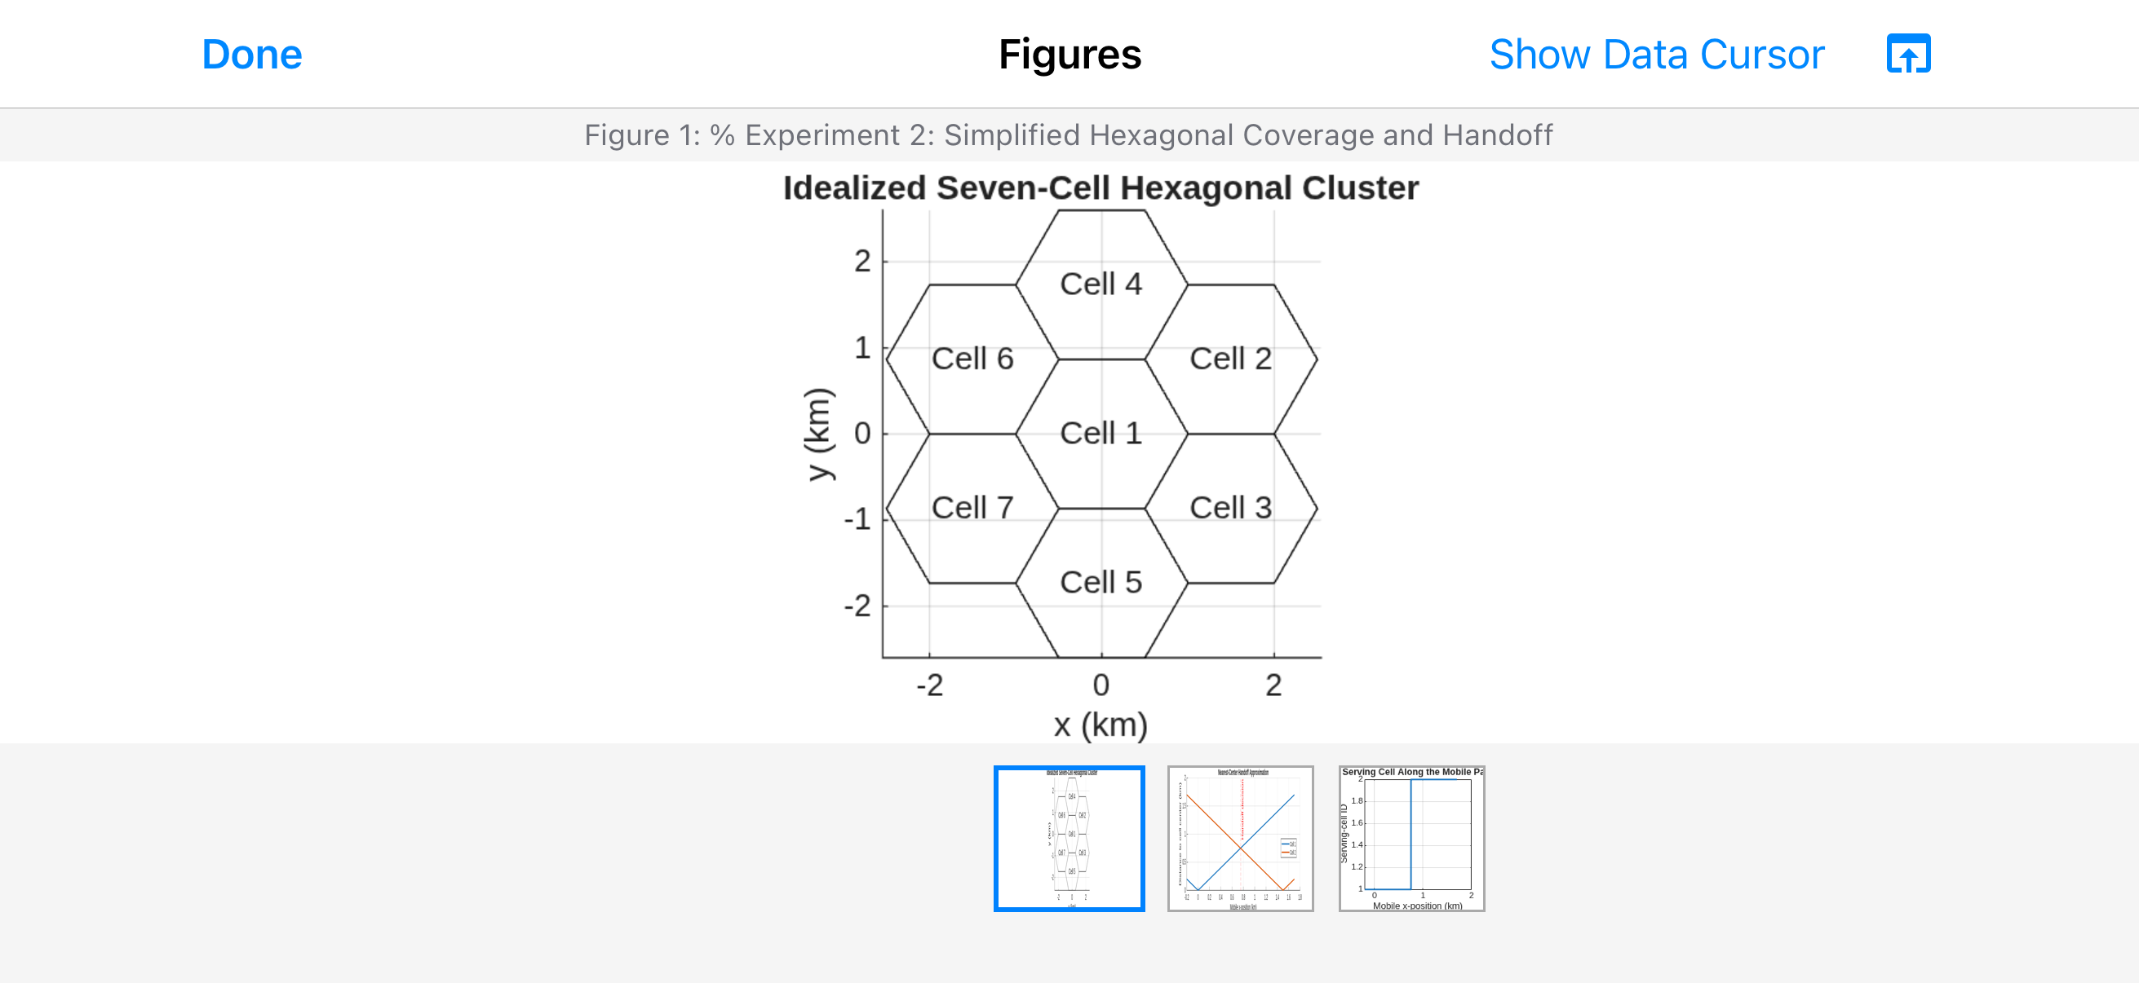
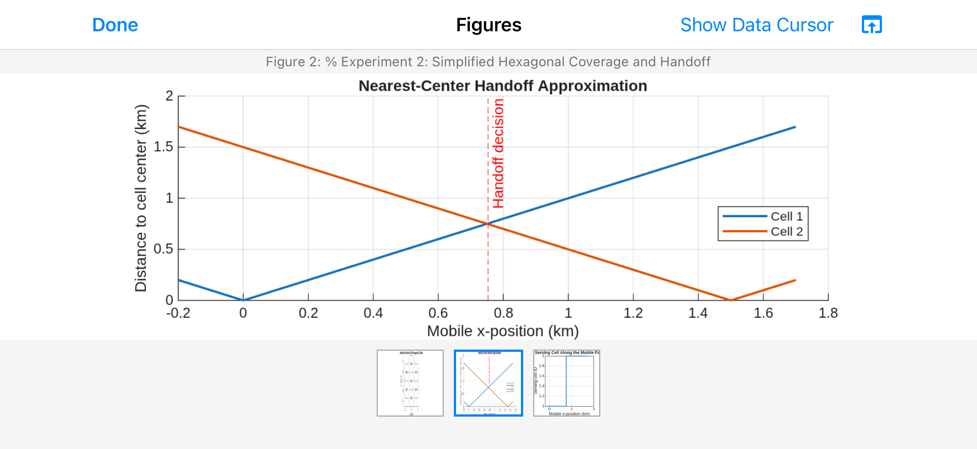
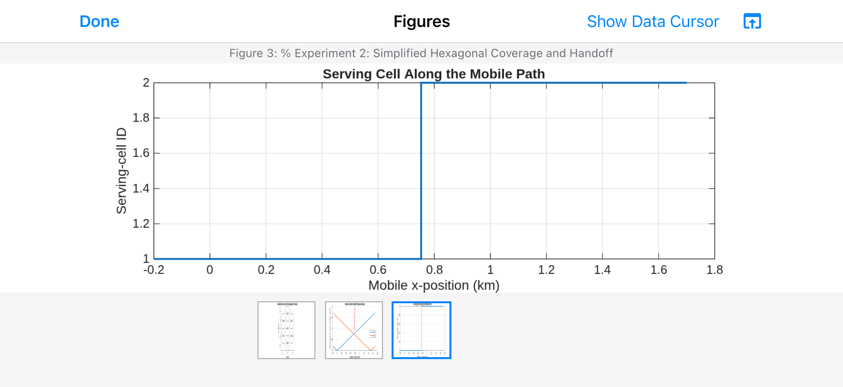

MATLAB Code
clc; clear; close all;
% Experiment 2: Hexagonal coverage and handoff
R = 1; % approximate cell radius in km
theta = 0:60:300;
hexX = R*cosd(theta);
hexY = R*sind(theta);
centers = [0 0; 1.5 0.866; 1.5 -0.866; ...
0 -1.732; -1.5 -0.866; -1.5 0.866; 0 1.732];
figure; hold on; axis equal;
for k = 1:size(centers,1)
patch(centers(k,1)+hexX,centers(k,2)+hexY,'w', ...
'EdgeColor',[0.25 0.25 0.25],'LineWidth',1.2);
text(centers(k,1),centers(k,2),sprintf('Cell %d',k), ...
'HorizontalAlignment','center');
end
xlabel('X (km)'); ylabel('Y (km)');
title('Idealized Seven-Cell Hexagonal Cluster');
grid on;
% Mobile moves along x-axis between Cell 1 and Cell 2
x = linspace(-0.2,1.7,200);
cell1Center = 0;
cell2Center = 1.5;
d1 = abs(x-cell1Center);
d2 = abs(x-cell2Center);
handoffX = (cell1Center+cell2Center)/2;
figure;
plot(x,d1,'LineWidth',1.5); hold on;
plot(x,d2,'LineWidth',1.5);
xline(handoffX,'r--','Handoff decision');
xlabel('Mobile x-position (km)');
ylabel('Distance to cell center (km)');
title('Nearest-Center Handoff Approximation');
legend('Cell 1','Cell 2','Location','best');
grid on;
servingCell = ones(size(x));
servingCell(d2 < d1) = 2;
figure;
stairs(x,servingCell,'LineWidth',1.5);
xlabel('Mobile x-position (km)');
ylabel('Serving-cell ID');
title('Serving Cell Along the Mobile Path');
ylim([0.8 2.2]); yticks([1 2]); grid on;

Experiment 3
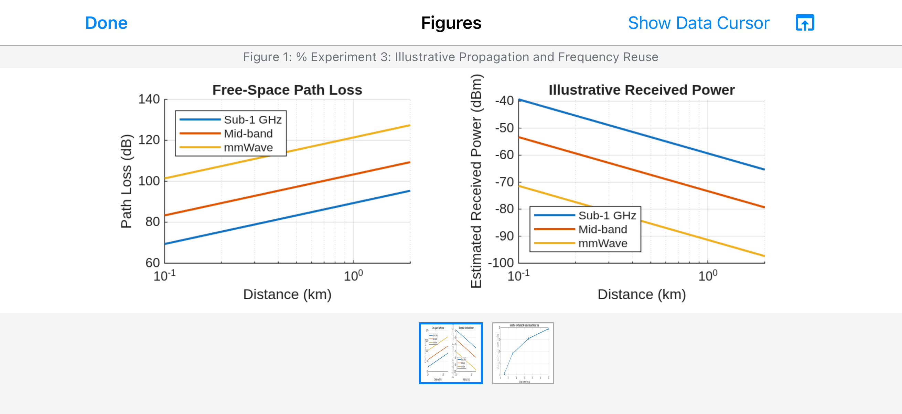
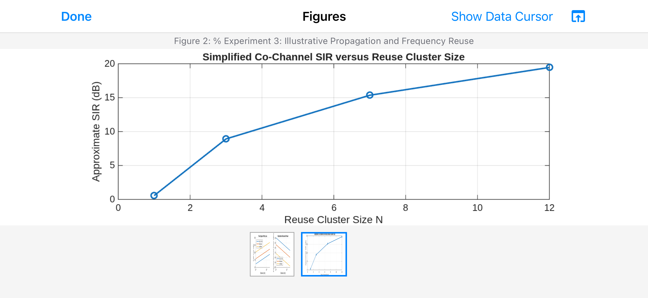

MATLAB Code
clc; clear; close all;
% Experiment 3: Propagation and frequency reuse
d = logspace(-1,log10(2),100); % distance in km
f_MHz = [900 1800 28000];
labels = {'Sub-1 GHz','Mid-band','mmWave'};
Pt_dBm = 30;
Gt_dBi = 0;
Gr_dBi = 0;
figure;
hold on;
for k = 1:numel(f_MHz)
% Free-space path loss: d in km, f in MHz
FSPL = 32.44 + 20*log10(f_MHz(k)) + 20*log10(d);
plot(d,FSPL,'LineWidth',1.5);
end
set(gca,'XScale','log');
xlabel('Distance (km)'); ylabel('Path loss (dB)');
title('Free-Space Path Loss');
legend(labels,'Location','best'); grid on;
figure;
hold on;
for k = 1:numel(f_MHz)
FSPL = 32.44 + 20*log10(f_MHz(k)) + 20*log10(d);
Pr_dBm = Pt_dBm + Gt_dBi + Gr_dBi - FSPL;
plot(d,Pr_dBm,'LineWidth',1.5);
end
set(gca,'XScale','log');
xlabel('Distance (km)'); ylabel('Estimated received power (dBm)');
title('Illustrative Received Power');
legend(labels,'Location','best'); grid on;
% Simplified co-channel SIR versus reuse cluster size
N = [1 3 7 12];
n = 4; % path-loss exponent
SIR_dB = 10*log10((3*N).^n/6);
figure;
plot(N,SIR_dB,'o-','LineWidth',1.5);
xlabel('Reuse cluster size N');
ylabel('Approximate SIR (dB)');
title('Simplified Co-Channel SIR versus Reuse Cluster Size');
grid on;

