Skaters Tricks Application

The application has been developed using ASP.NET MVC and MSSQL backend database. C Sharp is an integration of Java and C++. I opted to use C Sharp because my environment has not been configured for Java yet, but still the same code can be done in Java.

**How to run the program:**

1. Attach the database in MSSQL server using SQL Server Management Studio
2. If you are using Visual Studio please open the project called SkaterTricks.
3. Change the Connection String in web.config file to reflect the MSSQL database in your local environment
4. Run the Application. You will see the following page loading.

Home Page

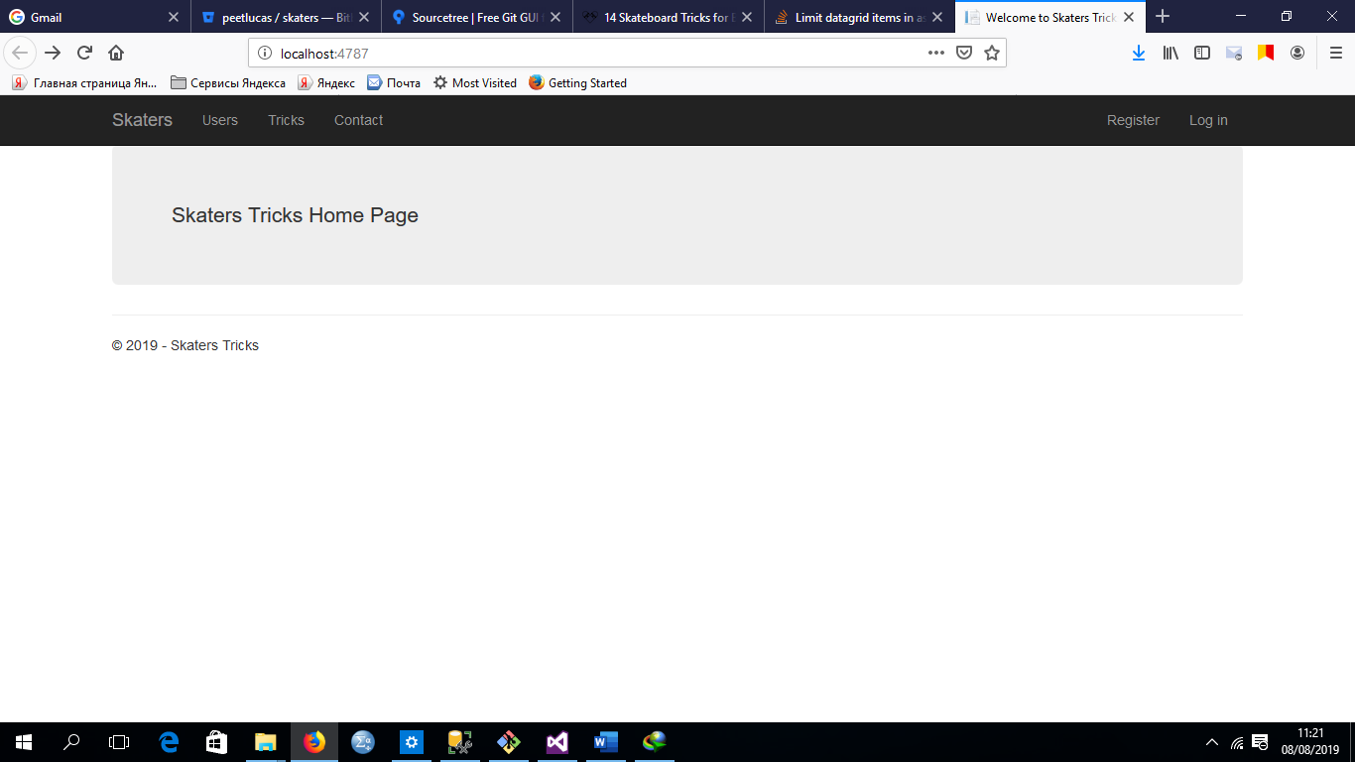

To Add a new user Click on Users link. It will load the following page listing registered users in the system.

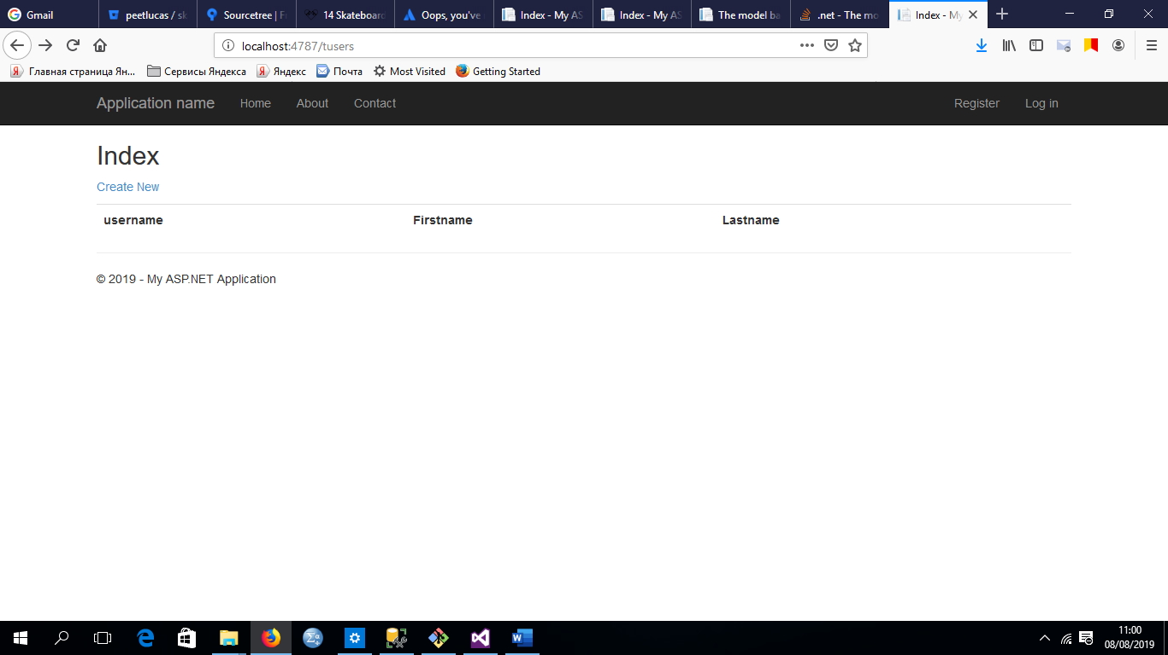

Click Create New to Add New users. The following page will load.

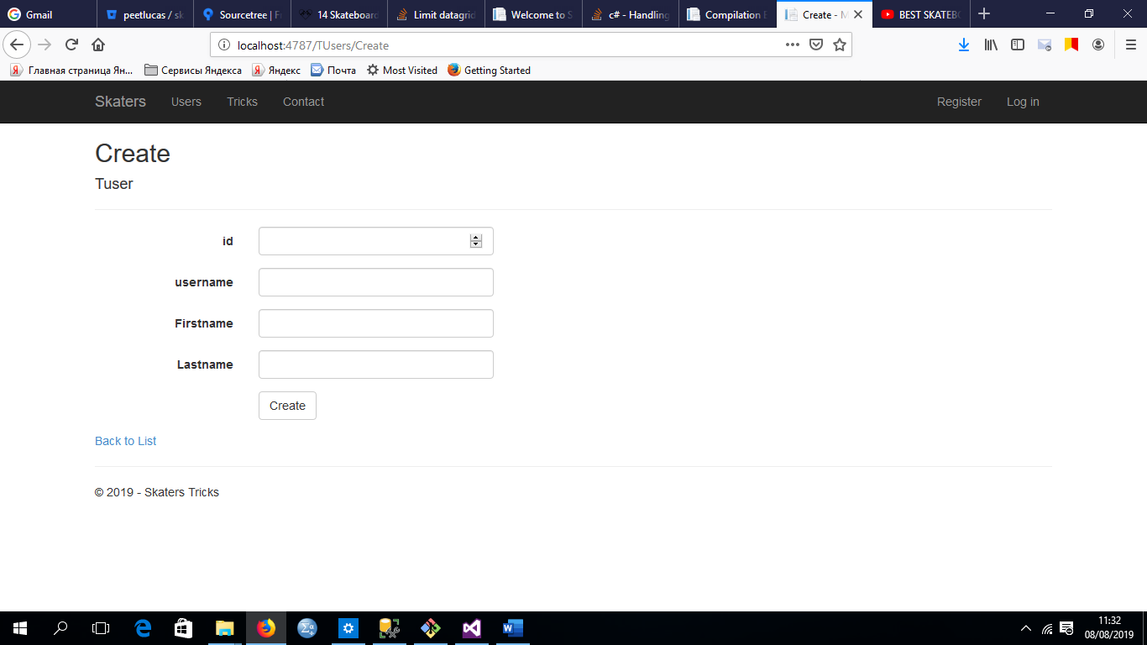

After adding a user the following page will display with the new user.

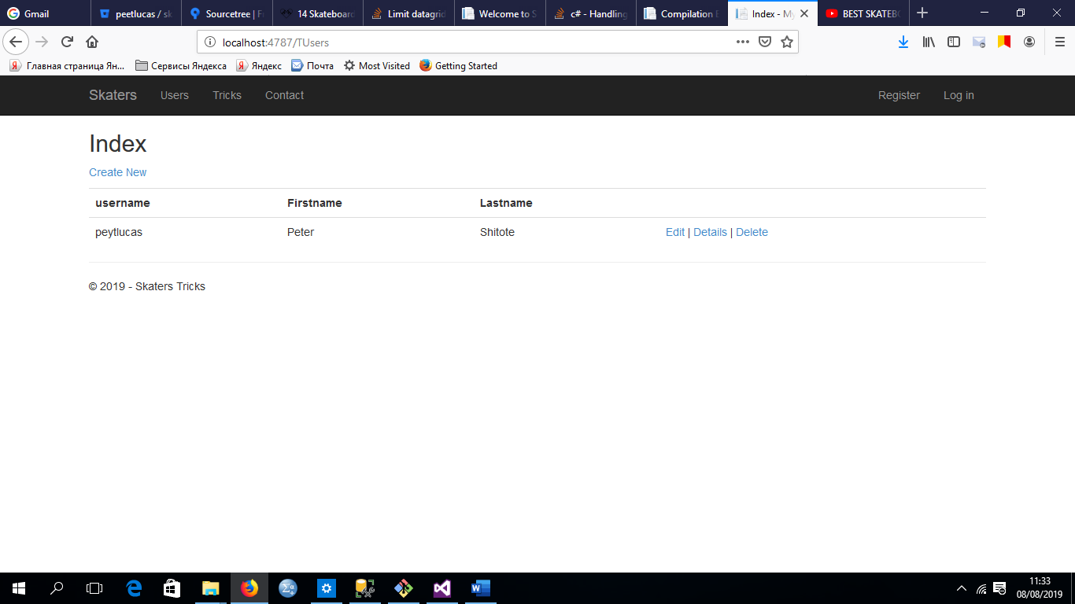

To Add a trick click on Tricks menu link. The following page will load allowing you to create new tricks.

Form to Add new tricks

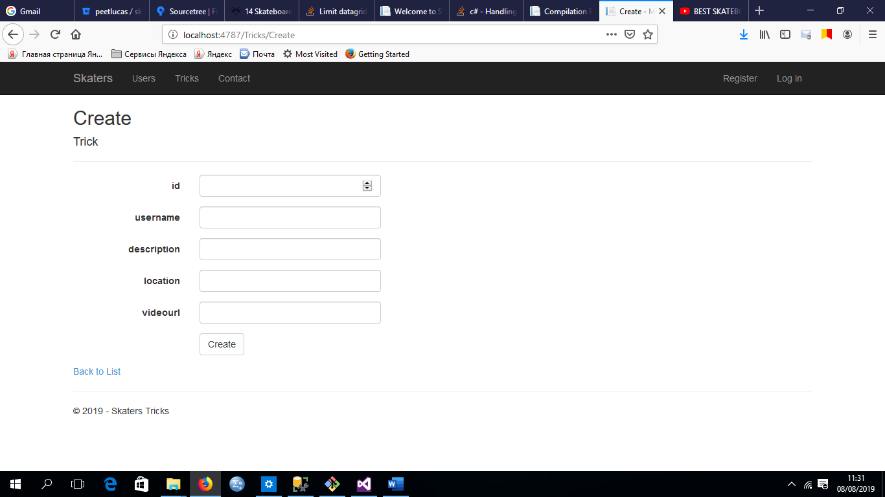

Once the Trick has been added. The following page will load displaying the trick, associated user and video url.

