# 

# 

# **AN AUTOMATED MANAGEMENT SYSTEM FOR POLICE DEPARTMENT**

CHARITY NYANCHERA ORINA

CHERORI DEDAN

PETER MURIMI WANJA

A research Project Submitted to the Department of Computer Science and IT in Partial

Fulfillment of the Requirement for the Award of Bachelor’s Degree in Information

Technology of Dedan Kimathi University of Technology.

## DECLARATION AND RECOMMENDATION

### Declaration

This research project is our original work and has not been presented for an award of a diploma or conferment of degree in any other university or institution.

Name: .......................................................................

Signature: ...................................................................... Date: ....................................

Name: .......................................................................

Signature: ...................................................................... Date: ....................................

Name: .......................................................................

Signature: ...................................................................... Date: ....................................

The Trio

C025-01-1013/2018

C025-01-1008/2018

C025-01-1031/2018

### Recommendations

This research project has been examined, passed and submitted with my approval as the University Supervisor.

Signature: ...................................................................... Date: ................................

Name: ......................................................................

Lecturer, Department of Computer Science and IT

Dedan Kimathi University of Science and Technology.

## 

## DEDICATION

We dedicate this work in recognition of the following people who have been of great help towards the delivery of this project. Our coordinator Jane Kuria and our Supervisor Madam Carren. Our lecture Michael Muchiri and his tutor Francis who gave us the best resources in learning java which we incorporated immensely in this project. Ismail Godfrin has been of great inspiration demonstrating how simple it is to manipulate java, he is our friend and mentor. We would also like to honour the class of 2018 in Information Technology for their continued support in the development of this project.

## 

## ACKNOWLEDGMENTS

Our sincere gratitude goes to the Lord God Almighty who bestowed upon us the zeal and courage to undertake this task to its conclusion.

## 

## 

## ABSTRACT

The system ‘Police Department Management System’ automates the manual process of managing the occurrence book, cell register, crime register, petty crime registers and the traffic crime register. This single system will manage the details of all occurrences in the police department. The details of any crime who register and all the daily duties performed by the police department. The system prompts a service number and a password before accessing the various registers. Backup of the registers is kept. The system also enables a quick search for any case file.

# 

Contents

**AN AUTOMATED MANAGEMENT SYSTEM FOR POLICE DEPARTMENT** 1

DECLARATION AND RECOMMENDATION 2

Declaration 2

Recommendations 2

DEDICATION 3

ACKNOWLEDGMENTS 4

ABSTRACT 5

**CHAPTER ONE:** 8

INTRODUCTION 8

1.1: Background of Study 8

1.2: Problem Statement 10

1.3: Objectives 10

1.4: Research Questions 10

1.5: Justification Problem 10

1.6: Scope 11

1.7: Limitations 12

**CHAPTER 2** 13

2.1 INTRODUCTION 13

2.2 Case Studies 14

Case 2.2.1: Tie Occurrence Book Automation to a Standardized Fines System 14

Case 2.2.2: Digitized Human Resource System 15

Case 2.2.3 Criminal Record Management System 16

2.3: Research Gap 16

2.4: Proposed Methodology 17

**CHAPTER 3** 17

SYSTEM METHODOLOGY 17

3.1 Introduction 17

3.2 Fact Finding Techniques 17

3.2.1 Software Development Procedure 18

3.2.2 Diagrammatic representation of the Methodology 19

3.2.3 Resources to be used 20

**CHAPTER 4** 21

SYSTEM ANALYSIS AND DESIGN 21

4.1 Introduction 21

4.2 Requirement Analysis 21

4.3 Non-Functional Requirement Analysis 22

4.4 Data Analysis 22

4.5 System Design 23

**CHAPTER FIVE** 28

TESTING AND RESULTS 28

5.1 Introduction 28

5.2 Software Testing 28

5.2.1 Functional Testing 28

5.2.2 Unit Testing 34

5.2.3 Integration Testing 34

5.2.4 System Testing 34

5.2.5 Acceptance Testing 34

**CHAPTER SIX** 35

Implementation and Deployment 35

6.1 Introduction 35

6.2 System Specification 35

6.3 Deployment 35

**CHAPTER SEVEN** 36

Conclusion and Recommendation 36

Conclusion 36

Recommendation 36

Challenges 36

References 37

# **CHAPTER ONE:**

## INTRODUCTION

## 1.1: Background of Study

The importance of police in the society cannot be denied in terms of the safety they provide to the people all around the world. The main responsibility of the police is to maintain the law and order situations in the country and restrict the criminal activities in the

society by bringing the criminals into court for justice through proper investigations. For the proper investigation it is important to solve the complex criminal cases and prove the truth in the court which is quite a complex process and requires a lot of effort. Every country has its own method of the investigation, but the situation of Kenya in this matter is worse. progressive countries are using different modern techniques for crime prevention and investigation purposes, these technologies can be categorized into hard and soft technologies. The hard devices include metal detectors, CCTV cameras and walkthrough gates.

In soft technology, face recognition and fingerprint recognition software’s are used. Here the quoted are few but these cannot be limited to the mentioned here.

The National Police Service has for the first time in the history of policing in the country launched an Information Management System aimed at digitizing all Police records including the Occurrence Book, Personnel Management, Crime Management and Administrative Systems.

 In the next few months, the Police Service will be operating on a fully digitized platform thanks to the ongoing digitization of government services for efficient public service delivery.  The launch of the program which was presided over by the Cabinet Secretary for Interior Dr. Fred Matiang’i at the Kilifi County Police headquarters was also graced by his ICT counterpart Joe Mucheru, Inspector General Joseph Boinnet among other senior government officials and top Police Commanders.

In his remarks, the Interior Cabinet Secretary noted that digitization of Police records and processes would ensure efficiency and transparency in the manner in which Police operations were conducted. Dr. Matiang’i specifically noted that disappearance of files and other Police records would be a thing of the past once the system was in place since all data would be secure in the system and available by the click of the mouse. He noted that a digitized system would ensure fairness and transparency especially in effecting transfers and promotions as well as track the progress of officers in their careers and family records.

The Cabinet Secretary for ICT in his remarks said that his ministry would digitize essential services within institutions in the criminal Justice System to facilitate ease of sharing information, especially criminal records between Police and Judiciary. This he said would eliminate the bureaucracies involved in tracing of files and tracking of cases.  Mr. Mucheru noted that under his stewardship, essential government services had been digitized across various government ministries and departments.

The Inspector general while welcoming the new development thanked the government for migrating policing services to a digital platform, saying that the Police would not be left behind as other sectors were being automated. Mr. Boinnet further noted that in this day and age, technology was so much advanced that it would be queer to find individuals operating without mobile phones.

Local leaders who also attended the occasion lauded the move saying that it would go far in reducing the rate of crime in the society and encouraged Police Officers to embrace the technology. In this regard, the National Police Service kicked off a countrywide biometric registration exercise for all Police Officers to capture the details of each officer electronically. The exercise is envisaged to be complete by February 2019.

The Nyeri police system has been much improved since few years by utilizing the information technology techniques which has also reduced the crime rate as compared to the other provinces. The process of investigation starts when some citizen (victim) registers OB against accused (criminal), the first step of investigation is mostly gathering proofs either the incident claimed by victim happened in real or not and on the basis of proofs the police arrests criminals for further investigation from them. All the proofs are recorded on a paper after the OB and the crime register for presenting to the court for further processing of the case in the court. After which a case file is opened.

The investigation methods can be different on the basis of nature of the crime. The successful investigation is directly dependent upon the information gained from different peoples which help for arresting the criminals that destroy the peace of society. These issues are almost same in the other countries also as reported by Ladapo in, about the issues faced in the Nigeria during the investigation of criminal cases. The use of technology is increasing day by day to make the human life easier. The police have not been provided the modern technology facilities and the record keeping is not computerized which reduced the efficiency of police stations. The advanced countries like the United States have provided the facilities of modern technologies for crime management and investigation which has enhanced the performance of the US police. The computers and software’s are been used in different organizations for record keeping, so intelligent software systems should be implemented in the police department to decrease the extra effort and motivate the police personals to work more with little effort and to save their valuable time.

In this study, we have tried to develop a software for the police department keeping in view the limitations of the already developed software and system in place. The main function of the software is record keeping to digitize the registers of the police station. They include occurrence book, crime register, traffic register, cell registers and many more. The developed software will fulfill the need of record keeping of the police department in an organized manner.

## 

## 1.2: Problem Statement

The Police and Police stations have its adequate importance all around the world in this era where the crime rate is very high, the situation of Kenya specifically Nyeri is also same. Currently, the police stations in Nyeri are utilizing the old method (hard paper) of Occurrence Book registration and which requires extra effort to maintain the record of criminals and to trace someone’s record also require unnecessary time which can be saved by digitizing the police stations records.

Although, some police stations do use digital record keeping in Excel sheets but the Integrity problem is noticed in file-based record also the access is slower for searching single record the officer/official has to go through all the records in the sheet which consumes extra time. The excel sheets can only be used by a single person at a time and also, they do not have any security mechanism, anyone who has access to the computer can easily access the sensitive record. To overcome these issues, we have developed an application for the police station to digitize the method of Occurrence Book system and other important official records about the staff and necessary registers used by police stations.

## 1.3: Objectives

1.3.1: GENERAL

The main objective of this software is to create a paperless environment for record keeping for the purpose of effectiveness and effortlessly managing the entire records and registers.

1.3.2: SPECIFIC

To allow for easy retrieval of records by search property using the OB number.

To safely keep records by not granting permission to those who are not authorized to view.

## 1.4: Research Questions

How to create user privileges.?

How the current system works?

What will be the benefits of rolling in a new system?

How well the people in question will adjust to the new system.

## 1.5: Justification Problem

We conducted a study in our local police station and observed how the current system works. The Existing system is a hard copy one and to access information from excel requires extra time. The maintenance of record in hard copy is quite difficult and also duplication of data does exists, as the integrity of data is also important so the hard copy is not reliable to be used in the sensitive department of police. To acquire information about the particular OB the police has the search all the records. The book can only be used by a single person at the same time, also it does not use employee’s user privileges and anyone can see and search the information without any security check. It relies on physical security of the room or the storage locker to keeps the records safe. Resources cannot also be limited; we viewed a scenario where a Crime records book was modified to be an occurrence book.

Our main purpose of conducting the research is to observe how the existing system works and to see how we might be able to help to make things run smoothly.

Our system will benefit the police department, it will make their work easier while helping them gain some hands-on skills on managing digital records. The general public will also gain profoundly as their cases will be handled faster with much more accuracy. This will help reduce the rate of crime.

## 1.6: Scope

The system will be a record keep system that will automate the registers in the police department by digitizing the manual system. This system will manage the day to day occurrence, the cell registry, the arms registry and other registers.

The system will contain the admin user and other users. The admin who will be the officer with the highest rank will have access to all records including the arms registry that he alone will have records to. The admin will also be responsible for adding users, modifying them or removing them from the system.

The users will view records in the other registries.

The proposed system includes the following features:

* Login for user and admin
* Occurrence book
* Arms register for admin
* Traffic register
* Cell register
* Crime register
* Petty crime register

The system should offer the following functionalities:

* The system requests the administrator to enter his/her service no and password
* The administrator enters his/her credentials.
* The system validates the entered service number and password, logs him/her in.
* The administrator maintains the record of information of various registers and related objects.
* If in the basic flow, the actor enters an invalid name, password the system displays an error message. The actor can return to the beginning of the basic flow.

## 

## 1.7: Limitations

Some of the limitations encountered during the research process include:

1. Limited time to conduct extensive research and build the system.
2. Lack of resources to research from since the structures of the registers are open to the public.
3. Many police officers are computer illiterate and to be trained from scratch the basics of computers

# **CHAPTER 2**

## 2.1 INTRODUCTION

The system ‘Police Department Management System’ will be used in automating the manual process of managing the occurrence book, cell register, crime register, petty crime registers and the traffic crime register. This single system will manage the details of all occurrences in the police department. The details of any crime who register and all the daily duties performed by the police department.

The system provides an interface for recording all the different registers in a single platform. This is a great step towards instant fines, bookings on the move and an equally standardized system for petty offenders. This system is designed to automatically detect the time and date of booking of an event occurrence. The system will have a login interface before any booking in order to keep track of the person assigned to be in charge of the booking office.

The proposed system will include the following features:

* Login for users and admin
* Complains and any occurrence registry into the Occurrence Book
* Recording of any cases into their relevant registers
* Criminal register management
* View status of an investigation in progress
* Cases history status
* Manage list of most wanted criminals
* Suspects register management
* Search for cases
* Manage preparation of case files

At the login interface, the system will request the user to enter their username and password. The user or admin enters the login credentials then the system authenticates the login details. The user or admin should then record or manage the records information. If in the login process, wrong credentials are given; the system should deny login and prompt the user or admin to login again.

## 2.2 Case Studies

### Case 2.2.1: Tie Occurrence Book Automation to a Standardized Fines System

The recent move by the Ministry of interior, National Police Service Commission and National police Service to automate the Occurrence Book (OB) is a key milestone towards ensuring sanity in the police department.

It is a tremendous step towards instant fines, bookings on the move and a standardized system for petty offenders. Over the past ten years the government has been toying with the idea of automating the occurrence book. Persons may also report lost items such as National Identity Cards which will be recorded in the occurrence book.

According to South Africa Police Standing Orders, the OB is the most important of all the registers used in the police department. It must contain a complete record of the history of a police station, besides serving as the control record of all other registers and the Crime Administration System (CAS).

The OB is under the custody of Officer Commanding of the police Station (OCS), but is assigned to a duty officer to among other tasks, record criminal bookings and persons seeking justice. The police Act Cap 84 (revised in 2010) states “Every police officer in charge of police station shall keep a record in such form as the commissioner may direct, and shall record therein all complaints and charges referred, the names of all persons arrested and the offences with which they are charged.

By law, the person arrested in the police cells must be listed in the OB with the officer assigned listing the date and time of arrest, reasons for arrest and property found in custody of the suspects.

Although this is a tremendous step in automating the occurrence book, it fails to capture the cell register, crime register, petty crime register and the traffic crime register which will be fully functional in our system.

### Case 2.2.2: Digitized Human Resource System

The government has launched a fully automated system to help in the management of the National Police Service.

Former interior CS Fred Matiangi led the process of launching the system dubbed the Digital Human Resource Information System Apart from the police human resource docket, the ministry shall also digitize administrative procedures, the Occurrence Book (OB), and the Crime Management System. CS Fred further stated that the automated system will help police officers to handle some of the reported cases in real time.

The digital human resource system shall be embedded in all levels of the National Police Service, which include the administrative Police Service (APS), the Kenya Police (KPS), and the Department of Criminal Investigations (DCI).

The automation is aimed at infusing accountability, efficiency, honesty and professionalism amongst members of the police service as part of the ongoing police reforms.

The system will bear accurate, real-time data on each officer, including their recruitment, training, career progress, deployment, family records, and other related information. In a society where the police are deemed to be poorly educated, pathetic managers, blood hungry coupled with a general hatred towards the Mwananchi, the automated system fails if the above is not better managed.

This project has proven to be difficult to manipulate by several officers since it has complex user interface which becomes difficult for a computer illiterate to handle. On the other hand, this project provides a very simple and a similarity to the normal police registers. It has almost similar formats which makes entry of data effective and easy.

### Case 2.2.3 Criminal Record Management System

Crime File System is a system used to report crime. This project is helpful in keeping records in their departments. This system will help police officers to manage their activities in a computerized environment. Currently all the activities are carried out manually, by computerizing the activities will be carried out easily and effectively.

The police departments to date are partially unconnected islands. Although there is a voice communication, the police are not fully connected. There is no system defined computerized system for keeping records in the police department. There is no system which enables officers to share criminal file records in real time except the manual records.

The goals of the is to facilitate collection, storage, retrieval, analysis, transfer and sharing of data and information at the police department and between the police department and the state Headquarters and the Central Police Organization.

Although this is a fully functional project, it captures only the crime records excluding other events which are recorded in the OB, arms record and other major registers which will be included in our project.

## 2.3: Research Gap

Occurrence books, cell register, crime register, traffic crime register, petty crime register are very bulky books which are poorly kept. These registers are few and the police department are sometimes forced to improvise them. With the help of digitizing these registers, duplicates can easily be created ensuring constant supply.

The registers are sometimes vulnerable to theft hence loss of data. The digital system will help the police department to create backups. Backups will ensure there is no data loss. Sometimes in a court session, the judge may order the occurrence book to be produced, the police have to travel to their respective stations to pick the occurrence books. Digitizing the system will simply mean pressing a button and producing the document shared to the nearest police station.

Furthermore, the developed systems in play have proven difficult to be manipulated and they fail to capture all the important registers in the police station.

## 2.4: Proposed Methodology

Police Department Management System will be developed using a plan-driven mode (waterfall). Waterfall will be crucial since the competition of one phase determines the beginning of the next phase. Waterfall development cycle will be employed fully that is, requirement definition, system and software design, implementation and unit testing, integration and system testing and operation and maintenance.

# **CHAPTER 3**

## SYSTEM METHODOLOGY

## 3.1 Introduction

The system will be developed using plan-driven model, specifically Waterfall model. The system will be developed in distinct phases of specification and development. This considers linear set of process activities of requirement definition, system and software design, Implementation and unit testing, Integration and system testing and operation and maintenance. In this model, a phase has to be completed before moving onto the next phase because the outcome of one phase acts as the input of the next phase.

## 3.2 Fact Finding Techniques

1. **Interviews:**

* **Closed interviews:** We conducted an interview with a predefined set of questions which the interviewees were more than willing to help because the understand the importance and urgency for the system engineered.
* **Open-Interview:** The requirement engineering team explores a range of issues with system stakeholders in order to get a better understanding of the system functionality and to come up with a better system facilitating their needs.

1. **Observation:** The team observed at the police station that the police officers are going through a lot of problem writing records in multiple books which occupy a lot of space, are tiresome to write and hard to refer back to older contents.
2. **Questionnaires:**  The tam design questionnaires and distributed it to our local police station to know what kind of system the wanted and with the functionality they want. They found out that a lot of them hate writing records since it was tiresome and time consuming. They also wanted a system to ease up their day to day work. The team used *paper questionnaires* to gather data from respondents.

### 3.2.1 Software Development Procedure

The sequential phases in the waterfall model are: -

* **Requirement definition** – The team met with the Sargent and several police constables and they gathered their views based on the system to be built and together they came up with a conclusion of the requirement necessary for the functioning of the system. They agreed to be working together up to the completion of the project. After all the gathering and analysis done, the team and the officers agreed on the requirements and signed a contract of it.
* **System design –** The team set aside a whole day for the designing of the system. They clearly discussed the entire appearance of the system- color, events and the types of frameworks to use.
* **Implementation and unit testing -** with inputs from the system design, the system is first developed in small programs called units, which are then integrated in the next phase. Each unit is developed and tested for its functionality, which is referred to as Unit Testing. The team first developed the log in unit for security purposes that can be available to authorized personnel only. The next unit was developed to hold records from the occurrence book and from other registers.
* **Integration and System Testing** – all the units developed in the implementation phase are now integrated into a system after testing of each unit. Post integration the entire system is tested for any faults or failures. The log in, occurrence book, petty crime registers, crime register, traffic control register are grouped together to form a single system.
* **Operation and Maintenance -** once the functional and non-functional testing is done, the product is deployed to the customer environment. The development team will now hand over the working Digitalize Police Department System to the officers. The original development team will ensure that the system is working fine in the client’s environment. The team will avail themselves to handle the system whenever a problem arises and improving the implementation of the system units.

### 3.2.2 Diagrammatic representation of the Methodology

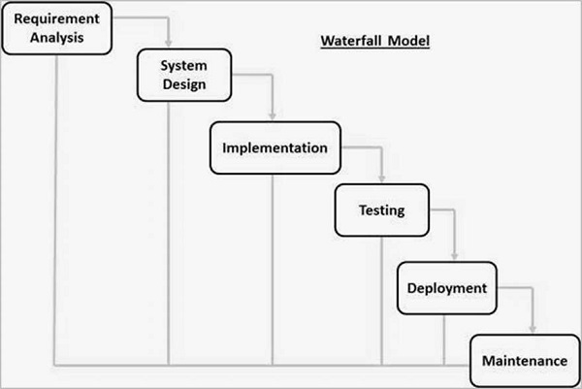

As can be seen from the above diagram, waterfall development model allows easy management and control of the development processes as compared to evolutionary model since a schedule can be set with deadlines for each stage of development and a product can proceed through the development process model phases one by one.

Waterfall model has a simple and easy to understand flow which clearly shows defined stages that makes it easy to arrange tasks during development stages while other development models such as Boehm’s spiral model are complicated, thus making development complicated.

### 3.2.3 Resources to be used

This consists of items to be used during the development process. The software development team decided to use:

* Online learning Communities – the team will utilize online learning communities such as Java T-point Udemy and Audacity.
* Self-taught Resources – the team will also use the knowledge they have to develop the system.
* Colleges and Universities – the team will utilize the school resources such as wi-fi and computers.
* Books, Magazines and online publications – The team will use available frameworks from the internet to facilitate the development. This will indeed make development fast thus saving time.

## **CHAPTER 4**

## SYSTEM ANALYSIS AND DESIGN

## 4.1 Introduction

System analysis is the process of collecting and interpreting facts, identifying the problems and decomposition of a system into its components. This is conducted for the purpose of studying a system or its parts in order to identify its objectives. This is conducted in order to identify the objective of the system and to ensure that all components work efficiently to accomplish their tasks.

System design is the process of defining a systems’ components to satisfy the specific requirements. It clearly identifies the layout of the system making it easy to engineer the system.

## 4.2 Requirement Analysis

Functional requirements: are the functionalities that the proposed system is going to undertake in order to provide the expected output.

The functional requirements of the proposed automated system for police department;

* To enable user login into the system; the user should be able to log into the system using valid service number and password.
* To digitalize occurrence book making it automated to reduce the repetition involved in writing the occurrence book.
* To relate different registers, that is the occurrence book, petty crime registers, crime register, traffic crime register and arms and movement register.
* It enables remote supervision of the progress and activities going on at a police station.
* It consists of a search button where records can be retrieved within a short period of time as compared to manually searching records which might take a lot of time.

## 4.3 Non-Functional Requirement Analysis

These requirements are the constraints on the services or functions offered by the system. And they include;

* The system should be reliable; the proposed system should work efficiently without failure and offer the desired output correctly.
* Ease to use; the proposed system should be easy to use as it requires minimal training on how to operate it.
* Security; the proposed system should be secure to avoid editing or deletion of the contents from the records.
* Availability; the proposed system should be ready for use immediately when its services are required.
* Speed; the proposed system should be fast in offering the services required to minimize on time from input to output delivery.

## 4.4 Data Analysis

The final conclusion indicated that majority of the officers were interested in our project thus giving us the motivation to continue engineering the software. This consists of 75% of the total data collected in the distributed questionnaires.

Majority of the officers were mostly concerned with the security factor of the project which was among the major issues raised. The engineering team convinced them of the security functionalities to be implemented and after all the explanations all their doubts were cleared. 18% of officers were left behind despite a lot of description of the functionalities and non-functionalities of the system. The 7% are the officers who still want to write the records manually and they also support the digitalized system making it unsure where they fall. They have no fixed ground based on their support.

## 4.5 System Design

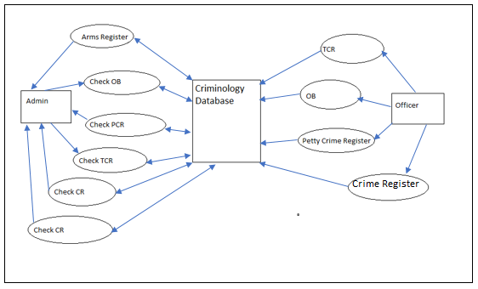

Figure 1: Data Flow Diagram

The data flow diagram above represents graphically how the system should operate

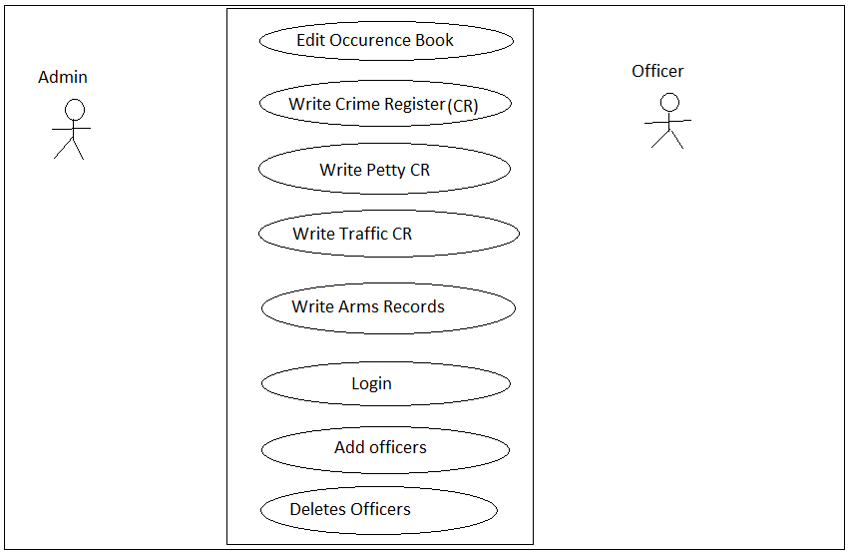

Figure 2: Use case Diagram

The use case above provides the graphical overview of the functionalities provided by the proposed system. It shows how the system interacts with its users.

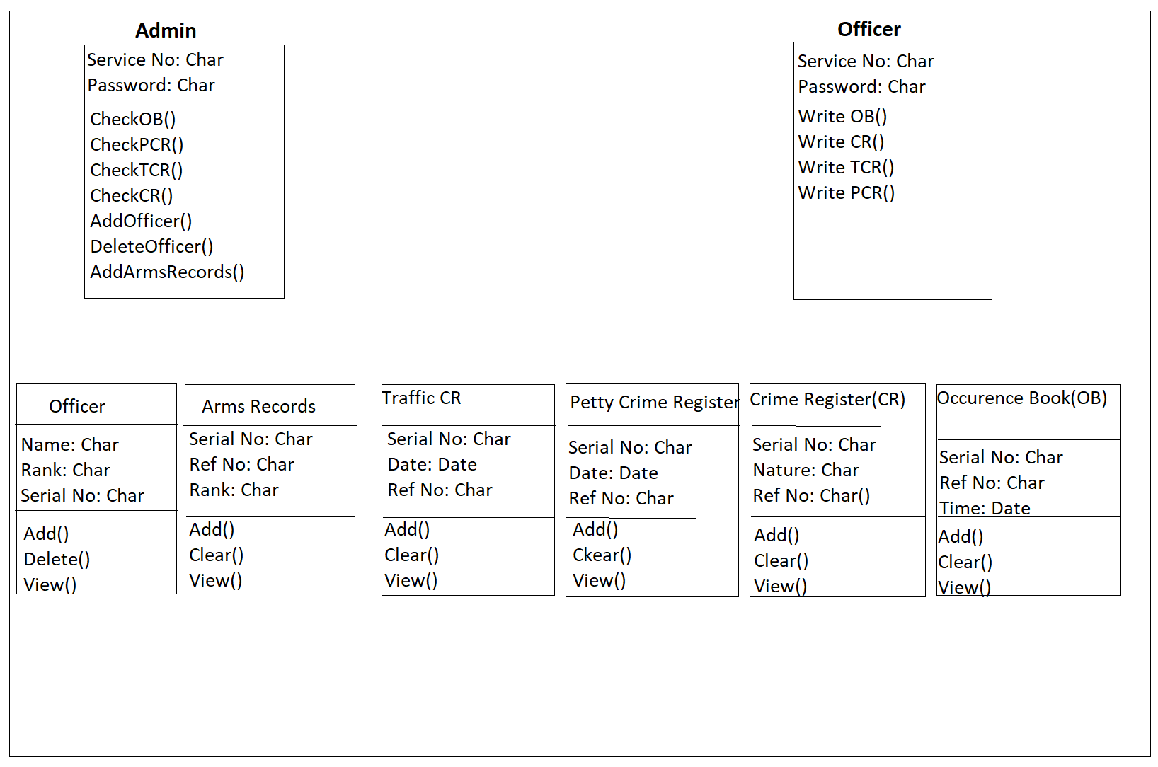

Figure 3: Class Diagram

The class diagram above represents the proposed system in an object-oriented model showing the classes in the system and the association between them.

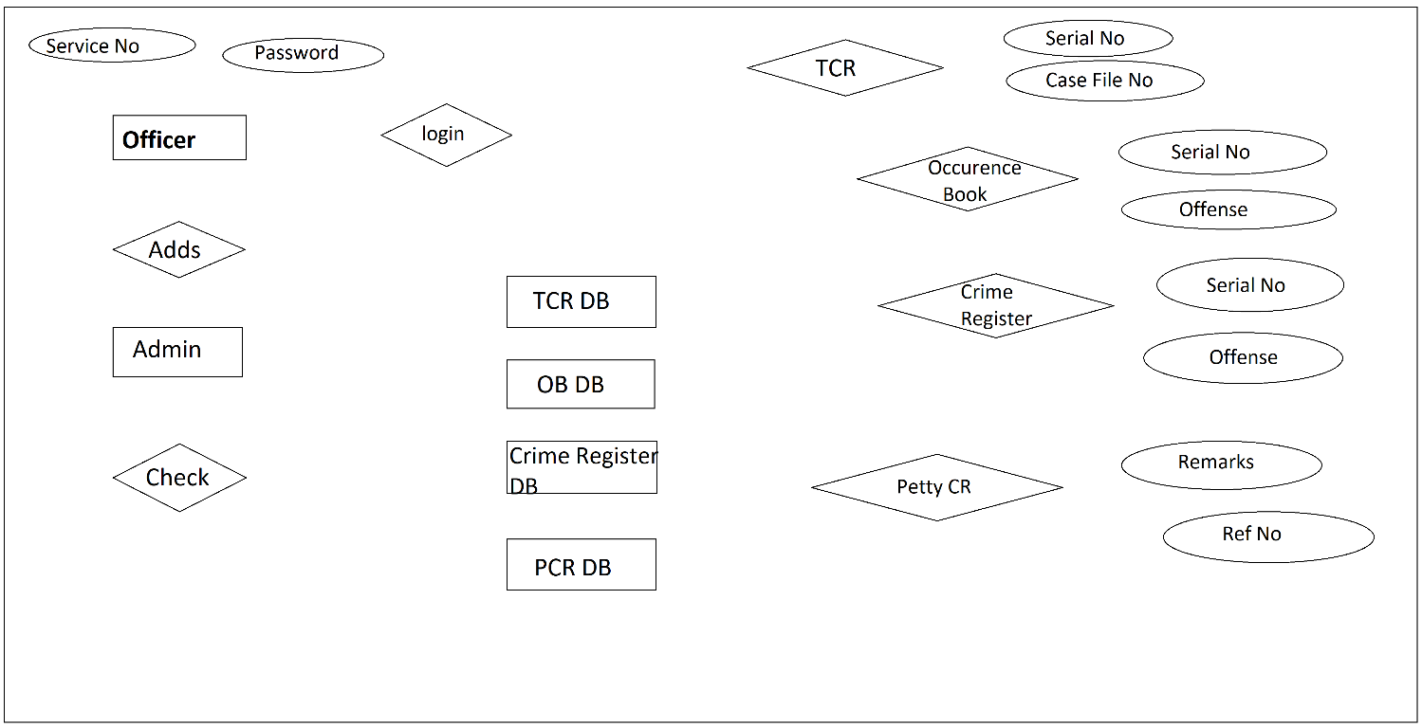

Figure 4: ERD Diagram

The ERD diagram above represents graphically how the system components integrate and work.

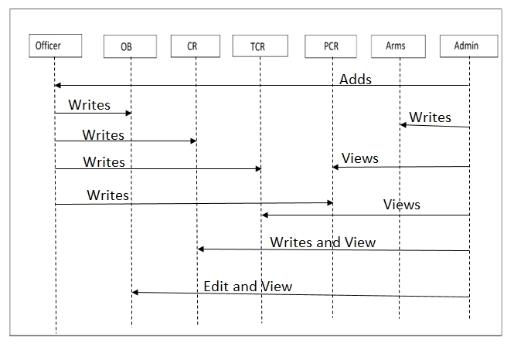

Figure 5: Sequence diagram

The above diagram shows the sequence of interactions that take place during a particular use case. It shows how the message, events and actions between the objects or components of the system.

# **CHAPTER FIVE**

## TESTING AND RESULTS

## 5.1 Introduction

The police management system has two layout interfaces for the admin and the user. When the desktop application is clicked, a login interface is displayed which prompts a service number and a password for validation and authentication. If the admin logs into the system he/she is logged to a different interface from that of a normal user.

## 5.2 Software Testing

### 5.2.1 Functional Testing

When a user opens the application the login page below will pop up.

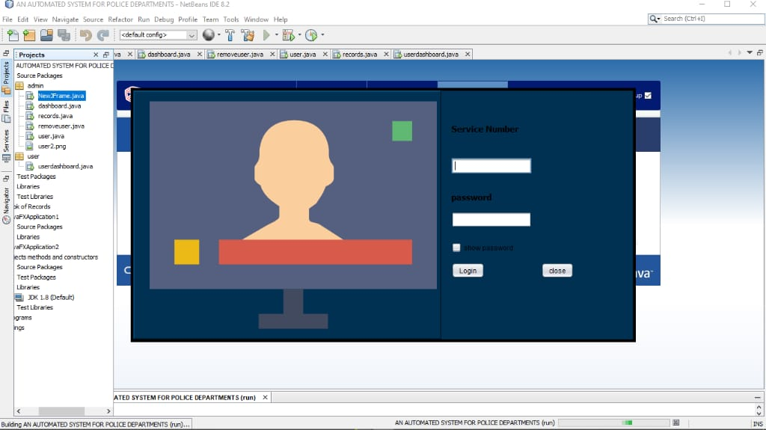

When admin or the user should key in their credentials. If the user inputs correct details, the pop interface as shown below will pop up.

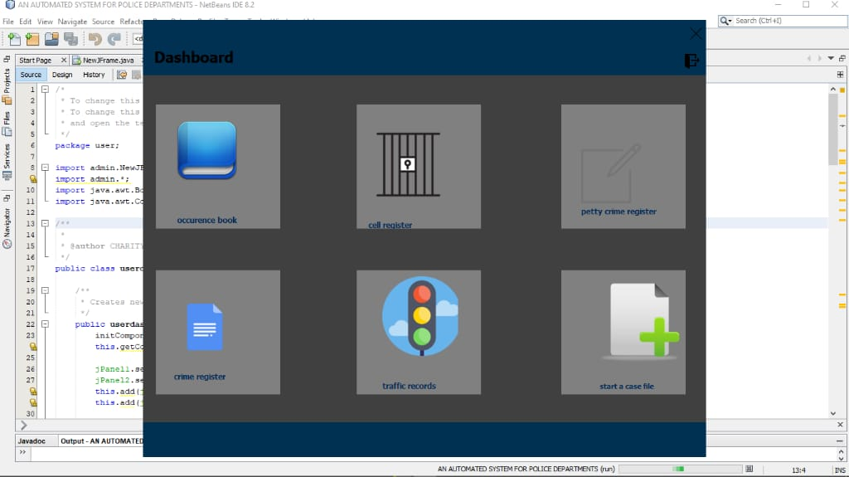

The user can read or write into the occurrence book, crime register, petty crime register, traffic crime register or the cell register. Crime register is a record for keeping pinole crimes. Occurrence book keeps records of any activity in the police station. Petty crime register keeps records of petty offenders. Traffic crime register keeps records of any crime charge reported by the traffic police. The records added into these registers should be saved into the database when the button save is clicked. The user can also print a copy of any register. The user should then log out of the system because if he or she does not, everything done at the moment is entitled to his or her name.

The button cell register shows the interface below.

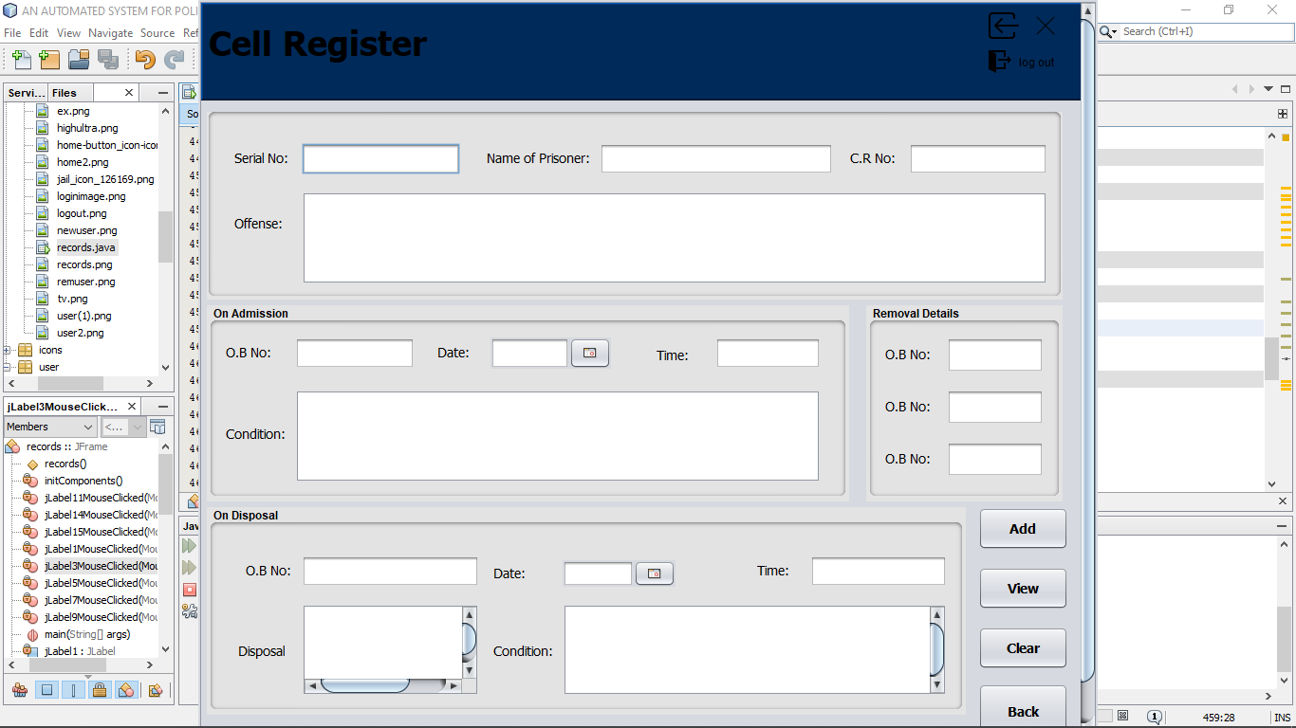

The button crime register shows the interface below.

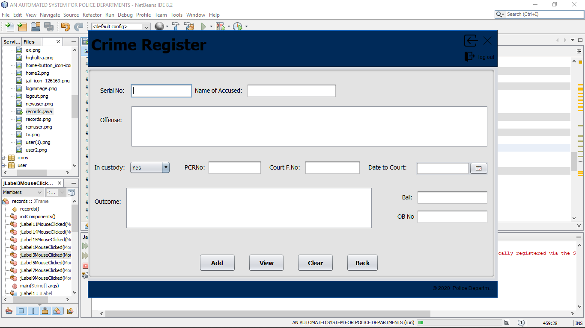

The button shows the interface below.

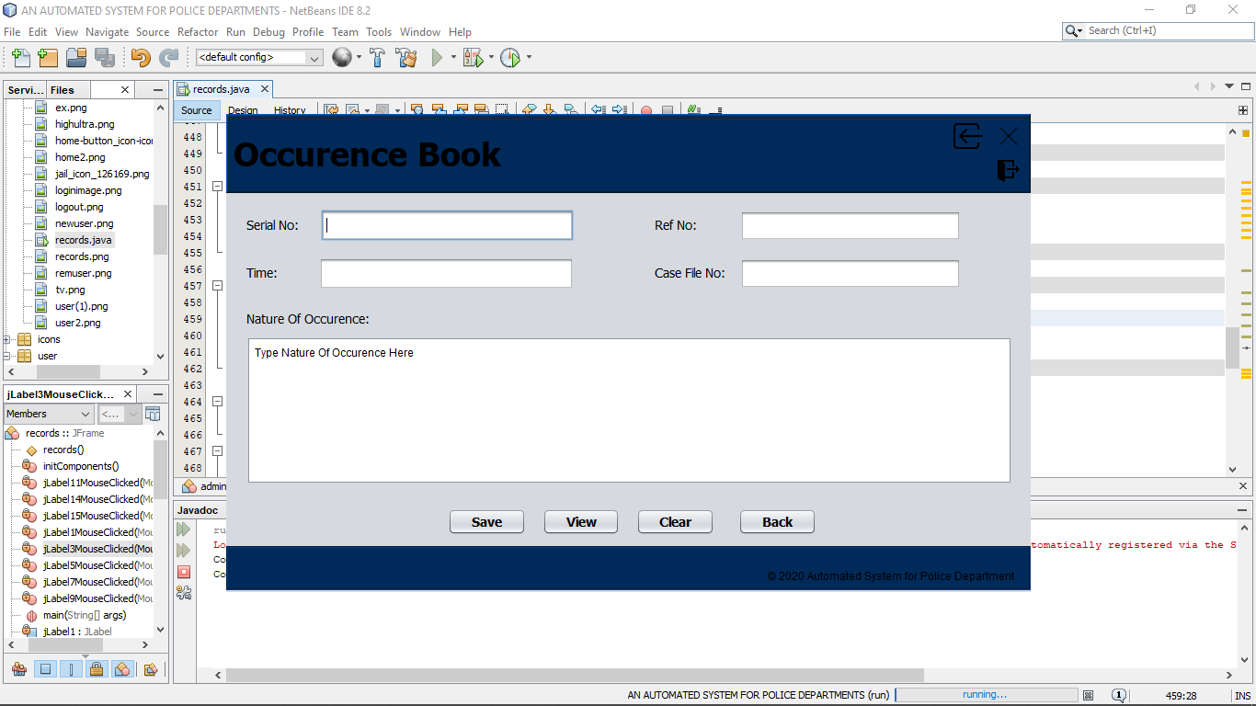

The button petty crime register shows the interface below.

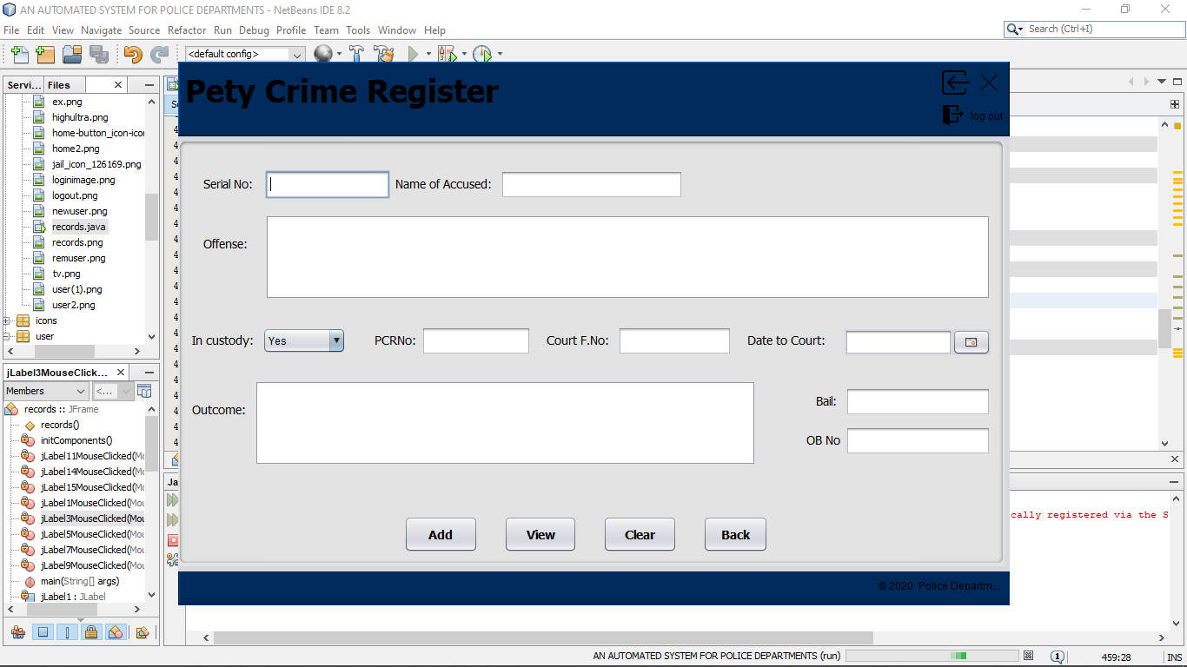

The button traffic crime register shows the interface below.

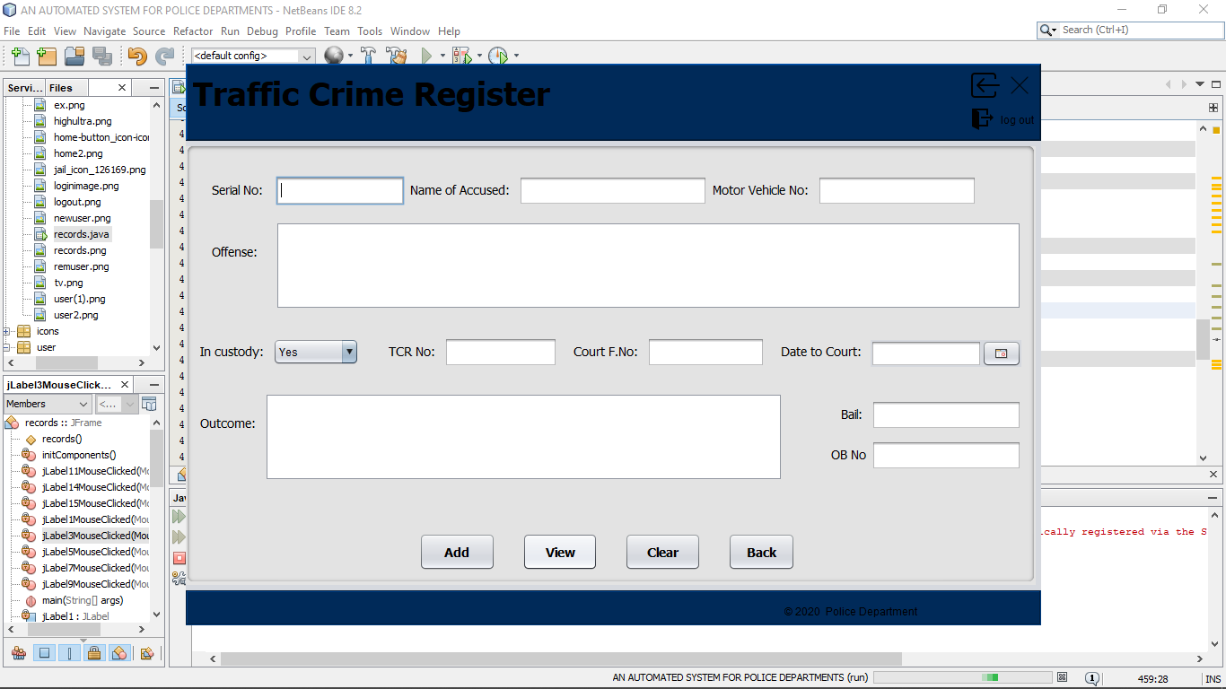

When the admin enters the authentication details, a different interface is displayed, it similar to that of the user but comes with other three components. The arms record, which keeps the record of police officers and the ammunitions in their custody. It also displays an interface which allows the admin to a add an officer into the database or delete an officer from the system in the occurrence of transfers. The admin should see the interface a shown below.

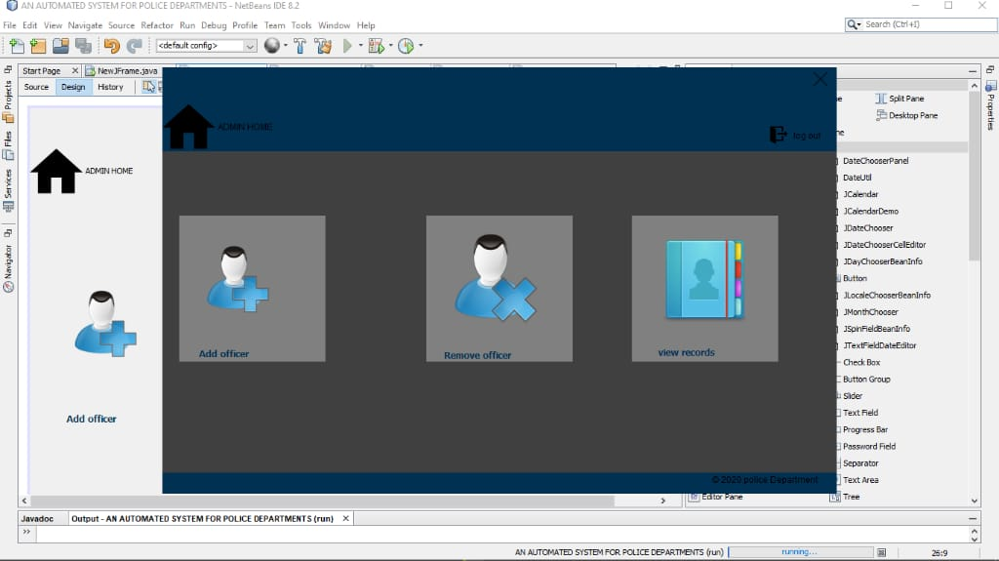

When the add officer button is clicked, the interface below is displayed. Which enables admin to add, delete and view a new officer into the system.

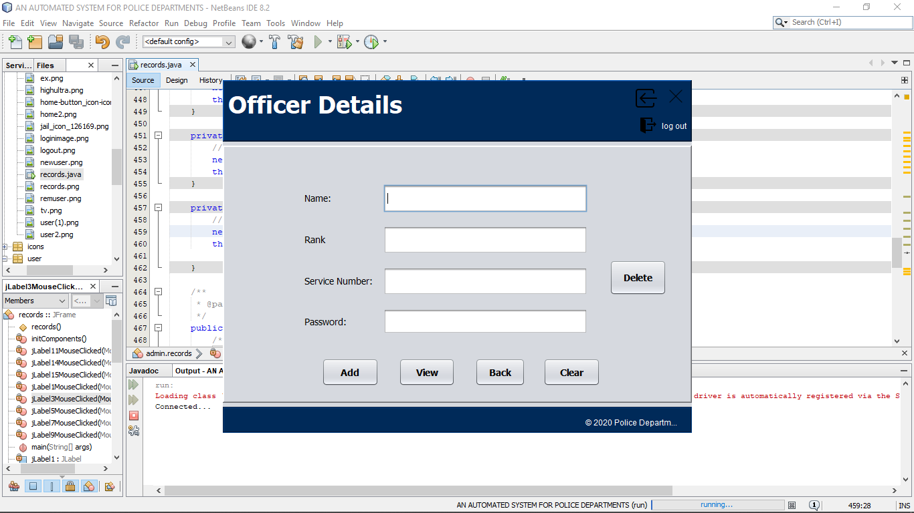

When the remove officer button is clicked, the interface below should be displayed.

The interface allows admin to search and delete for an officer.

When the button records is clicked the interface below is displayed. The arms record is used by the admin to keep the records of the officers and a description on how they are armed.

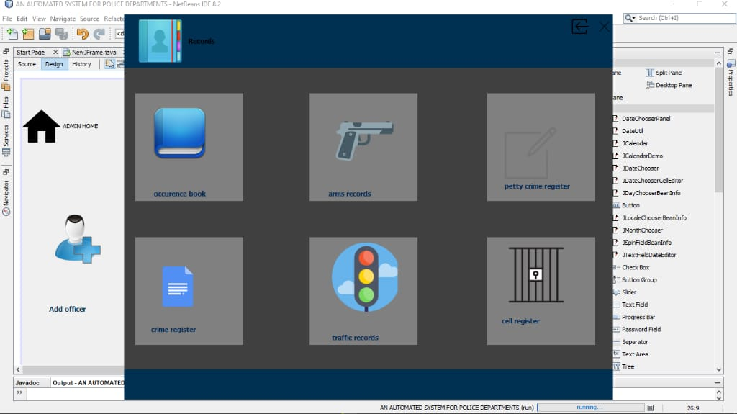

Arms record shows the interface below.

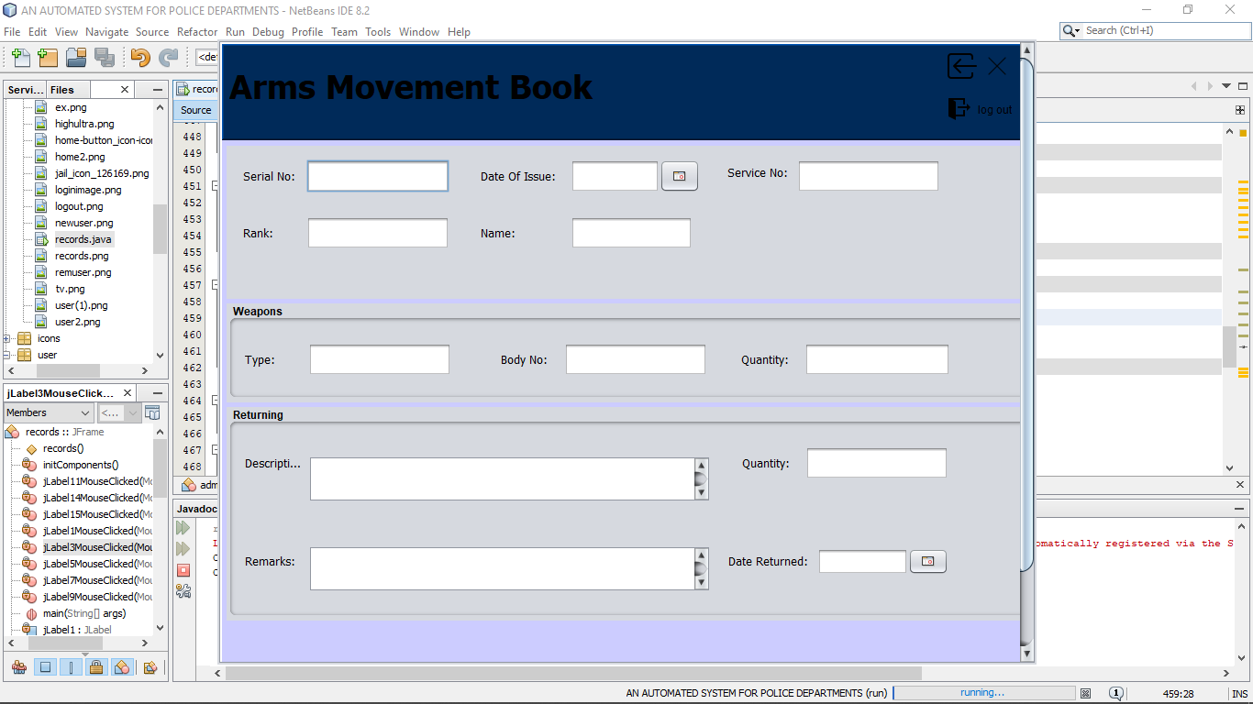

### 5.2.2 Unit Testing

Login Page

* The user or admin clicks the application
* An interface prompting a service number and password is displayed
* Service number and password are entered and one can click the button indicated show password to check whether the password is correct
* If the login credentials are correct, login into the system is validated. Else a pop message prompting the user to enter the correct service number and password.

Admin Dashboard

* The admin can write or read into any register and the occurrence book.
* Admin can write or read into the arms record book
* Admin can add officer into the system if the officer deployed to work at the station
* Admin can remove and officer from the system if the officer is transferred to another station.

User Dashboard

* The user can write or read any register
* User can also write into the occurrence book.

### 5.2.3 Integration Testing

When all modules are linked together, system should identify the user from the admin and log them to their specific dashboards. The user should be allowed to save records as well as the admin. Both of them can login at a later date and access the records kept.

### 5.2.4 System Testing

We presented the system to our Supervisor, Madam Carren and she tested the system functionalities. The system was fully functional as declared inn our proposal.

### 5.2.5 Acceptance Testing

We did an acceptance testing by giving one our friends to do a system check. He did manipulate the system well as described in the proposal. We took another step and visited the police station and explained to one officer Alfred Kirwa how the system works. He worked well with the system and even managed to book a case in the occurrence book.

# **CHAPTER SIX**

## Implementation and Deployment

## 6.1 Introduction

The project Automated Management System for Police Department is implemented using an object-oriented programming language with an inclusion of database connectivity for storage purposes. The deployment will be done manually by the team to one police post before being available online for download.

## 6.2 System Specification

Our project is a desktop application which is fully based on java, which has been used to design the graphical user interface and some its functionalities. We did used SQL queries to connect with the database.

## 6.3 Deployment

The Automated Management system for police department being a desktop application it can be used with any computer. We decided we would set it up at Kabiruini police station before being fully deployed to the entire police unit. Our project is similar to the one deployed by cs Matiangi which is currently in use in Embakasi. We shall explain the functionality of the system at Kabiruini. We shall also circulate manuals on how to use the application to ensure every officer will know how to use the system.

# **CHAPTER SEVEN**

## Conclusion and Recommendation

## Conclusion

The system automated management system for police department can be used in police stations to keep records and simply the task of writing into the bulky registers which are vulnerable to tear and theft. Given that the automated system provides backup, loss of information is not a case as in the manual process.

The automated system initiates the objective of providing the user with customized and powerful keeping of records in registers such as petty crime register, crime register, arms record book and the occurrence book. All the requirements specified during the analysis and design phase are fully met, thus resulting in the formation of good software. The interface provided is very user friendly and flexible for all times.

## Recommendation

We would like to recommend the use of this software in many police department since it will ease the process of managing files in a police station. With availability with enough resources we can make this application an online software. This enables officers to book and monitor their registers from anywhere.

## Challenges

* Most police officers lack the basic skills on how to use a computer.
* Courts prefer written document by hand, therefore, producing a soft copy of the occurrence book can be a challenge.
* There will be need of installation of computers in the reporting desk for police officers.
* Creating awareness to the police unit.

## References

* Chaiken, Jan M. and P. *Computer Programs for Allocating Police Patrol Cars.* Santa Monica,

California: the Rand Corporation. January 1975.

* Greenwood et al. *The Criminal Investigation Process*. Volume III : observation analytics. Santa Monica, California: the Rand Corporation. 1975
* Tie Occurrence Book Automation to standardized fines system. Sunday January 20 2019. Daily Nation.