**Speaking Hands: “A sign language translation glove”**

Samarth (B21221) Peeyush (B21112)

# Under the supervision of

Dr. Deepak Sachan [dsachan@iitmandi.ac.in](mailto:dsachan@iitmandi.ac.in) Dr. Rahul Shrestha

[rahul_shrestha@iitmandi.ac.in](mailto:rahul_shrestha@iitmandi.ac.in)



**Indian Institute of Technology Mandi**

# Certificate

This is to certify that the work contained in the project report entitled **“Speaking Hands: A sign language translation glove”**, submitted by G-43 to the Indian Institute of Technology Mandi, is a record of bonafide research works carried out by them under our direct supervision and guidance.

Dr. Deepak Sachan Signature and Date

Dr. Rahul Shrestha Signature and Date

# Acknowledgements

The completion of this project would not have been possible without the participation and assistance of a lot of individuals contributing to this project who guided us all along in this project. We owe a special thanks to our mentors, Dr. Deepak Sachan and Dr. Rahul Shrestha and also our T.A., Mr. Prashant Kumar for guiding us throughout the project. We also thank the IIT Mandi administration for giving us this opportunity to research problems in our society directly.

# Abstract

Deaf and Mute often have a problem of communication with the outer world and their messages do not get conveyed. One of the major reasons for this is the fact that literacy in sign language is far from what it should be so that normal people can understand what is being said by the differently abled person. In such conditions the disabled person feels helpless and treats himself differently from society. Therefore, we are going to make a product which can solve this problem using technology.

The title of our project is “Speaking Hands: A sign language translation glove”. The working of our product is such that the gestures made by the disabled person will be sensed by gyroscope and potentiometers. The sensors will send the values which determine the positioning of hand and it will detect the gesture with the help of artificial intelligence. The meaning of the gesture will then be produced as a speech using voice module.

**Contents**

|  |  |
| --- | --- |
|  |  |
| 1. Certificate | 2 |
| 2. Acknowledgement | 3 |
| 3. Abstract | 4 |
| 4. List of Figures | 6 |
| 5. List of Tables | 7 |
| 6. Abbreviations  7. Chapter 1: Introduction | 8  9 |
| 8. Chapter 2: Market Research | 11 |
| 9. Chapter 3: Conceptual Design | 14 |
| 10. Chapter 4: Embodiment and Detailed Design | 18 |
| 11. Chapter 5: Fabrication and Assembly | 27 |
| 12. References | 32 |
|  |  |
|  |  |
|  |  |
|  |  |
|  |  |
|  |  |

# List of Figures

* Figure 1: A flowchart of different approaches to the problem statement. 15
* Figure 2: Hardware Architecture. 18
* Figure 3: Potentiometer. 19
* Figure 4: Gyroscope Module. 19
* Figure 5: Transceiver Module. 20
* Figure 6: Amplifier. 20
* Figure 7: Arduino Nano. 21
* Figure 8: Teensy 4.1. 21
* Figure 9: SD Card 32GB. 22
* Figure 10: System-level design. 22
* Figure 11: Top-view 24
* Figure 12: Side-view 25
* Figure 13: Bent-fingers -view 25

# List of Tables

* Table 1: Different Project Ideas 16
* Table 2: Budget Details 27

# Abbreviations

* UNI: User Network Interface
* ASL: American Sign Language
* AI: Artificial Intelligence
* IoT: Internet of Things

# Chapter 1 Introduction

## 1. Background of the problem

Sign language is a natural way of communication between normal and mute people. It is mostly dependent on hand gesture recognition. However, it is not easy for people to identify and interpret sign language. Just like google translate translates one language to the other, there is not any medium or platform via which sign language can be converted to speech or visual text. The motive behind this project is to ease this communication barrier along with making communication possible between mute and blind people.

The device includes gloves with potentiometers, gyroscope, arduino model and SD- cards to detect every hand gesture and thereby read it and convert it to audio. The system consists of both physical and non-physical communication. Other developments in this field include artificial intelligence (AI) based image processing models where an image of the gesture is used to detect it, however this is not portable and efficient. Our model is compact and easy to use.

Sign language differs from country to country and is not universally the same like American Sign Language (ASL), British Sign Language and so on. Most of the countries follow ASL and our system is also based on the same.

## 2. Scope of the problem

This model solves a variety of problems from easing communication between mute and normal people, mute and blind people as well providing better understanding between disabled and normal people. **‘Communication is a fundamental human right’** and the greatest ideas and innovations evolve from exchange and interaction. By the help of this project, we are not only helping them communicate but also providing them dignity and recognition.

The problem touches areas of AI/ML (data training), electronics (arduino, potentiometers etc.), physics (gyroscope and orientation) as well as mechanics and manufacturing.

## 3. Design philosophy

Not only is the design of the glove simple and compact, it is also very user friendly. AI and IoT have been used to design and this helps learn from various gestures. The entire project has been completed with a sum that is much less than the amount allotted and hence is cost effective and accessible.

**4. Problem Statement**

American Sign Language to speech (audio) conversion using potentiometers and gyroscope mod.

## 5. Beneficiaries (Intended market)

The market or target audience is large and as per research, India itself is home to approximately 7 million mute people. Not only the Indian market but it can be extended to a global level as well.

## 6. Organization of this report

The whole report is divided into three major sections:

*1. Market Research:* In chapter 2, we discuss the existing products in the market and compare them with our product along with how our product is a better market fit.

*2. Designing:* In chapter 3, we discuss the conceptual design and in chapter 4, the detailed design.

*3. Assembly:* In chapter 5, we discuss the assembly and budget details.

# Chapter 2 Market Research

## Existing Products in Market

There does not exist a similar product in the market, however there is a product UNI which solves the similar problem that uses artificial intelligence to translate sign language into speech. The device uses a camera to capture hand movements, and then sends the data to a cloud-based AI system for analysis and translation.

## Comparison with Current Products

Despite the fact that both products aim to address the same issue, their operating models are rather different. In UNI, the device uses a camera to record hand movements before sending the information to a cloud-based AI system for analysis and translation. However, there is a problem with this approach if the fingers overlap each other with a particular camera angle, making it difficult to detect the perfect position of the fingers and leading to inaccurate statements. However, with our device, sample data points are stored using potentiometers and gyroscope module, 16x200 1D flattened arrays will be used as the data points. Each data point will be identified by an mp3 sound file.

## 3. Problems with Current Alternatives

Some problems associated with the existing alternative are:

I. The UNI hand gesture to speech converter may have a limited vocabulary, which means it may not be able to recognize all gestures and translate them accurately.

II. The accuracy of the translation may be affected by factors such as lighting conditions, distance from the device, and the user's hand movements. This can lead to errors in translation.

III. Users may need to undergo training to learn how to use the device effectively, which can be time-consuming and may require additional resources.

IV. The accuracy and robustness of the system in UNI can be affected by changes in camera angle, and there are also issues with camera stability.

**4. Our Product vs Existing Alternatives**

In the existing alternatives in the market, one of the main challenges with camera- based hand gesture recognition systems, such as the UNI system, is the potential for interference from the surrounding environment. Changes in lighting conditions, occlusions, and variations in camera angle can all affect the accuracy and robustness of the system. Additionally, camera-based systems may struggle to recognize hand gestures made behind the back or in positions that are not visible to the camera. Another issue with camera-based systems is the potential invasion of privacy, as the use of cameras may be perceived as intrusive in some contexts.

Finally, camera-based systems may require more processing power and specialized equipment compared to our product.

In our product we developed our own library that is training mode and testing mode. In the training mode, users could perform various hand gestures while wearing the gloves, and the system would record and analyze the sensor data to identify the unique characteristics of each gesture. This could then be used to train a machine learning model to recognize and classify hand gestures. Once the training process is complete, the machine learning model is able to make predictions for new inputs by applying the learned relationships between the input features and output labels. This is known as the testing or inference phase of the machine learning system. Overall, the training mode of a machine learning system can accurately recognize patterns and make predictions for new inputs. This does not imply that our current product is faultless or defect free.

Some issues with our product are also present, such as the fact that the range of hand motions the gloves can recognise may be limited due to the potentiometers range of motion. The size of the dataset used to train the machine learning model may have a limit on the number of hand motions that the gloves can recognise. Overall, both systems have their advantages and disadvantages, and the choice of system depends on the specific use case and requirements.

# Chapter 3 Conceptual Design

## How did we find our problem statement?

Initially, we had come up with a couple of ideas or problem statements. They consisted of automatic water tank cleaning robot, solar panel cleaning robot, convertible wheelchair, voice system for people who cannot speak, etc. Then, upon discussing with our mentors and considering the novelty of the idea we decided to go with the voice system idea. Our problem statement was -

"Deaf and Mute people often face difficulties in communicating with rest of the society as most of us are unaware of sign language. This makes them feel helpless and different from other people."

## 2. Brainstorming and Idea Generation

Our first implementation method involved use of potentiometers and accelerometers attached to hand gloves along with microcontroller. The potentiometers capture the movement of fingers and hands through bending of fingers which changes the resistance of potentiometer and corresponding voltage value is recorded in the microcontroller. Then, the alphabets from the sign language are recognized and given as output in form of voice.

However, on investigating further we found that this method is very common with many papers written about it. Also, we got to know about some limitations like the user would have to always carry the camera which can be hassle sometimes, accuracy and processing time can also affect user experience.

Hence, we came up with the idea of using gyroscope and potentiometers for capturing the gestures and then using AI for recognizing the gesture meaning.

We decided to use an **MPU6050 MEMS Gyroscope** which fits in the processing power limit, is easy to carry and use. The calculated values from sensors would then go through the AI model which would recognise the meaning

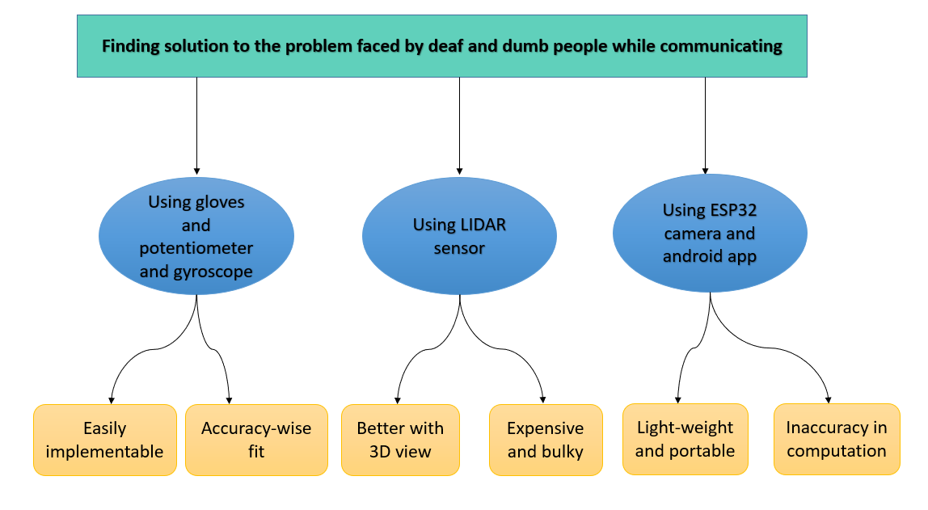

*Fig 1: A flowchart of different approaches to the problem statement.*

of gesture and convey it in the form of text. We then had discussions about the size of gyroscope, its power source, the position where it should be placed on the glove, the connections, etc.

## 3. Project Selection

The different problem statements that we initially encountered were mainly related to daily challenges faced by an individual. While listing down these scenarios, we found that the basic need of an individual for survival is communication. If we are not able to explain/ put up our point in front of others,

we feel suffocated. Similarly, it is happening with the disabled people. As communication is a fundamental human right. It is always possible between at least two people with the condition that both can understand each other’s message. When the facts related to the above statement were presented before the team, the team unanimously decided to work in the field of communication for disable people.

After discussing with the mentors and the group members we concluded that we would select **Speaking Hands: “A sign language translation glove”** as our final project. The reason behind choosing this project is:

Most of the projects which we had discussed are available in the market and can be easily implemented. Our project is also available (using potentiometers) but we can implement it by using voice module, gyroscope and AI (which is not present in the market) which help us to learn something new. As a solution to problem definition, our method is also realistic and affordable than the others.

|  |  |  |  |  |  |
| --- | --- | --- | --- | --- | --- |
| Criteria/ Ideas | Learning | Innovation | Cost to develop (0: High cost  5: least cost) | Outreach (More people is better) | Total |
| Solar panel cleaning robot | 5 | 1 | 3 | 5 | 14 |
| Automatic water tank cleaning robot | 2 | 3 | 3 | 1 | 9 |
| Convertible wheelchair | 3 | 2 | 2 | 4 | 11 |
| **Speaking Hands** | **5** | **4** | **4** | **3** | **16** |
| Smart glasses | 2 | 4 | 2 | 3 | 11 |

*Table 1: Different Projects that we thought of.*

Problems faced by the disabled person regarding communication can be overcome by our method. So, in the implemented work a gyroscope along with the AI model is developed which can convert gestures into voice output.

The idea is to recognise gestures and to understand the gesture using positioning of hand which is calculated using potentiometers and gyroscope. Since we get the orientation of our hand, our main work is to study the coordinates obtained and then we can recognise the gesture using AI that can help to explain the sign languages. Hence, this idea can be implemented to complete our product.

**4. Advantage**

I. One of the main advantages of the system is its wireless communication, which allows for greater mobility and ease of use for the user.

II. The use of the Teensy 4.1 microcontroller provides a powerful processing capability for real-time data analysis and transmission.

III. The use of potentiometers and MEMS gyroscopes also makes the system more accurate and sensitive to the user's hand movements.

IV. If manufactured efficiently, this could cost as little as Rs. 2500 for all the hardware combined.

# Chapter 4 Embodiment and Detailed Design

1. **Product Architecture**

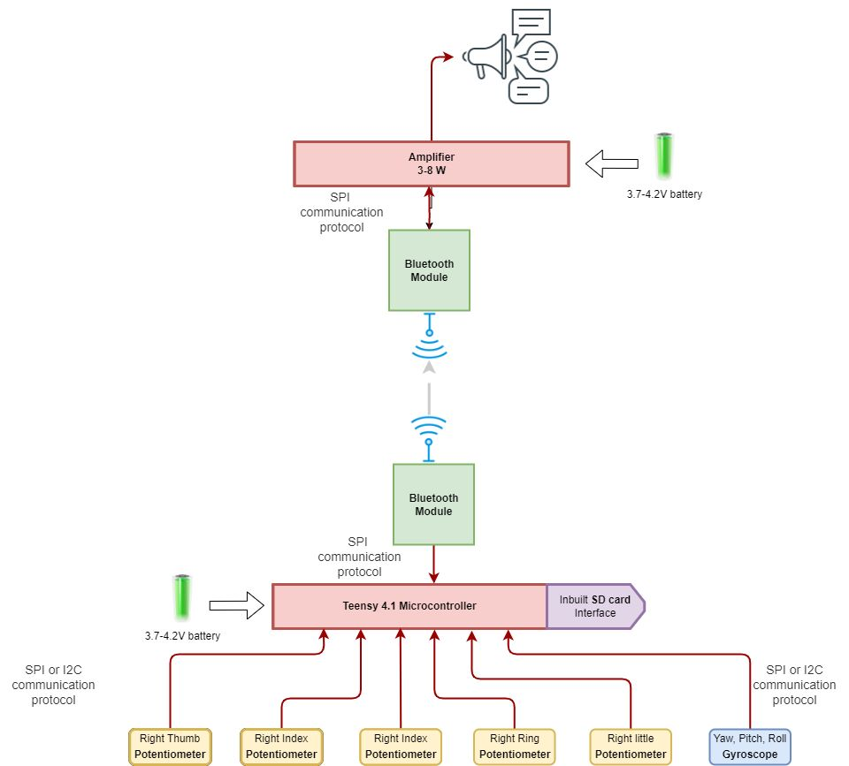

*Fig 2: Hardware Architecture.*

The working principle of the hardware architecture includes

**Potentiometer**- A **potentiometer** is a three-[terminal](https://en.wikipedia.org/wiki/Terminal_(electronics)) [resistor](https://en.wikipedia.org/wiki/Resistor) with a sliding or rotating contact that forms an adjustable [voltage divider](https://en.wikipedia.org/wiki/Voltage_divider) If only two terminals are used, one end and the wiper, it acts as a **variable resistor** or **rheostat**.

The measuring instrument called a [potentiometer](https://en.wikipedia.org/wiki/Potentiometer_(measuring_instrument)) is essentially a [voltage divider](https://en.wikipedia.org/wiki/Voltage_divider) used for measuring [electric potential](https://en.wikipedia.org/wiki/Electric_potential) (voltage); the component is an implementation of the same principle, hence its name.

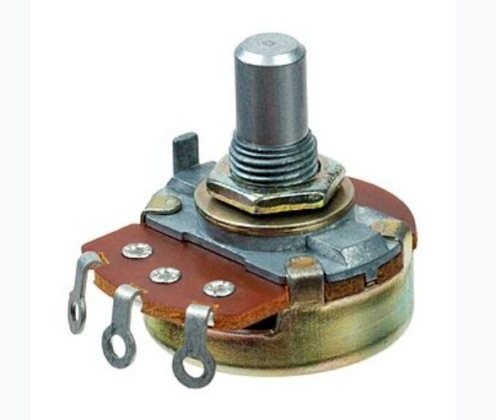

*Fig 3: Potentiometer.*

* **MPU6050 MEMS Gyroscope** – Gyroscopes use the Coriolis Effect to detect angular velocity, or how quickly the body is turning, as opposed to accelerometers, which measure acceleration along a three-axis. The basis for all MEMS gyroscopes with vibrating elements is the transfer of energy between two vibration modes brought on by Coriolis acceleration. An apparent acceleration that can be seen in a rotating frame of reference is the Coriolis acceleration, which is proportional to the angular velocity. We use the Yaw, Pitch, and Roll data that each gyroscope sends us to establish the orientation of our hand in space in our project.

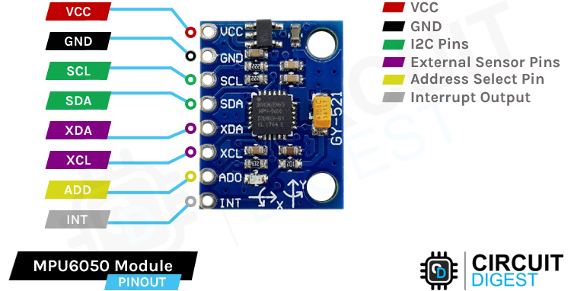

*Fig 4: Gyroscope Module.*

* **nRF24L01 Transceiver Module** - The nRF24L01 is a wireless single chip transceiver RF module with data sending and receiving capabilities on each module. The technology is permitted for engineering purposes in practically all nations because it uses the 2.4 GHz ISM range (with the global ISM frequency spectrum at 2.400 - 2.4835GHz). The nRF24L01 module is utilised in our project to transmit data from the left hand's potentiometer and gyroscope to the right hand, where our main microcontroller Teensy 4.1 performs some processing. Another nRF24L01 module, which would receive the mp3/mp4 voice format from the primary teensy microcontroller, is installed in the speaker box.

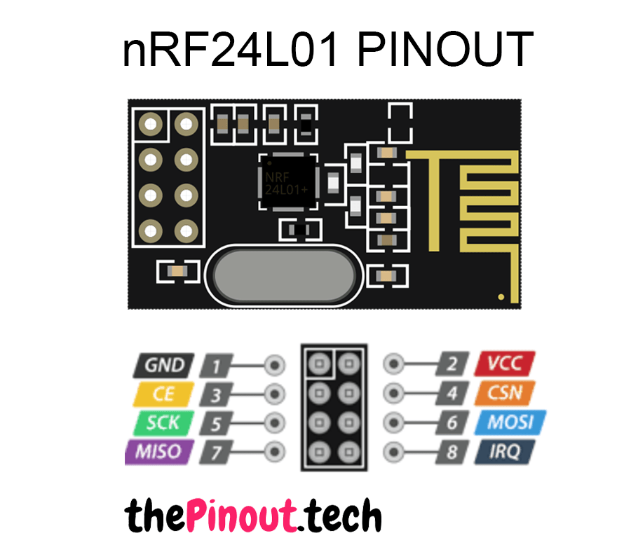

*Fig 5: Transceiver Module.*

* **Amplifier** - The idea behind an amplifier is to create an output signal that is a copy of the input signal but with a stronger magnitude. Recall that amplifiers increase or strengthen weak signals without altering input or data. The nRF24L01 module's signal will be amplified by the amplifier before being transferred to the speaker for playback.

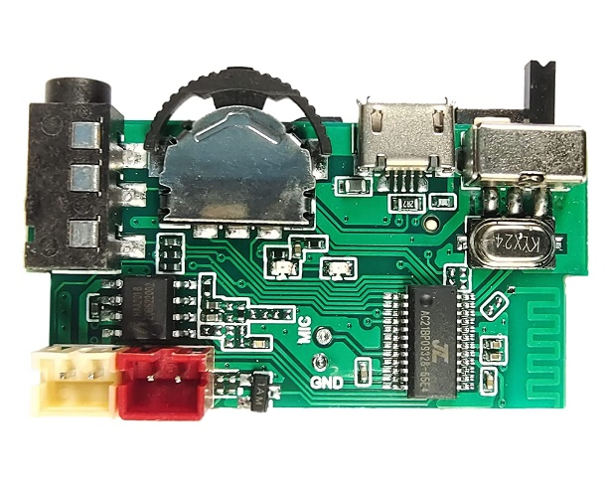

*Fig 6: Amplifier.*

* **Arduino Nano** - Small and straightforward, an Arduino Nano is a microcontroller. This is used to decode signals that are received in the speaker box via nRF24L01 or to process signals that are to be forwarded to the main microcontroller via nRF24L01.

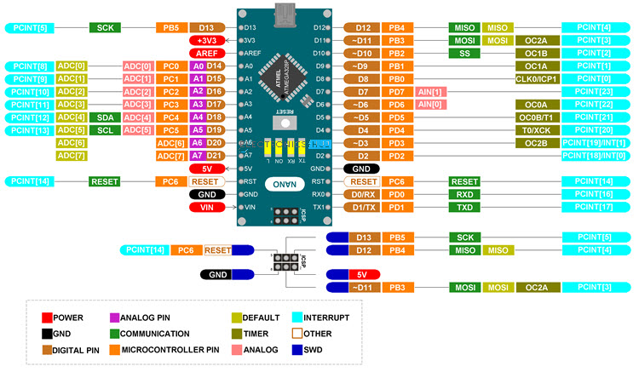

*Fig 7: Arduino Nano.*

* **Teensy 4.1** – With its ARM Cortex-M7 processor running at 600MHz in Teensy 4.1, a genuine real-time microcontroller platform, many potent CPU functions are now available. The performance of the CPU is much faster than that of standard 32-bit microcontrollers. The main USB port on Teensy serves as the device's principal communication interface and runs at 480 Mbit/sec speed in USB device / peripheral mode. 55 Total I/O Pins, 1 SDIO (4 bit) Native SD, 3 SPI, all with 16-word FIFO, 8 Serial Ports, 35 PWM pins, 18 analogue inputs, microSD Card Socket, and Power On/Off control are some additional features of the Teensy 4.1.

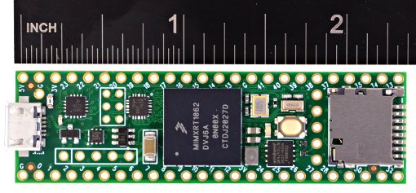

*Fig 8: Teensy 4.1.*

* **SD Card 32GB –** The array of data (10 inputs from potentiometer plus 3+3 inputs from gyroscope) is stored on an SD card for use in training. When the hardware is in testing mode, the teensy will compare the newly obtained data with all the training data points stored in the SD card module. The mp3/mp4 file corresponding to the training data point that most closely matches the newly acquired data point will then be sent to the speaker box via the nRF24L01 module for playing sound.

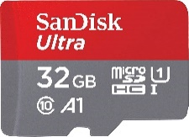

*Fig 9: SD Card 32 GB.*

1. **System-level Design** - The graphic below illustrates how each subcomponent or module interacts with one another at the product level.



*Fig 10: System-level design.*

* **SPI Communication Protocol** - SPI is a synchronous communication protocol that is intended for board-level communication across short distances. It transmits and receives data concurrently at high data transfer speeds. When several devices need to communicate, the SPI communication interface is ideal.
* **I2C Communication Protocol** - I2C uses messages to transfer data. Data frames are used to segment messages. Each message consists of an address frame that contains the slave's binary address and one or more data frames that hold the information being sent. In addition, the message contains read/write bits, ACK/NACK bits in between each data frame, and start and stop conditions.

1. **Design Configuration**

All the parts attached to the gloves are part of the project's basic design. To monitor twisting motions, the potentiometers were positioned above the fingers. The microcontroller and gyroscope module will be attached to the area between the wrist and knuckles. Near the wrist of the gloves, the battery will be fastened. The material for the gloves will be pleasant, sweat-resistant, anti-static, and made of thin material.

There will be a pin-style attachment within the speaker box. The user will find it simple to mount the speaker box on the shirt collar thanks to the attachment. A 3D-printed speaker box will be used.

**4. Detailed Design**

·   **Electrical/Electronic aspect:**

**Potentiometers** –

A **potentiometer** is a three-[terminal](https://en.wikipedia.org/wiki/Terminal_(electronics)) [resistor](https://en.wikipedia.org/wiki/Resistor) with a sliding or rotating contact that forms an adjustable [voltage divider](https://en.wikipedia.org/wiki/Voltage_divider). If only two terminals are used, one end and the wiper, it acts as a **variable resistor** or **rheostat**.

The measuring instrument called a [potentiometer](https://en.wikipedia.org/wiki/Potentiometer_(measuring_instrument)) is essentially a [voltage divider](https://en.wikipedia.org/wiki/Voltage_divider) used for measuring [electric potential](https://en.wikipedia.org/wiki/Electric_potential) (voltage); the component is an implementation of the same principle, hence its name.

.

**MPU6050 Gyroscope module** –

16-bit data output and a 16-bit AD converter are included into the MPU6050 chip. It offers raw data, rotation matrix, quaternion, and Euler Angle formats for I2C Digital-output of 6 or 9-axis Motion Fusion data. Motion Fusion, sensor timing synchronisation, and gesture identification are complicated tasks that are offloaded by the built-in Digital Motion Processing (DMP) engine. This is used to eliminate drag that develops over time. Additionally, it has a temperature sensor with digital output.

**nRF24L01 Transceiver Module**–

The nRF24L01 transceiver module is especially suited for industrial control applications because of its maximum operating speed of 2Mbps, GFSK modulation efficiency, and anti-interference ability. To satisfy the demands of communication, it offers 125 channels, multi-point communication, and frequency hopping. Multipoint connection address control and built-in hardware CRC error detection are both present. It uses extremely little power—1.9 to 3.6V, or about 1uA when in power-saving mode. Additionally, it contains a built-in voltage regulator, 2.4 GHz antenna, and Standard DIP Pitch Interface for embedded applications.

·       **Software part:**

Using the Arduino IDE, the project's primary coding is carried out.

To calibrate and modify the outputs of the potentiometer to suit our needs,

we have developed our own library. There will primarily be two operating

modes:

1. Training Mode
2. Testing Mode

Some labelled sample datapoints will be stored in the SD card module during the training mode. The data points will be a 16x200 1D flattened array. An mp3/mp4 sound file will be used to identify each data point.

The user's hand motions in testing mode will produce a new datapoint, a 16x200 array-sized datapoint. All the previously stored data points on the SD card will be compared to this new data point. The absolute mean error will be used as the foundation for comparison. The training data point will be deemed a match if it has the lowest absolute mean error in relation to the new data point and meets a minimal threshold criterion. The nRF24L01 module will transmit the mp3/mp4 file associated with the match to the speaker box, and the amplified signal will then be broadcast through the speaker.[2]

·       **Mechanical Aspects:**

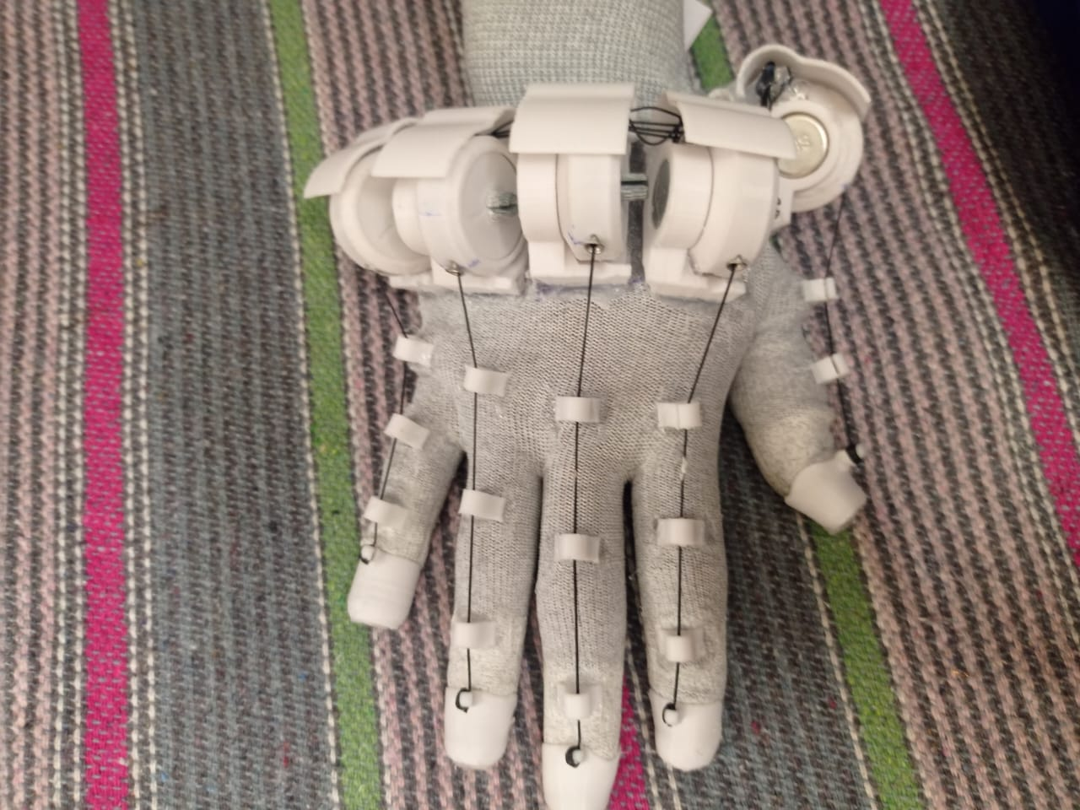

*Fig 11: top-view.*

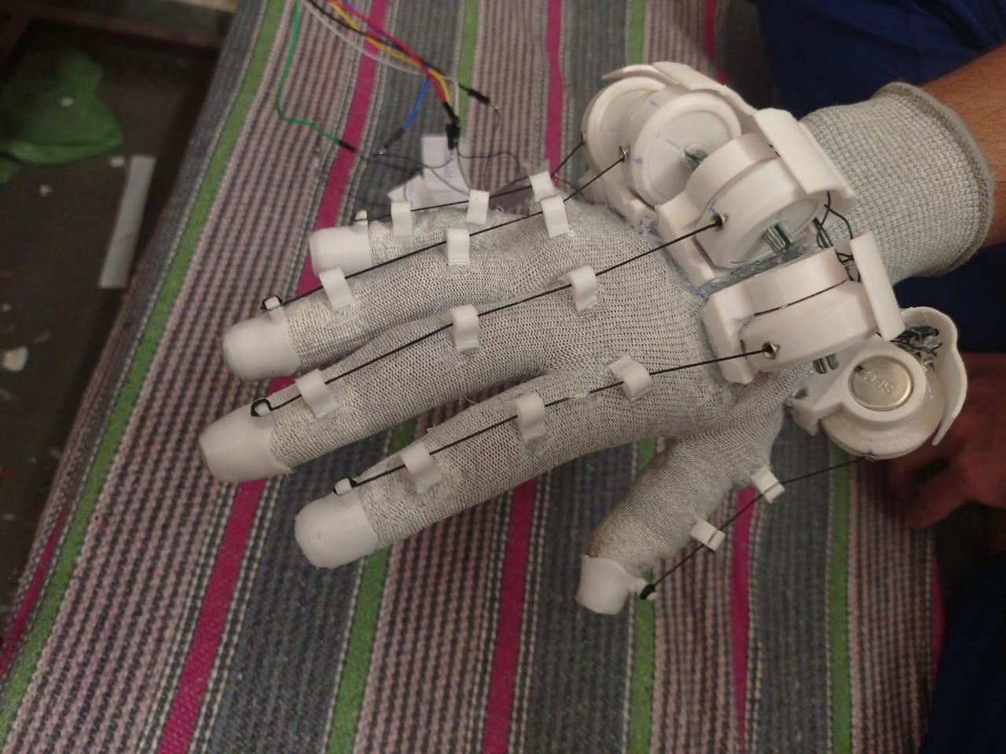

*Fig 12: side-view.*

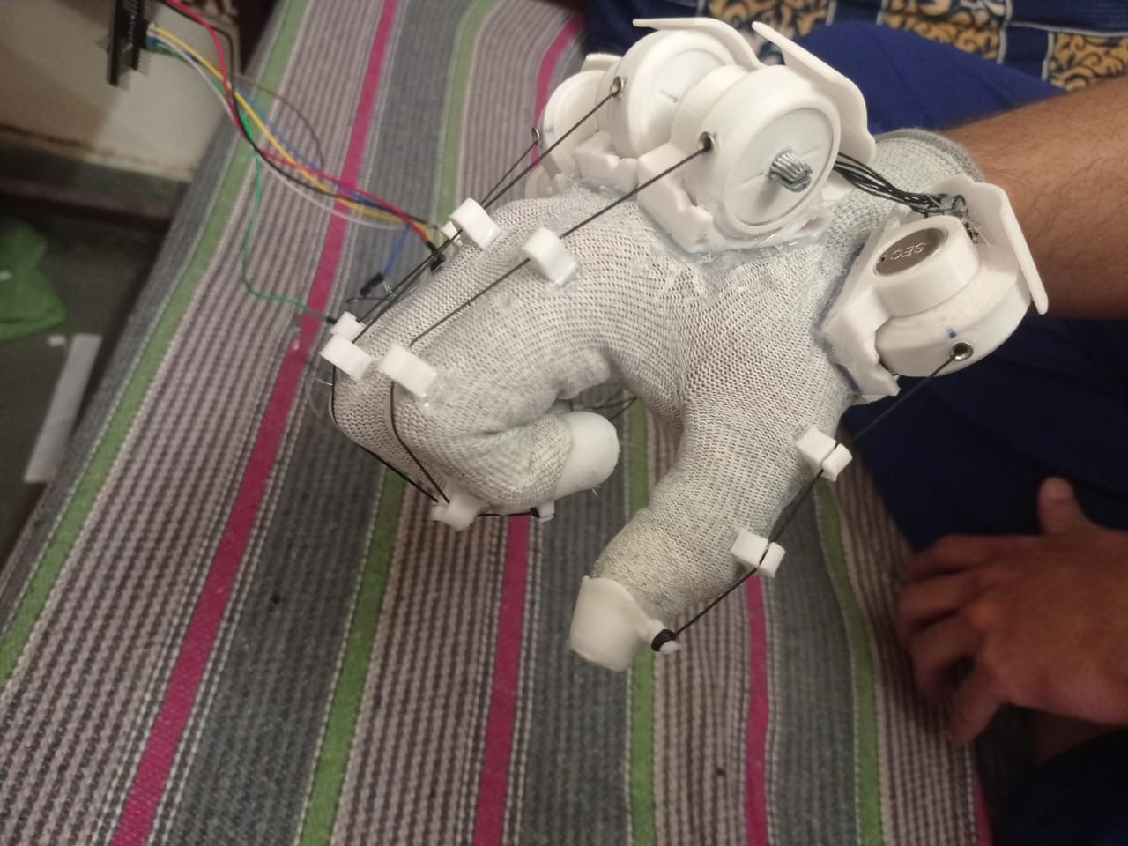

*Fig 13: bent fingers-view.*

1. **Results and Discussion**

Based on the design and implementation of the smart glove system, we were able to successfully track the finger movements and hand orientation of the user in real-time. The potentiometers were able to accurately detect the amount of bending in each finger, which was then transmitted to the main microcontroller through the nRF24L01 transceiver module. The MPU6050 MEMS gyroscope also provided accurate yaw, pitch, and roll values, which helped in determining the orientation of the hand in space. The Teensy 4.1 microcontroller was able to process the data received from the sensors and transceiver modules, and send the appropriate mp3/mp4 file to the speaker box for playing sound.

The smart glove system has various potential applications in the field of virtual reality, gaming, and medical rehabilitation. In virtual reality, the system can be used to track the hand movements of the user and provide a more immersive experience. In gaming, the system can be used as a controller for various games, providing a more natural and intuitive way of interacting with the game. In medical rehabilitation, the system can be used to monitor the progress of patients with hand injuries or disabilities, and provide feedback to the patient and healthcare provider.

One of the main advantages of the system is its wireless communication, which allows for greater mobility and ease of use for the user. The use of potentiometers and MEMS gyroscopes also makes the system more accurate and sensitive to the user's hand movements. Additionally, the use of the Teensy 4.1 microcontroller provides a powerful processing capability for real-time data analysis and transmission.

However, there are also some limitations to the system. One limitation is the cost of the components, which can be expensive for some users. Another limitation is the need for calibration of the sensors, which may require some expertise in electronics. Furthermore, the system may not be suitable for users with severe hand disabilities or injuries, as the sensors may not be sensitive enough to detect their hand movements.

In conclusion, the smart glove system has demonstrated the potential for various applications in virtual reality, gaming, and medical rehabilitation. Further development and improvements in the design and functionality of the system can provide even greater benefits for users in these fields. [3]

# Chapter 5

**Fabrication and Assembly**

1. **Budget Details**

|  |  |  |  |
| --- | --- | --- | --- |
| **S.NO.** | **Name of Items** | **Cost of Item** | **Quantity** |
| 1 | Jumper wires | 269 | 1 |
| 2 | Battery | 963 | 1 |
| 3 | NRF24L01 | 1300 | 1 |
| 4 | Mpu6050 gyroscope | 1036 | 2 |
| 5 | Esp32 Feather | 5745 | 1 |
| 6 | Tie cable | 180 | 1 |
| 7 | Gloves (Pair) | 250 | 1 |
| 8 | Flex sensor (major) | 5100 | 6 |
| 9 | Arduino nano | 490 | 1 |
| 10 | Hot glue gun | 363 | 1 |
| 11 | Shrink tube | 159 | 1 |
| 12 | SD card | 359 | 1 |
| 13 | Charging module | 698 | 1 |
| 14 | Teensy | 3430 | 1 |
| 15 | Flex sensor (minor) | 1960 | 4 |
| 16 | String | 349 | 1 |
| 17 | Spray | 139 | 1 |
| 18 | Potentiometer | 440 | 13 |
| 19 | Multimeter | 506 | 1 |
| 20 | 3D printing | 2410 | 1 |

*Table 2: Budget Details.*

**2. Manufacturing Process Description**

Sign to speech gloves are devices designed to translate sign language into spoken language, making it easier for people who are deaf or hard of hearing to communicate with those who do not know sign language. The manufacturing process for sign to speech gloves involves following steps:

**Design:** This involves creating a 3D model of the gloves, including the sensors, microcontrollers, and other electronic components that will be embedded in the gloves.

**Material selection:** Once the design is finalized, the materials for the gloves are selected. This includes choosing a flexible, durable, and breathable material for the gloves, as well as selecting the appropriate electronic components.

**Fabrication:** The gloves are then fabricated using the selected materials. We use glue gun to paste support for potentiometers as well as embedding the electronic components into the gloves.

**Sensor calibration:** After the gloves are fabricated, the sensors are calibrated to ensure accurate measurement of finger movements. This involves programming the microcontrollers to interpret the sensor readings and translate them into sign language.

**Testing:** Once the software is developed, the gloves are tested to ensure that they accurately translate sign language into spoken language. This involves testing the gloves with individuals who know sign language and verifying that the spoken language output is correct.

**Production:** After testing, the gloves are ready for production. The gloves are manufactured in batches, and each batch undergoes quality control to ensure that the gloves meet the required specifications.

**Packaging and shipping:** Once the gloves are manufactured, they are packaged and shipped to distributors or directly to customers.

Overall, the manufacturing process for sign to speech gloves involves a combination of design, materials selection, fabrication, sensor calibration, testing, production, packaging, and shipping. Each step is critical to ensuring that the gloves are accurate, reliable, and effective in translating sign language into spoken language.

**3. Assembly**

First, the electronic components that will be embedded in the gloves are prepared. This includes the microcontrollers, sensors, and other circuitry. Next, the selected fabric for the gloves. This includes the fingers, palm, and wrist sections.

The electronic components are then embedded into the glove. The sensors are placed on each finger to detect the movements of the fingers, while the microcontrollers and other circuitry are placed in the wrist section of the glove.

The wiring between the sensors and microcontrollers is connected and secured in place. The gyroscopes that give the gloves are inserted into the wrist section and connected to the circuitry. The gloves are then programmed to translate the sensor data into sign language using the installed software.

The translated sign language data is then converted into spoken language using the built-in speakers or a connected audio device. The gloves are tested to ensure that they accurately translate sign language into spoken language. This includes testing the gloves with individuals who know sign language and verifying that the spoken language output is correct.

Finally, the gloves are packaged and shipped to distributors or directly to customers.

The assembly of sign to speech gloves requires precision and attention to detail to ensure that the electronic components are securely embedded in the gloves and function correctly. It also involves programming the gloves to accurately translate sign language into spoken language and testing to verify their accuracy.

**4. Limitations and Challenges**

Sign to speech gloves, also known as gesture recognition gloves, are a type of wearable technology that can translate hand gestures and movements into spoken words or text. While these gloves have the potential to revolutionize communication for the deaf and hard-of-hearing communities, there are several limitations and challenges that must be overcome before they can be widely adopted.

Here are some of the limitations and challenges associated with sign to speech gloves:

**Accuracy:** One of the biggest challenges facing sign to speech gloves is accuracy. Hand gestures and movements can be complex and nuanced, and it can be difficult for the gloves to accurately interpret them all. This can lead to errors in the translation of sign language into speech, which can be frustrating and confusing for both the user and the listener.

**Adaptability:** Sign language is not universal and can vary widely between different regions and countries. This means that sign to speech gloves need to be adaptable to different sign languages and dialects. Creating gloves that can accurately recognize a wide range of sign language variations and dialects is a significant challenge.

**Cost:** Developing and manufacturing sign to speech gloves can be expensive, which may limit their availability to those who need them most. Additionally, the cost of maintaining and repairing the gloves can be prohibitively high, which can make them difficult to use over the long term.

**Accessibility:** Sign to speech gloves require users to wear a specialized piece of technology, which can be a barrier to accessibility. Some users may find the gloves uncomfortable to wear, and others may have difficulty operating the gloves due to physical limitations.

**Integration:** Finally, integrating sign to speech gloves into everyday communication can be a challenge. For example, not all hearing individuals are familiar with sign language, and may not know how to respond appropriately when communicating with someone wearing the gloves. Additionally, there may be situations where wearing the gloves is not practical or appropriate, such as in noisy environments or during physical activities.

**5. Contributions**

Every team member contributed equally in every team discussion and has an

equal role in making this project a success.The electrical work by Samarth and the software part by Peeyush .

**6. Conclusions**

This project combines a number of elements and concepts in order to achieve its

aim, which is to build a communication system for deaf and mute people. The working of our product is such that the gestures made by the disabled person will be sensed by gyroscope and potentiometers. The sensors will send the values which determine the positioning of hand and it will detect the gesture with the help of artificial intelligence. The meaning of the gesture will then be produces as a speech using voice module. Though this design still has flaws and can be made more efficient, it still gives a good starting point for anyone to work upon.

**References**

[1] S. Hussain, R. Saxena, X. Han, J. A. Khan and H. Shin, "Hand gesture recognition using deep learning," 2017 International SoC Design Conference (ISOCC), 2017, pp. 48-49, doi: 10.1109/ISOCC.2017.8368821.

[2] Pooja Shah, Jyoti Waykule, Pradnya Patil, Yash Jhunjhunwala, "Sign language to speech conversion using arduino" 2017 International Journal of Recent Innovation in Engineering and Research. Available: <https://www.researchgate.net/publication/339973280_SIGN_LANGUAGE_TO_SPEECH_CONVERSION_USING_ARDUINO>

[3] A. Haritha, A. Ganesh, B. Vishnu Vardhan Reddy, C.H. Vyshnavi, "Sign language to speech converter" 2021 International Journal of Creative Research Thoughts. Available: <https://www.ijcrt.org/papers/IJCRT2106668.pdf>