QNO. 3- LEETCODE (https://leetcode.com/problems/valid-parentheses/ )

ANS-

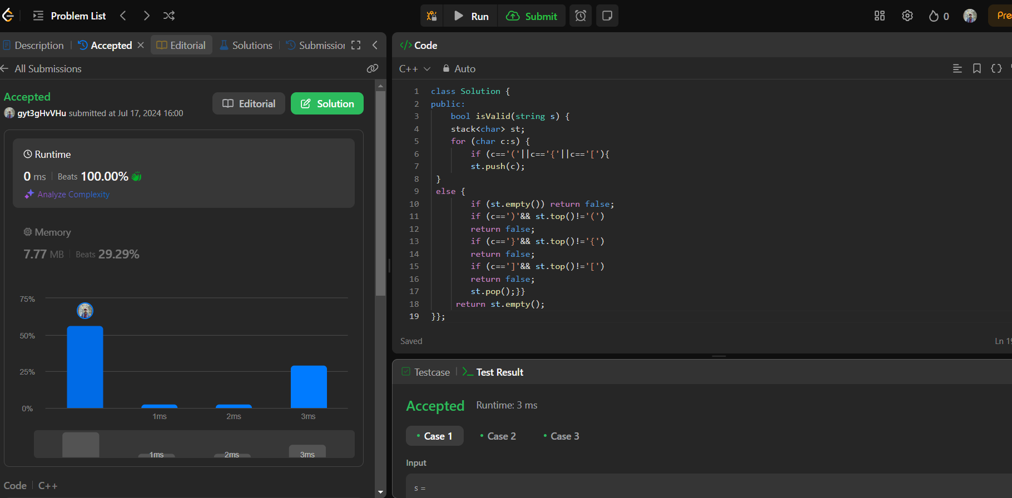

QN0. 4- LEETCODE(<https://leetcode.com/problems/two-sum/description/>)

ANS-

