[NTSWSR-2260](https://onejira.verizon.com/browse/NTSWSR-2260) Dev Test Evidence

1. **Adding New fields in tracker**

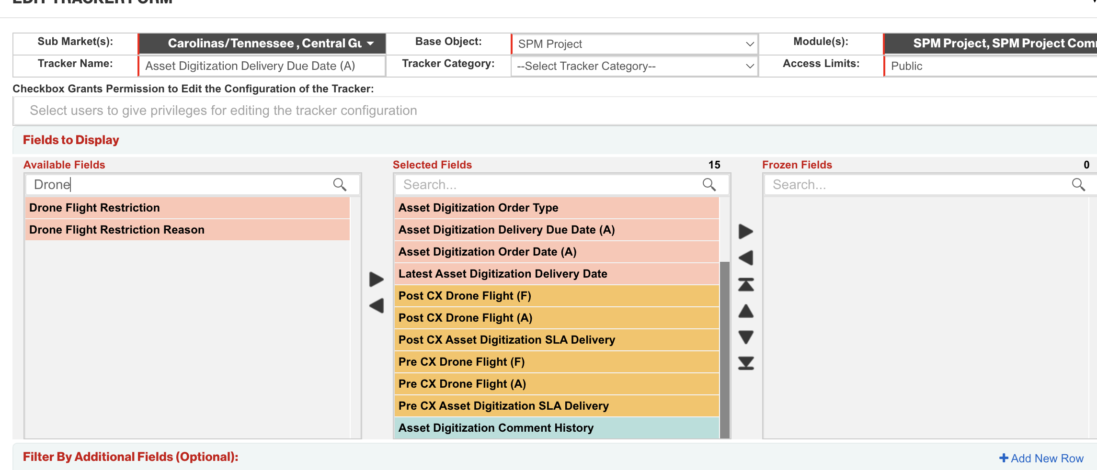

Drone Flight Restriction Field in tracker

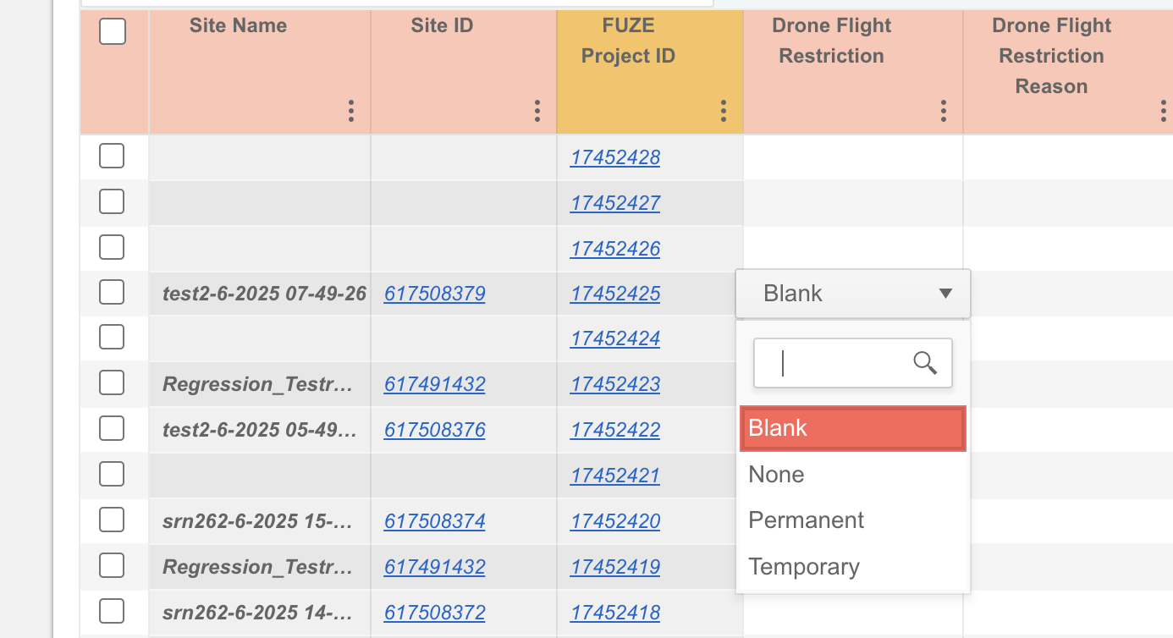

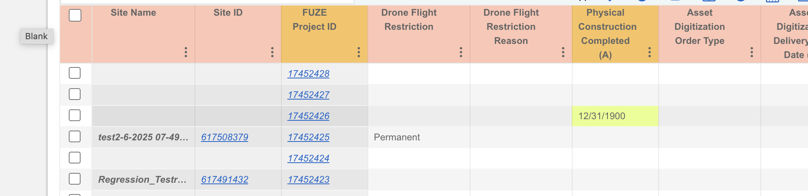

Multi Row update

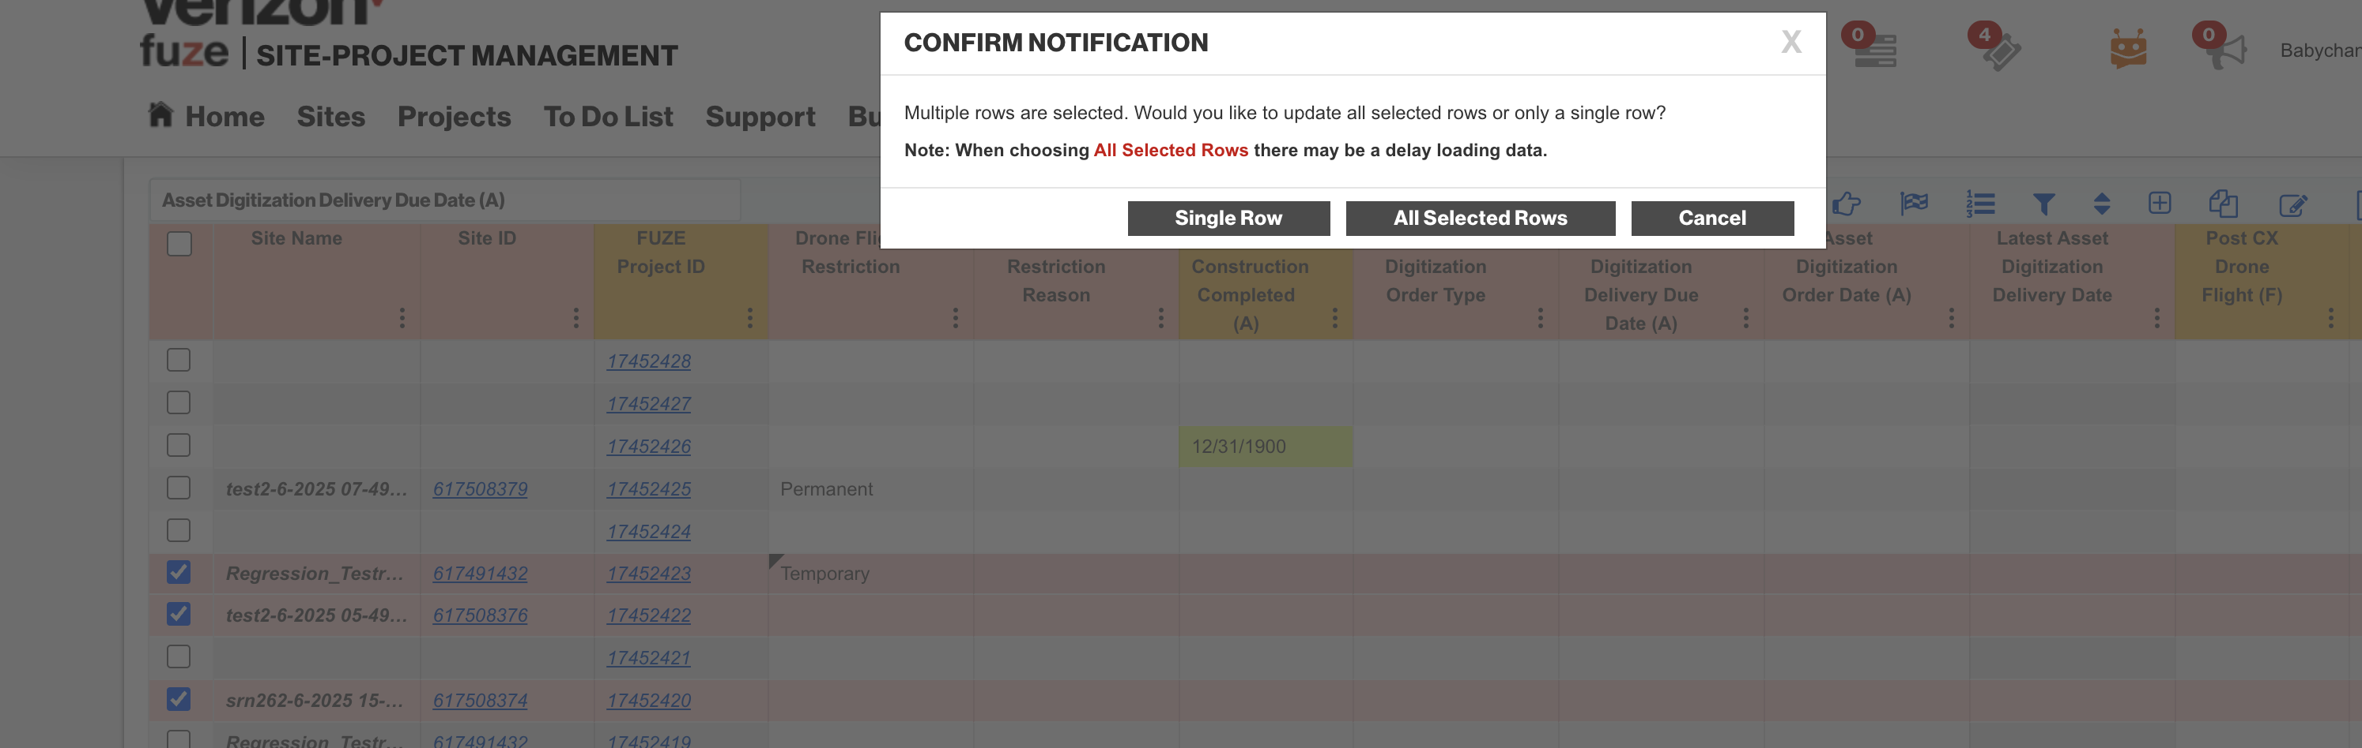

After update.

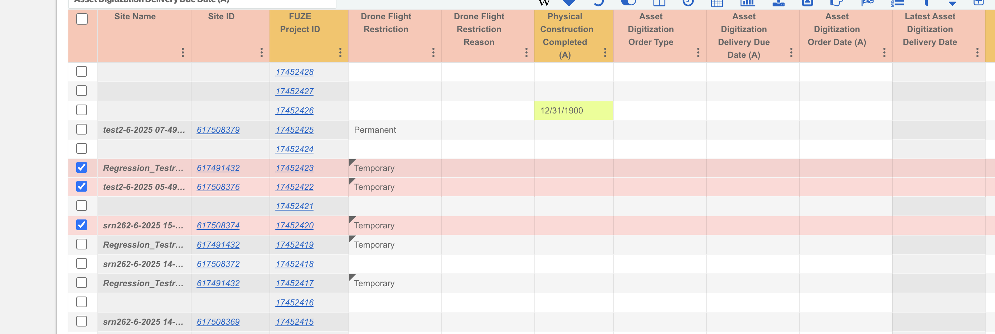

Drone Flight Restriction Reason

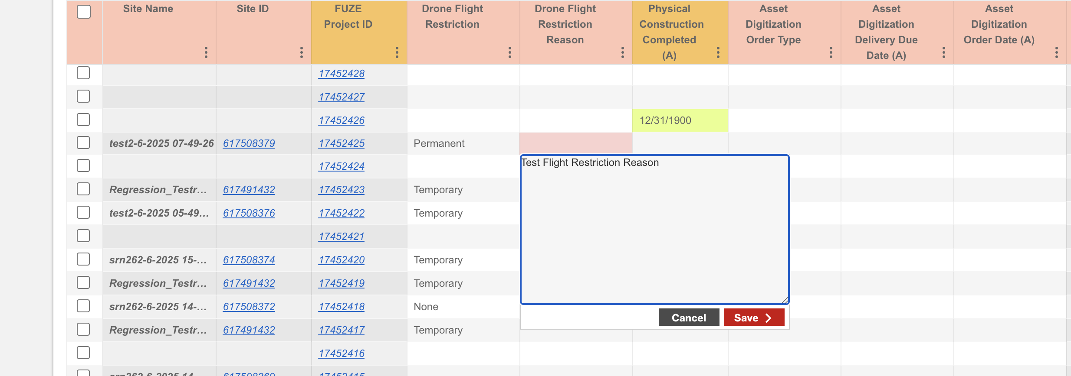

After update

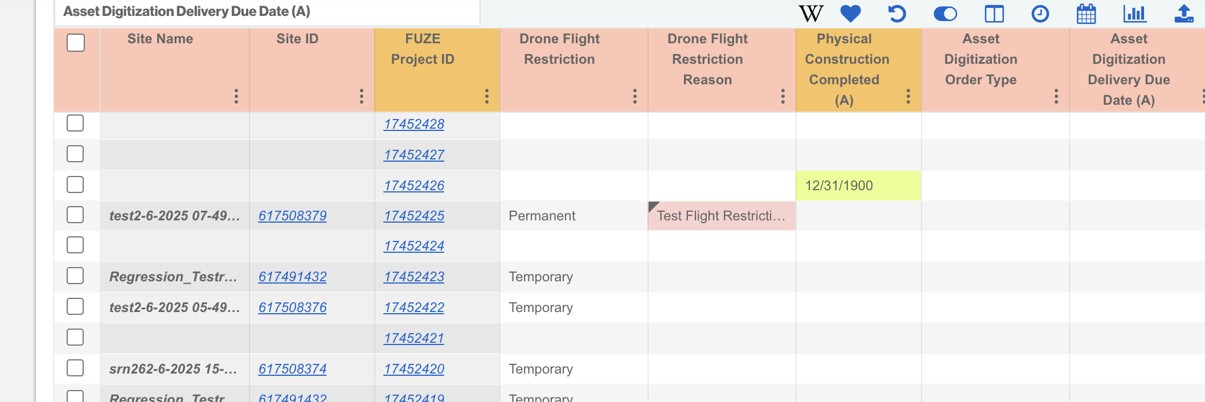

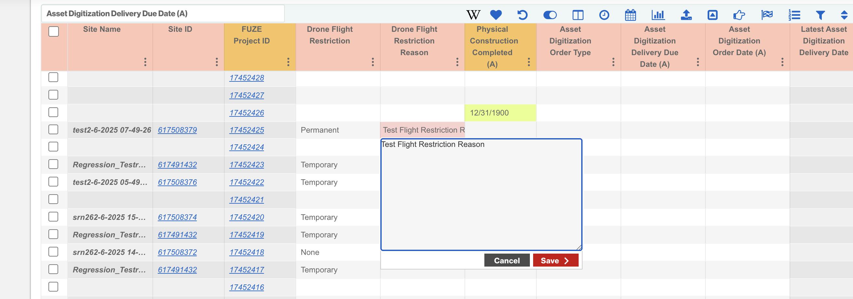

Multi Row Update

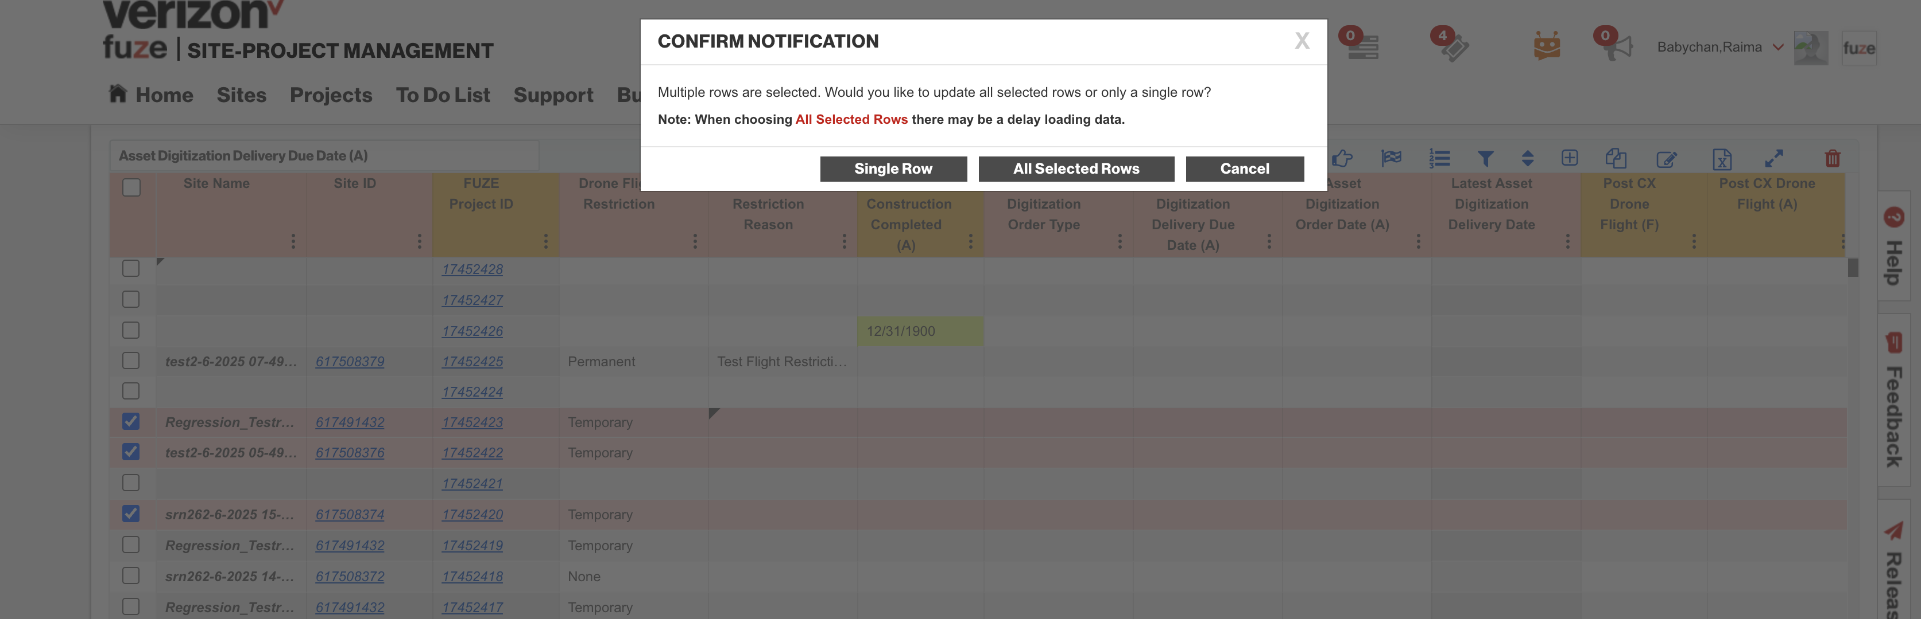

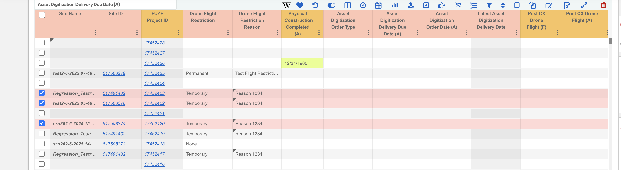

1. **Backend changes to get new field values in API for displaying in GUI**

<https://fuzesit.verizon.com/spm/sites.jsp?siteId=5049112>

API - projects-gateway/projects-service/drone/getSiteDigitalTwins

Response

