NTSWSC-1799

[[NTSWSC-1799] Mandate the auto creation of utility records - OneJira-Production](https://onejira.verizon.com/browse/NTSWSC-1799)

1. When Power Upgrade type is selected as AC Utility Install

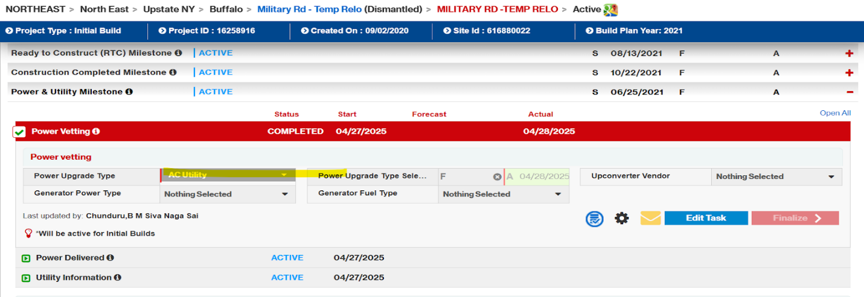

1. The Utility information task should not have an Add New Record Button

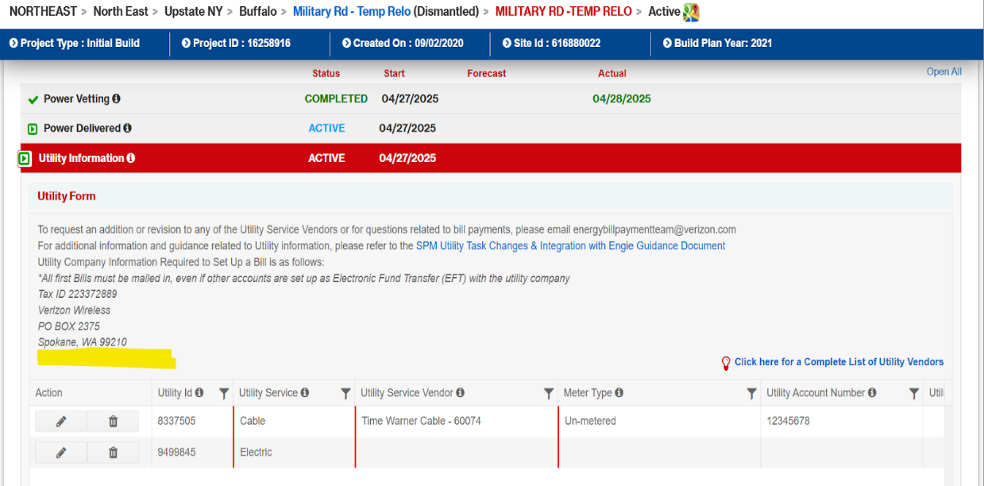

1. The Utility information task should have at least one Electric utility record.
   1. If Electric record already exists - Data should be filled

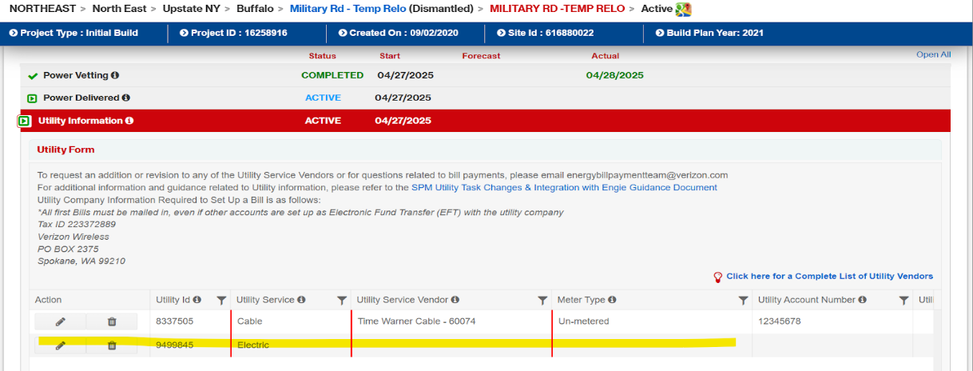

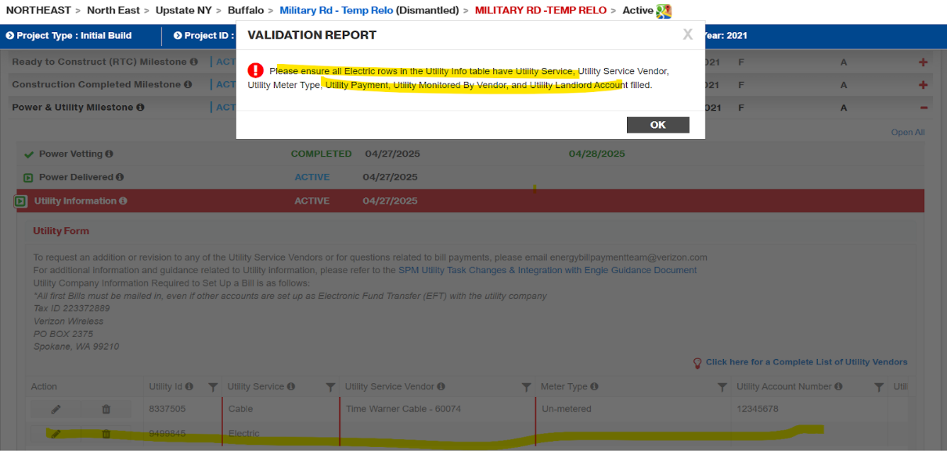

1. If No Electric record already exists - We should automatically add a new record and Data should be filled.

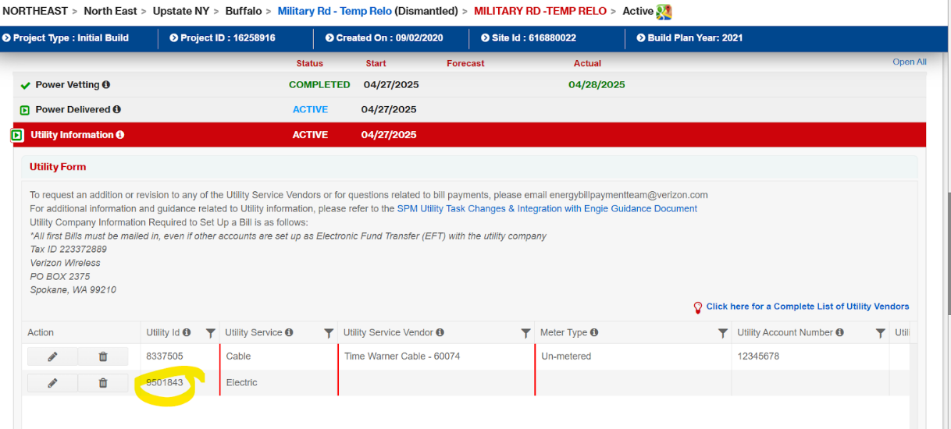

1. The Electric record details are mandatory for AC Utility Install type and it throws validation errors if details are not filled.

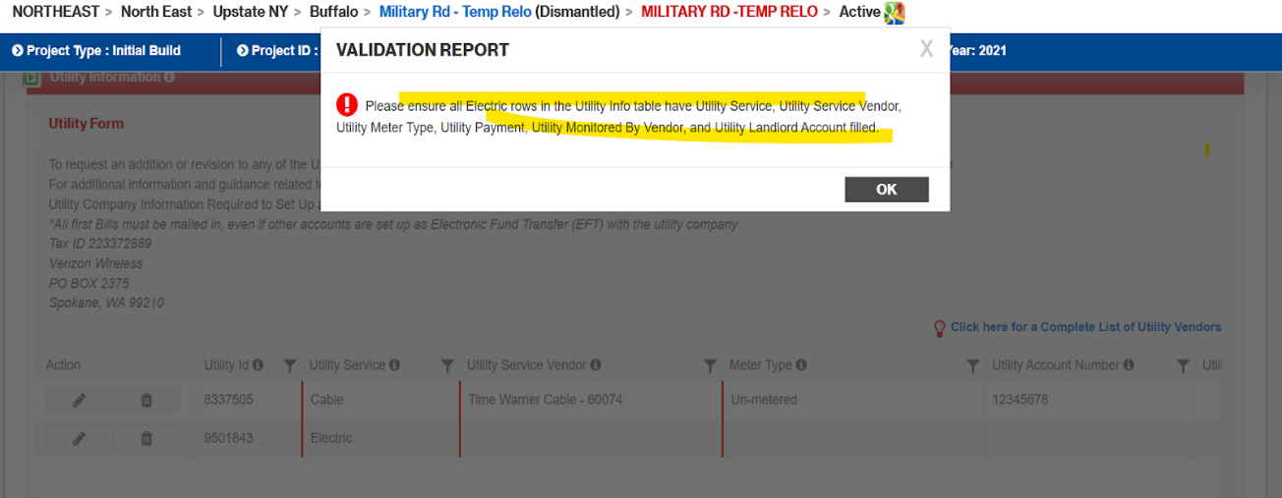

1. If all electric record details are filled, tasks should be able to be finalized without error.

