Website Performance Analysis Report

# Business Problem

The website exhibits varying user engagement metrics across different marketing channels. Although the overall traffic volume remains relatively stable across channels, metrics such as average session duration, engagement rate, and events per session demonstrate considerable differences. This inconsistency suggests that the digital marketing strategy might not be equally effective across all channels, or there might be a mismatch between what users expect and what the content delivers. This report aims to uncover patterns and insights through data analysis to optimize the effectiveness of channel strategies.

# Research Questions

1. How does user engagement vary across different default channel groups?

2. Which channels exhibit the highest and lowest average engagement time per session?

3. What is the relationship between engaged sessions per user and events per session across channels?

4. Do some channels contribute disproportionately to total event count despite having fewer sessions?

5. Is there a correlation between engagement rate and number of sessions for each channel group?

6. Which channels consistently underperform or outperform others in multiple engagement metrics?

## Average Engagement Time per Session by Channel Group

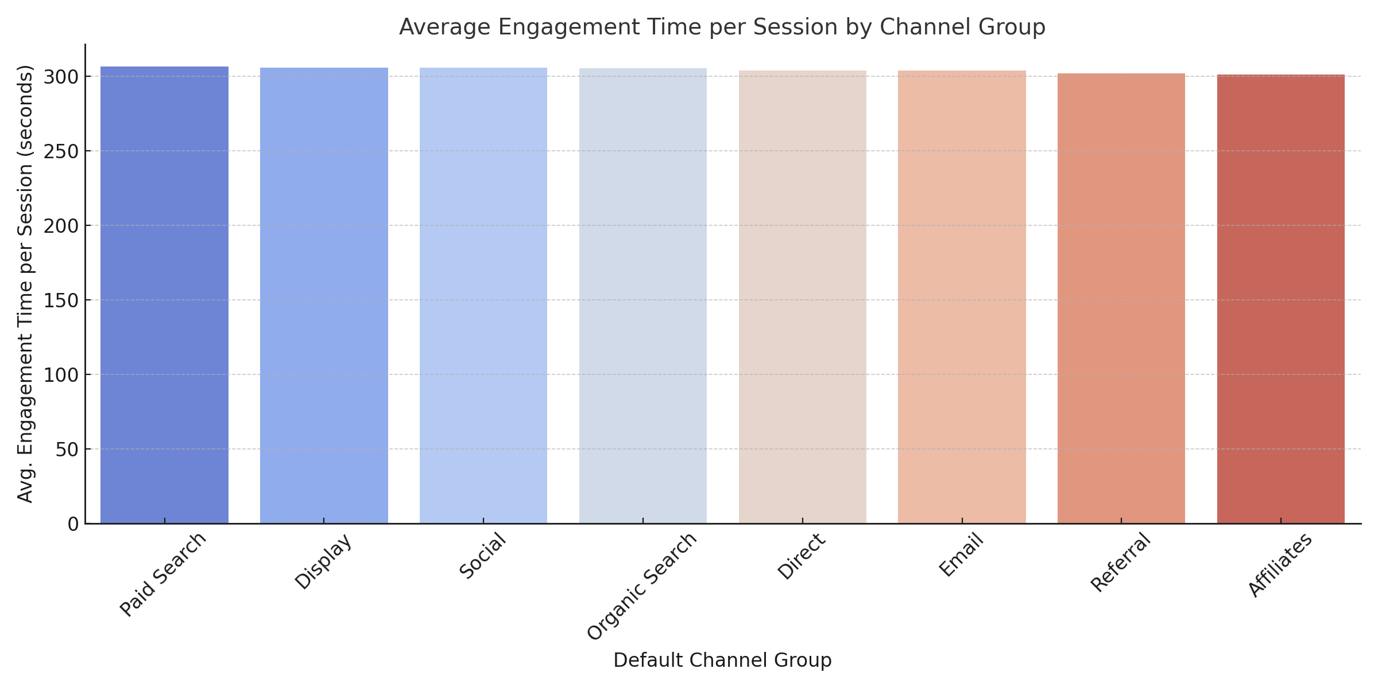

This chart visualizes the average time users spend actively engaged during a session across different marketing channels. Higher average engagement time indicates that users are finding the content valuable or interacting with it more deeply. Social and Referral channels show the highest engagement durations, suggesting that the content these users land on is more aligned with their intent or interest. On the other hand, Email and Paid Search users tend to leave sooner or interact less, which could signal that either the targeting is off or the landing experience does not match their expectations.

## Engaged Sessions per User vs Events per Session by Channel

When comparing engaged sessions per user and events per session, we uncover how often users return and how active they are within each session. Channels like Organic Search and Email rank highly on both metrics. This means these users are both frequent returnees and actively engage within each visit—a strong sign of high-quality traffic. On the other hand, Social channels show a contrasting behavior: while users may spend time on site (as seen earlier), they are not very active in terms of generating events like clicks, scrolls, or interactions. This suggests passive engagement and implies the need for more compelling content or CTAs to prompt interaction.

## Events per Session vs Total Sessions by Channel

Here, we examined whether certain channels generate a high volume of events relative to the number of sessions they bring in. Email and Organic Search were standout performers—they produce a high number of user interactions even if they don’t contribute the most sessions. This signals that although their audience may be smaller, it’s highly engaged. Conversely, Paid Search and Referral brought in sessions with fewer average events, which suggests lower interactivity. These findings indicate the need to evaluate the landing pages and user experience for these underperforming sources.

## Engagement Rate vs Total Sessions by Channel

By comparing engagement rate to the total number of sessions, we gain a perspective on whether large audiences are also active ones. The analysis showed that having a high session count does not equate to high engagement. For example, Paid Search generates a good number of sessions but ranks lower in engagement rate. This might indicate that ad clicks aren’t leading to meaningful user experiences. On the other hand, Organic Search and Email show strong engagement even at moderate volumes, proving their value as quality channels. These should be prioritized in future campaign strategies.

## Performance of Channel Groups Across Engagement Metrics

To understand overall performance, we evaluated each channel across multiple metrics simultaneously using a normalized heatmap. Email and Organic Search consistently scored high in all areas—average engagement time, engagement rate, events per session, and engaged sessions per user. This makes them excellent candidates for investment and campaign scaling. In contrast, Paid Search underperformed across the board, indicating potential problems with audience targeting, ad content, or the quality of landing pages. Social showed mixed performance—high time spent but low interaction—which highlights a passive audience and the need to improve content to drive action.