**ICC CRICKET WORLD CUP - 2019**

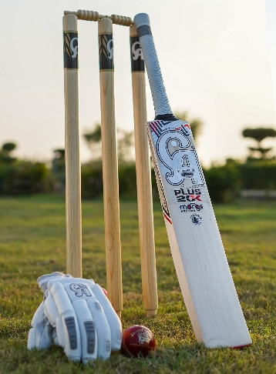 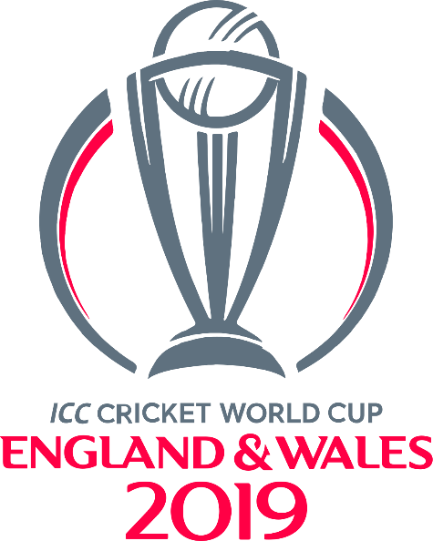

**Score Board**

|  |  |
| --- | --- |
| Self Team |  |
| Opponent Team |  |
| Self Score |  |
| Opponent Score |  |

|  |
| --- |
| Result: |