

|  |  |  |  |
| --- | --- | --- | --- |
| Academic  Year | Module | Assessment Number | Assessment Type |
| 2024 | 5CS037-Concept and Technology of AI. | **1** | **Report Writing** |

Analysis of the World Happiness Report: Exploring South Asia and Middle East Perspectives.

Student Id : 2408291

Student Name : Rohit Ghimire

Section : L5CG2

Module Leader : Siman Giri

Tutor : Sunita Parajuli

Submitted on : 20-12-2024

Submitted on : <dd-mm-yy>

**Table of Contents**

Contents

Introduction: 4

Data Exploration: 4

6

Data Visualization: 6

South-Asian and Middle East Countries: 9

Challenges Faced On this Assignment: 10

Conclusion: 11

# Introduction:

The report is about the World Happiness Report on south-east and middle east countries. The World Happiness Report focuses on happiness and well-being as the factors for government policy. The score is calculated by GDP, Life Expectancy and many more factors. It also shows the relationship between the nation and citizens of that country. How happy are they with countries policymakers and wealth of country. It highlights the state of happiness in these regions, examining how individual and national factors influence citizens' overall happiness.

## Data Exploration:

The use of pandas’ library is shown here and pd.read_csv() method to read csv file and print the first few 10 data found in csv file. With the help of second function dtypes() it is easier to find the datatypes of column.

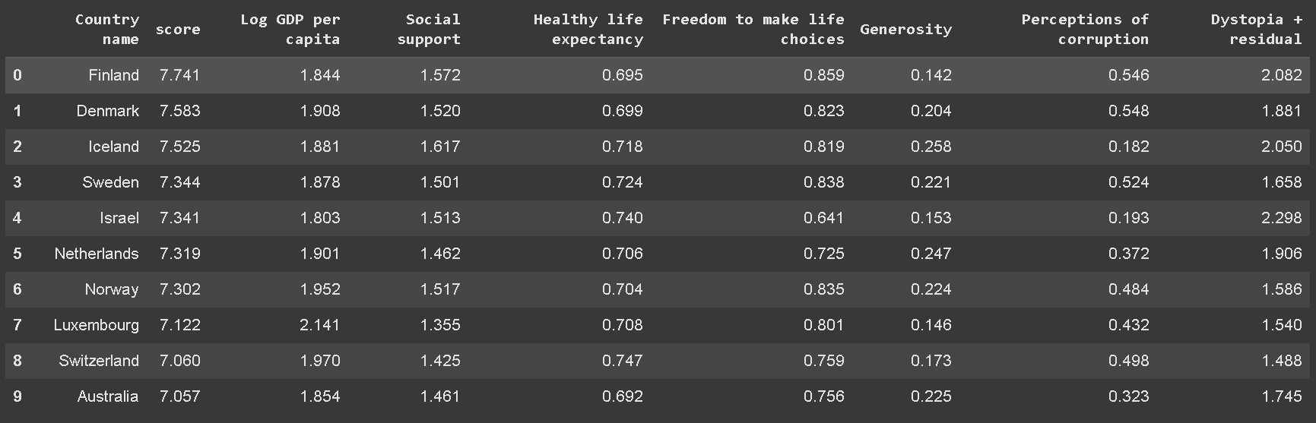

Dataframe is made from the csv file and from that file basic statistics are performed like mean, median and mode.

Use of isnull() function with sum() helps to find out null values in file and sum helps to calculate the number of null values in each column.

Dataframe can be filtered or sorted out by using below methods. To sort on ascending and descending order,

## Data Visualization:

Data Visualization is possible through libraries like matplotlib ,seaborn and many more seaborn is library which is made on top of matplotlib which helps for visualization of data.

Plt.bar(x-axis,y-axis,color,…) it helps to plot the bar chart with Title and x-label and y-label with its corresponding functions.

The South Asian Bar chart according to composite score.

Scatter plot using Seaborn of South Asian countries and Other High Scores.

## South-Asian and Middle East Countries:

Talking about comparison south Asian countries score is lesser than middle East countries. Talking about the first place of South-Asian countries Nepal is on the top with score of 5.158 and from Middle East countries Israel score is high with score of 7.341.

From the picture we can tell that middle east countries are more happier than south-Asian countries since the mean and standard deviation of there score is higher than that of south-Asian nations.

Positive and negative bar chart of South Asian Data.

## Challenges Faced On this Assignment:

The challenges I faced doing this assignment were at first but after discussing it with my tutor and my friends I can solve the question. Talking about the .Problem-3 and its rest of other tasks were bit hectic to find correlation and as well as to find outliers as it needs numpy and its other methods.

# Conclusion:

In conclusion, the datasets of World Happiness Report want to show the difference between other European and Asian countries relatively with South-Asian and Middle East countries. As some of them are developing countries it shows the freedom to make life choices of those Asian and middle east countries.

The above scatter plot of Score vs GDP per capita shows the country’s wealth.

WHR is important since it helps to find what countries are lacking and to find what makes people happy. GDP is also important but instead of targeting onto only these things since WHR depends on various factors like health, freedom, life expectancy it gives governments and communities an idea how to create a better living environment for citizens.