Contents

Introduction 2

Strength 2

Weakness 2

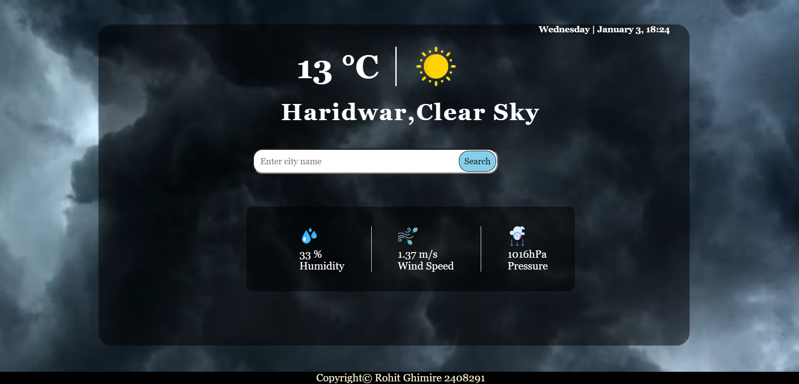

# Introduction

This is the assignment of Internet Software Architecture of creating a Weather App (Protoype1) using HTML, CSS and JS designed by Rohit Ghimire.(2408291) The default city assigned to me is Haridwar.

# Strength

The strength of Weather app are as follows:

* Use of HTML, CSS & JavaScript.:

The application is made from HTML and CSS and the using API the weather is extracted and use JS properties like objects and events to handle the events

* Weather of Present Time:

By fetching, Open Weather Api the current temperature, real time of any location is able to see, and other physical quantity are seen without the use of calculating and measuring them without devices

# Weakness

The weaknesses I would like to highlight first of all is, it is not made for mobile i.e., it is not responsive design.

* I have connected the icon of weather in GitHub which is linked through JS and due to this it takes a little extra time to load.
* This project does not contain weekly temperature