For Prod Copy: 10.254.118.110

Mqsiusr,

Mqsiuser2!

1. Login to 10.108.21.30 with Proponix ID(Filenet server) from the and dev servers(you will not be able to login from your local machine)
2. In Filenet server goto RUN and type **xapex** and enter, you will see the below window,

Enter the user ID as SysAdmin and PWD as SysAdmin1$ and press OK

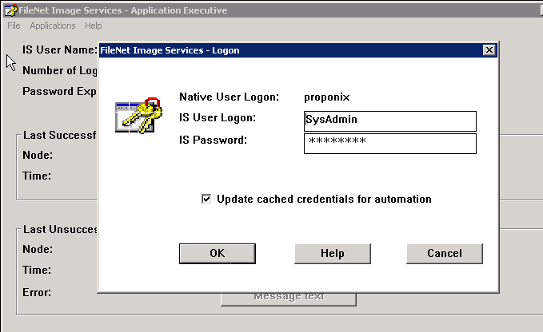

1. Goto Application>Security Administration
2. In Security Administration select users and then Add users and type the User name and then link OK

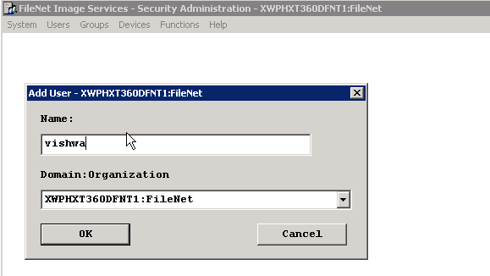

1. Click on Password Button and select on No Password Check Box

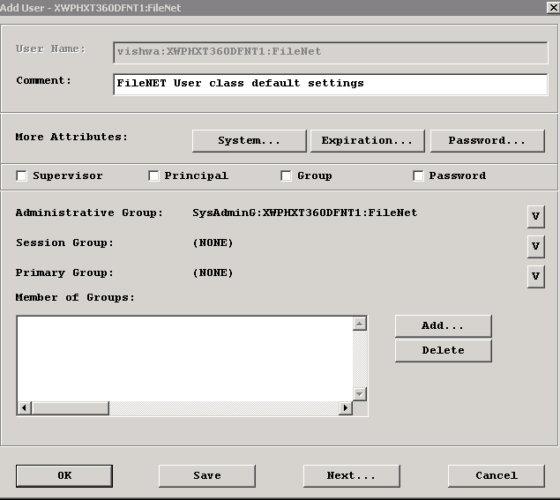

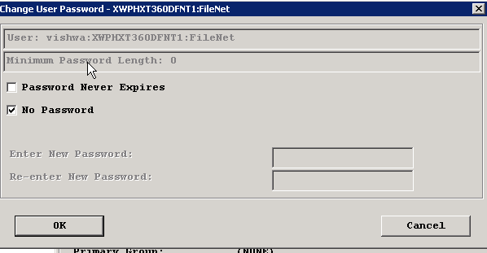

1. And in the Member of Group Block, click on Add and then type- OTLClientUser and OK, this will select the Group and then click on OK which will enable the Image to the User