Schema vdl-1.24.xsd

schema location: | E:\GriPhyN\VDL\vdl-1.24\vdl-1.24.xsd
targetNamespace: | http://www.griphyn.org/chimera/VDL

Elements | Groups | Complex types | Simple types | Attr. groups
definitions | InsideLeaf | InsideScalarType | ContainerType | DefinitionIdentifierAG
derivation | OutsideLeaf | LFNType | LinkageType | DescriptionAG
transformation |  | MetaType | MetadataType | TransformationMapAG
 |  | OutsideListType | NamespaceType
 |  | OutsideScalarType | ProfileNamespace
 |  |  | TransferType
 |  |  | VersionType

element definitions
diagram | 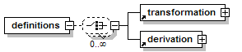
children | transformation derivation
attributes
  Name | Type | Use | Default | Fixed | Annotation
  version | VersionType | optional
  vdlns | NamespaceType | optional
annotation
  documentation | The virtual data modification language.

element derivation
diagram | 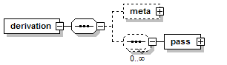
children | meta pass
used by
  element | definitions
attributes
  Name | Type | Use | Default | Fixed | Annotation
  name | xs:NMTOKEN | required
  namespace | NamespaceType | optional
  version | VersionType | optional
  uses | xs:NMTOKEN | required
  usesspace | NamespaceType | optional
  maxIncludeVersion | VersionType | optional
  minIncludeVersion | VersionType | optional
  description | xs:string | optional
  title | xs:string | optional
  keyword | xs:string | optional
  url | xs:anyURI | optional
annotation
  documentation | A "derivation" contains actual parameters. This element must occur, even if the list is empty.

element derivation/meta
diagram | 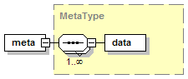
type | MetaType
children | data
annotation
  documentation | Annotates the derivation itself.

element derivation/pass
diagram | 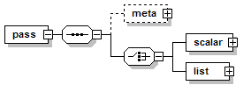
children | meta scalar list
attributes
  Name | Type | Use | Default | Fixed | Annotation
  bind | xs:NMTOKEN | required
  name | xs:NMTOKEN | optional
annotation
  documentation | The "pass" element established the binding between an actual parameter with its named formal counterpart.

element derivation/pass/meta
diagram
type | MetaType
children | data
annotation
  documentation | Annotates each single actual argument.

element derivation/pass/scalar
diagram | 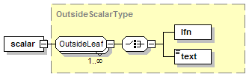
type | OutsideScalarType
children | lfn text

element derivation/pass/list
diagram | 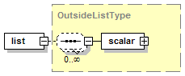
type | OutsideListType
children | scalar

element transformation
diagram | 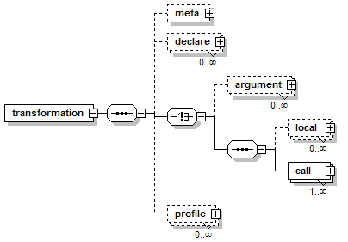
children | meta declare argument local call profile
used by
  element | definitions
attributes
  Name | Type | Use | Default | Fixed | Annotation
  name | xs:NMTOKEN | required
  namespace | NamespaceType | optional
  version | VersionType | optional
  argumentSeparator | xs:string | optional
    documentation | Please note that the default is a single space.
  description | xs:string | optional
  title | xs:string | optional
  keyword | xs:string | optional
  url | xs:anyURI | optional
annotation
  documentation | A "transformation" describes the specification of process environment with placeholders

element transformation/meta
diagram
type | MetaType
children | data
annotation
  documentation | Annotates the transformation itself.

element transformation/declare
diagram | 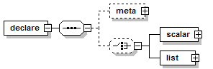
children | meta scalar list
attributes
  Name | Type | Use | Default | Fixed | Annotation
  name | xs:NMTOKEN | required
  link | LinkageType | required
  container | ContainerType |  | scalar
annotation
  documentation | Each parameter is declared using the "declare" element, specifying the name and container type.

element transformation/declare/meta
diagram
type | extension of MetaType
children | data
annotation
  documentation | Annotates each single formal argument.

element transformation/declare/scalar
diagram
type | OutsideScalarType
children | lfn text

element transformation/declare/list
diagram
type | OutsideListType
children | scalar
annotation
  documentation | A list of simple scalars.

element transformation/argument
diagram | 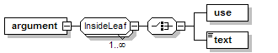
children | use text
attributes
  Name | Type | Use | Default | Fixed | Annotation
  name | xs:NMTOKEN
annotation
  documentation | A command line argument spec consists of an arbitrary number of namable chunks.

element transformation/local
diagram | 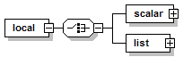
children | scalar list
attributes
  Name | Type | Use | Default | Fixed | Annotation
  name | xs:NMTOKEN | required
  link | LinkageType | required
  container | ContainerType |  | scalar
annotation
  documentation | Associates a local variable with a name to either an LFN or a parameter (const).

element transformation/local/scalar
diagram
type | OutsideScalarType
children | lfn text

element transformation/local/list
diagram
type | OutsideListType
children | scalar

element transformation/call
diagram | 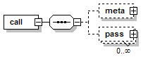
children | meta pass
attributes
  Name | Type | Use | Default | Fixed | Annotation
  uses | xs:NMTOKEN | required
  usesspace | NamespaceType | optional
  maxIncludeVersion | VersionType | optional
  minIncludeVersion | VersionType | optional
  description | xs:string | optional
  title | xs:string | optional
  keyword | xs:string | optional
  url | xs:anyURI | optional
annotation
  documentation | Like an anonymous "derivation" element, allows to call other transformations from within a compound.

element transformation/call/meta
diagram
type | MetaType
children | data
annotation
  documentation | Annotates the call structure, which is an anonymous DV.

element transformation/call/pass
diagram
children | meta scalar list
attributes
  Name | Type | Use | Default | Fixed | Annotation
  bind | xs:NMTOKEN | required
  name | xs:NMTOKEN | optional
annotation
  documentation | The "pass" element established the binding between an actual parameter with its named formal counterpart.

element transformation/call/pass/meta
diagram
type | MetaType
children | data
annotation
  documentation | Annotates each actual argument as it is passed.

element transformation/call/pass/scalar
diagram | 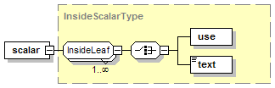
type | InsideScalarType
children | use text

element transformation/call/pass/list
diagram | 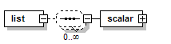
children | scalar
annotation
  documentation | A list of simple elements.

element transformation/call/pass/list/scalar
diagram
type | InsideScalarType
children | use text

element transformation/profile
diagram | 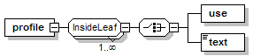
children | use text
attributes
  Name | Type | Use | Default | Fixed | Annotation
  key | xs:string | required
  namespace | ProfileNamespace | required
annotation
  documentation | Each "profile" element declares one DAGMan, Condor, VDS, or Unix environment variable.

group InsideLeaf
diagram | 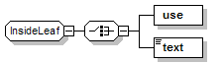
children | use text
used by
  elements | transformation/argument transformation/profile
  complexType | InsideScalarType
annotation
  documentation | "text" or "use" are permissable inside a TR.

element InsideLeaf/use
diagram
attributes
  Name | Type | Use | Default | Fixed | Annotation
  name | xs:NMTOKEN | required
  suffix | xs:string | optional
  separator | xs:string | optional
    documentation | The default is a single space.
  prefix | xs:string | optional
  link | LinkageType | optional
annotation
  documentation | References a bound variable.

element InsideLeaf/text
diagram
type | xs:string
annotation
  documentation | Pure text.

group OutsideLeaf
diagram | 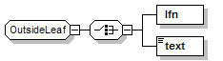
children | lfn text
used by
  complexType | OutsideScalarType
annotation
  documentation | "text" or "lfn" are permissable outside a TR.

element OutsideLeaf/lfn
diagram
type | LFNType
attributes
  Name | Type | Use | Default | Fixed | Annotation
  file | xs:string | required
  dontRegister | xs:boolean | optional | false
  dontTransfer | TransferType | optional | false
  link | LinkageType | required
  temporaryHint | xs:string | optional
  isTemporary | xs:boolean | optional
    documentation | DEPRECATED! Will be removed soon.
  optional | xs:boolean | optional | false
annotation
  documentation | A logical filename.

element OutsideLeaf/text
diagram
type | xs:string
annotation
  documentation | Pure text.

complexType InsideScalarType
diagram | 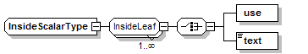
children | use text
used by
  elements | transformation/call/pass/scalar transformation/call/pass/list/scalar
annotation
  documentation | A simple element for text or files.

complexType LFNType
diagram
used by
  element | OutsideLeaf/lfn
attributes
  Name | Type | Use | Default | Fixed | Annotation
  file | xs:string | required
  dontRegister | xs:boolean | optional | false
  dontTransfer | TransferType | optional | false
  link | LinkageType | required
  temporaryHint | xs:string | optional
  isTemporary | xs:boolean | optional
    documentation | DEPRECATED! Will be removed soon.
  optional | xs:boolean | optional | false
annotation
  documentation | Defines attributes for a logical filename.

complexType MetaType
diagram | 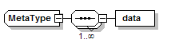
children | data
used by
  elements | transformation/meta transformation/declare/meta transformation/call/meta transformation/call/pass/meta derivation/meta derivation/pass/meta
annotation
  documentation | A generic metadata encapsulation.

element MetaType/data
diagram
attributes
  Name | Type | Use | Default | Fixed | Annotation
  key | xs:token | required
  type | MetadataType | required
  value | xs:anySimpleType | optional
  gid | xs:decimal | optional
annotation
  documentation | A row of metadata.

complexType OutsideListType
diagram | 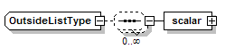
children | scalar
used by
  elements | transformation/declare/list transformation/local/list derivation/pass/list
annotation
  documentation | A list element containing simple elements.

element OutsideListType/scalar
diagram
type | OutsideScalarType
children | lfn text
annotation
  documentation | A simple element for text or logical filenames.

complexType OutsideScalarType
diagram | 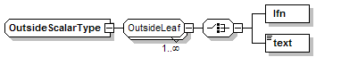
children | lfn text
used by
  elements | transformation/declare/scalar transformation/local/scalar derivation/pass/scalar OutsideListType/scalar
annotation
  documentation | A simple element for text or files.

simpleType ContainerType
type | restriction of xs:NMTOKEN
used by
  attributes | transformation/declare/@container transformation/local/@container
facets
  enumeration | scalar
  enumeration | list
annotation
  documentation | defines the three basic containers for parameters.

simpleType LinkageType
type | restriction of xs:NMTOKEN
used by
  attributes | transformation/declare/@link transformation/local/@link LFNType/@link InsideLeaf/use/@link
facets
  enumeration | input
  enumeration | output
  enumeration | inout
  enumeration | none
annotation
  documentation | defines the usage of a logical filename.

simpleType MetadataType
type | restriction of xs:token
used by
  attribute | MetaType/data/@type
facets
  enumeration | boolean
  enumeration | string
  enumeration | float
  enumeration | integer
  enumeration | datetime
annotation
  documentation | enumerates the permissable metadata types.

simpleType NamespaceType
type | restriction of xs:string
used by
  attributes | DefinitionIdentifierAG/@namespace TransformationMapAG/@usesspace definitions/@vdlns
facets
  pattern | [\-A-Za-z_/][\-A-Za-z_0-9./]*
annotation
  documentation | defines the permissable range for namespace identifiers.

simpleType ProfileNamespace
type | restriction of xs:NMTOKEN
used by
  attribute | transformation/profile/@namespace
facets
  enumeration | vds
  enumeration | condor
  enumeration | dagman
  enumeration | env
  enumeration | hints
  enumeration | globus
  enumeration | selector
annotation
  documentation | defines the legal namespaces of execution profiles.

simpleType TransferType
type | restriction of xs:NMTOKEN
used by
  attribute | LFNType/@dontTransfer
facets
  enumeration | false
  enumeration | optional
  enumeration | true
annotation
  documentation | defines the tri-state transfer modes.

simpleType VersionType
type | restriction of xs:string
used by
  attributes | TransformationMapAG/@maxIncludeVersion TransformationMapAG/@minIncludeVersion definitions/@version DefinitionIdentifierAG/@version
facets
  pattern | [0-9.]+
annotation
  documentation | defines the permissable range for version numbers.

attributeGroup DefinitionIdentifierAG
used by
  elements | derivation transformation
attributes
  Name | Type | Use | Default | Fixed | Annotation
  name | xs:NMTOKEN | required
  namespace | NamespaceType | optional
  version | VersionType | optional
annotation
  documentation | provides the unique identifier for a definition.

attributeGroup DescriptionAG
used by
  elements | transformation/call derivation transformation
attributes
  Name | Type | Use | Default | Fixed | Annotation
  description | xs:string | optional
  title | xs:string | optional
  keyword | xs:string | optional
  url | xs:anyURI | optional
annotation
  documentation | describe a tranformation or derivation with metadata.

attributeGroup TransformationMapAG
used by
  elements | transformation/call derivation
attributes
  Name | Type | Use | Default | Fixed | Annotation
  uses | xs:NMTOKEN | required
  usesspace | NamespaceType | optional
  maxIncludeVersion | VersionType | optional
  minIncludeVersion | VersionType | optional
annotation
  documentation | describe the mapping data towards a transformation

XML Schema documentation generated with XMLSPY Schema Editor http://www.altova.com/xmlspy

