Schema iv-1.3.xsd

schema location: | E:\GriPhyN\VDL\iv-1.3\iv-1.3.xsd
targetNamespace: | http://www.griphyn.org/chimera/Invocation

Elements | Complex types | Simple types | Attr. groups
invocation | JobType | DottedQuad | FQDI
 | RUsageType | PositiveDecimal
 | StatCallType

element invocation
diagram | 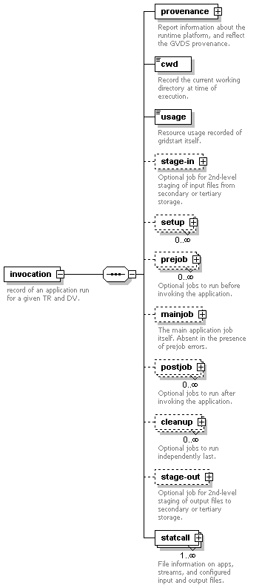
children | provenance cwd usage stage-in setup prejob mainjob postjob cleanup stage-out statcall
attributes
  Name | Type | Use | Default | Fixed | Annotation
  version | xs:NMTOKEN | required
  start | xs:dateTime | required
    documentation | Start of application according to host clock.
  duration | PositiveDecimal | required
    documentation | Duration of application run in seconds with microsecond fraction, according to host clock.
  pid | xs:decimal | optional
    documentation | process number of the gridlaunch application itself.
  uid | xs:integer | optional
    documentation | real user id on the compute node that started grid launch.
  gid | xs:integer | optional
    documentation | real group id of the user that started gridlaunch
annotation
  documentation | record of an application run for a given TR and DV.

element invocation/provenance
diagram | 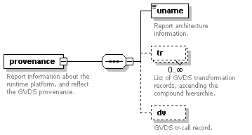
children | uname tr dv
attributes
  Name | Type | Use | Default | Fixed | Annotation
  host | DottedQuad | optional | 0.0.0.0
  pool | xs:string | optional
annotation
  documentation | Report information about the runtime platform, and reflect the GVDS provenance.

element invocation/provenance/uname
diagram | 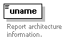
type | extension of xs:token
attributes
  Name | Type | Use | Default | Fixed | Annotation
  archmode | xs:NMTOKEN | optional
    documentation | IA32, IA64, ILP32, LP64
  system | xs:NMTOKEN | required
  nodename | xs:NMTOKEN | required
  release | xs:NMTOKEN | required
  machine | xs:NMTOKEN | required
  domainname | xs:NMTOKEN | optional
annotation
  documentation | Report architecture information.

element invocation/provenance/tr
diagram | 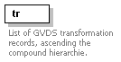
attributes
  Name | Type | Use | Default | Fixed | Annotation
  namespace | xs:string | optional
  name | xs:NMTOKEN | required
  version | xs:string | optional
annotation
  documentation | List of GVDS transformation records, ascending the compound hierarchie.

element invocation/provenance/dv
diagram | 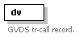
attributes
  Name | Type | Use | Default | Fixed | Annotation
  namespace | xs:string | optional
  name | xs:NMTOKEN | required
  version | xs:string | optional
annotation
  documentation | GVDS tr-call record.

element invocation/cwd
diagram | 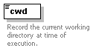
type | restriction of xs:string
facets
  maxLength | 4096
  whiteSpace | preserve
annotation
  documentation | Record the current working directory at time of execution.

element invocation/usage
diagram | 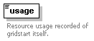
type | RUsageType
attributes
  Name | Type | Use | Default | Fixed | Annotation
  utime | xs:decimal | required
    documentation | Total amount of user time used, in seconds with millisecond fraction.
  stime | xs:decimal | required
    documentation | Total amount of system time used, in seconds with millisecond fraction.
  minflt | xs:unsignedLong | required
    documentation | Number of soft page faults (i.e. those serviced by reclaiming a page from the list of pages awaiting reallocation.
  majflt | xs:unsignedLong | required
    documentation | Number of hard page faults (i.e. those that required I/O).
  nswap | xs:unsignedLong | required
    documentation | Number of times a process was swapped out of physical memory.
  nsignals | xs:unsignedLong | required
    documentation | Number of signals delivered.
  nvcsw | xs:unsignedLong | optional
    documentation | Number of voluntary context switches, i.e. because the process gave up the process before it had to (usually to wait for some resource to be available).
  nivcsw | xs:unsignedLong | optional
    documentation | Number of involuntary context switches, i.e. a higher priority process became runnable or the current process used up its time slice.
annotation
  documentation | Resource usage recorded of gridstart itself.

element invocation/stage-in
diagram | 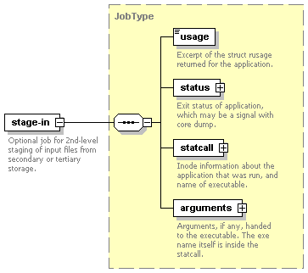
type | JobType
children | usage status statcall arguments
attributes
  Name | Type | Use | Default | Fixed | Annotation
  start | xs:dateTime | required
  duration | PositiveDecimal | required
  pid | xs:decimal | optional
annotation
  documentation | Optional job for 2nd-level staging of input files from secondary or tertiary storage.

element invocation/setup
diagram | 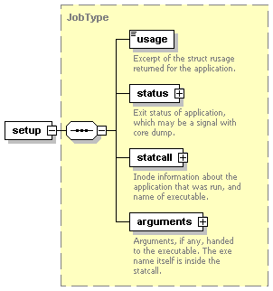
type | JobType
children | usage status statcall arguments
attributes
  Name | Type | Use | Default | Fixed | Annotation
  start | xs:dateTime | required
  duration | PositiveDecimal | required
  pid | xs:decimal | optional

element invocation/prejob
diagram | 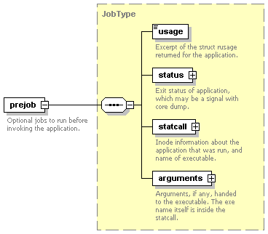
type | JobType
children | usage status statcall arguments
attributes
  Name | Type | Use | Default | Fixed | Annotation
  start | xs:dateTime | required
  duration | PositiveDecimal | required
  pid | xs:decimal | optional
annotation
  documentation | Optional jobs to run before invoking the application.

element invocation/mainjob
diagram | 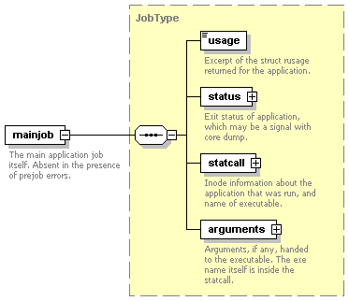
type | JobType
children | usage status statcall arguments
attributes
  Name | Type | Use | Default | Fixed | Annotation
  start | xs:dateTime | required
  duration | PositiveDecimal | required
  pid | xs:decimal | optional
annotation
  documentation | The main application job itself. Absent in the presence of prejob errors.

element invocation/postjob
diagram | 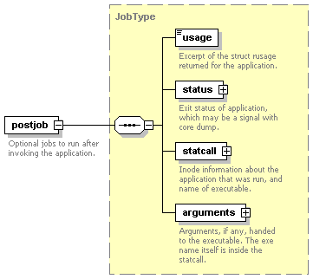
type | JobType
children | usage status statcall arguments
attributes
  Name | Type | Use | Default | Fixed | Annotation
  start | xs:dateTime | required
  duration | PositiveDecimal | required
  pid | xs:decimal | optional
annotation
  documentation | Optional jobs to run after invoking the application.

element invocation/cleanup
diagram | 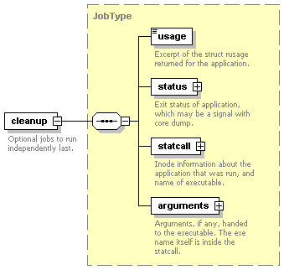
type | JobType
children | usage status statcall arguments
attributes
  Name | Type | Use | Default | Fixed | Annotation
  start | xs:dateTime | required
  duration | PositiveDecimal | required
  pid | xs:decimal | optional
annotation
  documentation | Optional jobs to run independently last.

element invocation/stage-out
diagram | 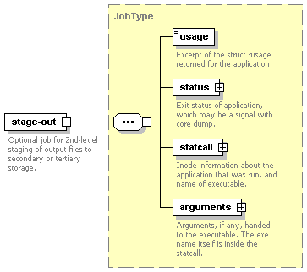
type | JobType
children | usage status statcall arguments
attributes
  Name | Type | Use | Default | Fixed | Annotation
  start | xs:dateTime | required
  duration | PositiveDecimal | required
  pid | xs:decimal | optional
annotation
  documentation | Optional job for 2nd-level staging of output files to secondary or tertiary storage.

element invocation/statcall
diagram | 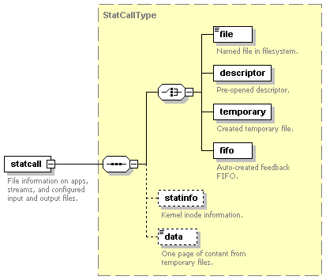
type | extension of StatCallType
children | file descriptor temporary fifo statinfo data
attributes
  Name | Type | Use | Default | Fixed | Annotation
  error | xs:int | required
    documentation | result from the stat call on a named file or descriptor.
  id | xs:string | optional
  lfn | xs:string | optional
annotation
  documentation | File information on apps, streams, and configured input and output files.

complexType JobType
diagram | 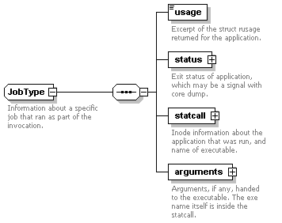
children | usage status statcall arguments
used by
  elements | invocation/cleanup invocation/mainjob invocation/postjob invocation/prejob invocation/setup invocation/stage-in invocation/stage-out
attributes
  Name | Type | Use | Default | Fixed | Annotation
  start | xs:dateTime | required
  duration | PositiveDecimal | required
  pid | xs:decimal | optional
annotation
  documentation | Information about a specific job that ran as part of the invocation.

element JobType/usage
diagram | 
type | RUsageType
attributes
  Name | Type | Use | Default | Fixed | Annotation
  utime | xs:decimal | required
    documentation | Total amount of user time used, in seconds with millisecond fraction.
  stime | xs:decimal | required
    documentation | Total amount of system time used, in seconds with millisecond fraction.
  minflt | xs:unsignedLong | required
    documentation | Number of soft page faults (i.e. those serviced by reclaiming a page from the list of pages awaiting reallocation.
  majflt | xs:unsignedLong | required
    documentation | Number of hard page faults (i.e. those that required I/O).
  nswap | xs:unsignedLong | required
    documentation | Number of times a process was swapped out of physical memory.
  nsignals | xs:unsignedLong | required
    documentation | Number of signals delivered.
  nvcsw | xs:unsignedLong | optional
    documentation | Number of voluntary context switches, i.e. because the process gave up the process before it had to (usually to wait for some resource to be available).
  nivcsw | xs:unsignedLong | optional
    documentation | Number of involuntary context switches, i.e. a higher priority process became runnable or the current process used up its time slice.
annotation
  documentation | Excerpt of the struct rusage returned for the application.

element JobType/status
diagram | 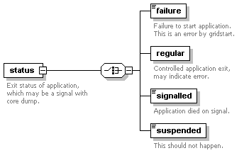
children | failure regular signalled suspended
attributes
  Name | Type | Use | Default | Fixed | Annotation
  raw | xs:int | required
annotation
  documentation | Exit status of application, which may be a signal with core dump.

element JobType/status/failure
diagram | 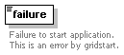
type | extension of xs:string
attributes
  Name | Type | Use | Default | Fixed | Annotation
  error | xs:byte | required
annotation
  documentation | Failure to start application. This is an error by gridstart.

element JobType/status/regular
diagram | 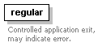
attributes
  Name | Type | Use | Default | Fixed | Annotation
  exitcode | xs:byte | required
annotation
  documentation | Controlled application exit, may indicate error.

element JobType/status/signalled
diagram | 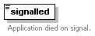
type | extension of xs:string
attributes
  Name | Type | Use | Default | Fixed | Annotation
  signal | xs:byte | required
  corefile | xs:boolean | optional
annotation
  documentation | Application died on signal.

element JobType/status/suspended
diagram | 
type | extension of xs:string
attributes
  Name | Type | Use | Default | Fixed | Annotation
  signal | xs:byte | required
annotation
  documentation | This should not happen.

element JobType/statcall
diagram | 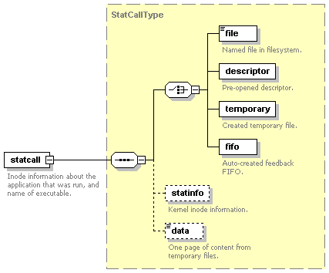
type | StatCallType
children | file descriptor temporary fifo statinfo data
attributes
  Name | Type | Use | Default | Fixed | Annotation
  error | xs:int | required
    documentation | result from the stat call on a named file or descriptor.
annotation
  documentation | Inode information about the application that was run, and name of executable.

element JobType/arguments
diagram | 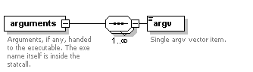
children | argv
attributes
  Name | Type | Use | Default | Fixed | Annotation
  argc | xs:integer | required
annotation
  documentation | Arguments, if any, handed to the executable. The exe name itself is inside the statcall.

element JobType/arguments/argv
diagram | 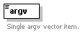
type | xs:string
annotation
  documentation | Single argv vector item.

complexType RUsageType
diagram | 
used by
  elements | invocation/usage JobType/usage
attributes
  Name | Type | Use | Default | Fixed | Annotation
  utime | xs:decimal | required
    documentation | Total amount of user time used, in seconds with millisecond fraction.
  stime | xs:decimal | required
    documentation | Total amount of system time used, in seconds with millisecond fraction.
  minflt | xs:unsignedLong | required
    documentation | Number of soft page faults (i.e. those serviced by reclaiming a page from the list of pages awaiting reallocation.
  majflt | xs:unsignedLong | required
    documentation | Number of hard page faults (i.e. those that required I/O).
  nswap | xs:unsignedLong | required
    documentation | Number of times a process was swapped out of physical memory.
  nsignals | xs:unsignedLong | required
    documentation | Number of signals delivered.
  nvcsw | xs:unsignedLong | optional
    documentation | Number of voluntary context switches, i.e. because the process gave up the process before it had to (usually to wait for some resource to be available).
  nivcsw | xs:unsignedLong | optional
    documentation | Number of involuntary context switches, i.e. a higher priority process became runnable or the current process used up its time slice.
annotation
  documentation | Information from the rusage record.

complexType StatCallType
diagram | 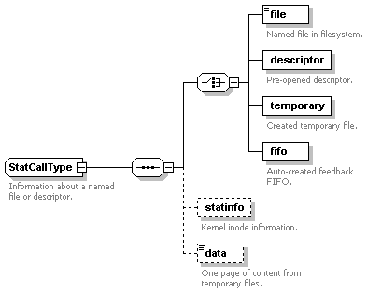
children | file descriptor temporary fifo statinfo data
used by
  elements | invocation/statcall JobType/statcall
attributes
  Name | Type | Use | Default | Fixed | Annotation
  error | xs:int | required
    documentation | result from the stat call on a named file or descriptor.
annotation
  documentation | Information about a named file or descriptor.

element StatCallType/file
diagram | 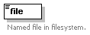
type | extension of xs:hexBinary
attributes
  Name | Type | Use | Default | Fixed | Annotation
  name | xs:string | required
    documentation | A named file may be a regular file like a shell script or executable, or it may be a device file like /dev/null. Only regular files may incur element content.
  md5sum | xs:hexBinary | optional
annotation
  documentation | Named file in filesystem.

element StatCallType/descriptor
diagram | 
attributes
  Name | Type | Use | Default | Fixed | Annotation
  number | xs:nonNegativeInteger | required
annotation
  documentation | Pre-opened descriptor.

element StatCallType/temporary
diagram | 
attributes
  Name | Type | Use | Default | Fixed | Annotation
  name | xs:string | required
  descriptor | xs:integer | required
annotation
  documentation | Created temporary file.

element StatCallType/fifo
diagram | 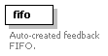
attributes
  Name | Type | Use | Default | Fixed | Annotation
  name | xs:string | required
  descriptor | xs:integer | required
  count | xs:nonNegativeInteger | optional | 0
  rsize | xs:nonNegativeInteger | optional | 0
  wsize | xs:nonNegativeInteger | optional | 0
annotation
  documentation | Auto-created feedback FIFO.

element StatCallType/statinfo
diagram | 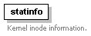
attributes
  Name | Type | Use | Default | Fixed | Annotation
  size | xs:integer | required
  mode | xs:token | optional
    documentation | file protection in octal number with leading zero.
  inode | xs:integer | optional
  nlink | xs:integer | optional
  blksize | xs:integer | optional
  atime | xs:dateTime | optional
  mtime | xs:dateTime | optional
  ctime | xs:dateTime | optional
  uid | xs:integer | optional
  gid | xs:integer | optional
annotation
  documentation | Kernel inode information.

element StatCallType/data
diagram | 
type | extension of xs:string
attributes
  Name | Type | Use | Default | Fixed | Annotation
  truncated | xs:boolean | optional
    documentation | This flag will be true, if there is more information than included in the data tag.
annotation
  documentation | One page of content from temporary files.

simpleType DottedQuad
type | restriction of xs:string
used by
  attribute | invocation/provenance/@host
facets
  minLength | 7
  maxLength | 15
  whiteSpace | collapse
  pattern | (\d{1,3}\.){3}\d{1,3}
annotation
  documentation | dotted quad notation of a IPv4 host address.

simpleType PositiveDecimal
type | restriction of xs:decimal
used by
  attributes | invocation/@duration JobType/@duration
facets
  minInclusive | 0
annotation
  documentation | restricted version of the 'decimal' type.

attributeGroup FQDI
used by
  elements | invocation/provenance/dv invocation/provenance/tr
attributes
  Name | Type | Use | Default | Fixed | Annotation
  namespace | xs:string | optional
  name | xs:NMTOKEN | required
  version | xs:string | optional
annotation
  documentation | fully-qualified definition identifier.

XML Schema documentation generated with XMLSPY Schema Editor http://www.altova.com/xmlspy

