Schema iv-1.8.xsd

schema location: | C:\Documents and Settings\voeckler.ISI1\Desktop\iv-1.8\iv-1.8.xsd
targetNamespace: | http://www.griphyn.org/chimera/Invocation

Elements | Complex types | Simple types
invocation | JobType | DottedQuad
 | RUsageType | PositiveDecimal
 | StatCallType

element invocation
diagram | 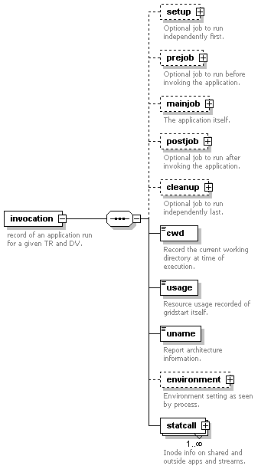
namespace | http://www.griphyn.org/chimera/Invocation
children | setup prejob mainjob postjob cleanup cwd usage uname environment statcall
attributes
  Name | Type | Use | Default | Fixed
  version | xs:NMTOKEN | required
  start | xs:dateTime | required
  duration | PositiveDecimal | required
  transformation | xs:string | optional | null
  derivation | xs:string | optional | null
  resource | xs:string | optional
  hostaddr | DottedQuad | optional | 0.0.0.0
  hostname | xs:string | optional
  pid | xs:decimal | optional
  uid | xs:integer | optional
  user | xs:string | optional
  gid | xs:integer | optional
  group | xs:string | optional
  wf-label | xs:string | optional
  wf-stamp | xs:dateTime | optional

element invocation/setup
diagram | 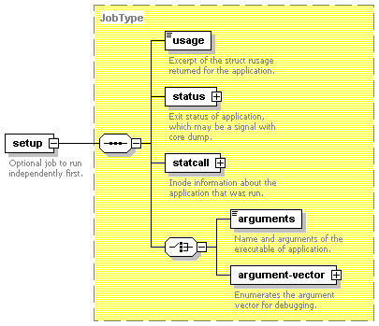
namespace | http://www.griphyn.org/chimera/Invocation
type | JobType
children | usage status statcall arguments argument-vector
attributes
  Name | Type | Use | Default | Fixed
  start | xs:dateTime | required
  duration | PositiveDecimal | required
  pid | xs:decimal | optional

element invocation/prejob
diagram | 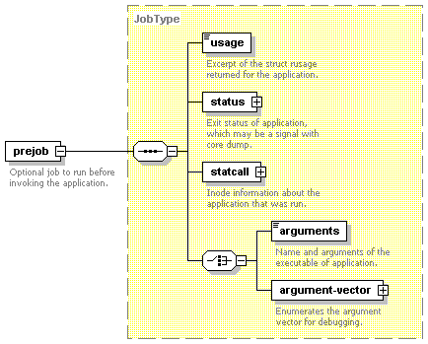
namespace | http://www.griphyn.org/chimera/Invocation
type | JobType
children | usage status statcall arguments argument-vector
attributes
  Name | Type | Use | Default | Fixed
  start | xs:dateTime | required
  duration | PositiveDecimal | required
  pid | xs:decimal | optional

element invocation/mainjob
diagram | 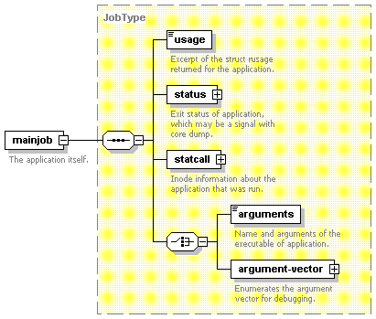
namespace | http://www.griphyn.org/chimera/Invocation
type | JobType
children | usage status statcall arguments argument-vector
attributes
  Name | Type | Use | Default | Fixed
  start | xs:dateTime | required
  duration | PositiveDecimal | required
  pid | xs:decimal | optional

element invocation/postjob
diagram | 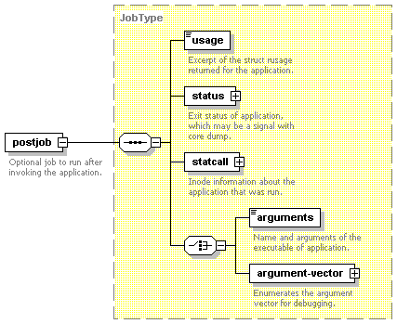
namespace | http://www.griphyn.org/chimera/Invocation
type | JobType
children | usage status statcall arguments argument-vector
attributes
  Name | Type | Use | Default | Fixed
  start | xs:dateTime | required
  duration | PositiveDecimal | required
  pid | xs:decimal | optional

element invocation/cleanup
diagram | 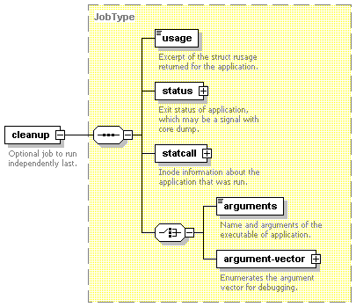
namespace | http://www.griphyn.org/chimera/Invocation
type | JobType
children | usage status statcall arguments argument-vector
attributes
  Name | Type | Use | Default | Fixed
  start | xs:dateTime | required
  duration | PositiveDecimal | required
  pid | xs:decimal | optional

element invocation/cwd
diagram | 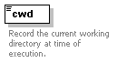
namespace | http://www.griphyn.org/chimera/Invocation
type | restriction of xs:string
facets
  maxLength | 4096
  whiteSpace | preserve

element invocation/usage
diagram | 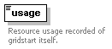
namespace | http://www.griphyn.org/chimera/Invocation
type | RUsageType
attributes
  Name | Type | Use | Default | Fixed
  utime | xs:decimal | required
  stime | xs:decimal | required
  minflt | xs:unsignedLong | required
  majflt | xs:unsignedLong | required
  nswap | xs:unsignedLong | required
  nsignals | xs:unsignedLong | required
  nvcsw | xs:unsignedLong | optional
  nivcsw | xs:unsignedLong | optional

element invocation/uname
diagram | 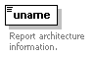
namespace | http://www.griphyn.org/chimera/Invocation
type | extension of xs:token
attributes
  Name | Type | Use | Default | Fixed
  archmode | xs:NMTOKEN | optional
  system | xs:NMTOKEN | required
  nodename | xs:NMTOKEN | required
  release | xs:NMTOKEN | required
  machine | xs:NMTOKEN | required
  domainname | xs:NMTOKEN | optional

element invocation/environment
diagram | 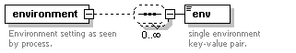
namespace | http://www.griphyn.org/chimera/Invocation
children | env

element invocation/environment/env
diagram | 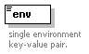
namespace | http://www.griphyn.org/chimera/Invocation
type | extension of xs:string
attributes
  Name | Type | Use | Default | Fixed
  key | xs:string | required

element invocation/statcall
diagram | 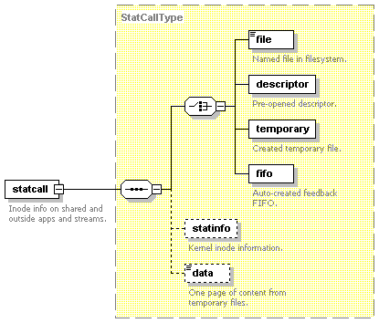
namespace | http://www.griphyn.org/chimera/Invocation
type | extension of StatCallType
children | file descriptor temporary fifo statinfo data
attributes
  Name | Type | Use | Default | Fixed
  error | xs:int | required
  id | xs:NMTOKEN | required
  lfn | xs:NMTOKEN | optional

complexType JobType
diagram | 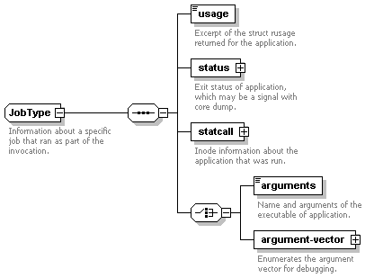
namespace | http://www.griphyn.org/chimera/Invocation
children | usage status statcall arguments argument-vector
used by
  elements | invocation/cleanup invocation/mainjob invocation/postjob invocation/prejob invocation/setup
attributes
  Name | Type | Use | Default | Fixed
  start | xs:dateTime | required
  duration | PositiveDecimal | required
  pid | xs:decimal | optional

element JobType/usage
diagram | 
namespace | http://www.griphyn.org/chimera/Invocation
type | RUsageType
attributes
  Name | Type | Use | Default | Fixed
  utime | xs:decimal | required
  stime | xs:decimal | required
  minflt | xs:unsignedLong | required
  majflt | xs:unsignedLong | required
  nswap | xs:unsignedLong | required
  nsignals | xs:unsignedLong | required
  nvcsw | xs:unsignedLong | optional
  nivcsw | xs:unsignedLong | optional

element JobType/status
diagram | 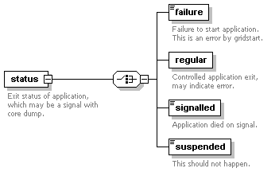
namespace | http://www.griphyn.org/chimera/Invocation
children | failure regular signalled suspended
attributes
  Name | Type | Use | Default | Fixed
  raw | xs:int | required

element JobType/status/failure
diagram | 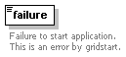
namespace | http://www.griphyn.org/chimera/Invocation
type | extension of xs:string
attributes
  Name | Type | Use | Default | Fixed
  error | xs:short | required

element JobType/status/regular
diagram | 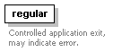
namespace | http://www.griphyn.org/chimera/Invocation
attributes
  Name | Type | Use | Default | Fixed
  exitcode | xs:unsignedByte | required

element JobType/status/signalled
diagram | 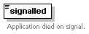
namespace | http://www.griphyn.org/chimera/Invocation
type | extension of xs:string
attributes
  Name | Type | Use | Default | Fixed
  signal | xs:byte | required
  corefile | xs:boolean | optional

element JobType/status/suspended
diagram | 
namespace | http://www.griphyn.org/chimera/Invocation
type | extension of xs:string
attributes
  Name | Type | Use | Default | Fixed
  signal | xs:byte | required

element JobType/statcall
diagram | 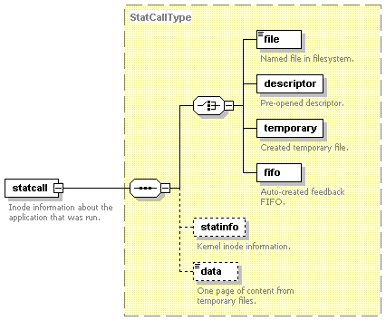
namespace | http://www.griphyn.org/chimera/Invocation
type | StatCallType
children | file descriptor temporary fifo statinfo data
attributes
  Name | Type | Use | Default | Fixed
  error | xs:int | required

element JobType/arguments
diagram | 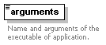
namespace | http://www.griphyn.org/chimera/Invocation
type | extension of xs:string
attributes
  Name | Type | Use | Default | Fixed
  executable | xs:string | optional

element JobType/argument-vector
diagram | 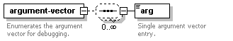
namespace | http://www.griphyn.org/chimera/Invocation
children | arg
attributes
  Name | Type | Use | Default | Fixed
  executable | xs:string | optional

element JobType/argument-vector/arg
diagram | 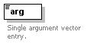
namespace | http://www.griphyn.org/chimera/Invocation
type | extension of xs:string
attributes
  Name | Type | Use | Default | Fixed
  nr | xs:nonNegativeInteger | required

complexType RUsageType
diagram | 
namespace | http://www.griphyn.org/chimera/Invocation
used by
  elements | invocation/usage JobType/usage
attributes
  Name | Type | Use | Default | Fixed
  utime | xs:decimal | required
  stime | xs:decimal | required
  minflt | xs:unsignedLong | required
  majflt | xs:unsignedLong | required
  nswap | xs:unsignedLong | required
  nsignals | xs:unsignedLong | required
  nvcsw | xs:unsignedLong | optional
  nivcsw | xs:unsignedLong | optional

complexType StatCallType
diagram | 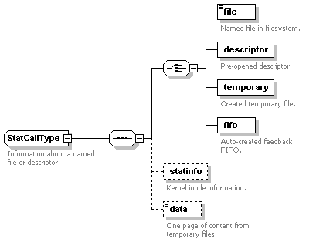
namespace | http://www.griphyn.org/chimera/Invocation
children | file descriptor temporary fifo statinfo data
used by
  elements | invocation/statcall JobType/statcall
attributes
  Name | Type | Use | Default | Fixed
  error | xs:int | required

element StatCallType/file
diagram | 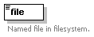
namespace | http://www.griphyn.org/chimera/Invocation
type | extension of xs:hexBinary
attributes
  Name | Type | Use | Default | Fixed
  name | xs:string | required

element StatCallType/descriptor
diagram | 
namespace | http://www.griphyn.org/chimera/Invocation
attributes
  Name | Type | Use | Default | Fixed
  number | xs:nonNegativeInteger | required

element StatCallType/temporary
diagram | 
namespace | http://www.griphyn.org/chimera/Invocation
attributes
  Name | Type | Use | Default | Fixed
  name | xs:string | required
  descriptor | xs:integer | required

element StatCallType/fifo
diagram | 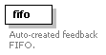
namespace | http://www.griphyn.org/chimera/Invocation
attributes
  Name | Type | Use | Default | Fixed
  name | xs:string | required
  descriptor | xs:integer | required
  count | xs:nonNegativeInteger | optional | 0
  rsize | xs:nonNegativeInteger | optional | 0
  wsize | xs:nonNegativeInteger | optional | 0

element StatCallType/statinfo
diagram | 
namespace | http://www.griphyn.org/chimera/Invocation
attributes
  Name | Type | Use | Default | Fixed
  size | xs:integer | required
  mode | xs:token | optional
  inode | xs:integer | optional
  nlink | xs:nonNegativeInteger | optional
  blocks | xs:nonNegativeInteger | optional
  blksize | xs:nonNegativeInteger | optional
  atime | xs:dateTime | optional
  mtime | xs:dateTime | optional
  ctime | xs:dateTime | optional
  uid | xs:integer | optional
  user | xs:string | optional
  gid | xs:integer | optional
  group | xs:string | optional

element StatCallType/data
diagram | 
namespace | http://www.griphyn.org/chimera/Invocation
type | extension of xs:string
attributes
  Name | Type | Use | Default | Fixed
  truncated | xs:boolean | optional

simpleType DottedQuad
namespace | http://www.griphyn.org/chimera/Invocation
type | restriction of xs:string
used by
  attribute | invocation/@hostaddr
facets
  minLength | 7
  maxLength | 15
  whiteSpace | collapse
  pattern | (\d{1,3}\.){3}\d{1,3}

simpleType PositiveDecimal
namespace | http://www.griphyn.org/chimera/Invocation
type | restriction of xs:decimal
used by
  attributes | invocation/@duration JobType/@duration
facets
  minInclusive | 0

XML Schema documentation generated with XMLSPY Schema Editor http://www.altova.com/xmlspy

