# Apache Server Hardening steps and commands - Ubuntu

These are the steps, procedures and commands and configuration settings are used to *harden* a default Apache Server installation on Ubuntu Linux 19.04 (Debian).

## Installing apache

1. sudo apt install apache

## Installing OpenSSL server

1. sudo install openssh-server

## Keep system up to date

1. sudo apachectl start

## Using Host Firewall – using ufw (uncomplicated firewall)

1. sudo ufw status verbose// check if the Ubuntu firewall is enabled
2. sudo ufw enable/disable // enable/disable host firewall
3. sudo ufw allow from 192.168.x.x port 22 // add firewall rule open port 22 and allow only 192.168.x.x access
4. sudo ufw delete 1 // disable the first rule in the firewall
5. sudo ufw delete allow ssh // remove ssh rule in the firewall

## Starting Apache

1. sudo apachectl -k start
2. In web browser, type in localhost. The *default Apache2 Ubuntu Default Page* appears (see screen shot).

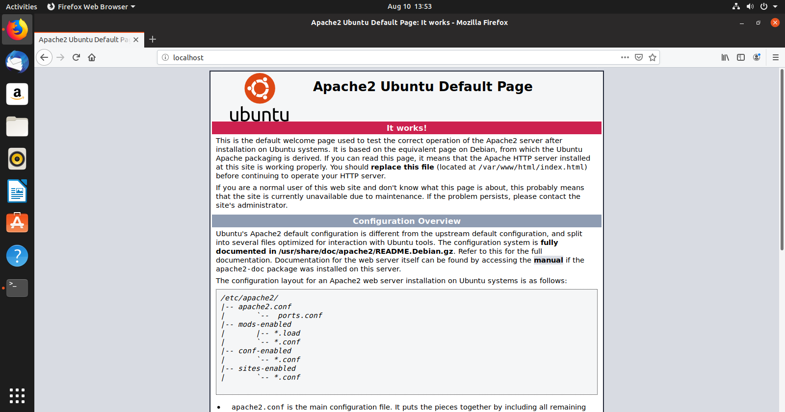

## Connecting to Ubuntu server

1. ssh -p22 ruben@192.168.x.x // connect to ubuntu server.

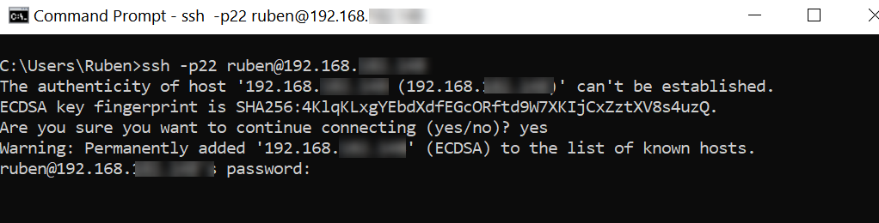

Removing default Apache page index.html

1. sudo rm index.html

Edit default Apache page index.html

1. sudo vim index.html

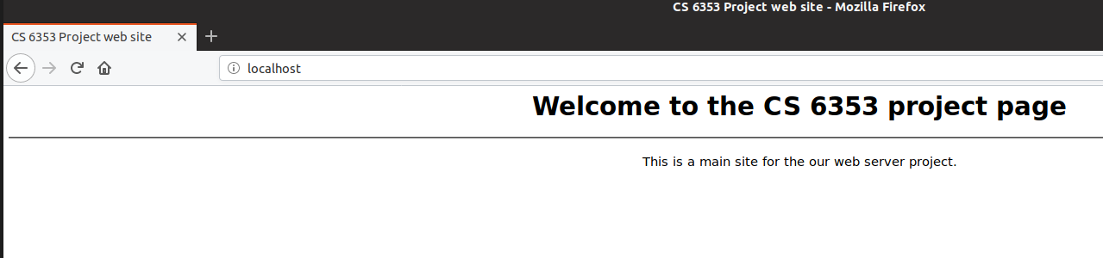

## Backup Apache2.conf file before editing

1. sudo cp apache2.conf apache2-backup.conf

## Removing HTTP Response Header

1. In FireFox web browser, in accessing the *Web Developer* tool (F12), then clicking on *Network* tab for the localhost index.html page, we can analyze the http headers for this page request. The raw headers can be displayed (see screenshot below).

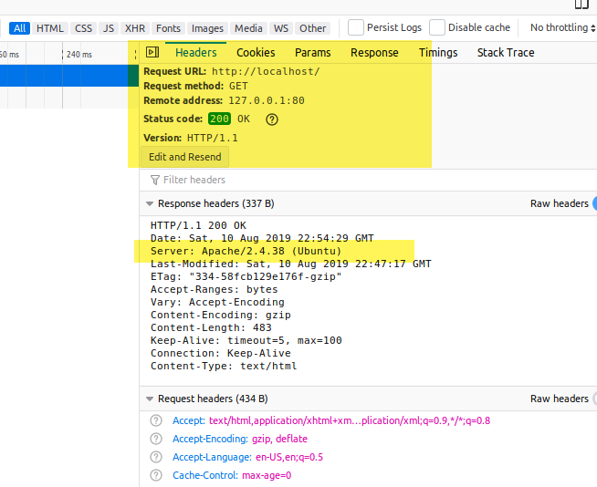

Before enabled ServerTokens directive

### Removing the Apache 2.4 Response header and server signature to stop information leaking.

1. Edit apache 2 config file

sudo /etc/apache2/apache2.conf

add these directives:

1. ServerTokens Min
2. ServerSignature off
3. See <http://httpd.apache.org/docs/2.4/mod/core.html#servertokens>

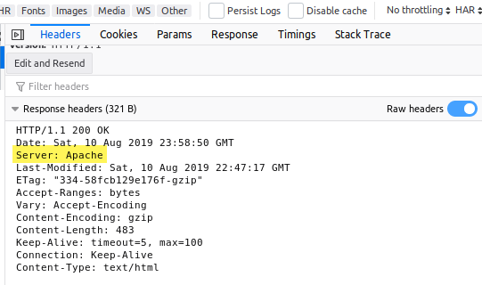

Before enabled ServerTokens directive

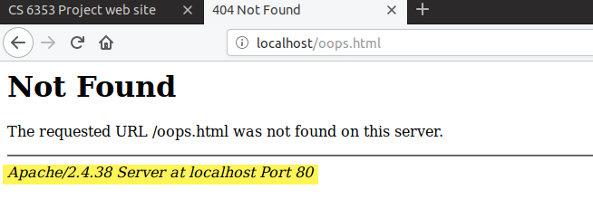

Before enabling *ServerSignature* directive

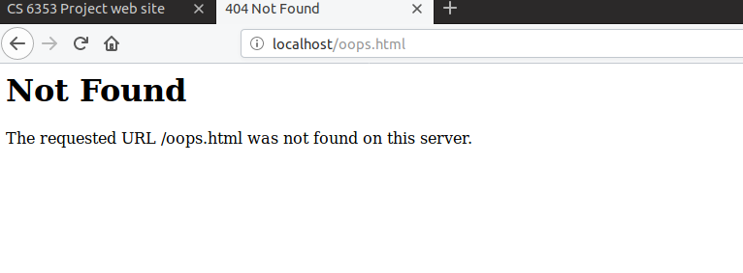

After enabling *ServerSignature* directive

## Disabling Directory Listing

By default, apache display the directory listing of a web site.

1. In apache2.conf, add directive:

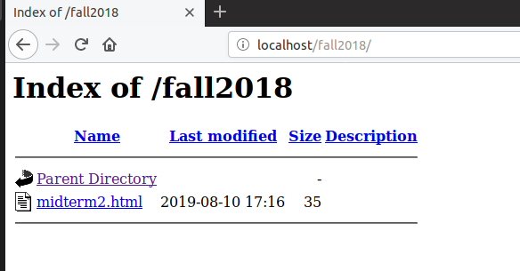

Before enabling *Options -Indexes* directive

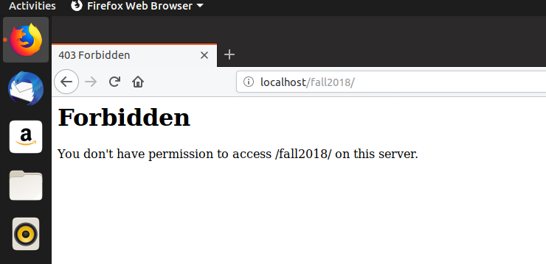

After enabling *Options -Indexes* directive

## Running Apache as a non-root different user

1. Add a group *apache2*

sudo groupadd apache2

1. Add a user apache2  
   useradd -G apache2 apache2

chown –R apache:apache /opt/apache

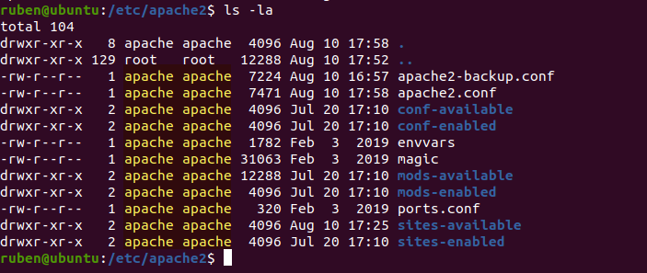

After changing ownership to apache user

### Disabling .htaccess

1)bDisabling .htaccess to allow vhosts to override the main apache2 configuration file

Inside <Directory /> directory directive tag, change AllowOverride to *None*. Note with Apache 2.4, this setting is already to None but default.

### Disable unneeded modules

1. The status module display server status information. This page is display with the *status* module.

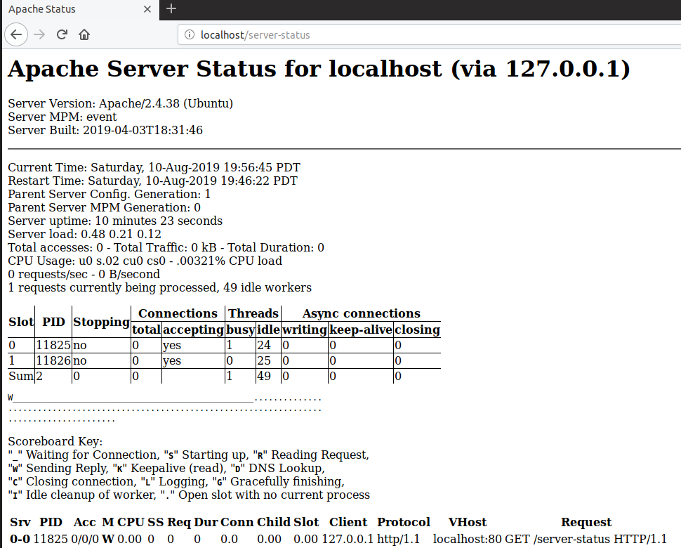

Before disabling *status* module

Disable the status (*mod_status.so*) module

sudo a2dismod status

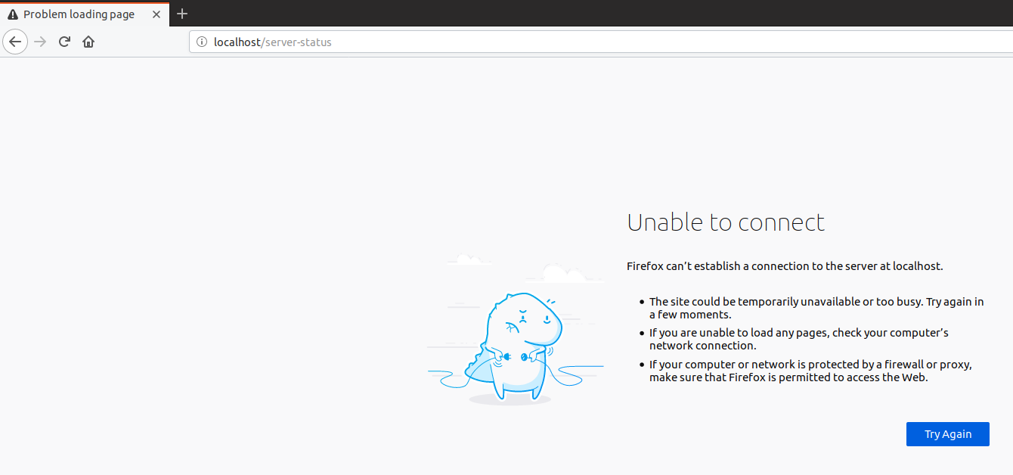

After disabling *status* module

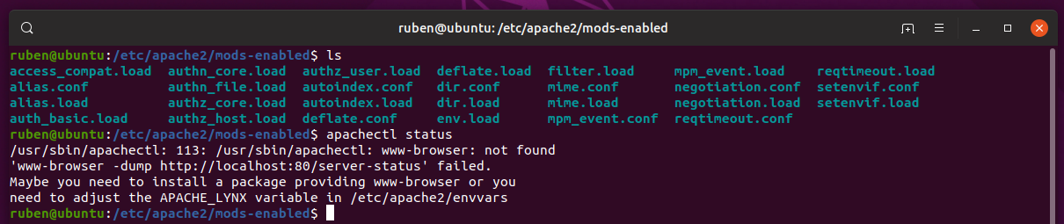

After disabling *status* module, part 2

## Creating a Self-Signed Certificate

1. openssl:

sudo openssl req -x509 -nodes -days 365 -newkey rsa:2048 -keyout /etc/ssl/private/apache-selfsigned.key -out /etc/ssl/certs/apache-selfsigned.crt

## 

## Enabling SSL on Apache

1. switch directory to sites-available directory

cd etc/apache2/sites-available

1. modify the default ssl conf file

sudo vim default-ssl.conf

1. Inside default-ssl.conf *comment out* these parameters:

#SSLCertificateFile /etc/ssl/certs/ssl-cert-snakeoil.pem

#SSLCertificateKeyFile /etc/ssl/private/ssl-cert-snakeoil.key

1. Inside default-ssl.conf *add* these parameters:

ServerName localhost

Redirect “/” “https:localhost”

SSLCertificateFile /etc/ssl/certs/apache-selfsigned.crt

SSLCertificateKeyFile /etc/ssl/private/apache-selfsigned.key

1. Enable SSL module  
   sudo a2ensite default-ssl

## Enabling Redirect module

1. Enable the redirect module with a2enmod command

sudo a2enmod rewrite

1. Enable the default ssl web site:  
   sudo a2ensite default-ssl

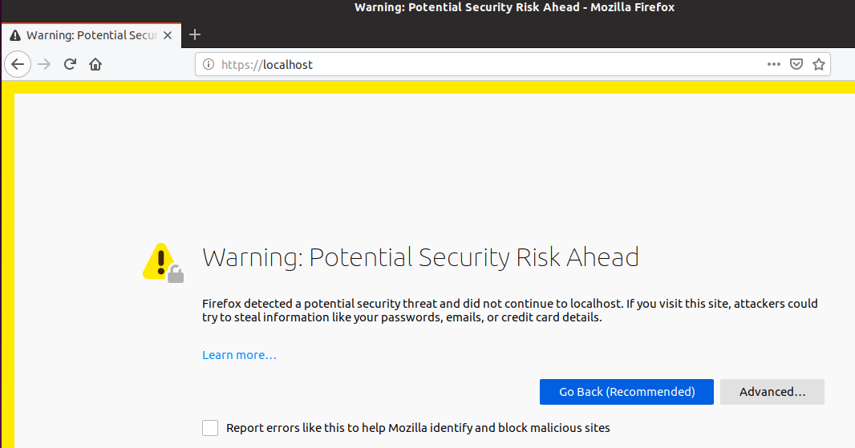

Firefox warning about self-signed certificate

1. In Firefox web browser, a security exception can be added to allow web browser to not display “Security Risk Ahead” message.

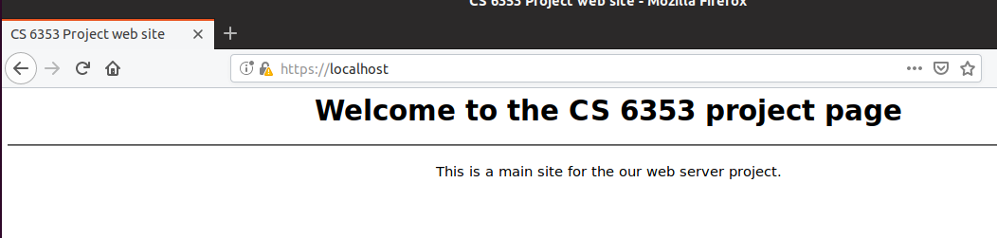

Site with SSL encryption and FireFox exception added.

## Enabling TLS encryption and Disable older encryptions

1. In the ssl.conf module  
   sudo vim ssl.conf
2. Comment out this line (#):

SSLProtocol all -SSLv2

1. Add this line:

SSLProtocol -all +TLSv1.3

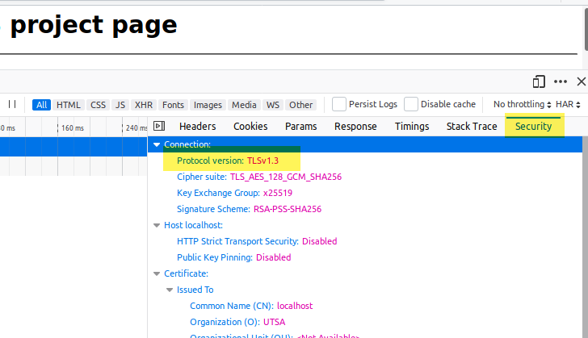

The web page connection using TLSv1.3 after adjusting the *ssl.conf* file.

## Disabling weak ciphers

1. sudo vim ssl.conf
2. comment out this line:

SSLCipherSuite HIGH:!aNULL

1. Add this line:  
   SSLCipherSuite HIGH:!MEDIUM:!aNULL:!MD5:!RC4

## Enable mod_ALLOWMETHODS module

1. Run a2enmod to enable allow methods mod:  
   sudo a2enmod allowmethods
2. Stop and Start apache2  
   sudo apachectl -k stop  
   sudo apachectl -k start
3. Edit apache2.conf

Add the LimitExcept directive code block in yellow.

<Directory /var/www/>

#Options Indexes FollowSymLinks

# CS6353 - Disable Directory listing

Options -Indexes

AllowOverride None

Require all granted

<LimitExcept GET POST>

Deny from all

</LimitExcept>

</Directory>

## Remove ETag header and set timeout setting

1. Sudo vim apache2.conf
2. Change timeout setting from 300 to 60:

Timeout 60

1. Add Directive:

Add directive: FileETag None

## 

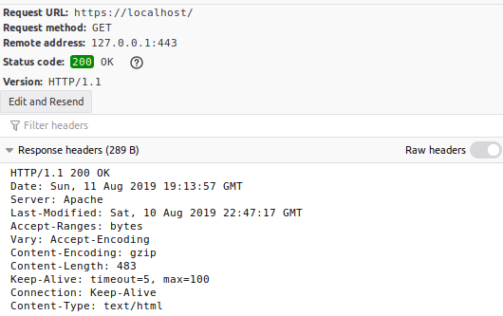

Raw headers without ETag response header.