SAY NO TO PLASTIC - MASTER WEBSITE BLUEPRINT
Chapter 2: Complete Landing Page Build Instructions for Wix Studio
This chapter is the exact construction guide for the landing page. Build the sections in the order shown. Use the approved assets, live website text, responsive behavior, and interaction rules below. Do not replace the visual direction with a template interpretation.
A. Landing page master build sequence
- Create the global page shell and section anchors.
- Build Section 1: Hero.
- Build Section 2: This Changes Everything.
- Build Section 3: The Evidence.
- Build Section 4: Where to Start.
- Build Section 5: Homo Plasticus.
- Build Section 6: Meet Dr. Elie Haddad.
- Build Section 7: TEDx.
- Build Section 8: Join the Movement.
- Build Section 9: Footer.
- Run responsive, accessibility, performance, link, and conversion QA.
Specification | Required implementation
Page URL | /
Page H1 | The greatest pollution crisis is no longer around us. It is within us.
Desktop reference width | 1440 px.
Content max width | 1240 px.
Desktop section padding | 96-128 px top and bottom.
Mobile section padding | 64-80 px top and bottom.
Primary narrative | Awareness -> evidence -> solutions -> trust -> participation.
Primary conversion | Join the email community.
Secondary conversions | Explore science, explore solutions, watch TEDx, explore the book.

1. Hero section - exact construction
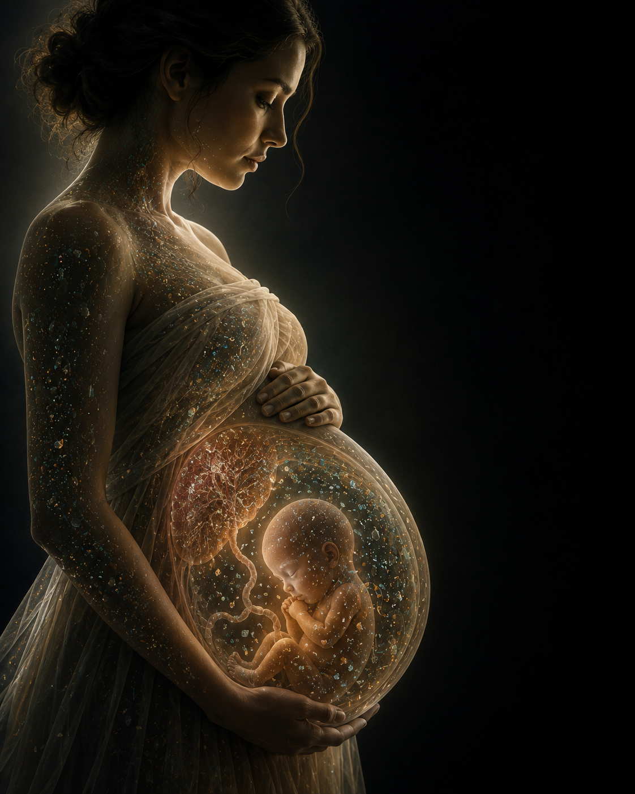
Approved hero artwork. Keep the mother, placenta, fetus, and dark negative space visible.
1.1 Build the section container
- Add a full-width section directly below the global header.
- Set desktop minimum height to 92vh and maximum practical height to 980 px.
- Set tablet minimum height to 820 px.
- Set mobile minimum height to 780 px, but allow content to expand naturally.
- Set overflow to hidden.
- Set background color to Midnight Navy #09121F as the fallback.
1.2 Place the approved hero artwork
- Upload separate desktop and mobile crops.
- Desktop: position the mother and fetus within the left 45-52% of the canvas; preserve the negative space on the right.
- Set image to cover the full section, then manually set the focal point on the fetus and mother's face.
- Add a left-to-right or center-to-right navy gradient overlay only behind live text. Start near 10-15% opacity and increase to 45-60% behind the copy.
- Do not add any text, logo, or button inside the image file.
- Do not crop the fetus, placenta, mother's hands, or face.
1.3 Create the live content block
LEFT 48-52%  H  e  r  o  a  r  t  w  o  r  k | RIGHT 40-44%  Eyebrow  H1 headline  Supporting paragraph  Primary + secondary CTA  Microcopy

Specification | Required implementation
Content width | Desktop 520-590 px; tablet 460-520 px; mobile 100%.
Vertical alignment | Center the content block within the hero, offset slightly upward by 20-35 px.
Horizontal placement | Right-side negative-space area on desktop; lower third on mobile.
Text alignment | Left aligned on all breakpoints.
Maximum line length | Headline 9-12 words per line; body 55-70 characters per line.

1.4 Use this final copy
Eyebrow: PHYSICIAN-LED. EVIDENCE-BASED. HUMAN.
Headline: The greatest pollution crisis is no longer around us. It is within us.
Supporting copy: Microplastics and nanoplastics have been identified throughout the human body. Say No To Plastic translates emerging science into practical steps that help people reduce unnecessary exposure without fear or perfectionism.
Primary CTA: START HERE
Secondary CTA: WATCH THE TEDx TALK
Microcopy: Learn the science. Focus on what matters. Begin with one meaningful change.
1.5 Typography and spacing
Specification | Required implementation
Eyebrow | Inter Semibold, 12-13 px, 0.12em letter spacing, muted gold.
H1 desktop | 72-82 px, serif, line-height 1.02, white or warm ivory.
H1 tablet | 56-64 px.
H1 mobile | 40-48 px.
Supporting copy | 19-21 px desktop; 17-18 px mobile; line-height 1.6.
Eyebrow to H1 | 16 px.
H1 to body | 24 px.
Body to CTA row | 28-32 px.
CTA row to microcopy | 16 px.

1.6 Button behavior
Specification | Required implementation
START HERE | Scroll smoothly to Section 3, The Evidence. Use gold fill and navy text.
WATCH THE TEDx TALK | Scroll smoothly to Section 7. Use transparent background and ivory border.
Hover | 150-200 ms color transition. No bounce or large shadow.
Focus | Visible 2 px focus ring.
Mobile | Stack full-width, primary above secondary, 12 px gap.

1.7 Motion
- Fade the full hero from opacity 0 to 1 over 800-1000 ms.
- Reveal the copy group after 150-250 ms with opacity and 16 px upward movement.
- Optional: scale the hero image from 1.00 to 1.02 during the first 25% of the page scroll.
- Disable the movement under prefers-reduced-motion.
1.8 Mobile-specific composition
- Use a dedicated vertical crop.
- Keep the mother's face, fetus, and at least one hand visible.
- Do not place text over the brightest anatomy.
- Use a bottom navy gradient to create a readable content zone.
- Ensure the headline and primary CTA are visible before the visitor scrolls.
1.9 Hero completion checklist
- No embedded fake buttons.
- Both CTAs work.
- Fetus and placenta are visible.
- No horizontal overflow at 320 px.
- Image is not blurry on 1440 px screens.
- Hero loads without layout shift.
- Only one H1 exists on the page.
2. This Changes Everything - exact construction
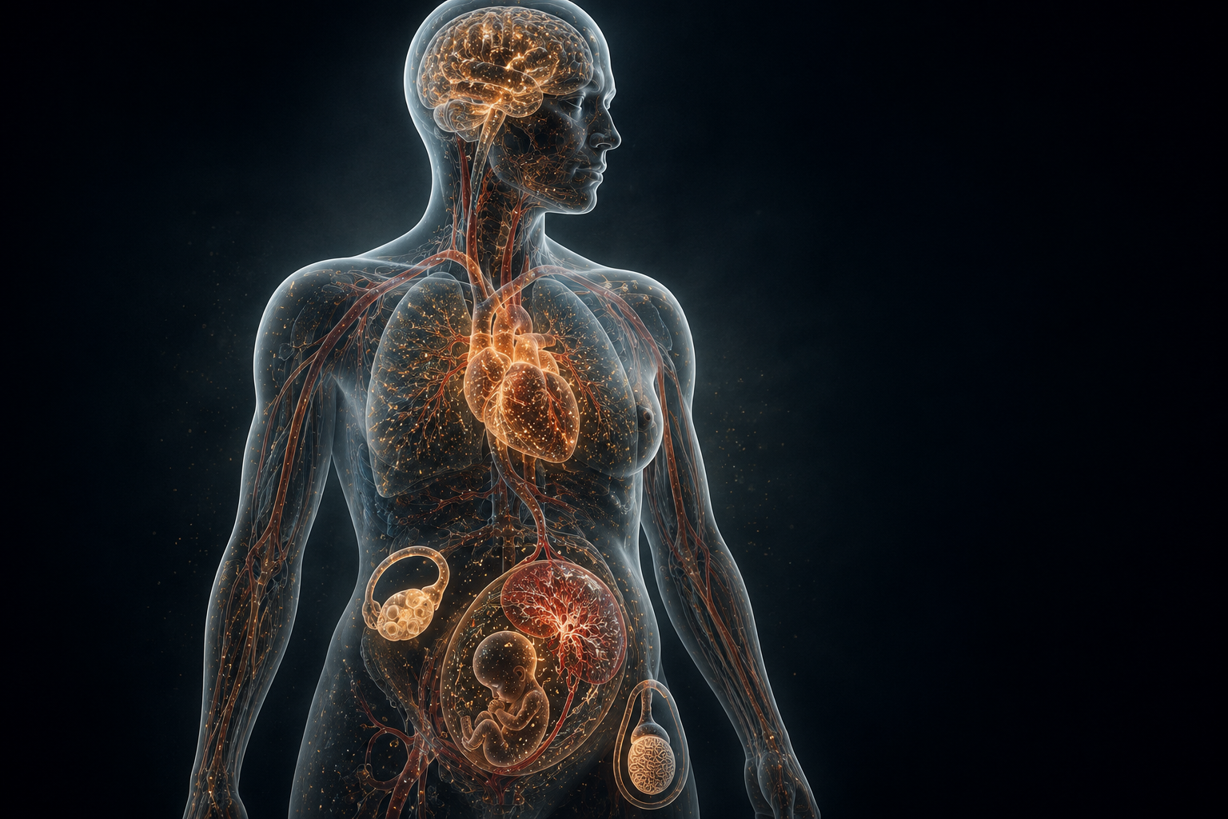
Approved translucent anatomy artwork.
2.1 Section shell
- Create a full-width section with Warm Ivory #F5F1E8.
- Set desktop vertical padding to 112-128 px.
- Set mobile vertical padding to 72-80 px.
- Add anchor ID: invisible-threat.
2.2 Desktop layout
COPY - 42 to 46%  Eyebrow  H2  Two paragraphs  CTA | IMAGE - 54 to 58%  Full translucent anatomy  Brain  Heart  Circulation  Reproductive anatomy

- Create a 12-column grid inside the 1240 px content container.
- Place copy across columns 1-5.
- Place image across columns 6-12.
- Align the copy block vertically to the center of the anatomical torso.
- Keep at least 64 px between copy and image.
2.3 Use this final copy
Eyebrow: THIS CHANGES EVERYTHING
Headline: Plastic pollution has crossed the boundary into human biology.
Paragraph 1: For decades, plastic pollution was framed primarily as an environmental problem. The discovery of microscopic plastic particles in human tissues has made the issue far more personal.
Paragraph 2: The science is still evolving, and not every health consequence is fully established. But the presence of these particles in the body is enough to justify informed, practical exposure reduction.
CTA: UNDERSTAND THE EVIDENCE
2.4 Image treatment
- Do not place the artwork inside a small card.
- Keep the full figure visible; do not crop it into a torso-only composition.
- Use a very subtle radial navy haze behind the figure only if needed for separation.
- Do not add labels directly on top of the anatomy in this section.
2.5 Optional organ reveal animation
- When the section reaches approximately 35% viewport visibility, fade the figure in.
- Then brighten the brain, heart, vascular network, and reproductive anatomy in a restrained sequence.
- Total sequence duration: 1800-2400 ms.
- Do not use pulsing or alarming red flashes.
- Under reduced motion, display the final static image immediately.
2.6 CTA behavior
UNDERSTAND THE EVIDENCE scrolls to Section 3. Use a text-arrow link or secondary button rather than another large gold block.
2.7 Mobile
- Stack copy first and image second.
- Keep 36-48 px between copy and image.
- Set image width to 100% and preserve the full human outline.
- Do not hide the reproductive anatomy.
- Use H2 at 36-42 px and body copy at 17 px.
2.8 Completion checklist
- Copy is readable at 200% zoom.
- Image remains anatomically legible on tablet.
- The section does not appear like a medical clinic advertisement.
- The CTA takes the visitor to the evidence cards.
3. The Evidence - exact construction
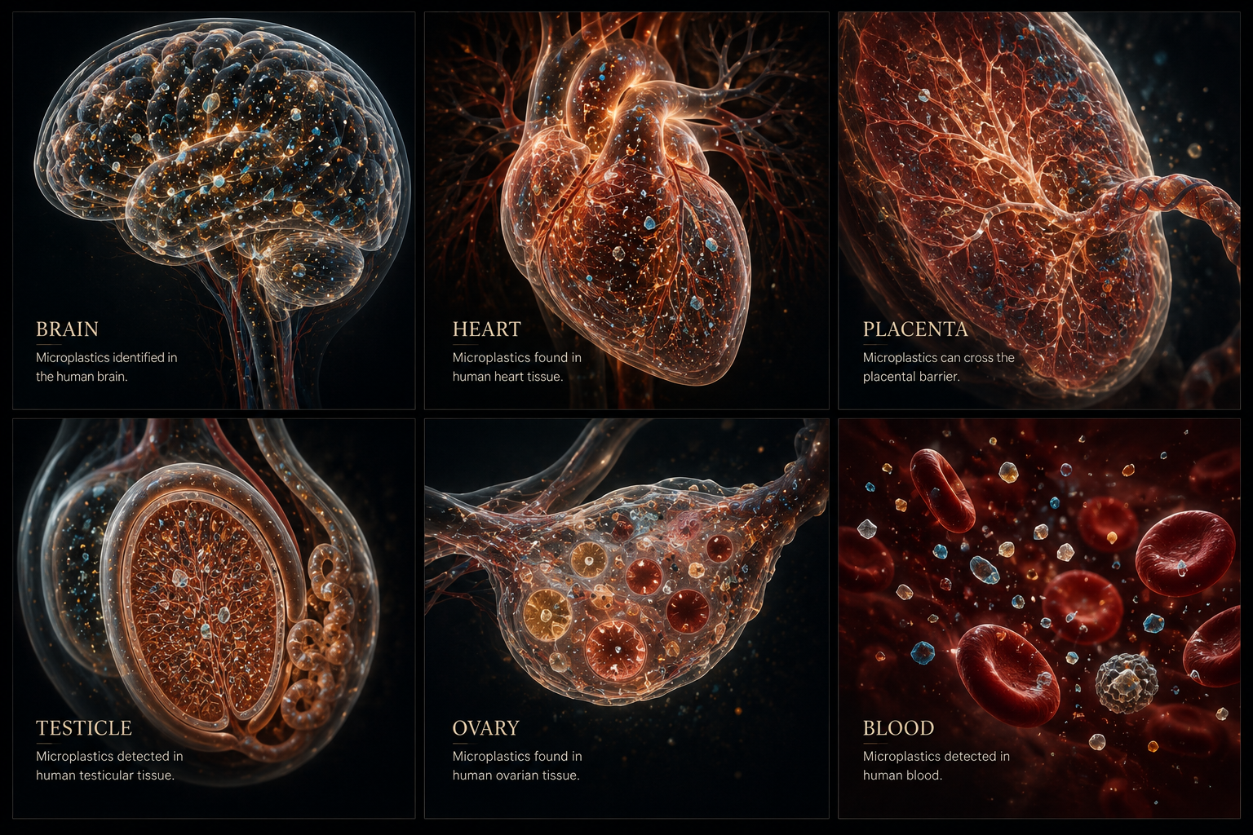
Approved six-panel visual. Prefer separating it into six individual card crops.
3.1 Section shell
- Create a full-width Midnight Navy #09121F section.
- Set desktop vertical padding to 120-136 px.
- Set mobile padding to 72-88 px.
- Add anchor ID: evidence.
3.2 Heading block
Eyebrow: FOLLOW THE EVIDENCE
Headline: What scientists are finding inside the human body
Intro: Research teams have detected microplastics or nanoplastics in a growing range of human tissues. These findings do not prove that every detected particle causes disease, but they have changed the conversation about exposure.
Specification | Required implementation
Heading width | 760-880 px centered.
Alignment | Centered on desktop and tablet; left aligned on mobile.
Heading color | Warm ivory.
Intro color | White at 78-85% opacity.
Heading to grid gap | 56-72 px.

3.3 Build six real cards
- Export or crop the composite visual into six separate images: Brain, Heart, Placenta, Testicle, Ovary, Blood.
- Create six Wix repeater items or individual accessible cards.
- Desktop grid: 3 columns x 2 rows.
- Tablet grid: 2 columns x 3 rows.
- Mobile: 1 column. Avoid a swipe carousel unless each card remains fully readable and keyboard accessible.
- Use equal card heights within each breakpoint.
Specification | Required implementation
Card background | Charcoal #202020 or navy lifted 4-6% from the section background.
Card radius | 14 px.
Card border | 1 px white at 10-14% opacity.
Image ratio | 4:3 or 1:1 depending on the crop; keep consistent.
Internal padding | 24 px desktop; 20 px mobile.
Title | 26-30 px serif, ivory.
Summary | 15-16 px sans serif, white at 78-85% opacity.
Card gap | 24 px desktop; 18 px mobile.

3.4 Live card copy
Brain
Human brain-tissue studies have reported plastic particles, raising questions about how very small particles may cross biological barriers.
Heart
Researchers have reported microplastics in cardiovascular tissues and plaque, making the heart and circulation a major area of investigation.
Placenta
Placental findings have made prenatal exposure one of the most urgent and emotionally significant areas of research.
Testicle
Detection in testicular tissue has intensified questions about male reproductive health, hormones, and fertility.
Ovary
Emerging research involving ovarian tissue and follicular environments is expanding concern about female reproductive exposure.
Blood
Particles identified in blood suggest a pathway by which exposure may circulate and reach multiple tissues.
3.5 Interaction
- On hover, move the card upward by 2-4 px or scale to 1.02; do not use both if the result feels busy.
- Change the border to muted gold.
- Show a live text link: READ THE EVIDENCE.
- On click, open the corresponding Science page or an accessible details drawer.
- Do not hide critical copy only inside hover states.
3.6 Section CTA
CTA label: EXPLORE THE SCIENCE
Place it centered 48-56 px below the grid. Link to /science.
3.7 Accessibility
- Each card must be a real link or button, not only a clickable background.
- Use descriptive alt text for each organ visual.
- Any text embedded in the generated artwork must also exist as live text.
- Focus states must mirror hover states.
3.8 Completion checklist
- Six cards are separate and responsive.
- No card requires pinching on mobile.
- All six destinations work.
- No medical claim is presented as stronger than the supporting evidence.
- The composite image is not used as the only accessible content.
4. Where to Start - exact construction
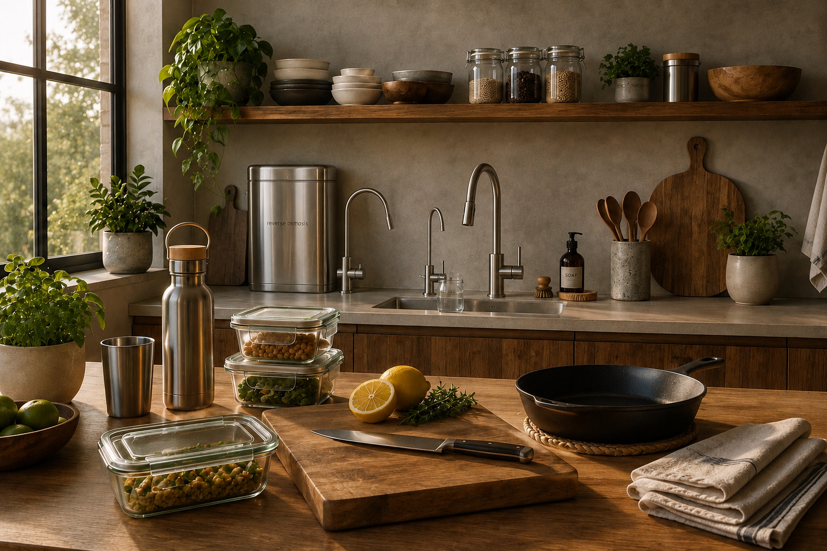
Approved kitchen image with stainless reverse-osmosis unit.
4.1 Section shell
- Use Warm Ivory #F5F1E8.
- Set desktop vertical padding to 112-128 px.
- Add anchor ID: solutions.
4.2 Desktop layout
IMAGE - 56 to 60%  Kitchen  RO filter  Glass containers  Steel bottle  Cast iron  Wood | COPY - 40 to 44%  Eyebrow  H2  Intro  Numbered list  CTA

- Place image columns 1-7 and copy columns 8-12.
- Vertically center the copy.
- Keep 56-72 px between image and copy.
- Use a 16 px image radius at most; no heavy shadow.
4.3 Use this final copy
Eyebrow: PROGRESS, NOT PERFECTION
Headline: Begin with the changes that matter most.
Body: You do not need to eliminate every source of plastic overnight. Start with repeated exposures involving heat, food, water, and the products you use every day.
4.4 Build the five-step list
1. Filter drinking water
Choose a system appropriate for your home and local water quality.
2. Change food storage
Store and reheat food in glass, ceramic, or stainless steel rather than plastic.
3. Replace daily drinkware
Use stainless steel or glass bottles and cups.
4. Reduce heat plus plastic
Favor cast iron, stainless steel, wood, and durable ceramic around hot food.
5. Simplify textiles and personal care
Choose natural fibers and simpler products where practical.
4.5 List styling
Specification | Required implementation
Number | 42-48 px serif in muted gold.
Title | 19-21 px Inter Semibold or 25-28 px serif.
Description | 16-17 px Inter, charcoal at 82-90%.
Divider | 1 px navy at 10-15% opacity between items.
Item padding | 18-22 px top and bottom.

4.6 CTA
Primary CTA: SEE THE SOLUTIONS
Link to /solutions. Use a navy-filled button with ivory text in this light section.
Microcopy: Start with one room, one habit, or one product at a time.
4.7 Mobile
- Place image first.
- Crop so the RO filter, glass storage, stainless bottle, and wood/cast-iron elements remain visible.
- Place copy and list below with 36-44 px spacing.
- Keep the five steps visible; do not hide them all inside accordions.
4.8 Completion checklist
- The reverse-osmosis unit is visible.
- The list is scannable in under 20 seconds.
- The section feels hopeful and practical after the evidence section.
- The CTA links to a real Solutions page.
5. Homo Plasticus book - exact construction
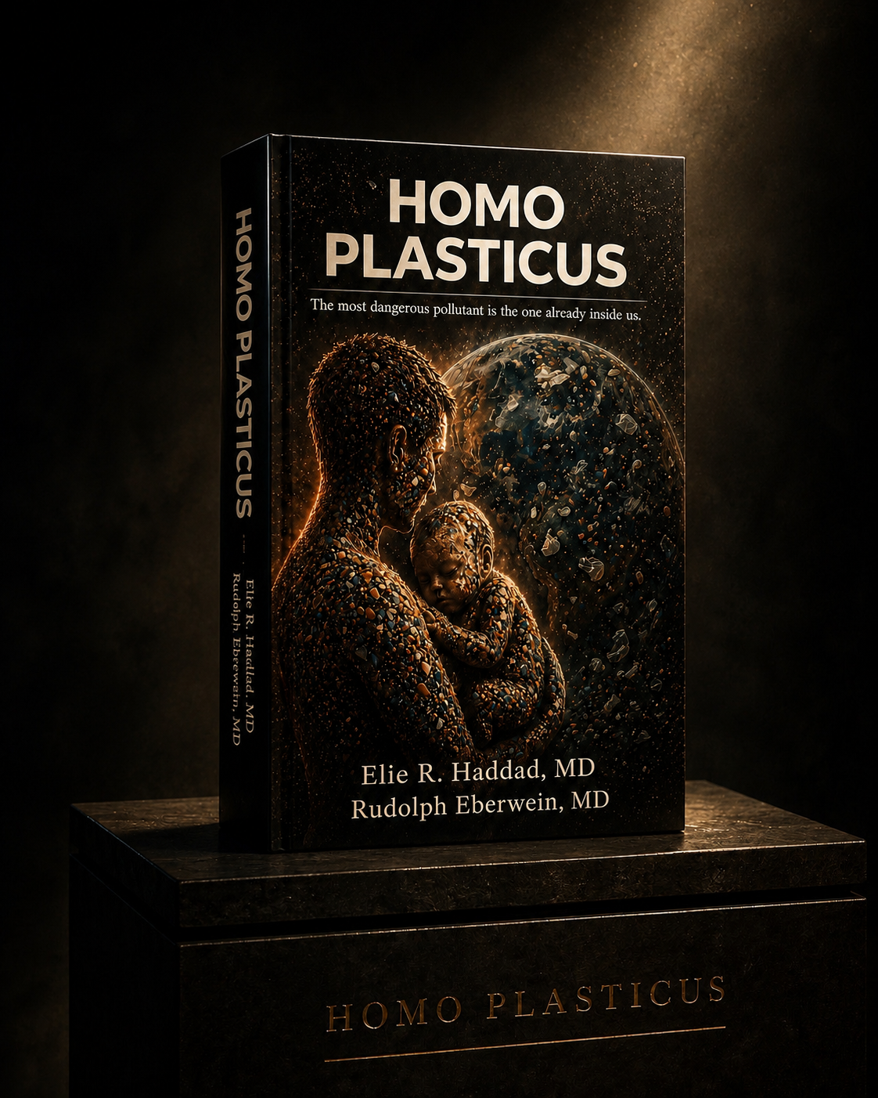
Approved book image without the background figure.
5.1 Section shell
- Create a Charcoal #202020 or Midnight Navy section.
- Set desktop padding to 112-128 px.
- Add anchor ID: book.
5.2 Layout
BOOK IMAGE - 46 to 50%  Large book  Dark pedestal  Museum lighting | COPY - 46 to 50%  Eyebrow  Title  Subheadline  Body  Pull quote  CTA

- Place the book image large enough to read the cover.
- Keep the image vertically centered.
- Do not add a carousel or secondary products.
- Use no more than two CTAs.
5.3 Use this final copy
Eyebrow: THE BOOK
Headline: Homo Plasticus
Subheadline: The science of microplastics, translated for everyday life.
Body: Homo Plasticus explores how plastic moved from a symbol of convenience into the air, food, water, and tissues of the human body. It combines scientific evidence with practical guidance for reducing the exposures that matter most.
Pull quote: The question is no longer only whether plastic is inside us. The question is what we choose to do with that knowledge.
Primary CTA: EXPLORE THE BOOK
Optional secondary CTA: READ AN EXCERPT
5.4 Typography
Specification | Required implementation
Title | 58-68 px desktop; 42-48 px mobile; warm ivory.
Subheadline | 21-24 px; white at 90%.
Body | 17-19 px; white at 78-85%.
Pull quote | 24-30 px serif italic; muted gold or warm ivory.

5.5 CTA behavior
- EXPLORE THE BOOK links to /homo-plasticus.
- READ AN EXCERPT opens a dedicated excerpt page or accessible PDF only if one exists.
- Do not use the visual pedestal text as the clickable control.
5.6 Mobile
- Place the book image first and center it.
- Limit image width to approximately 82-90% of the content width.
- Place copy below with 36-48 px separation.
- Keep buttons full width if two are used.
6. Meet Dr. Elie Haddad - exact construction
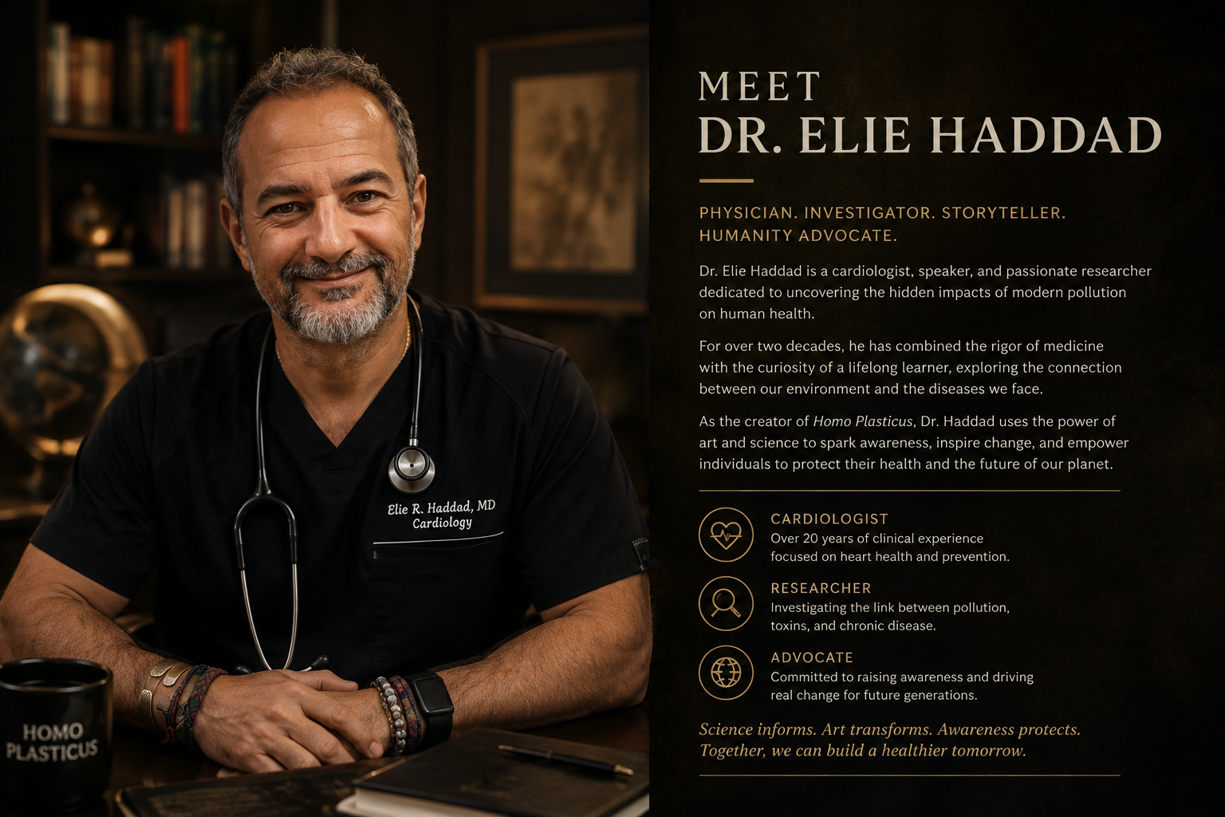
Composition reference only. Use the portrait as the visual; rebuild all biography text as live content.
6.1 Asset rule
Do not use the full generated composite as one flattened image. Crop or recreate the portrait portion only. All biography copy, credentials, links, and trust elements must be live Wix content.
6.2 Section shell and layout
- Use Warm Ivory #F5F1E8.
- Set desktop padding to 112-128 px.
- Use a two-column 50/50 layout.
- Place portrait on the left and copy on the right.
- Add anchor ID: about.
6.3 Portrait direction
- Use a natural, recognizable portrait based on the supplied face references.
- Do not over-age, over-smooth, or significantly alter facial structure.
- Use warm side lighting and a calm dark background.
- No white coat and no stethoscope.
- Black scrubs or a dark shirt are acceptable.
- Crop from approximately mid-torso upward with direct eye contact.
6.4 Use this final copy
Eyebrow: BEHIND THE SCIENCE
Headline: Meet Dr. Elie Haddad
Paragraph 1: Dr. Elie R. Haddad is a cardiologist and cardiac electrophysiologist with more than two decades of clinical experience, as well as an author, educator, and TEDx speaker.
Paragraph 2: His work on plastic exposure began with a physician's question: what environmental influences are we overlooking when illness appears earlier, more often, and in people who do not fit the expected pattern?
Paragraph 3: Through Say No To Plastic, he translates a rapidly evolving body of research into calm, evidence-based guidance designed to help people protect themselves and future generations.
Credential line: Cardiologist | Cardiac Electrophysiologist | Author | TEDx Speaker
Primary CTA: READ DR. HADDAD'S STORY
Secondary CTA: MEDIA & SPEAKING
6.5 Trust row
- Add a restrained row of verified media, book, speaking, or TEDx marks below the bio.
- Use monochrome or muted-gold logos.
- Keep logo height consistent at approximately 24-32 px.
- Do not use logos without permission or verified affiliation.
6.6 Mobile
- Place portrait first.
- Use an aspect ratio that preserves the face and upper body.
- Place copy below and left align.
- Stack CTA buttons.
- Move the trust row below the buttons and allow logos to wrap.
6.7 Completion checklist
- Portrait is recognizable and natural.
- Biography is live text.
- Credentials are accurate.
- No generic hospital imagery is present.
- Both CTA destinations exist.
7. TEDx - exact construction
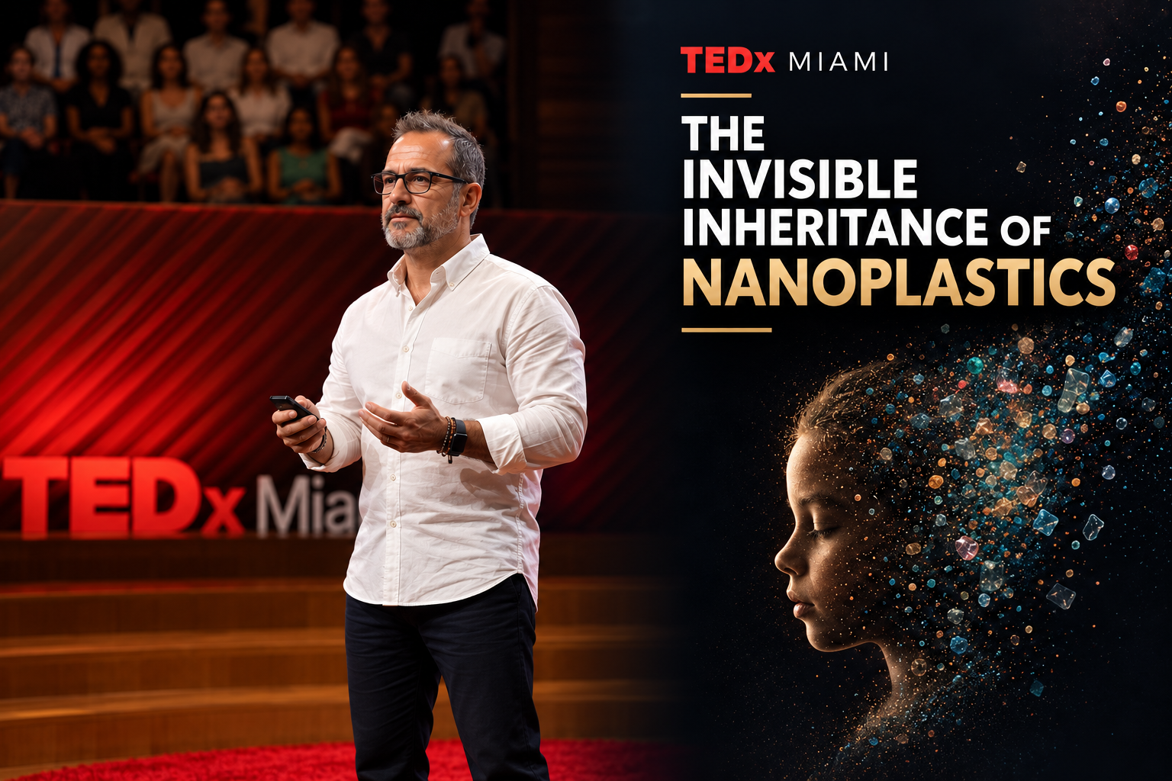
Approved TEDx visual. Correct title: The Invisible Inheritance of Nanoplastics.
7.1 Section shell
- Use Midnight Navy #09121F.
- Set desktop padding to 112-128 px.
- Add anchor ID: tedx.
7.2 Visual placement
- Place the approved TEDx artwork as a full-width feature image within the 1240 px container.
- Use a 16 px radius maximum.
- Do not add another large title on top of the title already visible in the visual.
- Add a real live play button over the stage area or directly below the artwork.
- The play button must be a Wix control, not embedded in the image.
7.3 Supporting copy
Eyebrow: TEDx MIAMI
Headline: The Invisible Inheritance of Nanoplastics
Body: In this talk, Dr. Haddad explores how plastic pollution moved from the environment into human biology, why reproductive and prenatal exposure matter, and how awareness can become practical action.
Primary CTA: WATCH THE TALK
Secondary CTA: VIEW THE SOURCES
7.4 Layout options
Specification | Required implementation
Preferred desktop | Feature image first; copy block below in a centered 760-860 px column.
Alternative desktop | Image 62%; copy 38% only if title remains readable.
Mobile | Image first, then copy and buttons.

7.5 Video behavior
- Load a lightweight poster image initially.
- On click, open the official video in an accessible lightbox or dedicated /tedx page.
- Do not autoplay sound.
- Provide captions.
- Provide a transcript link when available.
- Close the modal with Escape and return focus to the play control.
7.6 Completion checklist
- Talk title is correct.
- Video opens and plays.
- No fake embedded button is relied upon.
- Caption and transcript options are present when available.
- The section loads quickly on mobile.
8. Join the Movement - exact construction
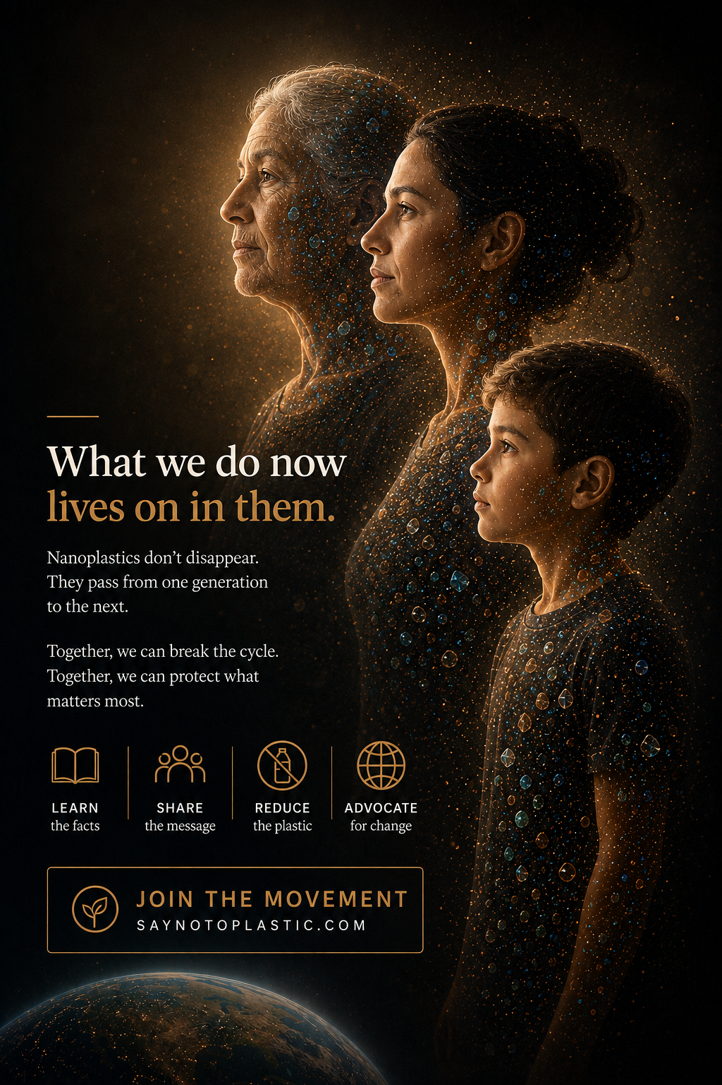
Approved generational composition: elderly woman, adult woman, and young boy.
8.1 Critical asset handling
Preferred implementation: create a text-free crop of the three generations and use it as the background or right-side visual. Rebuild the headline, movement pillars, email fields, and CTA as live Wix elements. If the current editorial asset is used temporarily, the visible button in the artwork is decorative only and must not be relied upon as the functional control.
8.2 Section shell
- Use a deep navy-to-charcoal background.
- Set desktop padding to 120-144 px.
- Add anchor ID: join.
- Use a 12-column grid.
8.3 Desktop layout
LIVE CONTENT - 48 to 52%  Eyebrow  H2  Body  Four pillars  Email form | THREE GENERATIONS - 48 to 52%  Elderly woman  Adult woman  Young boy  Subtle particles

8.4 Use this final copy
Eyebrow: FOR THE GENERATIONS AHEAD
Headline: What we do now lives on in them.
Body: Nanoplastics do not simply disappear. Exposure can begin before birth and continue throughout life. Together, we can reduce what is avoidable, share what is known, and protect what matters most.
8.5 Four movement pillars
LEARN
Understand the evidence without sensationalism.
SHARE
Bring credible information into your family and community.
REDUCE
Focus on practical changes that meaningfully lower exposure.
ADVOCATE
Support healthier products, environments, and policies.
8.6 Email form
Specification | Required implementation
Form headline | Join the Say No To Plastic community
Supporting copy | Receive new research summaries, practical exposure-reduction guidance, and updates from the movement.
Fields | First name and Email address.
Button | JOIN THE MOVEMENT.
Consent | By subscribing, you agree to receive email updates. Unsubscribe at any time.
Success message | You're in. Welcome to the movement.
Error message | Use specific plain-language errors directly beneath the affected field.

8.7 Form layout
- Desktop: place First Name and Email side by side only if the fields remain at least 220 px wide.
- Place the submit button on the next line or aligned to the email field depending on available width.
- Mobile: stack all fields and the button at full width.
- Keep the form within a maximum width of 620 px.
- Do not request phone number, location, date of birth, or health information.
8.8 Backend configuration
- Connect the form to the selected email platform.
- Apply the source tag: Landing Page - Join Movement.
- Enable double opt-in if legally or strategically required.
- Send the correct welcome email after successful confirmation.
- Test the flow using at least two external email addresses.
- Add spam protection that does not create excessive friction.
8.9 Mobile
- Place live copy and form first.
- Place the three-generation visual below or as a controlled background crop.
- Ensure the young boy remains visible and the two adult women are not replaced.
- Avoid placing essential form text over faces.
8.10 Completion checklist
- Final image shows elderly woman, adult woman, young boy.
- The live CTA submits a real form.
- Embedded artwork text is not the only accessible text.
- Success and error states work.
- Subscriber receives the expected welcome flow.
9. Footer - exact construction
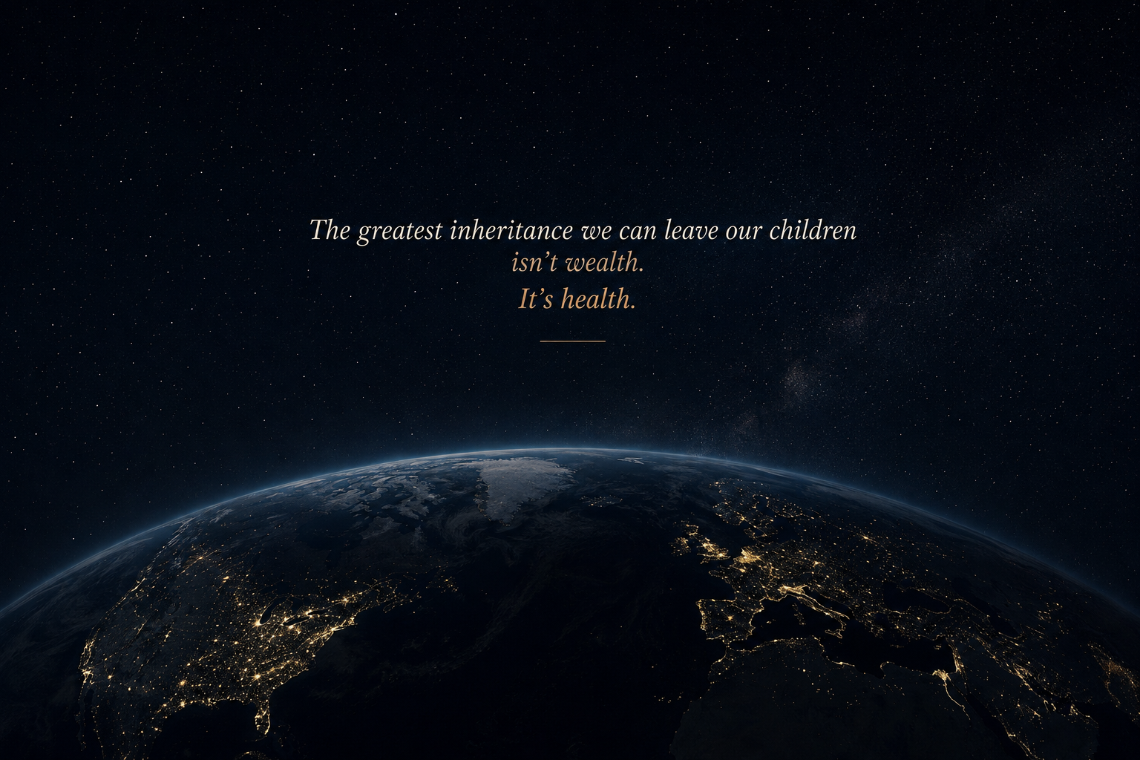
Approved Earth-at-night visual.
9.1 Footer image zone
- Use the Earth image as a wide, shallow cinematic background.
- Set the visual zone to approximately 360-480 px high on desktop and 320-420 px on mobile.
- Preserve the Earth's curve and deep navy sky.
- Add a bottom dark gradient so live footer content remains readable.
- Do not place navigation links directly over the brightest city lights.
9.2 Quote
The greatest inheritance we can leave our children isn't wealth. It's health.
Specification | Required implementation
Quote width | 640-760 px centered.
Font | Serif italic, 30-38 px desktop; 24-30 px mobile.
Color | Warm ivory with 'It's health.' in muted gold if rebuilt as live text.
Spacing below | 56-72 px before footer navigation.

9.3 Footer navigation structure
Specification | Required implementation
Column 1 | Say No To Plastic wordmark and mission sentence.
Column 2 | Science | Solutions | Resources | About.
Column 3 | Homo Plasticus | TEDx | Podcast | Community.
Column 4 | Newsletter email field and Subscribe button.
Bottom row | Privacy Policy | Terms | Contact | Media Inquiries | Accessibility.
Copyright | Current year generated dynamically.

Mission sentence: A physician-led platform translating microplastic research into practical steps that protect human health and future generations.
9.4 Remove current template remnants
- Remove '2035 by Business Name'.
- Remove Wix Studio promotional banner before launch.
- Remove duplicate newsletter forms.
- Remove any placeholder social icon without a destination.
9.5 Social and legal behavior
- Open external social links in a new tab and include accessible labels.
- Keep legal links in the same tab.
- Ensure Privacy and Terms pages are published before the form is activated.
- Include a visible Contact or Media Inquiries route.
9.6 Mobile
- Stack footer columns.
- Use accordions only for link groups if necessary, but keep Contact and Newsletter visible.
- Keep touch targets at least 48 px.
- Avoid very small legal text; use at least 14 px.
10. Section-to-section transition rules
Specification | Required implementation
Hero -> Anatomy | Dark cinematic hero transitions to warm ivory. Use a clean hard section change or 40-60 px gradient bridge.
Anatomy -> Evidence | Ivory transitions to navy. Keep 96-128 px breathing space; no decorative waves.
Evidence -> Solutions | Navy transitions to ivory to create emotional relief.
Solutions -> Book | Ivory transitions to charcoal for premium product focus.
Book -> About | Charcoal transitions back to ivory.
About -> TEDx | Ivory transitions to navy.
TEDx -> Join | Maintain dark palette but change image composition and spacing to signal a new action phase.
Join -> Footer | Blend into the dark Earth-at-night footer.

- Do not place thin decorative separators between every section.
- Use contrast, spacing, and background shifts as the primary separators.
- Keep all section headings aligned to a consistent grid.
11. Anchor navigation and CTA map
Specification | Required implementation
Header START HERE | Scroll to #evidence.
Hero WATCH THE TEDx TALK | Scroll to #tedx.
Anatomy UNDERSTAND THE EVIDENCE | Scroll to #evidence.
Evidence EXPLORE THE SCIENCE | Open /science.
Solutions SEE THE SOLUTIONS | Open /solutions.
Book EXPLORE THE BOOK | Open /homo-plasticus.
About READ DR. HADDAD'S STORY | Open /about-dr-elie-haddad.
About MEDIA & SPEAKING | Open /contact or a dedicated speaking page.
TEDx WATCH THE TALK | Open video lightbox or /tedx.
TEDx VIEW THE SOURCES | Open the source list.
Join JOIN THE MOVEMENT | Submit the email form.

12. Landing page responsive QA
Desktop checks
- 1440 px: content uses max-width correctly and does not look stretched.
- 1366 px laptop: no navigation crowding.
- 1024 px: two-column sections remain balanced.
- All live text remains selectable and editable.
Tablet checks
- 768 px portrait and 1024 px landscape tested.
- Evidence grid converts to two columns.
- Hero crop preserves face and fetus.
- Buttons remain easy to tap.
Mobile checks
- 320 px, 360 px, 390 px, and 430 px widths tested.
- No horizontal scroll.
- No body text below 16 px.
- All forms and buttons are full-width where appropriate.
- No essential face, fetus, organ, book title, or CTA is cropped.
- Sticky header does not cover section headings after anchor scrolling.
13. Accessibility QA
- One H1 only.
- Logical heading order.
- Every functional image has descriptive alt text.
- Decorative images have empty alt text.
- Color contrast passes WCAG AA.
- Keyboard focus is visible.
- All modals trap focus correctly and close with Escape.
- Video has captions and transcript access.
- Forms have visible labels, errors, and success state.
- The site remains usable at 200% zoom.
- Reduced-motion mode removes nonessential animation.
14. Performance QA
- Hero image is not lazy-loaded.
- All below-the-fold images are lazy-loaded.
- Responsive image variants are served.
- Full YouTube or video player loads only after interaction.
- Unused font weights and Wix apps are removed.
- No unnecessary third-party scripts run before consent.
- Largest Contentful Paint is checked on mobile.
- Cumulative Layout Shift is minimized by defining image dimensions.
15. Analytics and conversion tracking
- Track hero START HERE clicks.
- Track hero TEDx clicks.
- Track each evidence card click.
- Track Solutions, Book, About, and TEDx CTA clicks.
- Track Join form starts, successful submissions, and errors.
- Track video plays at 25%, 50%, 75%, and completion if supported.
- Use clear event names such as home_hero_start, home_evidence_brain, home_join_submit.
16. Final designer sign-off checklist
- All nine sections are present and in the correct order.
- All approved images are used in the specified sections.
- No generic stock medical photography remains.
- No fake image-based button is treated as functional.
- The TEDx title is correct.
- The kitchen includes the stainless reverse-osmosis unit.
- The Join visual contains an elderly woman, adult woman, and young boy.
- Dr. Haddad's portrait is recognizable, natural, and not over-aged.
- All final copy is live text.
- Every CTA has a real destination.
- The email form is connected and tested.
- Mobile is intentionally designed, not merely scaled.
- Wix placeholders and promotional branding are removed.
- Privacy, Terms, and Contact pages are live.
- Accessibility and performance QA are complete.
Definition of done
The landing page is ready for approval only when a first-time visitor can understand the health relevance of plastic exposure, identify practical next steps, trust the source, watch the TEDx talk, explore the book and science, and successfully join the community on both desktop and mobile.

