Using InsightFace for Cows Identification Based on the 2D Frontal Images of a Large Herd

Abstract
Introduction: Cow indentificaiton using computer vision and machine learning approaches have shown many encourage achievements. However, most researches using coat pattern were conducted based on a small number of cows. In this study, we investigate the feasibility of identifying individual cows based on a large herd (1000 cows), including purely black coating.
Materials and Methods: A cow frontal image dataset that consisted of 78339 2D RGB images from 1369 cows were created. It used the same ‘training + validation’ set (61998 images from 1000 cows) to trained 4 different neural networks with different image resolutions and different cropping sizes. The training pipeline was developed based on the open-sourced neural network, insightFace. Four models were trained using images of: 1) low resolution containing the whole cow; 2) high resolution containg the whole cow; 3) high resolution containg only the face region; and 4) high resolution containing only the body region. Two different inference algorithms were used to evaluate the trained models, using the same inference image set (13380 images from 991 cows).
Results: For the four different training models, the training accuracy achieved 100%, 99.09%, 40.00%, and 90.09% respectively. The corresponding inference error rates were 5.64%, 0.96%, 4.22%, and 1.35%.
Conclusion: The trained network could identify a large herd of cows with 0.96% error rate. It was found that model trained with a higher resolution could yield better inference result. Lastly, the results demenstrated that a model trained with body region could yield better inference result than a model trained with face region region.

Key findings:
1. A cow frontal 2D RGB image dataset was created, which contains 1369 cows with 78339 images;
2. Using the insightFace pipeline, we trained 4 different neural networks using 61998 images from 1000 cows, and achieved a training accuracy higher than 99%.
3. Based on two inference algorithms we used, the inference error rate could achieve 0.96%.
4. It was found that model trained with higher resolution images yielded a lower inference error rate.
5. Two different sections of the cow, face section and body section, were compared to investigate which section played a more important role to train a model. It found that the body section is more important, and we speculate this difference was caused by head movement.

1. Introduction:

1.1 Motivation:
This paper is to provide a proof of concept the feasibility of identifying an individual cow from a large milking herd which consist of multiple breeds including purely black coat cows. We will explore the image dataset set up using a 2D CCTV camera to capture cows’ frontal images at a rotary platform, applying machine learning approach that already showed positive result on human face detection to train neural networks for cow inditification, evaluating the accuracy of the training and inference, and analysis the most important features of the cow that a trained model utilised to distinguish different cows, in other words, is it the facial features like the size and position of their eyes, or is it the coat and body shapes that a model ‘learned’ from.

1.2 Related work around cow identification:
There are many reasons why we need to detect, trace, and indentify every individual milking cow. For example, it is required by export and consumer demands for many countries [1]. Many countries have introduced legally mandatory frameworks [2] revolving around databases in conjunction with ear-tagging [3] [4] [5].

Of those tranditional ID approaches, such as branding, tattooing [1], and electronic solutions [6], RFID ear-tagging would be the most widely used approach in New Zealand and internationally [7]. However, ear-tagging also has been called into questions on numerous occasions, such as loss and physical demage [8], animal welfare concerns [9] [10]. Therefore, the automated and non-invasive approaches using computer visions and machine learning have been tested and developed in the past decades.

Non- invasive approaches using computer vision and machine learning methods might be seperated mainly into three categories: 1) muzzle patterns using semi-automated methods [11] [12]; 2) rare systes that utilize retina patterns [13]; amd 3) identifying facial or body features using 2D or 3D images. This study would be categorized as the third approach.

Holstein Friesian cattle are distinctive for exhibiting individually-unique black and white coat patterns. Buding on Principal Component Analysis (PCA) and Scale-Invariant Feature Tranform (SIFT) on image sequences [14], previous work have shown robust individual identification across small herd [15]. Alternative approaches to cattle indentification include constructiong cattle facial representations based on Local Binary Patter (LBP) [16], utilizing 3D visual apprearances [17] [18].

1.3 Deep neural network for object identification:
Recent improvement in deep convolutional neural networks (CNN) have seen them outperform tranditional computer vision techniques in object detection [19] [20], as well as image classification tasks across benchmark dataset [21]. Many benchmark network approaches have shown postive result for human face identification, such as the ResNet [22], YOLO [23], Facenet [24], and ArcFace [25].

Researches aound cattle detection and indentification using CNN had also developed in the past decades. Andrew et al. utilised sill image input for individual Friesian cattle identification using R-CNN baseline, and achieved a accuracy of 86.1% based on 89 individuals [26]. Li et al. tested Friessian cattle identification using the Inception V3 network and achieved a 95 % accuracy with 30 cows (21600 images) [27]. Bergamini used multiple views of cattle face iamges and found it’s poorly related with human face identification [28]. Ardo et al. demenstrated that CNN approach could be used for cattle detection and counting purpose at a barn setup environment with watchdog camera [29]. However, most of the cattle detection and identification approaches deals with small number of cows and mainly focused on Holstain Fresian cattles. To the best of our knowledge, there was no research conducted to indentify individual cattle based on a large herd with more than 500 cows that containing pure black coat cattles.

Besides, due to the popularity of human detection and identification, there were many open-sourced large human face and torso dataset published, such as the FaceScrub [30], the WIDER FACE [31], the Google Facial Expression Comparison Dataset [32], and plenty other datasets [33]. The accessbility of large variaty of dataset helped human face identification quickly involved in the past decades. However, unlike human identification reasearches, there were much less public accessible cattle face or cattle torso dataset, such as FriesianCattle2017 [34], AerialCattle2017 [35]. Thus, many cattle identification researches needed to created their own dataset, and often based on a small number of cattles [36] [27].

1.4 Paper outline:
In this study, we investigate the possibility of identify a large herd of individual cows mixed with 3 breeds (include purely black coat cows) using their frontal images taken from a farm rotary platform. We firstly created an image dataset that contains 78339 cows’ frontal images from 1369 cows for training, validation and inference purpose. Then, we trained 4 different neural networks using the same training set with different resizing and different cropping regions. Last, we investigate the inference error rate of 4 different neural networks and draw conclusions of the feasibility of identifying cows using neural networks.

2. Materials and Method:
2.1 Farm setting:
This study was conducted at the Bennett farm, a splitng calving farm that has both spring and autumn calving, during 2020/04/01-2020/08/21. There were around 900 cows on the farm. It normally needs two milkings/day (a morning milking and an afternoon milking) in the summer to milk around 880 cows, while 1 milking/day in the winter to milk around 500 cows. For the 54 bails rotary platform, each round took around 8 minutes to milk, and milking the entire herd took around 75 – 130 minutes (9-16 rounds). The rotary platform is shown in Figure 2.1:

Figure 2.1: the rotary platform at the Bennett farm

There are 3 types of cows on this farm: 1) Holstien Friesian, 2) Jersey, and 3) KiwiCross, and their coat were shown in Figure 2.aaa. The ratio is around xx : xx : xx. The KiwiCross a crossbreeding cow that could be black and white coat as Holstein Friesian or purely black coat, which makes recognition of each individual KiwiCross much more challenging.

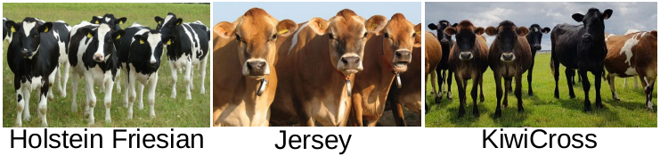
Figure 2.aaa: Three types of cows on the farm

2.2 Camera:
In this study, we choosed the HikVision IP camera, model DS-2CD4A26FWD-IZD. The recording resolution was set as 1920 x 1080, with frequency at 25 frames per second . The camera is mounted on a verticle metal pipe that fixed on the ceiling, shown in Fig 2.2:

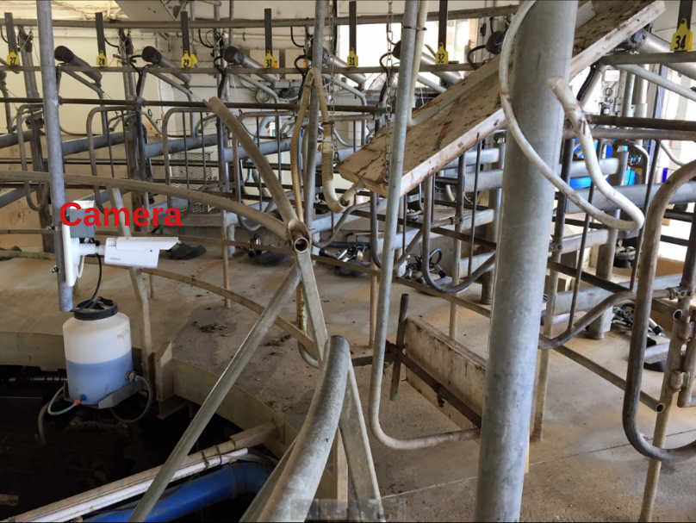
Figure 2.2: Camera mounted on a verticle metal pipe.

The original field of view is shown in Figure 2.3 (Left). In this study, the camera is rotated 90 degrees, shown in Figure 2.3 (Right), because each cow needs to be captured intact and taking as much portion of the image as possible. Considering the range of head movement, the 90 degrees rotation fixation could ensure the entire cow captured in the field of view with the maximum portion. For example, Figure 2.3 Left did not include cow’s feet. In order to include the entire cow, we would need to move the camera further.

The camera has two modes: 1) color mode; and 2) infrared mode. The infrared mode would automatically turned on when the environmental light get too dim, shown in Figure 2.4. In this study, we only use the afternoon milking images, as we found that the afternoon milking has more consistent lighting condition, which means much less infrared images are collected. The infrared mode images in the afternoon milkings are eleminated when we train the neural network, as we need to test the performance using only one type of image mode. Thus we selected the majortiy color mode images.

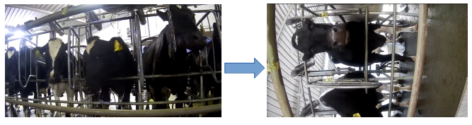
Figure 2.3: Camera was rotated 90 degrees.

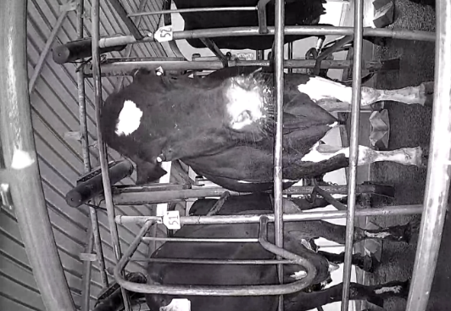
Figure 2.4: Infrared mode image
(Did not rotate 90 degree as you suggested, because the following images have to be in this orientation to explain the cooridnates.)

2.3 Dataset:
2.3.1 Extract images from videos:
Figure 2.5 demenstrates the installation positions of the camera and the Radio Frequency ID (RFID) reader. After a cow enters the rotary, its RFID got detected and uploaded to the Protack system, where each cow’s unique RFID number and its corresponding bail number are stored. As the camera facing bail and the RFID facing bail are 30 bails apart, at the time RFID receive a signal, the camea would facing a cow that is 30 bails apart from the RFID reader. For example, when RFID reader detected a cow on bail 31, the system extracted a frame, which pointed to a cow on bail 1.

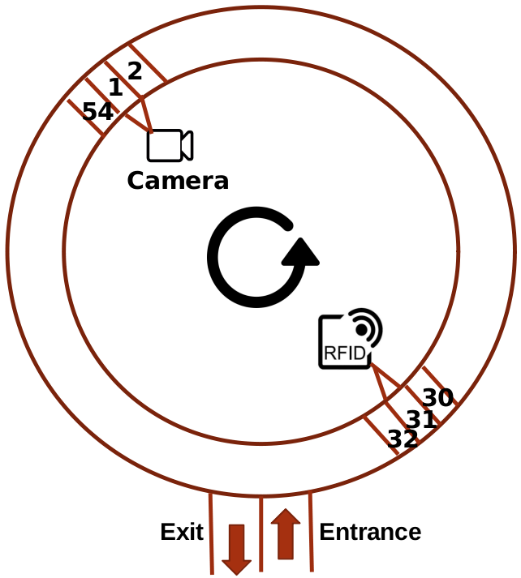
Figure 2.5: Camera and RFID location

The Protrack system log the start and the end of each bail by detecing the same machnism attached at the same position on every bail. For each milking, we only extract one image for each cow at the time the Protrack system log the detection of a bail. Within four months, we created a consistent dataset that each bail in an image landed at the same position. For example, when the Protrack system detected bail 31, we extract an image, where bail 1 landed at a fixed position. By several months collection, we formed a dataset structured as in Figure 2.6. Each cow would have a number of images collected from different milkings.

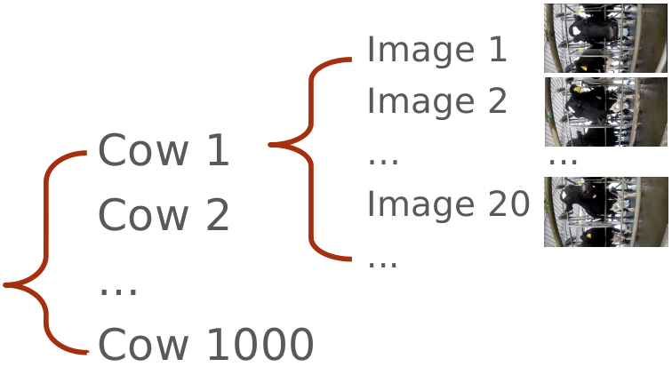
Figure 2.6: Dataset structure

2.3.2 Split the data:
Figure 2.7 shows the pipeline of spliting the dataset. The entire dataset contains 113195 images from 1369 cows during 2020/04/01 – 2020/08/21. Firtst, it got split into color set, infrared set, and purple set, based on the RGB (red, green, blue) channels values. The color set contains 78339 images (69.21%) from 1369 cows, the infrared set contains 34804 images (30.75%) from 1303 cows, while the purple set contains 52 (0.04%) images from 51 cows. The purple image occationally occured when the camera switching between the color mode and the infrared mode, shown in Figure 2.x. We only kept the color mode images for training, validation, and inference purpose.

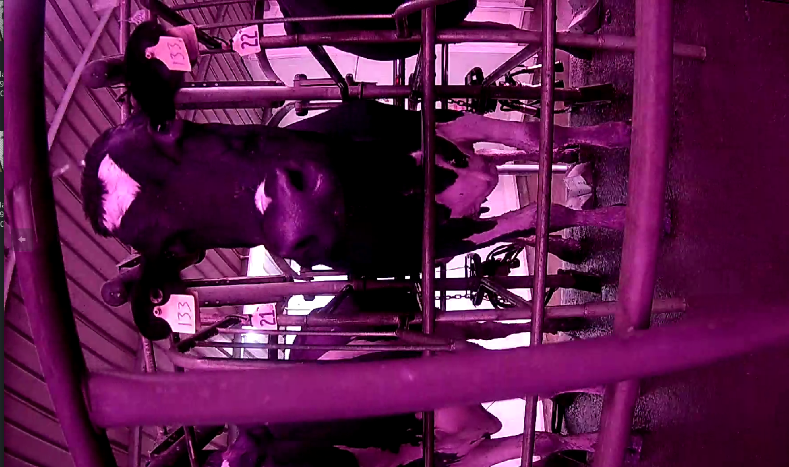
Figure 2.x: Purple images occured when camera swithing between color and infrared modes.

Then, based on the recording date, the color set got split into ‘Train + Validation’ set and ‘Inference’ set. The ‘Train + Validation’ set are images collected during 2020/04/01 – 2020/07/31, containing 64959 images from 1257 cows, while the ‘Inference’ set are images collected during 2020/08/01 – 2020/08/21, containing 13380 images from 993 cows. We choose 2020/08/01 as the time stamp to split the data based on two considerations: 1) Images collected after 2020/08/01 accounted for 17.1% (13380/78339) of the entire color set, as most machine learning models would take 10% - 20% of the dataset as inference set; 2) The ‘Train + Validation’ set are images collected eariler than the ‘Inference’ set as it better mimic the practical situation, where people train a model first and then inference later images.

Last, we took the top 1000 cows (61998 images) that contains the most images for training and validation purpose, as we need each cow contains as many images as possible. There were ate least 25 images per cow in the training + validation set. The training set accounts for 90% of top 1000 cows (900 cows, with 55649 images), while the validation set accounts for 10% (100 cows, with 6349 images). For the 991 cows that in the inference set, 702 cows appeared in the ‘training’ set, but the rest 291 cows never appeared while training. These 291 cows are new cows joining the milking herd after 2020/08/01.

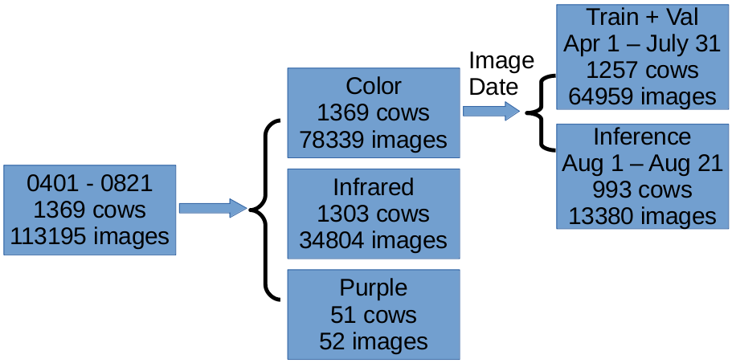
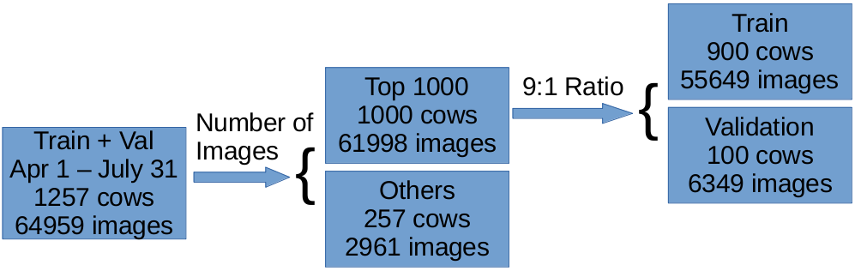
Figure 2.7: The pipeline of spliting the dataset

Figure 2.8 shows the distribution of the number of images for the training set (55649 55524 images). The percentile is demenstrated in Table 2.1.

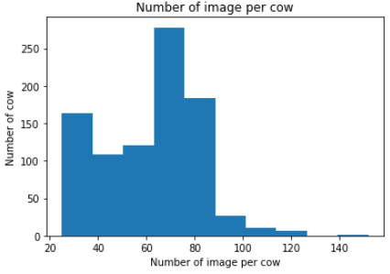
Figure 2.8: The distribution of the number of images for the training set.

Table 2.1: The percentiles of number of images for the training set:
Percentile | 0 | 25 | 50 | 75 | 100
Number of images | 25 | 45 | 66 | 76 | 152

2.4 Dataset noise:
There are 2 types of noise: 1) Wrong RFID, and 2) Big movement, shown in Figure 2.9 (Right).
Wrong RFID means the Protrack system logged a RFID number that is not the real RFID number of the cow. To estimate the rate of RFID error, we randomly selected 30 cows (2002 images) as a sample, as it is infeasible to manually estimate all 78339 images in the color set. We found 2 cases of wrong RFID. The sample error rate is 2/2002 = (0.1%), which is the same error rate based on consulting engineers working on the Protrack system.

Big head movement means the cow positioned out of the detection region. Detection region means the region of interest (ROI) that we crop to pass to neural network for training, as the rectangle box in Figure 2.9. Big movement could cause the training with lower accuracy. Based on the 2002 images, there are 1.7% (35/2002) big movement.

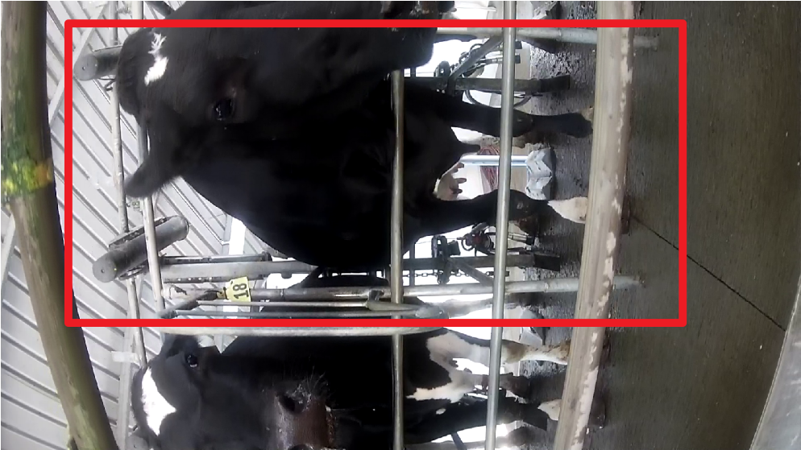
Figure 2.9: Dataset noise: Big head movment

2.5 Train:
In this study, the training pipeline is developed based on the open sourced network, insightFace [37]. By default, we selected the Resnet-100 as the network, and we choosed the ArcFace as the loss function. As the network only takes squared images for training, we cropped the ROI and resized to 112 x 112, or 222 x 222 lower resolusion squared images, as shown in Figure 2.10.

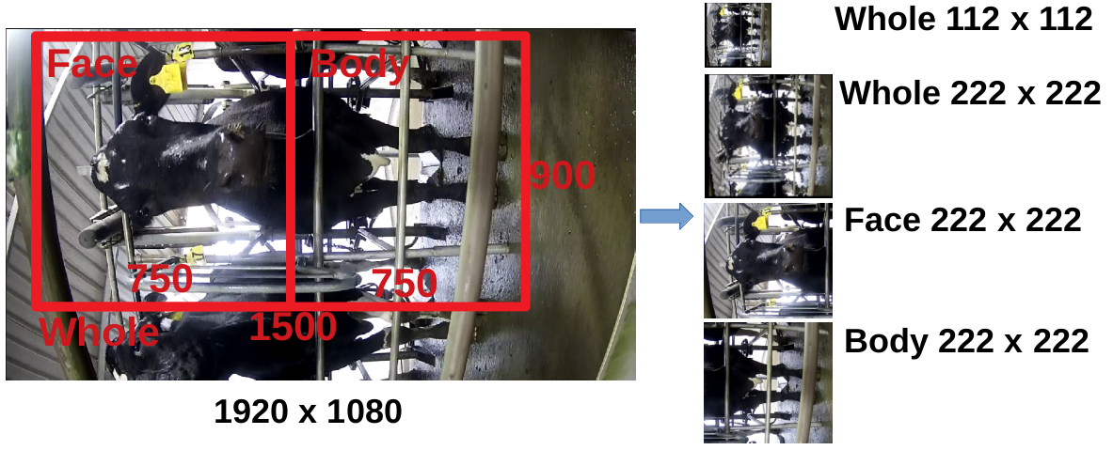
Figure 2.10: The origianl 1920 x 1080 images are cropped to 1500 x 900 or 750 x 900 images, and resized to 112 x 112 or 222 x 222 lower resolusion images for training.

Because we want to test: 1) the impact of different resolution to the training/reference accuracy; and 2) is the face region or the body region more important to differentiate cows, we developed 4 different ways to crop the original images for training:

- Crop the whole cow as ROI (1500 x 900), and resize to 112 x 112;
- Crop the whole cow as ROI (1500 x 900), and resize to 222 x 222
- Crop the face region as ROI (750 x 900), and resize to 222 x 222
- Crop the body region as ROI (750 x 900), and resize to 222 x 222

The 1st and the 2nd crop is to test the impact of different resolution, while the 3rd and the 4th crop are to test which region is more import to differentiate cows. We also keep the cropped face and body region the same size for comparison reason.

Table 2.2 shows the unique training setting and stopped epoch.

Table 2.2: Different training setting:
Crop | Number of GPU | Batch size / GPU | Speed (samples/sec) | Initial learning Rate | Training time  (hours)
Whole-112 | 1 | 100 | 78 | 0.01 | 44
Whole-222 | 2 | 10 | 34 | 0.01 | 40
Face only-222 | 1 | 10 | 17 | 0.001 | 120
Body only -222 | 1 | 10 | 34 | 0.01 | 72

2.6 Inference
To evaluate the performance of the trained models, we need to test the model using the inference set shown in Figure 2.7. For each image in the inference set (993 cows with 13380 images), it first got cropped into the same ROI as the corresponding training set, and then it got converted into a 512 x 1 nomorlized feature vector (embedding) using the trained model, shown in Figure 2.11.

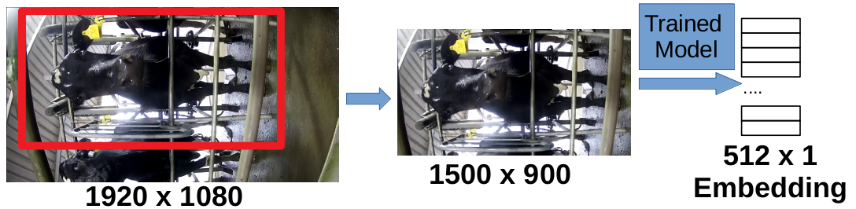
Figure 2.11: Each image got cropped and converted to a 512 x 1 feature vector.

After every image being converted into a 512 x 1 feature vector, we could calculate the Eucliden distance between any two images. The distance between two vectors, v₁ = (x₁, x₂, x₃, ... , x₅₁₂) and v₂ = (y₁, y₂, y₃, ... , y₅₁₂), is calculated using eucliden distance (equation 2.1):

(2.1)

x_{i} and y_{i} represend the i^{th} value in the feature vector. We used the following two algorithms to evaluate the error rate:

1. The k-nearest neighbors (k-NN) algorighm [38]:
In this study, we choosed the 5-nearest neighbors (5-NN). Figure 2.12 demenstrates using the 5-NN algorithm to calculate the error rate in a 2D space. We first calculated the nearest 5 neighbour images for each evaluating image. For example, the circled 5 images were the top 5 nearest neighbours of the evaluating image in Figure 2.12. If at least one images of the top 5 neigibours was not the same cow as the evaluating image, the evaluating image would be counted as an error image. In this example, the nearest 5 neighbours of the evaluating image contains one image that was not cow 1, which means the evaluating image was evaluated as an error.

After we finished calculate the 5-NN for every image, the error rate could be calculated as:

e = N/T (2.2)

In equation 2.2, ‘e’ represents the error rate, ‘N’ represent the number of images that has at least 1 neighbouring image belongs to another cow, and ‘T’ represent the total image number.
For this algorithm to work, we also eliminated cows that contains no more than 6 images, as all images for cows with less than 6 images would refered as an error.

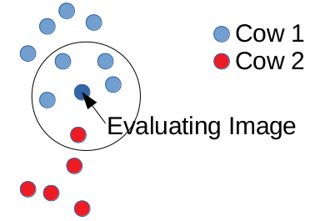
Figure 2.12: ‘The 5-nearest neighbors’ algorithm to evaluate the error rate.

2. The nearest centroid algorithm [39]:
The nearest centroid classifier is also known as the Rocchio classifier. Figure 2.13 demenstrates using the nearest centroid algorithm to evaluate the error rate in a 2D dimension. We first calculated the centroid of each cow based on all images of this cow using Equation 2.3:

Centroid = (mean(X₁, X₂, ... X_{n}), mean(Y₁, Y₂, ... Y_{n}), ... , mean(Z₁, Z₂, ... Z_{n})) (2.3)

In this equation, ‘n’ represents number of images of each paticular cow. ‘X, Y, Z’ are the 1st, 2nd, ... , 512th dimension of each image. For each evaluating image, we calculate the distances between itself and all cows’ centroids and generated a ranking from the nearest to the furthest, starting from 0 to (M-1) (M means the total number of cows to inference). If the evaluating image’s nearest centroid was the corresponding cow, this image would be marked as a correct inference.

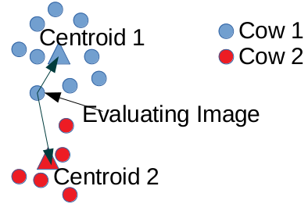
Figure 2.13: ‘The nearest centroid’ algorithm to evaluate the error rate.

3. Results:
3.1 Training accuracy:
Table 3.1 shows the training accuracy, validation accuracy, loss value, and xNorm of the 4 different cropping. It also shows the epoch we stopped training, the epoch we used for inference and its corresponding training accuracy.

Table 3.1: Different training accuracy and loss value:
Training accuracy | Loss Value
Crop: whole 112 x 112
Stopped Epoch = 294; Stopped Acc = 100
Epoch for Inference = 200; Corresponding Acc = 100
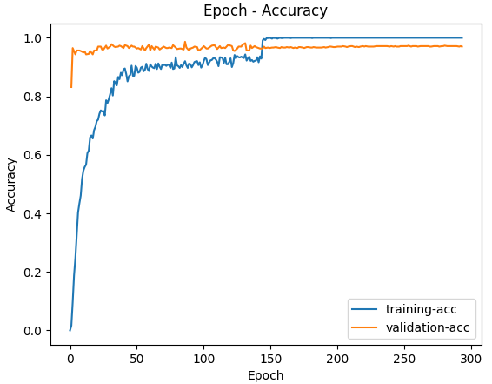 | 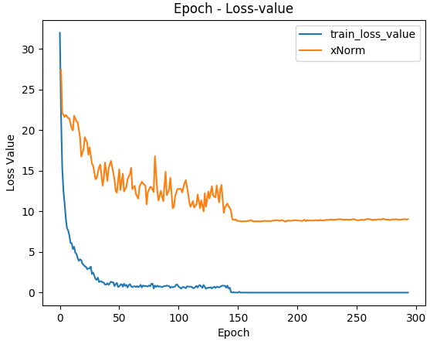
Crop: whole 222 x 222:
Stopped Epoch = 44; Stopped Acc = 99.09
Epoch for Inference = 40; Corresponding Acc = 98.18
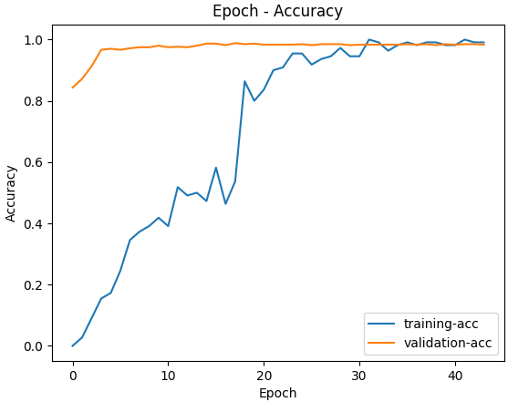 | 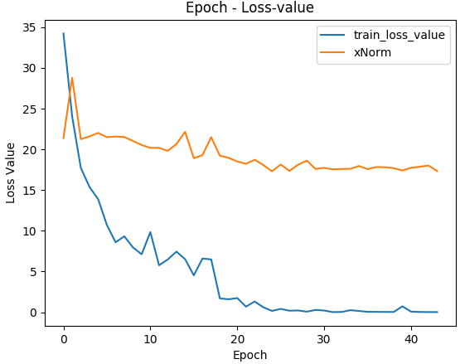
Crop: Face Only 222 x 222
Stopped Epoch = 60; Stopped Acc = 40.00
Epoch for Inference = 40; Corresponding Acc = 36.36
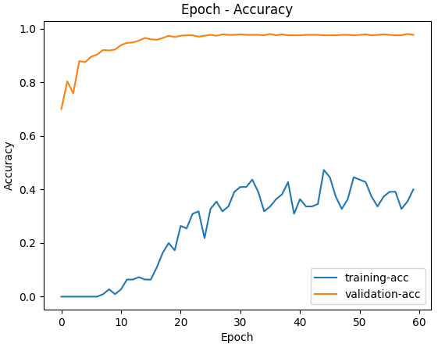 | 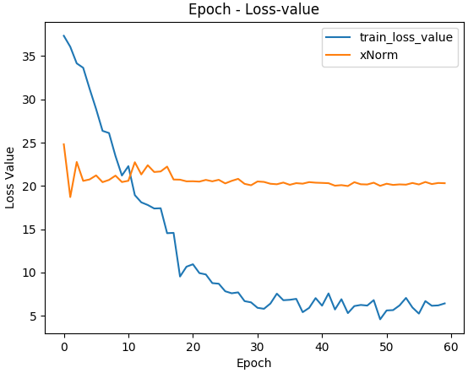
Crop: Body Only 222 x 222
Stopped Epoch = 91; Stopped Acc = 99.09
Epoch for Inference = 40; Corresponding Acc = 98.18
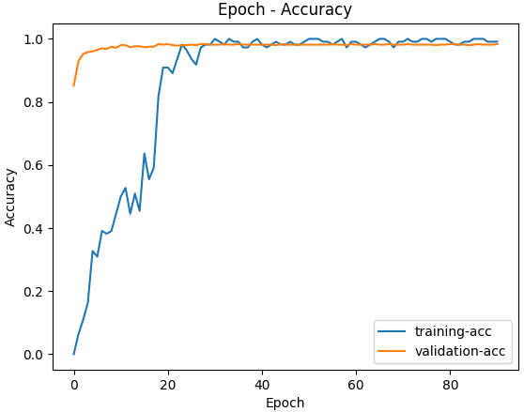 | 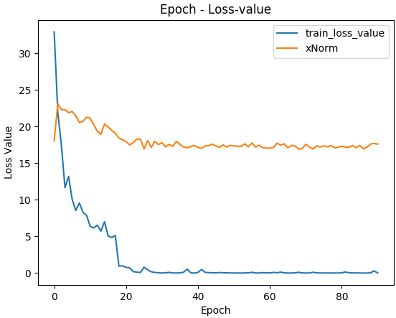

3.2 Inference accuracy:
Table 3.2 shows the inference error rate. Numbers in the bracket are the (number of images inferenced as wrong cow)/(number of total inferenced images).

Table 3.2: Different inference error rates:
Crop region | 5-NN | Nearest Centroid
Whole 112 | 14.86% (1936/13024) | 5.64% (754/13368)
Whole 222 | 8.02% (1044/13024) | 0.96% (128/13368)
Face Only 222 | 23.32% (3037/13024) | 4.22% (564/13368)
Body Only 222 | 8.44% (1099/13024) | 1.35% (181/13368)

3.3 Overlapped wrongly inferenced images using 112 and 222 sets:
Figure 3.1 shows the overlapped number of wrongly inferenced cow between the training with the whole 112 x112 set and the training with 222 x 222 set. Of the 128 wrongly inferenced images in the ‘train with whole 222’ set, there are 83.6% (107/128) were inferenced wrongly inferenced using the model ‘trained with the whole 112’ set.

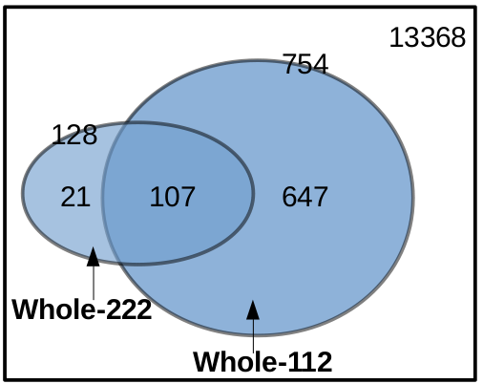
Figure 3.1: the overlapped number of wrongly inferenced cow between the training with the whole 112 x112 set and the training with 222 x 222 set.

4. Discussions:
4.1 Low training accuracy of the face-only set:
According to Table 3.1 and Table 3.2, it was clearly indicated that the training accuracy of the body-only set is significantly higher than the face-only set (99.09 VS 40.00%). In addition, the inference error rate of the body-only set is lower than the face-only set (1.35% VS 4.22%). We speculate the low training accuracy for the face-only set is caused by the much higher variant of the cow face position that we observed (bigger head movement than body movement on the rotary). Unlike human face dataset, it’s extremely hard to create a cow face dataset with consistent position and angle of view [28]. In this study, each image was cropped when the bail rotated to the same position. However, due to the constraint bail space, each cow would normally move their head much more comparing to the body. It means the cow face would contain more variants as the cow faces would landed at different positions with different angle of views, while the cow’s body were more consistent.

4.2 Increase resolution reduce inference error:
It was found that increasing the resolusion from 112 x 112 to 222 x 222 can significantly reduce the inference error rate from 5.64% to 0.96% using the nearest centroid algorithm. We speculate this was because the increased resolution provided enough details for the neural network to ‘learn’, especially the coat pattern of the body.

Of the 754 wrongly inferenced images with the 112 x 112 model using the nearest centroid algorithm, 85.8% (647/754) were inferenced correct using the 222 x 222 model, as shown in Figure 3.1. We then selected the first 100 images out of those 647 images, and 65% (65/100) of the images are black cows. We noticed that increasing resolution could help the neural network to better differentiate two black cows, which is a hard task for un-trained person. We speculate the network might use some subtle features, such as the chest width or length of the legs, to achieve this.

For the 21 images that inferenced wrongly using the 222 x 222 model, as shown in Figure 3.1, it was odd that the low resolution model inferenced correct while the high resolution model inferenced wrong. We manually checked these 21 images and we found 15/22 images are cows with their body section covered or cow with big head movement. We assume the low resolution trained model inference these ‘difficult’ images by ‘luck’.

4.3 Possibility of creating a bigger image set:
In this study, a dataset that contains 78339 color images was created using nearly 4 months of video recordings. As we only extracted one image per cow during each milking, we could double or triple the dataset size by extracting more than one image per cow from different viewing angles during each milking, as shown in Figure 4.1. The reason we only extract one image at the beginning stage is to reduce any possible variant, such as the position of the cows, to create a clean dataset for better training performance.

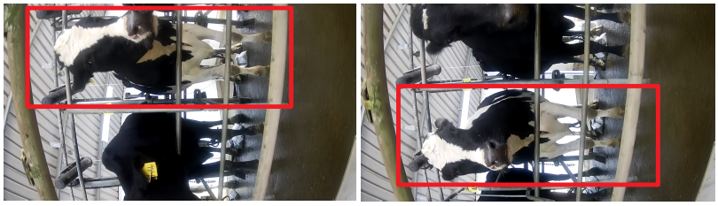
Figure 4.1: Cow’s images cropped from different viewing angles during the same milking.

4.4 Removing wrong RFID images:
It was noted that the dataset contains around 0.1% wrong RFID images. Due to the face that it is infeasible to manually remove all wrong RFID images, we training the model containing this type of noise. However, we strongly believe removing wrong RFID images could further improve the training and inference accuracy.

We also used the whole-222 model to inference the entrire ‘train + validation’ set (61998 images). It yeilded a 0.21% (132/61998) error rate using the nearest centroid algorithm. Due to the time constraint, we manually checked the first 50 images of these 132 wrongly inferenced RFID image, and found 10% (5/50) wrong RFID, which is much higher than the Protrack stated error rate (0.1%). Therefore, it is possible to reduce dataset noise by inference the training set.

4.5 Infrared images:
It was noted that the camera can switch between color mode and infrared mode due to the environmental lighting condition. The reason is that we need to make sure to have our own lighting resource to capture both morning milking and afternoon milking events, as morning milking normally happened before the sunrise. However, as we need to minimize the variants in the dataset, when creating the dataset, we only kept the color images from the afternoon milking, which accounts for 69.2% (78339/113195) of the entire image set.

We haven’t tested training a dataset containing infrared images, but a dataset that combined color images and infrared images could adapt to more environments, such as morning milkings, which contains majority of infrared images. In addition, we could also train a model purely using infrared images. In the practical applications, we could have two models running, a color one and an infrared one, and switching between them based on the feeding image mode to achieve a better inference performance.

4.6 Higher error rate using the 5-NN algorithms:
It was found that the error rate using the 5-NN algorithm was always higher than using the nearest neighbors algorithm. This is because the nearest 5 neighbours was a more strict rule to eastimate the error rate. For the 5-NN algorithm, it required all 5 nearest neighbors to be the same cow as the evaluating image. It was harder to achieve comparing to the nearest controid algorithm.

Conclusions:
This work demonstrates that the task of identifying a herd of more than 1000 cows could reach a training accuracy of 99.09%, based on their 2D color image taken from a rotary platform. The inference error rate could reach 0.96% with 991 cows, of which 70.8% (702/991) were cows that were seen in the training set. In addition, it was found that training a model with higher resolution could significantly reduce the inference error rate from 5.64% to 0.96%. Lastly, it was concluded that the body section of the cow contains most of the details to recognize it comparing to the face section.

References:
[1] M. B. Bowling et al., “Identification and traceability of cattle in selected countries outside of North America,” Prof. Anim. Sci., vol. 24, no. 4, pp. 287–294, 2008.
[2] E. Parliament, “Council. Establishing a system for the identification and registration of bovine animals and regarding the labelling of beef and beef products and repealing council regulation (ec) no 820/97, 2000.”
[3] R. Houston, “A computerised database system for bovine traceability,” Rev. Sci. Tech.-Off. Int. Epizoot., vol. 20, no. 2, p. 652, 2001.
[4] W. Buick, “Animal passports and identification,” Defra Vet. J., vol. 15, pp. 20–26, 2004.
[5] C. Shanahan, B. Kernan, G. Ayalew, K. McDonnell, F. Butler, and S. Ward, “A framework for beef traceability from farm to slaughter using global standards: an Irish perspective,” Comput. Electron. Agric., vol. 66, no. 1, pp. 62–69, 2009.
[6] W. Rossing, “Animal identification: introduction and history,” Comput. Electron. Agric., vol. 24, no. 1–2, pp. 1–4, 1999.
[7] M. Vlad, R. A. Parvulet, and M. S. Vlad, “A survey of livestock identification systems,” 2012, pp. 165–170.
[8] G. Fosgate, A. Adesiyun, and D. Hird, “Ear-tag retention and identification methods for extensively managed water buffalo (Bubalus bubalis) in Trinidad,” Prev. Vet. Med., vol. 73, no. 4, pp. 287–296, 2006.
[9] D. Edwards, A. Johnston, and D. Pfeiffer, “A comparison of commonly used ear tags on the ear damage of sheep,” Anim. Welf., vol. 10, no. 2, pp. 141–151, 2001.
[10] D. Wardrope, “Problems with the use of ear tags in cattle,” Vet. Rec., vol. 137, no. 26, p. 675, 1995.
[11] S. Kumar and S. K. Singh, “Automatic identification of cattle using muzzle point pattern: a hybrid feature extraction and classification paradigm,” Multimed. Tools Appl., vol. 76, no. 24, pp. 26551–26580, 2017.
[12] S. Kumar, S. K. Singh, R. S. Singh, A. K. Singh, and S. Tiwari, “Real-time recognition of cattle using animal biometrics,” J. Real-Time Image Process., vol. 13, no. 3, pp. 505–526, 2017.
[13] A. Allen, B. Golden, M. Taylor, D. Patterson, D. Henriksen, and R. Skuce, “Evaluation of retinal imaging technology for the biometric identification of bovine animals in Northern Ireland,” Livest. Sci., vol. 116, no. 1–3, pp. 42–52, 2008.
[14] C. A. Martinez-Ortiz, R. M. Everson, and T. Mottram, “Video tracking of dairy cows for assessing mobility scores,” 2013.
[15] W. Andrew, S. Hannuna, N. Campbell, and T. Burghardt, “Automatic individual holstein friesian cattle identification via selective local coat pattern matching in rgb-d imagery,” 2016, pp. 484–488.
[16] C. Cai and J. Li, “Cattle face recognition using local binary pattern descriptor,” 2013, pp. 1–4.
[17] A. C. Arslan, M. Akar, and F. Alagöz, “3D cow identification in cattle farms,” 2014, pp. 1347–1350.
[18] J. R. Thomasen et al., “Individual cow identification in a commercial herd using 3D camera technology,” 2018, p. 613.
[19] P. Sermanet, D. Eigen, X. Zhang, M. Mathieu, R. Fergus, and Y. LeCun, “Overfeat: Integrated recognition, localization and detection using convolutional networks,” ArXiv Prepr. ArXiv13126229, 2013.
[20] R. Girshick, J. Donahue, T. Darrell, and J. Malik, “Rich feature hierarchies for accurate object detection and semantic segmentation,” 2014, pp. 580–587.
[21] A. Krizhevsky, I. Sutskever, and G. E. Hinton, “Imagenet classification with deep convolutional neural networks,” Adv. Neural Inf. Process. Syst., vol. 25, pp. 1097–1105, 2012.
[22] K. He, X. Zhang, S. Ren, and J. Sun, “Deep residual learning for image recognition,” in Proceedings of the IEEE conference on computer vision and pattern recognition, 2016, pp. 770–778.
[23] J. Redmon, S. Divvala, R. Girshick, and A. Farhadi, “You only look once: Unified, real-time object detection,” 2016, pp. 779–788.
[24] F. Schroff, D. Kalenichenko, and J. Philbin, “Facenet: A unified embedding for face recognition and clustering,” 2015, pp. 815–823.
[25] J. Deng, J. Guo, N. Xue, and S. Zafeiriou, “Arcface: Additive angular margin loss for deep face recognition,” 2019, pp. 4690–4699.
[26] W. Andrew, C. Greatwood, and T. Burghardt, “Visual localisation and individual identification of holstein friesian cattle via deep learning,” 2017, pp. 2850–2859.
[27] Z. Li, C. Ge, S. Shen, and X. Li, “Cow individual identification based on convolutional neural network,” 2018, pp. 1–5.
[28] L. Bergamini et al., “Multi-views embedding for cattle re-identification,” 2018, pp. 184–191.
[29] H. Ardö, O. Guzhva, M. Nilsson, and A. H. Herlin, “Convolutional neural network‐based cow interaction watchdog,” IET Comput. Vis., vol. 12, no. 2, pp. 171–177, 2018.
[30] “http://vintage.winklerbros.net/facescrub.html.” .
[31] “http://shuoyang1213.me/WIDERFACE/.” .
[32] “https://research.google/tools/datasets/google-facial-expression/.” .
[33] “https://facedetection.com/datasets/.” .
[34] “https://data.bris.ac.uk/data/dataset/2yizcfbkuv4352pzc32n54371r.” .
[35] “https://data.bris.ac.uk/data/dataset/3owflku95bxsx24643cybxu3qh.” .
[36] Z. Kaixuan and H. Dongjian, “Recognition of individual dairy cattle based on convolutional neural networks.,” Trans. Chin. Soc. Agric. Eng., vol. 31, no. 5, 2015.
[37] “http://insightface.ai/.” .
[38] N. S. Altman, “An introduction to kernel and nearest-neighbor nonparametric regression,” Am. Stat., vol. 46, no. 3, pp. 175–185, 1992.
[39] I. C. Mogotsi, “Christopher D. Manning, Prabhakar Raghavan, and Hinrich Schütze (2008). ‘Vector space classification’. Introduction to information retrieval,” Inf. Retr., vol. 13, no. 2, pp. 192–195, Apr. 2010, doi: 10.1007/s10791-009-9115-y.

