Using InsightFace for 2D Cows Identification Based on the Frontal Image for a Large Herd

Abstract
Introduction: We investigated the accuracy of using insightFace to identify dairy cows based on their frontal images. Materials and Methods: We used 1000 cows (55k images) to train a

Introduction:
Face detection is getting really powerful in the recent years. Talk about human face detection approaches.
For dairy cow detection, there are many approaches, such as 3D, infrared camera, drone, 2D images. Talk about cow ID approaches, but most of the approaches deals with small number of cow
In this study, we investigate the accuracy of cow’s using 2D camera captured cow’s frontal image to identify large number of cow (1000 individual cows from 3 different breeds).

2. Materials and Method:
2.1 Farm setting:
This study was conducted at the Bennett farm during 2020/04/01-2020/08/21. It normally needs two milkings/day (a morning milking and an afternoon milking) in the summer to milk around 880 cows, while 1 milking/day in the winter to milk around 500 cows. For the 54 bails rotary platform, each milking takes around 9-16 rounds (75-130 minutes) to milk the entire herd. The rotary platform is shown in Figure 2.1:

Figure 2.1: the rotary platform at the Bennett farm

2.2 Camera:
In this study, we choosed the HikVision IP camera, model DS-2CD4A26FWD-IZD. The recording resolution was set as 1920 x 1080, with frequency at 25 frames per second . The camera is mounted on a verticle metal pipe that fixed on the ceiling, shown in Fig 2.2:

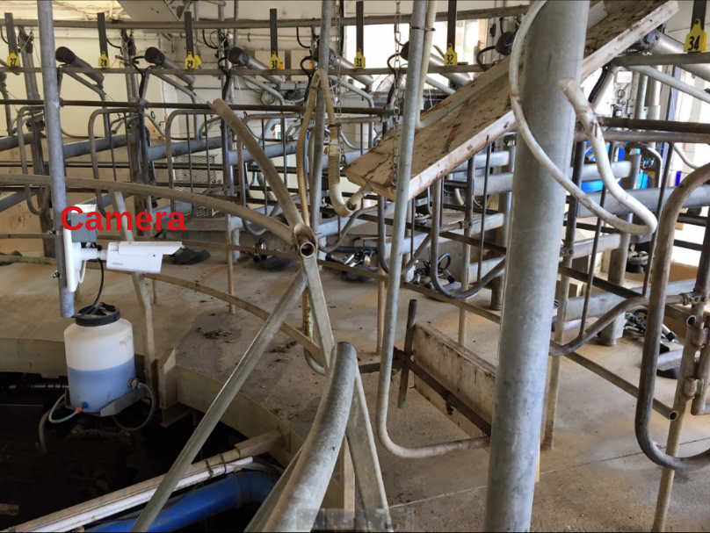
Figure 2.2: Camera mounted on a verticle metal pipe.

We rotated the camera 90 degrees as it could tolerante much bigger head movement, as shown in Figure 2.3. In addition, the camera has two modes: 1) color mode; and 2) infrared mode. The infrared mode would automatically turned on when the environmental light get too dim, shown in Figure 2.4.

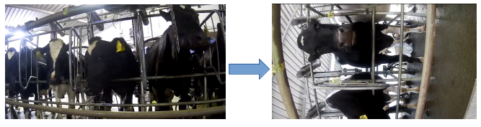
Figure 2.3: Camera was rotated 90 degrees.

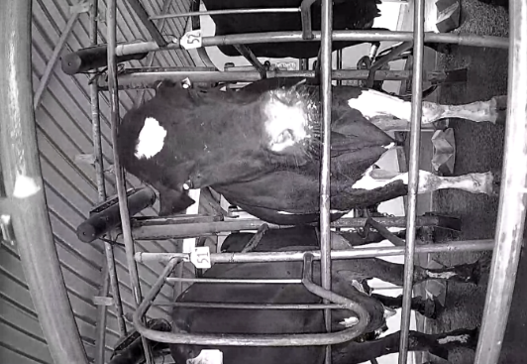
Figure 2.4: Infrared mode image

2.3 Dataset:
2.3.1 Extract images from videos:
Figure 2.5 demenstrates the installation positions of the camera and the RFID (Radio Frequency ID) reader. After a cow enters the rotary, its RFID got detected and uploaded to the Protack system, where each cow’s unique RFID number and its corresponding bail number are stored. As the camera facing bail and the RFID facing bail are 30 bails apart, at the time RFID receive a signal, the camea would facing a cow that is 30 bails apart from the RFID reader. For example, when RFID reader detected a cow on bail 31, the system extracted a frame, which pointed to a cow on bail 1.

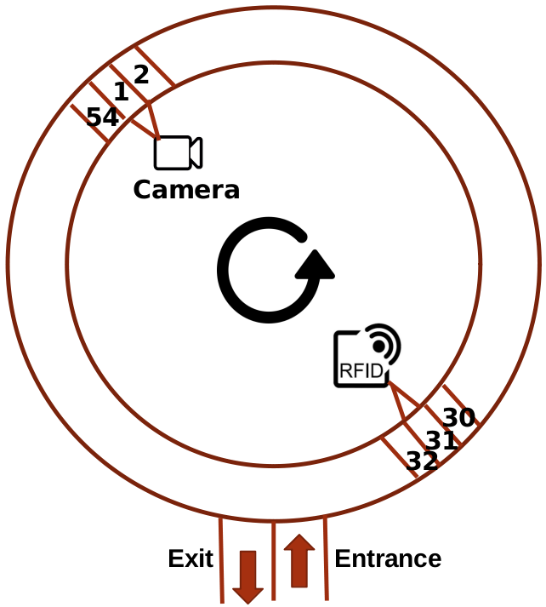
Figure 2.5: Camera and RFID location

For each milking, we only extract one image for each cow when its bail moves to a certain position. After several months, we formed a dataset structured as in Figure 2.6. Each cow would have a number of images collected from different milkings. In this study, we only use the afternoon milking images, as we found that the afternoon milking has more consistent lighting condition, which means much less infrared images are collected.

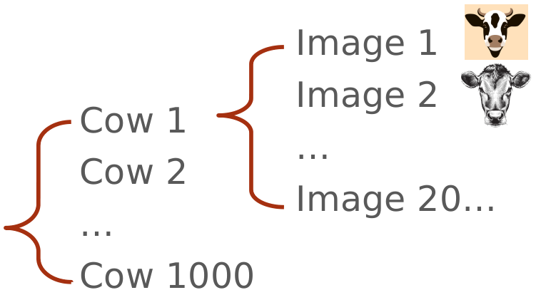
Figure 2.6: Dataset structure

2.3.2 Split the data:
Figure 2.7 shows the pipeline of spliting the dataset. The entire dataset contains 113195 images from 1369 cows during 2022/04/01 – 2020/08/21. Firtst, it got split into color set and B/W (black and white) set. The color set contains 78339 images from 1369 cows, while the B/W set contains 34804 images from 1303 cows. Then, based on the recording time, the color set got split into ‘Train + Validation’ set and ‘Inference’ set. The ‘Train + Validation’ set are images collected during 2020/04/01 – 2020/07/31, containing 64959 images from 1257 cows, while the ‘Inference’ set are images collected during 2020/08/01 – 2020/08/21, containing 13380 images from 993 cows. Last, We took the top 1000 cows (61998 images) that contains the most images for training and validation purpose. The training set accounts for 90% (900 cows with 55649 images), while the validation set accounts for 10% (100 cows with 6349 images).

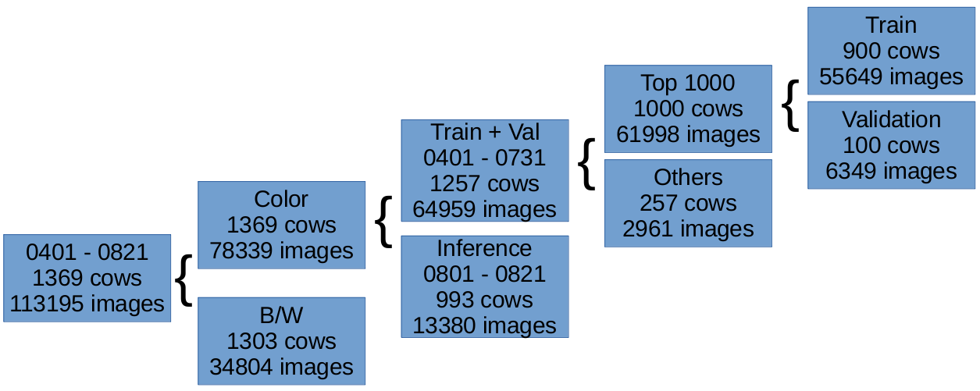
Figure 2.7: The pipeline of spliting the dataset

Figure 2.8 shows the distribution of the number of images for the training set (55649 images). The percentile at [0, 0.25, 0.5, 0.75, 1] are [25, 45, 66, 76, 152].

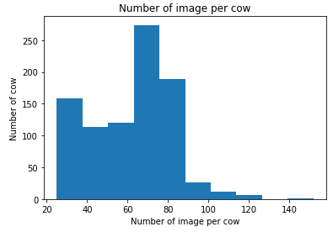
Figure 2.8: The distribution of the number of images for the training set.

Table 2.1 shows the number of overlapped cows between the ‘Train’ set and the ‘Inference’ set. For the 993 cows that in the inference set, 702 cows appeared in the ‘Train’ set, but the rest 291 cows never appeared while training.

Table 2.1: The overlapped cows between the train set and the inference set:

 | Train | Validation | Inference | Overlapped cows | New cows
Number of cows/images | 900/55649 | 100/6349 | 993/13380 | 702/0 | 291/0

2.4 Dataset noise:
There are 3 types of noise: 1) Purple image, shown in Figure 2.9 (Left); 2) Big head movement, shown in Figure 2.9 (Right); and 3) Wrong RFID.
Purple image happened when the camera switching mode. We only noticed purple images while doing the inference work. There are totally 51/78339 (0.06%) purple images in the training and the inference set.
Big head movement means the cow moving its head out of the detection region. This could cause the train with lower accuracy. We did not quantify the big head movement.
For the wrong RFID, we randomly selected 30 cows (2002 images) as a sample, and we found 2 cases of wrong RFID. The error rate is 2/2002 = (0.1%), which is similar as the Protrack system stated error rate.

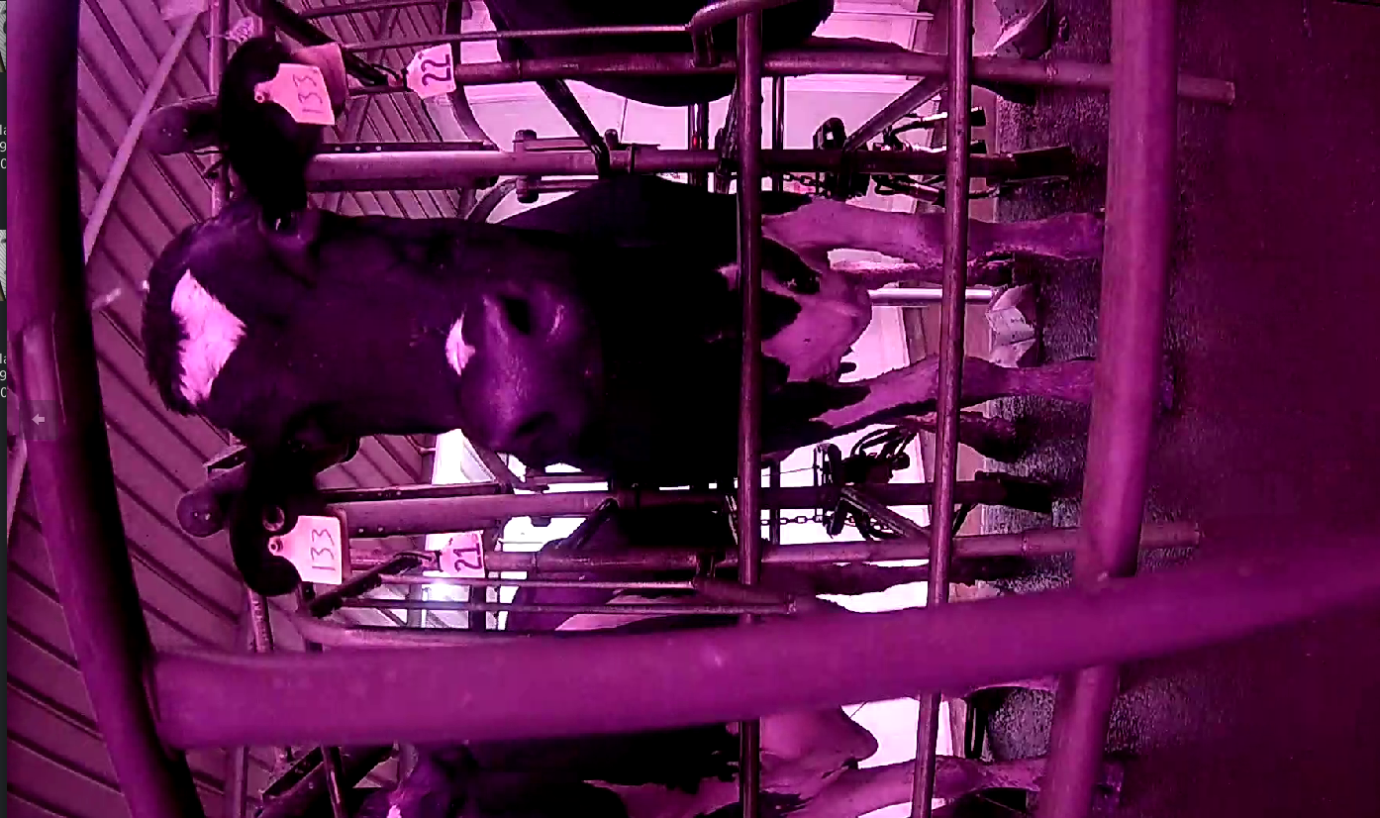
Figure 2.9: Dataset noise, Left: Purple image; Right: Big head movment

2.5 Train:
In this study, the training pipeline is developed based on the open sourced network, insightFace [Ref]. We selected the Res100 as the network, and we choose arcFace as the loss function.
The default network took 112 x 112 cropped images as the training

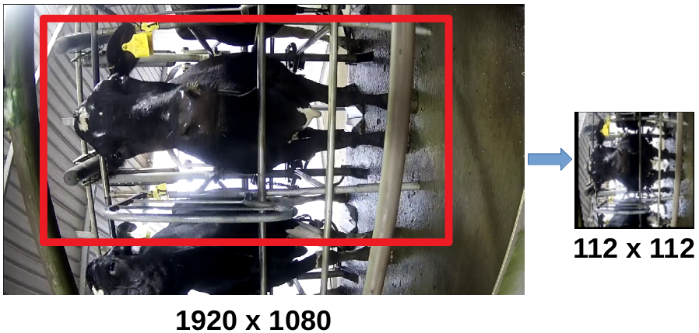

Different training setting:
Crop | Number of GPUBatch size / GPU | Batch size / GPU | Speed (samples/sec) | Initial learning Rate | Training time (hours) | Stopped Epoch and accuracy; | Epoch used for inference and accuracy
Whole 112 x 112 | 1 | 100 |  | 0.01 | 44 | 3xx; 99.x | 200; 99.x
Whole 222 x 222 | 2 | 10 | 34 | 0.01 | 40 | 65; 99.x | 50; 99.x
Face only 222 | 1 | 10 | 17 | 0.001 | 120 | 77; 46.6 | N/A
Body only 222 | 1 | 10 | 34 | 0.01 | 72 | 111; 100 | 100; 100

2.6 Inference
2.6.1 Two different inference accuracy algorithms:
1. Top 5 neighbours:

2. Index > 0:

2.6.2 Inferece setting:
Blocking:
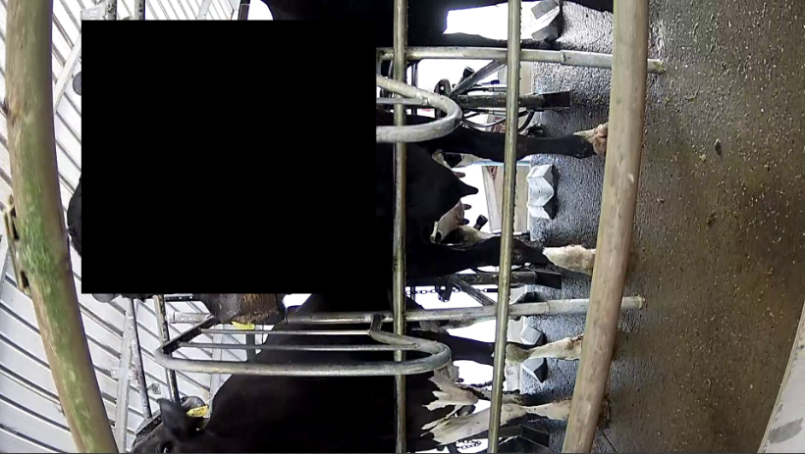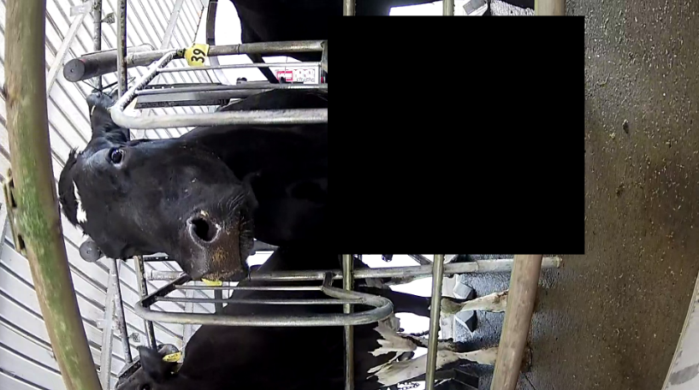

Different inference:
Crop region
Whole 112
Whole 222
Block Head 222
Block Body 222
Face Only 222
Body Only 222

3. Results:
3.1 Training accuracy:

Different training accuracy:
Crop | Training accuracy | Loss Value
Whole 112 x 112 | 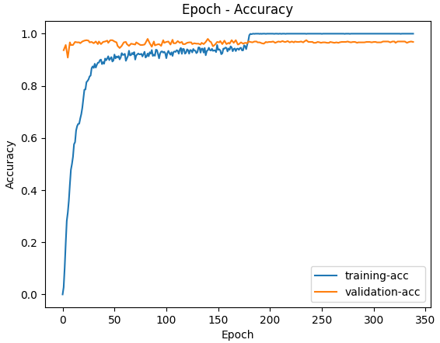 | 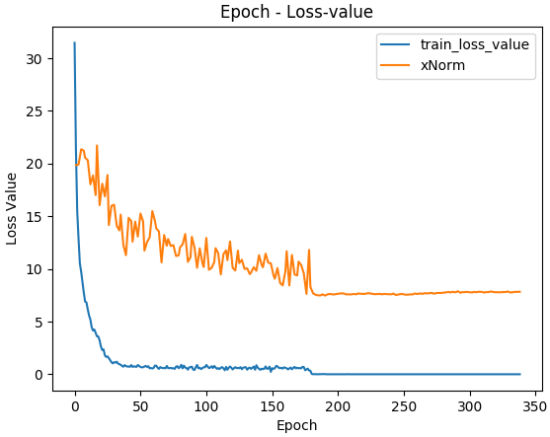
Whole 222 x 222 | 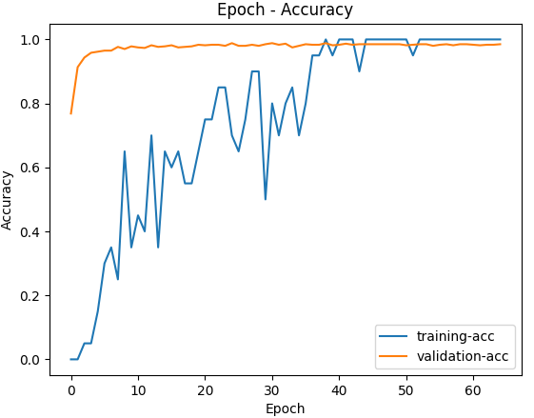 | 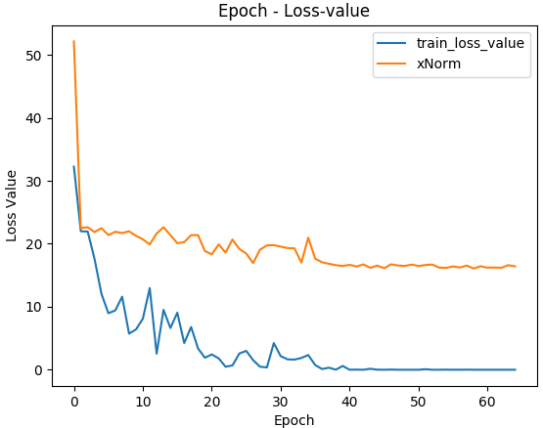
Face only 222 | 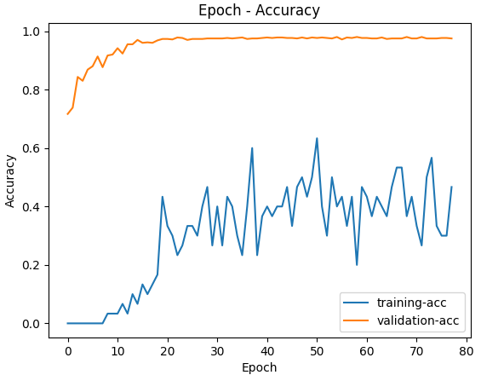 | 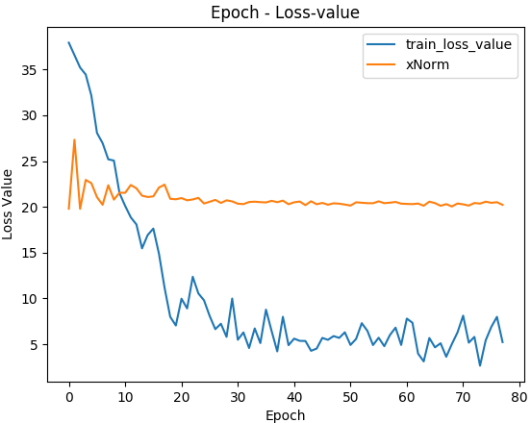
Chest down 222 | 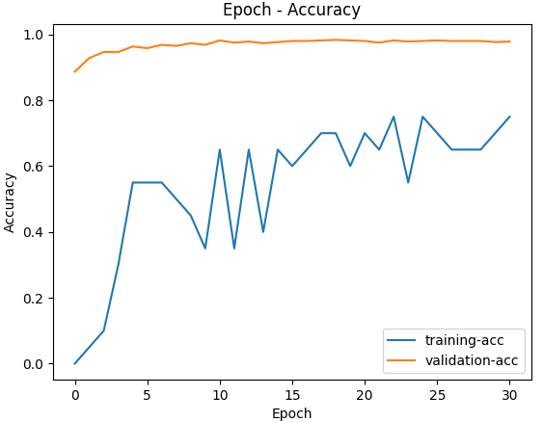 | 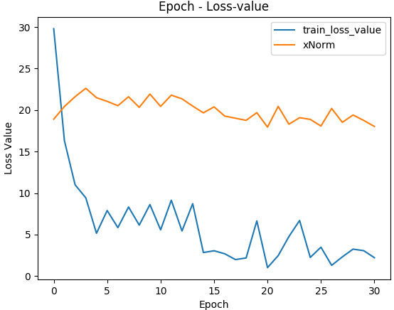

3.2 Inference accuracy:
Different inference accuracy (error rate):
Crop region | Top 5 neighbours | index>0
Whole 112 | 15.73% (2050/13036) | 5.93% (793/13380)
Whole 222 | 7.36% (960/13036) | 0.96% (129/13380)
Block Head 222 | 95.30% (12423/13036) | 29.58% (3958/13380)
Block Body 222 | 11.48% (1497/13036) | 1.79% (240/13380)
Face Only 222 | N/A | N/A
Body Only 222 | 8.51% (1110/13036) | 1.36% (182/13380)

3.3 Inference error, 112 VS 222:
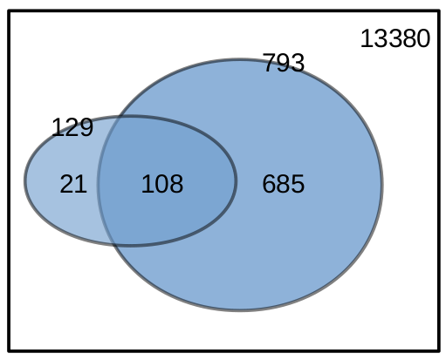

4. Discussions:
1. We find the chest region is more important than face region. We believe it’s caused by the variant of the face position.
2.

Conclusions:
1. A cow frontal image dataset was created, which contains 1369 cows with 113195 images;
2. We trained a NN to identify cow frontal image with 99% training accuracy, and 92 – 99 % inference accuracy, using two different identification algorithms;
3. Higher resolution significantly increase the inference accuracy;
4. Chest down region is more important than the face region.

References:

Questions:
2. should I mention Protrack log and how to generate the dataset? no.
3. To demenstrate that chest down region is more important than the face, should I use the blocked inference set, or the face-only training set? Face only training set.
4. I should mention the purple images and the b/w images? Yes.
5. should I mention the data integrity result, such as 1) the 10 minutes videos sections? 2) different type of errors? no

