Exploring Cow-Face-Dataset Project

1. Some Findings (Background Knowledge):
1.1
There are maximum 2 cows in each frame
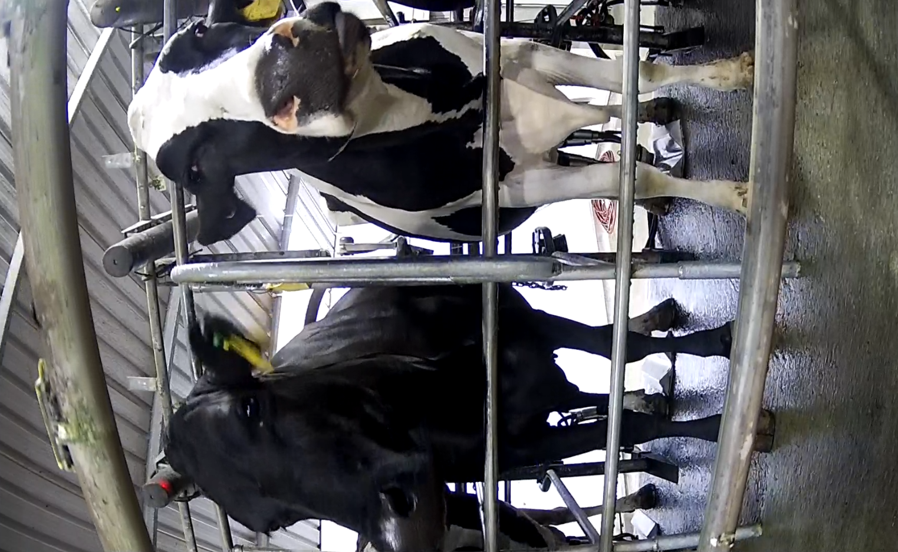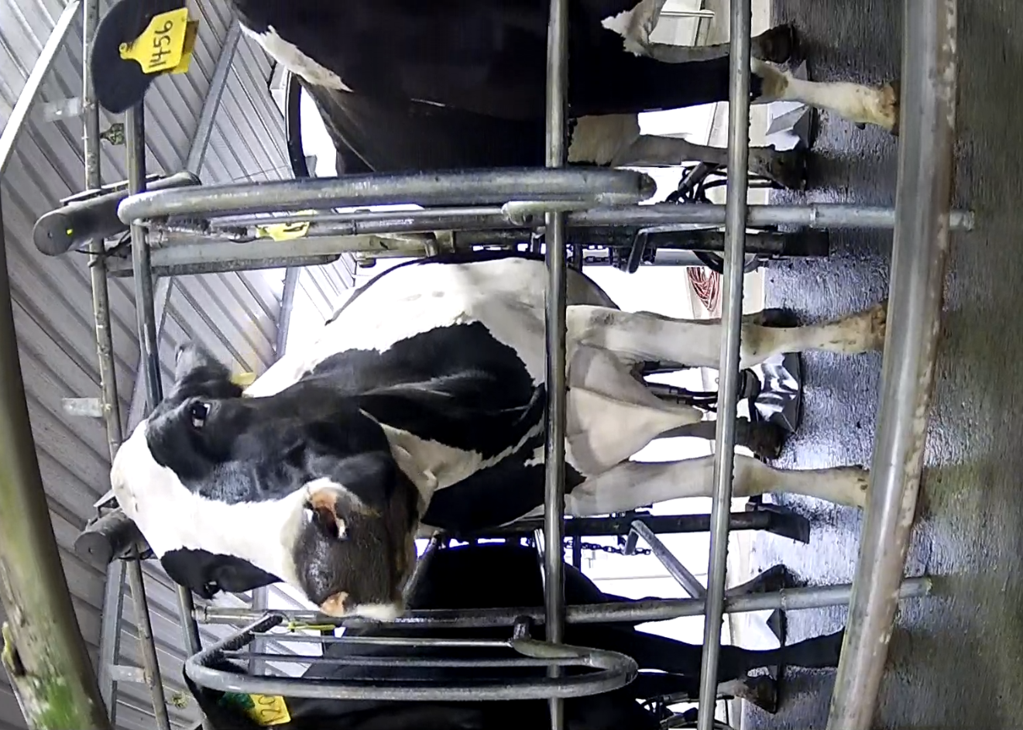

1.2
Some blocked faces:
1. The race beam blocked almost entire face
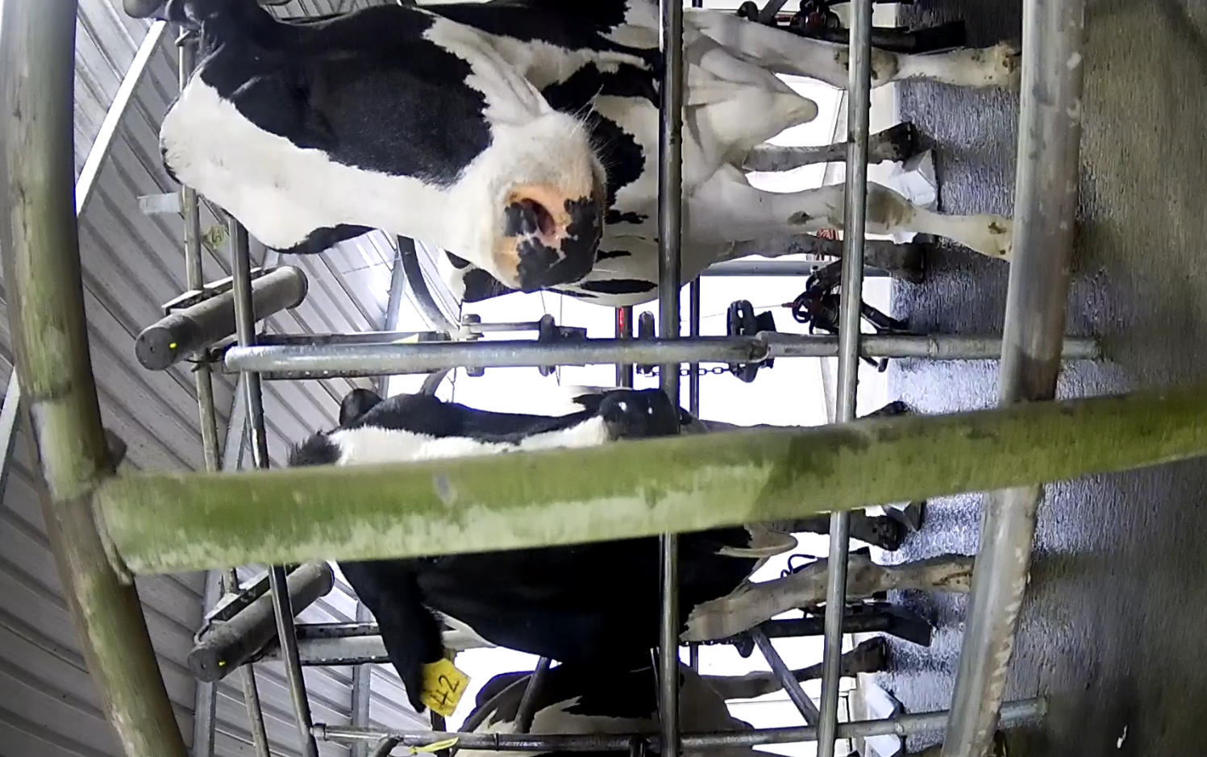

2. A tag blocked part of the face
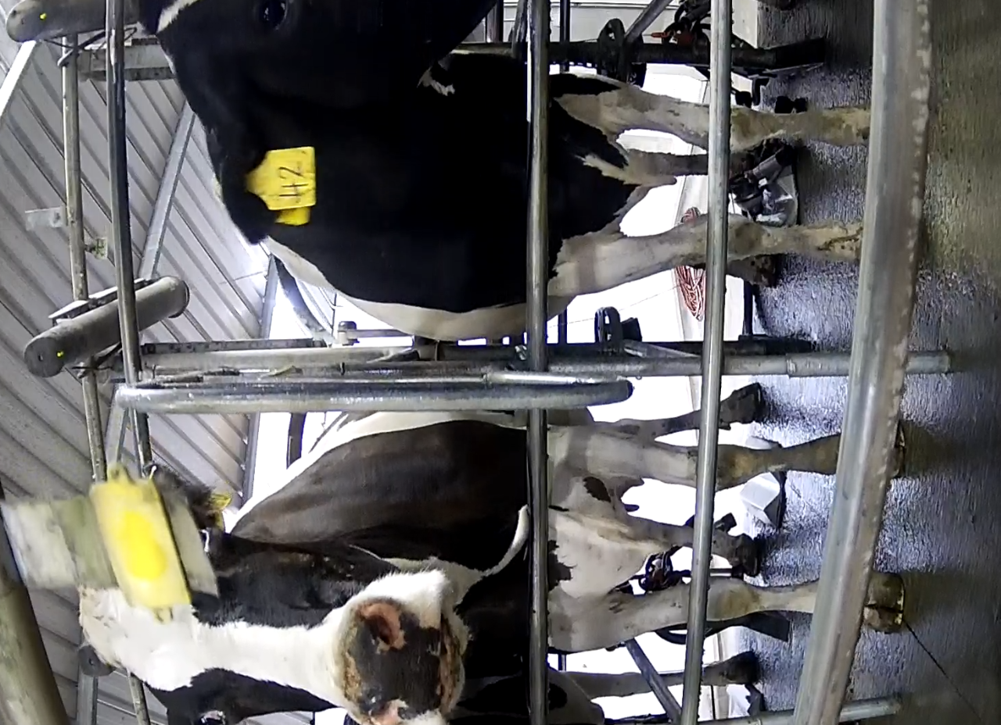

3. Blocked tiny bit of the face:
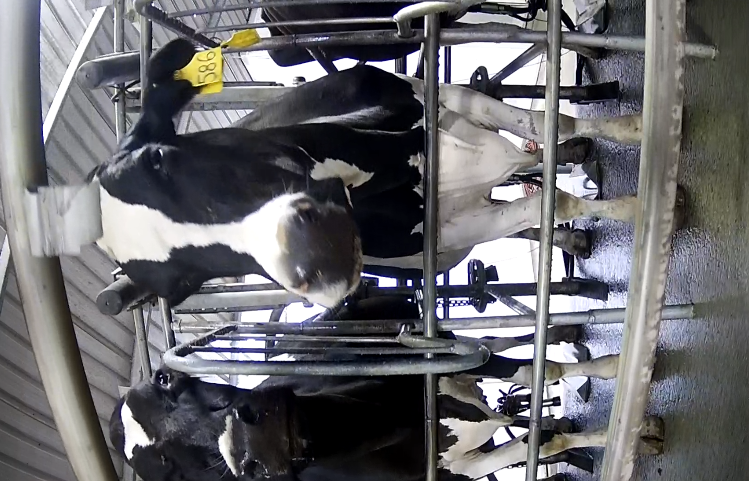

4. Odd scenarios:
Cow lean forward, appears earlier than usual:
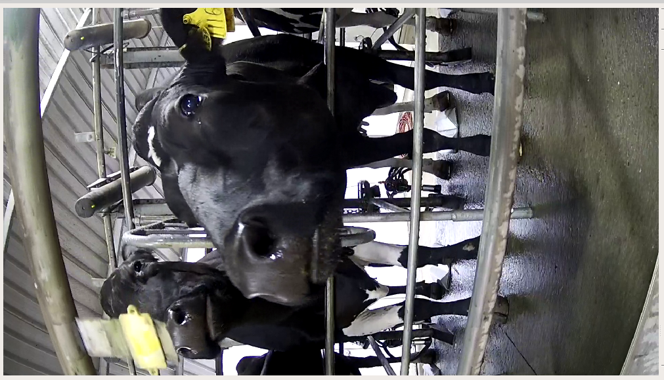

1.3
There are 54 bails on the platform;
It takes 9 seconds for each bail to pass EID;
Takes 9s x 54 = 486s = 8m6s (8m4s) for one round;
Takes 16.3 rounds (880/54) to milk 880 cows;
Takes 16.3 x 8.1 = 132m(2h12m) to milk 880 cows
On average, each cow ‘alive’ in the camera for 10 seconds; (Alive means the entire face is captured.)
This number varies.

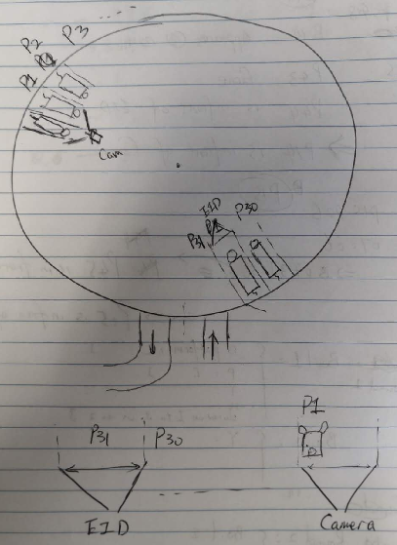

1.4
There are 30 bails between EID and Camera.
When the 1st cow fully appears in the camera, the 30th cow should disappear from EID detection, the 31st cow should be detected.
In term of time, if the platform runs smooth, it takes 9s x 30 = 270s(4m30s) for each cow to transfer from EID to camera.

1.5
Protrack log file quick glimpse:
/data/gpueval/imageProcessing/peguo0/cowFace/PT.log/PT-200128-034738_modified.log

- G,0: Cow get read at platform;
- r_platformReader, 3: Cow get read in every 80 ms;
- P,1: Bail 1;
- L,1: Bail 1 response from Minda

For one cow:
- 2 X r_PlatformReader;
- G,0;
- lots of r_PlatformReader,
- P,1...54;
- L,1...54

28/01/2020 04:30:29.006 r,PlatformReader,3,LA 00000 0 982 123531951928
28/01/2020 04:30:29.086 r,PlatformReader,3,LA 00000 0 982 123531951928
28/01/2020 04:30:29.086 G,0,982 123531951928,0,0,0,0,0,0
28/01/2020 04:30:29.166 r,PlatformReader,3,LA 00000 0 982 123531951928
28/01/2020 04:30:29.246 r,PlatformReader,3,LA 00000 0 982 123531951928
28/01/2020 04:30:29.326 r,PlatformReader,3,LA 00000 0 982 123531951928
... lots for r, PlatformReader
28/01/2020 04:30:38.370 r,PlatformReader,3,LA 00000 0 982 123531951928
28/01/2020 04:30:38.450 r,PlatformReader,3,LA 00000 0 982 123531951928
28/01/2020 04:30:38.530 r,PlatformReader,3,LA 00000 0 982 123531951928
... roughly 3 seconds later
28/01/2020 04:30:41.263 P,3,982 123531951928,0,0,0,0,0,0
28/01/2020 04:30:41.263 L,3,982 123531951928,1,43858.1878738773,43858.1878366435,43858.1878912963,43858.1879459491,43858.1878217322
... ignore: roughly 8 minutes later, some r_DraftReader info
28/01/2020 04:38:44.966 r,DraftReader,3,LA 00000 0 982 123531951928
28/01/2020 04:38:44.966 Q,0,982 123531951928,0,0,0,0,0,0,D
28/01/2020 04:38:45.047 r,DraftReader,3,LA 00000 0 982 123531951928
... more r_DraftReader

some cow got O,TFASomaticCellCount between P and Q:
28/01/2020 04:32:39.632 O,TFASomaticCellCount,982 123464414456,43858.1893475926,2,234
28/01/2020 04:34:20.476 O,TFAMilkMeter,982 123464414456,43858.1905147685,5.7,2,6589,1,100,0,1.5,4.62,35.6,0,220,0,0,
28/01/2020 04:34:20.476 O,TFAMilkComposition,982 123464414456,43858.1905147685,2,5.21,-1,3.52

For more than one cow’s G,0 (6-13 seconds):
28/01/2020 04:30:07.969 G,0,982 123739375359,0,0,0,0,0,0
28/01/2020 04:30:20.393 G,0,982 123464414456,0,0,0,0,0,0
28/01/2020 04:30:29.086 G,0,982 123531951928,0,0,0,0,0,0
28/01/2020 04:30:38.912 G,0,982 091001180997,0,0,0,0,0,0
28/01/2020 04:30:44.524 G,0,982 123518698347,0,0,0,0,0,0
28/01/2020 04:31:03.640 G,0,982 091001181009,0,0,0,0,0,0
28/01/2020 04:31:20.090 G,0,982 091001194055,0,0,0,0,0,0
28/01/2020 04:31:27.834 G,0,982 123520571417,0,0,0,0,0,0
28/01/2020 04:31:37.013 G,0,982 091004778634,0,0,0,0,0,0
28/01/2020 04:31:46.175 G,0,982 000189575800,0,0,0,0,0,0
28/01/2020 04:31:55.805 G,0,982 123726496176,0,0,0,0,0,0
28/01/2020 04:32:02.301 G,0,982 123531951931,0,0,0,0,0,0
28/01/2020 04:32:15.711 G,0,982 123485232547,0,0,0,0,0,0
28/01/2020 04:32:25.391 G,0,982 123480992318,0,0,0,0,0,0
28/01/2020 04:32:30.788 G,0,982 123520571323,0,0,0,0,0,0
28/01/2020 04:32:41.016 G,0,982 091001181397,0,0,0,0,0,0
28/01/2020 04:32:47.774 G,0,982 123475146650,0,0,0,0,0,0
28/01/2020 04:32:59.645 G,0,982 123476954855,0,0,0,0,0,0
28/01/2020 04:33:06.956 G,0,982 123478534984,0,0,0,0,0,0
28/01/2020 04:33:14.473 G,0,982 123475146610,0,0,0,0,0,0

For more than one cow’s P,1...54(9 seconds, very consistant):
28/01/2020 04:30:23.469 P,1,982 123739375359,0,0,0,0,0,0
28/01/2020 04:30:32.303 P,2,982 123464414456,0,0,0,0,0,0
28/01/2020 04:30:41.263 P,3,982 123531951928,0,0,0,0,0,0
28/01/2020 04:30:59.044 P,4,982 091001180997,0,0,0,0,0,0
28/01/2020 04:31:14.804 P,5,982 123518698347,0,0,0,0,0,0
28/01/2020 04:31:23.626 P,6,982 091001181009,0,0,0,0,0,0
28/01/2020 04:31:32.557 P,7,982 091001194055,0,0,0,0,0,0
28/01/2020 04:31:41.539 P,8,982 123520571417,0,0,0,0,0,0
28/01/2020 04:31:50.439 P,9,982 091004778634,0,0,0,0,0,0
28/01/2020 04:31:59.387 P,10,982 000189575800,0,0,0,0,0,0
28/01/2020 04:32:08.315 P,11,982 123726496176,0,0,0,0,0,0
28/01/2020 04:32:18.399 P,12,982 123531951931,0,0,0,0,0,0
28/01/2020 04:32:27.704 P,13,982 123485232547,0,0,0,0,0,0
28/01/2020 04:32:36.439 P,14,982 123480992318,0,0,0,0,0,0
28/01/2020 04:32:45.355 P,15,982 123520571323,0,0,0,0,0,0
28/01/2020 04:32:54.323 P,16,982 091001181397,0,0,0,0,0,0
28/01/2020 04:33:03.190 P,17,982 123475146650,0,0,0,0,0,0
28/01/2020 04:33:12.061 P,18,982 123476954855,0,0,0,0,0,0
28/01/2020 04:33:20.917 P,19,982 123478534984,0,0,0,0,0,0
28/01/2020 04:33:29.931 P,20,982 123475146610,0,0,0,0,0,0

1.6
EID reading overlapping
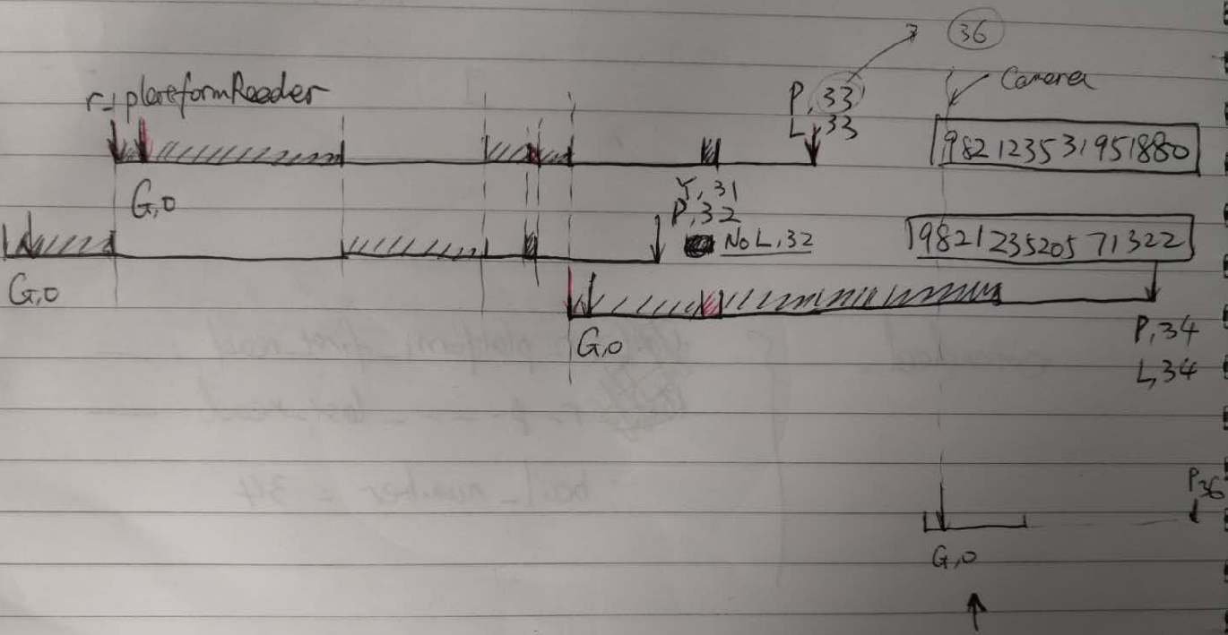

1.7
P and r/G log visualization

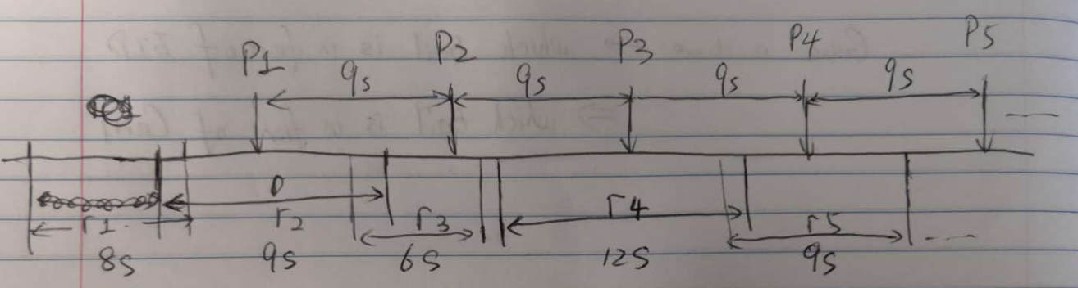
- G,0 = the first r_PlatformReader
- P,i – P i+1 = 9 seconds;
- G,0(i) – G,0 (i+1) = 6~13 seconds;
- P,i is always later than G,0 and the last r_PlatfromReader
- P,i is more reliable than G,0 or r_PlatformReader

1.8
Other logs:
U,26: Unknown cow on 26;
E,33: Empty Bail 33;
Y,31: Swapped unknown for EID

U + L (no G):
28/01/2020 05:15:01.878 U,26,,0,0,0,0,0,0
28/01/2020 05:15:01.878 L,26,,1,43858.218666875,0,0,0,43858.2186137972

E + L (no G):
28/01/2020 07:02:52.437 E,33,,0,0,0,0,0,0
28/01/2020 07:02:52.437 L,33,,0,43858.2935602083,0,0,0,43858.2935079806

1.9
Ideally:
- G == P (got a EID, then bail number)
- P + U + E == L (a known cow, or an unknown cow, or empty = everything)

Reality:
- G = 888
- P = 887
- U = 5;
- E = 80;
- L = 970
- Y = 1

G != P
Because:
This one only got read for 1.2 second, and got a Y, no P, no L:
28/01/2020 04:35:03.241 r,PlatformReader,3,LA 00000 0 982 123520571501
28/01/2020 04:35:03.321 r,PlatformReader,3,LA 00000 0 982 123520571501
28/01/2020 04:35:03.321 G,0,982 123520571501,0,0,0,0,0,0
28/01/2020 04:35:03.475 r,PlatformReader,3,LA 00000 0 982 123520571501
28/01/2020 04:35:03.555 r,PlatformReader,3,LA 00000 0 982 123520571501
28/01/2020 04:35:03.635 r,PlatformReader,3,LA 00000 0 982 123520571501
28/01/2020 04:35:03.715 r,PlatformReader,3,LA 00000 0 982 123520571501
28/01/2020 04:35:03.795 r,PlatformReader,3,LA 00000 0 982 123520571501
28/01/2020 04:35:03.875 r,PlatformReader,3,LA 00000 0 982 123520571501
28/01/2020 04:35:03.955 r,PlatformReader,3,LA 00000 0 982 123520571501
28/01/2020 04:35:04.035 r,PlatformReader,3,LA 00000 0 982 123520571501
28/01/2020 04:35:04.115 r,PlatformReader,3,LA 00000 0 982 123520571501
28/01/2020 04:35:04.195 r,PlatformReader,3,LA 00000 0 982 123520571501
28/01/2020 04:35:04.275 r,PlatformReader,3,LA 00000 0 982 123520571501
28/01/2020 04:35:04.355 r,PlatformReader,3,LA 00000 0 982 123520571501
28/01/2020 04:35:04.435 r,PlatformReader,3,LA 00000 0 982 123520571501
28/01/2020 04:35:04.515 r,PlatformReader,3,LA 00000 0 982 123520571501
...
28/01/2020 04:35:17.298 Y,31,982 123520571501,0,0,0,0,0,0

Conclusion:
- G = P + Y
- Most reliable info of a known cow is P, not G;

P + U + E = 972 > L (970)
Because there is a case of E, but no L; a P but no L:
28/01/2020 04:34:59.337 P,30,982 123476954804,0,0,0,0,0,0
28/01/2020 04:34:59.337 L,30,982 123476954804,1,43858.1908605903,43858.1908209259,43858.1908724605,43858.1909353472,43858.1908078608
28/01/2020 04:35:08.306 U,31,,0,0,0,0,0,0
28/01/2020 04:35:08.306 L,31,,1,43858.1909645486,0,0,0,43858.1909115299
28/01/2020 04:35:17.298 P,32,982 123520571322,0,0,0,0,0,0
28/01/2020 04:35:26.202 P,33,982 123531951880,0,0,0,0,0,0
28/01/2020 04:35:26.202 L,33,982 123531951880,1,43858.1911724306,43858.1911225463,43858.1911875075,43858.1912506134,43858.1911193528
28/01/2020 04:35:34.983 P,34,982 123518698333,0,0,0,0,0,0
28/01/2020 04:35:34.983 L,34,982 123518698333,1,43858.1912754861,43858.1912320833,43858.1912698311,43858.1913071065,4385
Conclusion:
- Each bail must have either a P, a U, or a E.
- Most reliable bail info is P + U + E; not L
Combo:
- G + P + L; a bail got a cow, then her bail number
- G + Y; a bail got a cow, wait a sec, maybe not a cow, bail number
- U + L; a bail got an unknown cow, the first read, bail number
- E + L; a bail got no cow, bail number

2. Objective + Design
2.1 Material:
- Video (contains time)
- Protrack log files

2.2 Final goal:
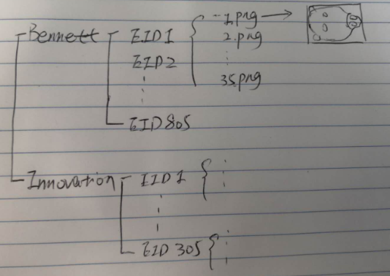
Error rate < 5 %; this error rate needs to be proven.

2.3 First goal:
A Face tracker with EID displayed along the moving face

2.4 Proposed EID assignment:
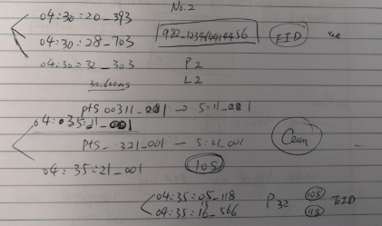

A frame of a Video (with pts) – timestamp – which cow/bail in front of EID (P32)- which cow/bail in front of camera (P32 – 30 = P2) – assign P2 to current frame

1. What time a face is fully appears, eg. Pts00311_001;
2. Which cow is in front of EID reader, eg. P32;
3. Which cow is in front of Camera, eg. P32 – 30 = P2;
4. What is P2’s EID, 982-123464414456;
5. Assign this EID to this cow @ this given time.

2.4 Two different designs:
1. Detection, then Tracking, then assign EID to cows;
2. Detection and assign at the same time, then tracking.

I prefer design one, as it can separate the project into several independent modules.

3. Proposed steps (Design 1)
3.1 Create a cow face detector (I’m thinking Yolo):
A given frame, whether there’s a cow? And where?
- inputs: 100-1000 manually cropped rotated cow face
- output: a cow-face detector/a NN model

Steps:
1. Test Yolo exist cow face detector, get an accuracy. (1 week)
2. Prepare a dataset contains 100-1000 cow face (1 week)
3. Feed the dataset images to yolo pipeline, get a NN model (1 weeks)
4. Inference, get the accuracy (1 week)

Aim:
- Expecting high TP (>98%); FP needs to be low(<2%); I don’t want jumping box;
- Reliability: can be low; >80%; allow high FN (20%); Missed cow from time to time (1/5) is ok.

3.2 Create a cow-face tracker (three weeks - one month):
Assign each detected cow to a group; remove odd groups and odd frames
- input: 1) a video + 2) the cow-face detector
- output: 1) a dictionary object - cowFaces; 2) annotation.csv

Some Reasonable Assumptions:
1. Cow cannot jump; cow centre speed <40 pixels/second
2. Size(width and height) doesn’t change > 10%
3. Cow alive for >5 seconds

Steps:
1. Implement cow-face detector; write the detection result:
Each detected cow would be assigned to an exist cow, if the distance is small (Assumption 1).
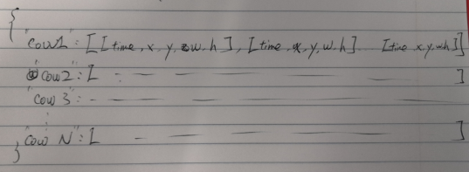
cowFaces dictionary

2. Remove short live cow and jump size cows (one week)
Assumption 2: remove jumping sized cow
Assumption 3: remove
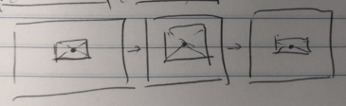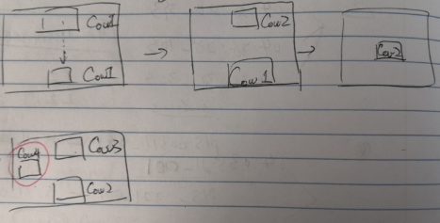

3. Convert cowFaces to annotation.csv – for visualization purpose (one week):
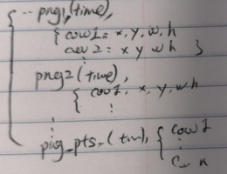

3.3 Assign each cow an EID number (one month – five weeks)
- input: 1) log file; 2) cowFaces(from step 3.2)
- output: 1) cowFacesEID; 2) annotationEID.csv; 3)

Steps:
1. Load log file as a dict, do data cleaning
2. Assign cow1-cowN to EID1 – EIDN (lots or conditions; two weeks)
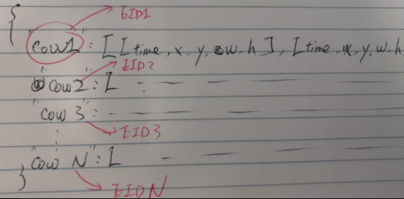
3. Update annotation.csv
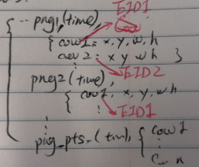

4. Crop each png, and saved to different EID folders (two weeks).
5. Test the error rate (one-two weeks):
Definition: cow based, not frame based.
A cow appear, system assign an EID, compare this EID to the ground truth(EID). All combinations:

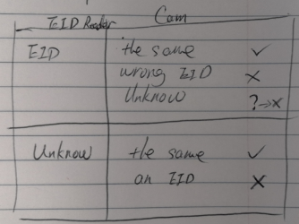

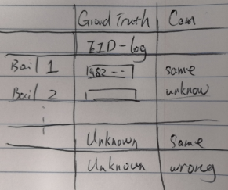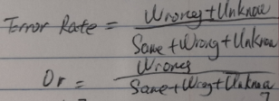
Note:
1. Accuracy is cow based, not frame based?
eg. If a cow appears for 250 frames (10 seconds), but we only have 200 frames, that count as one accurate case.

2. An unknown cow may not count as an error.
eg. If a timestamp falls into the middle of both EID read, or platform is moving back and forth, or some odd situations, the EID-assigning algorithm can’t decide which cow, I would dump it (assign as unknow). This won’t affect the quality of dataset.

Step 0: Prove of concept:
Create subtile files (srt) for each video, to display cow EID
1
0:00:57,761 --> 0:00:59,761
Round:1; Bail:1; EID:982 123531002757/Unknown/Empty

2
0:01:06,701 --> 0:01:08,701
Round:1; Bail:2; EID:982 123519007055/Unknown/Empty

log VS camera:
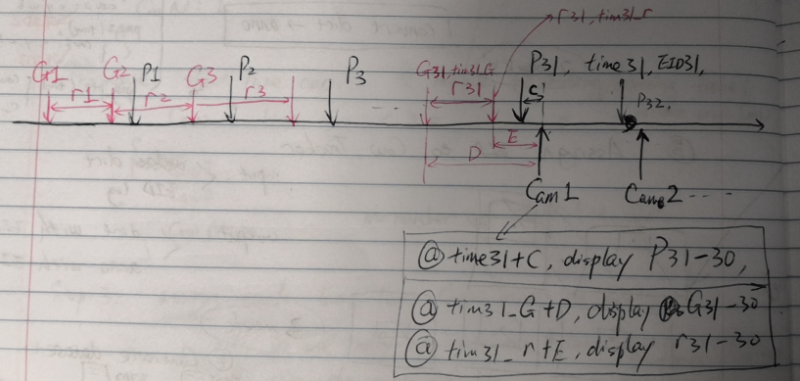

Protrack log and video:
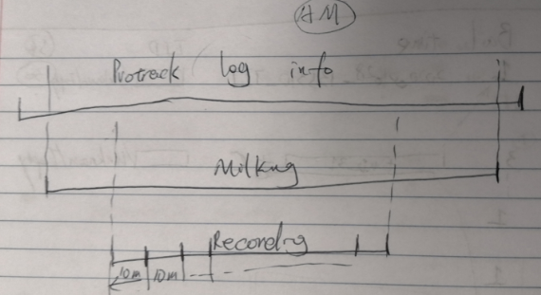
Note: Recording could be longer or shorter than milking

Steps:
1. Convert log file to a table:
(eg. /data/gpueval/imageProcessing/peguo0/cowFace/P+U+E.txt)

input: log file;
output: a table
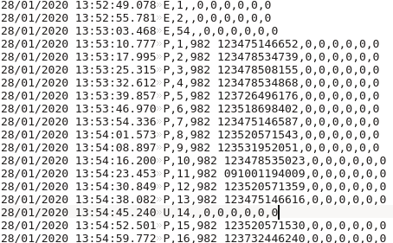
->
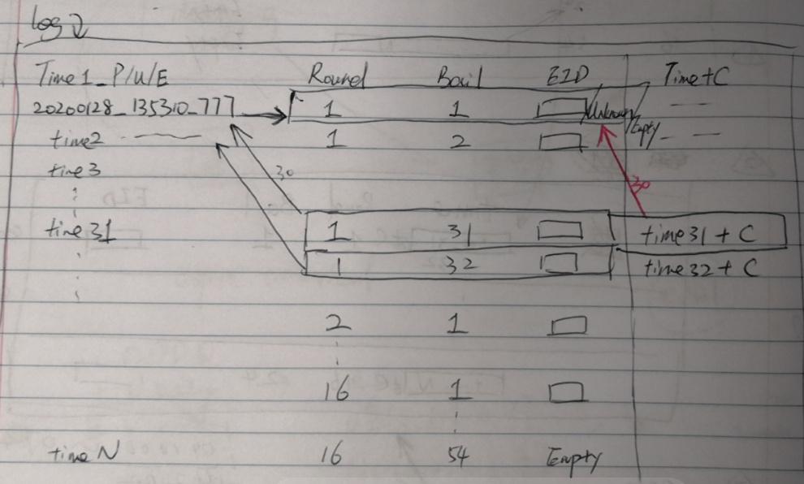
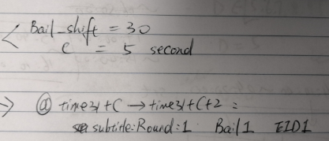
Note: EID column must have a state: EID/Unknown/Empty

2. Create srt file for each video:
inputs: 1. the table above; 2. bunch of video names;
output: bunch of srt files corresponding to video names.
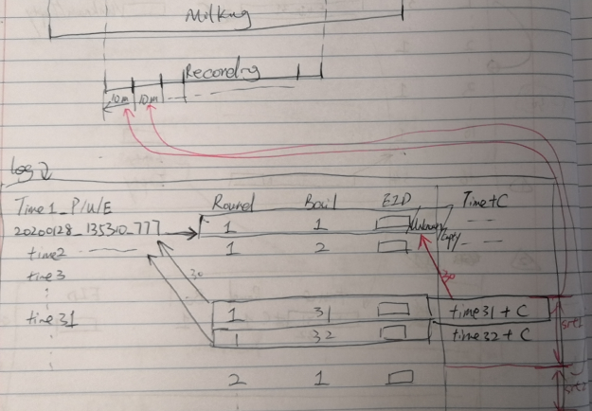

e.g. output srt file:
QBH-PlatFace1.shed8003993.20200128_042000.srt:
1
0:00:57,761 --> 0:00:59,761
Round:1; Bail:1; EID:982 123531002757/Unknown/Empty

2
0:01:06,701 --> 0:01:08,701
Round:1; Bail:2; EID:982 123519007055/Unknown/Empty

More details about the step 1:
1. How to decide the start line of round 1;
2. How to assign round number to each line; what if a bail is missing or duplicated;
28/01/2020 04:34:59.337 P,30,982 123476954804,0,0,0,0,0,0
28/01/2020 04:35:08.306 U,31,,0,0,0,0,0,0
28/01/2020 04:35:17.298 Y,31,982 123520571501,0,0,0,0,0,0
3. Do I need to save the table as a file along with ‘PT*.log’
4. I don’t need video file; but need video name (start timestamp) + pts file.
Assign each time_N to the closest pts.
5. I need to generate pts for each video first (Hieu has pts generator).
eg.
‘*.mp4.pts’ (15 frames/second):
0
66
133
200
266
333
400
466
533
600
666
733
800
866
933
1000
...
598200
598266
598333

More details about the step 2:
1. How to convert real time (table 2) to relative time in srt;
28/01/2020 13:53:07.609 -> 0:03:06,609
Watch out video didn’t start at 10 minutes sharp: eg.
8003993/202002/20200227/QBH-PortHead.shed8003993.20200227_151501.mp4
2. Display 2 seconds? Watch out ‘time_N + 2’ > ‘the end of the video’

Others:
Coding details:
Farm unique parameters:
Farm ID, e.g. 8003993
Maximum number of cows in each frame, e.g. 2

