Nicole Arruda
Anjana Chiluka
Eddie Gurnee
Mike Nitchie

Final Report

To improve our app to the level of a $4.99 app on the Play Store, we would add several features, clean up our current UI, and tighten up our code.

A very powerful addition to our app would be in the form of including GPS functionality. This could allow us to track the robot on Google Maps to show the paths that it has taken, or to drive it by sending it coordinates that it would be able to navigate to. The benefit of the GPS is that the user would not have to remain with in line of sight with the robot for the robot to be able to navigate, simultaneously, this absence of direct user control could be very detrimental. To combat this shortcoming, we would add a camera to the robot that would send video back to the android device, allowing the user to reliably control it without needing to be within line of sight of the robot.

There are many improvements that could be made to the voice control. A major upgrade would be to remove the button that is currently needed to activate a voice command and allow the user to “activate” the robot with some verbal prefix; for example: “Hello robot!” The phone would then receive the next spoken words and interpret them as commands, properly sending the robot in the correct direction. This activation command, along with all other verbal commands, should be completely customizable for a more complete user experience.

We would need to consider in our implementation that different Android devices support different versions of the OS and different screen resolutions. Some of our functionality is only supported on older versions of Android, while others are only supported on newer versions. We would need to find API's that give us the functionality that we want while still being reasonably backwards compatible. We would also need to design different UI’s for devices with smaller screens, like phones, and devices with larger screens, such as tablets.

The linear swipe view is not conducive to quick navigation of the app: if the user wants to quickly go from the connect view to the accelerometer view or gyroscope view, then they would have to swipe from all the way on the left across all other screens to get to the furthest screen to the right. A far better idea would be to allow the user to “zoom out” from any view, creating a view that would contain thumbnails of all the other views. From here the user could touch whatever view they wanted to use and jump directly into that view, making navigation take at most two touches (instead of the current maximum of n – 1 touches, with n being the total number of views).

We could add several customization options to the settings of our app. For example, we could allow the user to add custom voice commands and indicate what action the robot should take upon each command. We could allow the user to set the sensitivity of the gyroscope and accelerometer. There could be options for changing the color scheme of the app through the settings.

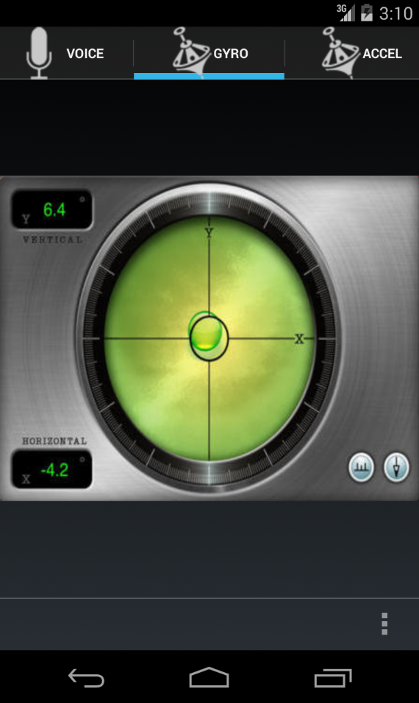

To complete the current UI of our app we will add more informative UI's to our gyroscope and accelerometer views. The gyroscope view will feature an icon resembling a bubble level (see screenshot) that will indicate the direction and amount of acceleration. As previously referenced, the sensitivity of the accelerometer can be scaled up or down by the user in the settings menu.

The accelerometer view will look very similar to the traditional “touch-button” drive view. However, instead of the buttons reacting to a push they will change state based on the feedback from the accelerometer. If the accelerometer measures positive Y acceleration than the top button will light up. If it measures negative Y acceleration than the bottom button will light up; same goes for the “X” direction.

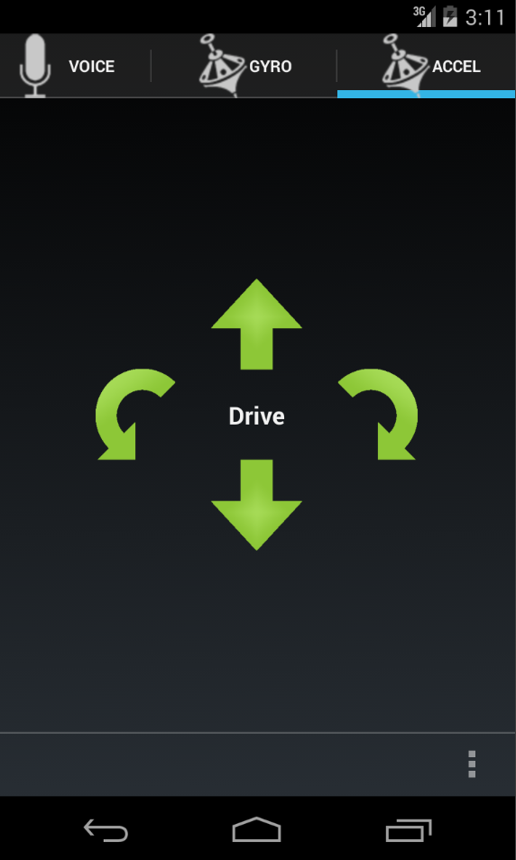

And as a final addition for our version 2.0 robot we will implement this: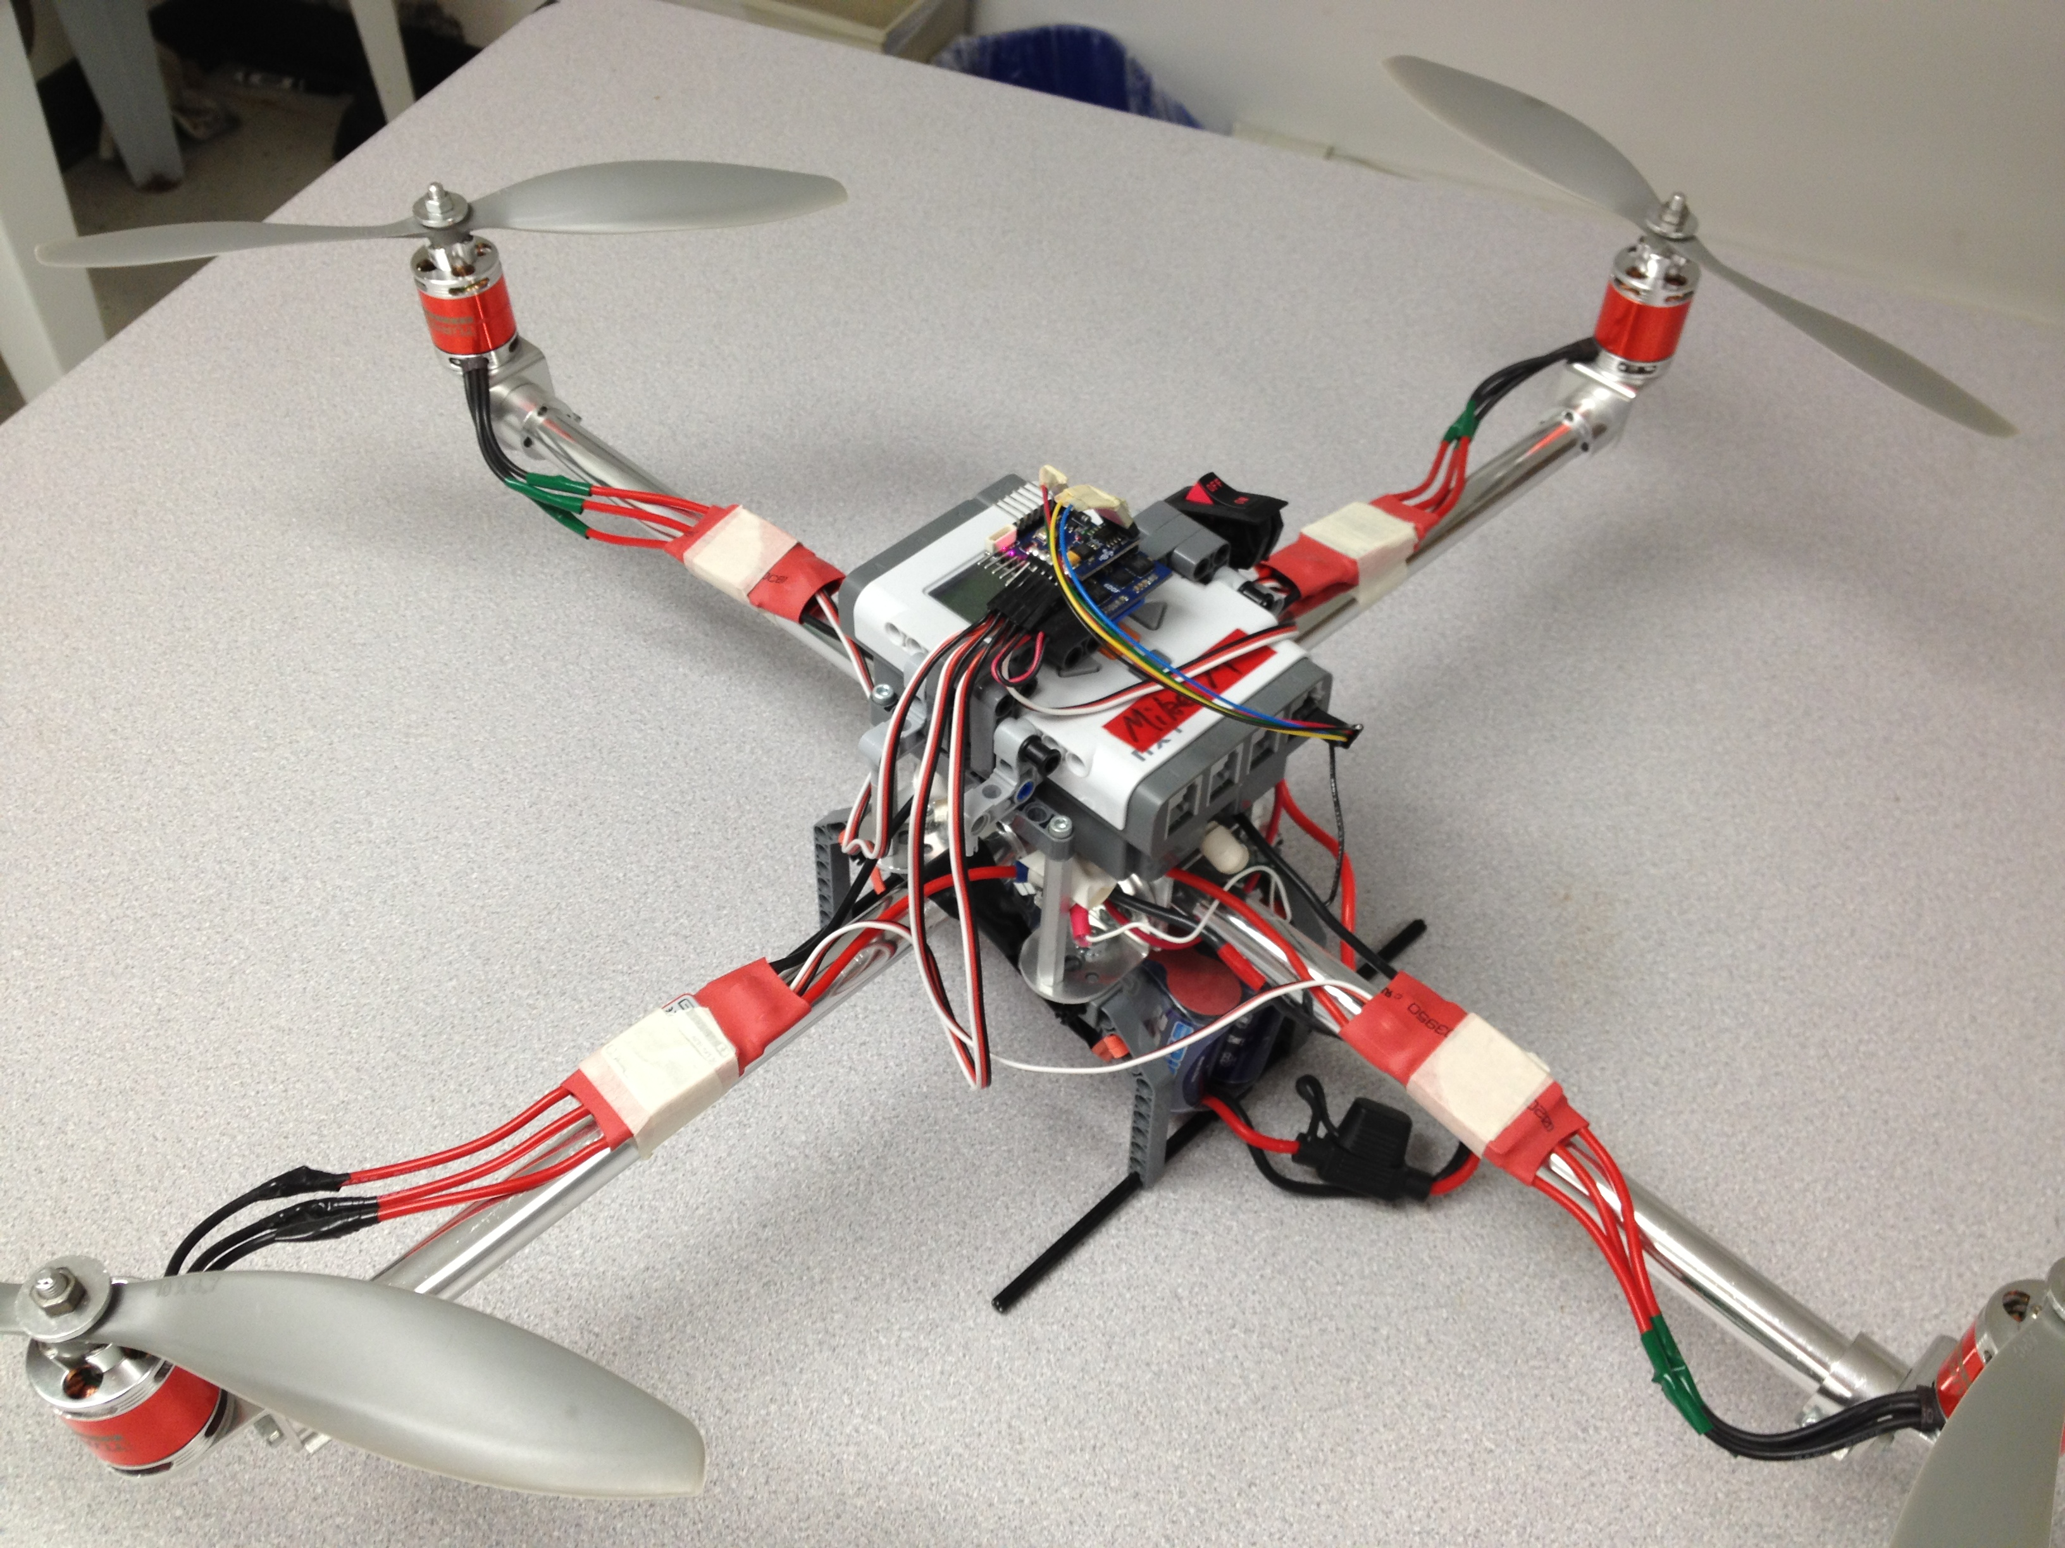

The end.

